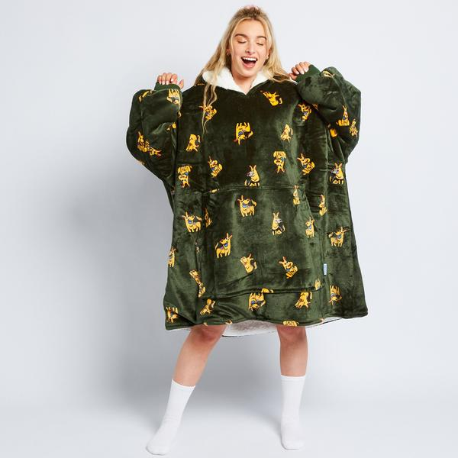
Consultancy Report 2020
Prepared by: 703793X
Prepared for: Evan Franco

Contents
EXECUTIVE SUMMARY 3
COMPANY OVERVIEW 4
Presentation of Findings 4
CHALLENGE 5
RISKS 5
OVERCOMING RISKS 5
Seasonal Shipping 5
New product line 6
Customer loyalty 6
OPPORTUNITIES 7
Conclusion 8
Appendix 9
References 10

EXECUTIVE SUMMARY

Based on analysis of The Oodie business model, three threats to the business model have been identified. The three risks are:
- The Oodie being a seasonal item – not a product Australians purchase all year around
- The company has been created around a single product
- The Oodie is a product that consumers only want one of
In the body of our report, the risks will be expanded and explored while each risk will have a recommendation to mitigate the risk.
In addition, through exploration of the business model, a massive opportunity was identified for The Oodie company. This opportunity is for the business to license new designs that are highly desirable to the market place.
Each risk and opportunity will be explored in more detail in the body.

COMPANY OVERVIEW

The Oodie sells a “one size fits most” hooded blanket made from flannel and Sherpa fleece “perfect for chilly mornings and afternoon naps”. After a discussion with David, CEO of The Oodie, his business initially launched just Oodies with a plain solid colour design but within the past year, The Oodie has expanded their product line with new designs such as pandas, pizza, avocado, Tie-Dye and introduced a complementary line of other products.
The Oodie, currently manufactures in China and sells online to Australia, New Zealand, United Kingdom, Europe, Canada and America.
The Oodie’s primary customer market is identified as both males and females aged 20-30.

Presentation of Findings
Based on analysis of the business, we will present the following findings:
- Potential risks facing the business
- Suggested solutions and opportunities to overcome the outlined risks
- Analysis of an opportunity for product expansion

CHALLENGE

After discussion with the CFO, one present challenge The Oodie faces is meeting the high product demand, because sales have unexpectedly increased. This challenge will become even more prevalent as Black Friday and Christmas approach.
Two possible solutions to combat this challenge is:
- Having multiple manufacturers around the globe
- Rather than shipping their products, The Oodie could transport them via air
The extra manufacturer will increase the amount of product being created but will not increase the rate at which the product is delivered. It’s critical for The Oodie to assess whether or not a significant profit margin is achievable with the excess cost of airline expense.

RISKS
Based on analysis and discussion with management, we’ve identified the following risks with the Oodie business model.
- The Oodie is a seasonal item, predominantly worn in winter only because of its warmth. This means, a product that is predominantly sold in Australia, will notice a significant drop of revenue streams during the summer months.
- David has created a company around only one product, not multiple items or a series of product lines.
- An Oodie is a product a customer will only want to purchase once, meaning the product does not require consistent customer loyalty. After discussion with the CFO of The Oodie, the average number of orders per customer is 1.27 therefore proving most customers only purchase once each customer does not bring in consistent customer revenues.

OVERCOMING RISKS
In order for the business to continue to grow and remain viable, with the risks identified in previous section, we recommend the following actions to overcome the possible negative consequences associated with the risks.

Seasonal Shipping
As the Oodie is a seasonal product, it’s important to market the global customer segment appropriately. Our proposition is to market to countries such as Europe during Australian summer to maintain a consistent revenue stream.

New product line
To attract more customers and increase revenue streams, Oodies can release new products, consistent with brand image and primary target market. We recommend expanding the Oodie brand and introducing products such as yoga pants, beanies and fuzzy socks, all matching the same comfort and warmth aspect as the Oodie.

Customer loyalty
The Oodie is a once-off purchase making it difficult to attain consistent frequent customers. To mitigate the risk, it’s necessary to introduce new, innovative designs and products. It is recommended also to create a kid’s size so when children grow out of their oodie, they are forced to purchase a larger size, therefore increasing revenue streams. Customer loyalty can increase due to frequent marketing channels such as email subscriptions, Instagram, Facebook and Tik Tok adds (Appendix 1).

OPPORTUNITIES
A recommended opportunity that The Oodie could use to grow is licensing Disney character designs. This would expectantly increase the younger customer demographic as well as Disney fanatics. Not only is Disney an opportunity, but many other brands like the AFL. Football is a very large part of Australian culture and with footy team designs, this would increase the male percentage of customers.

Conclusion
In conclusion, The Oodie faces many threats to its business model such as the product being only seasonal, and the entire business is created upon a single product that consumers only desire one of. These threats can be mitigated through seasonal shipping, new products and increasingly customer loyalty. The Oodie can further expand its target market and revenue streams by licensing Disney character designs and sport team designs.

Word Count: 885

Appendix
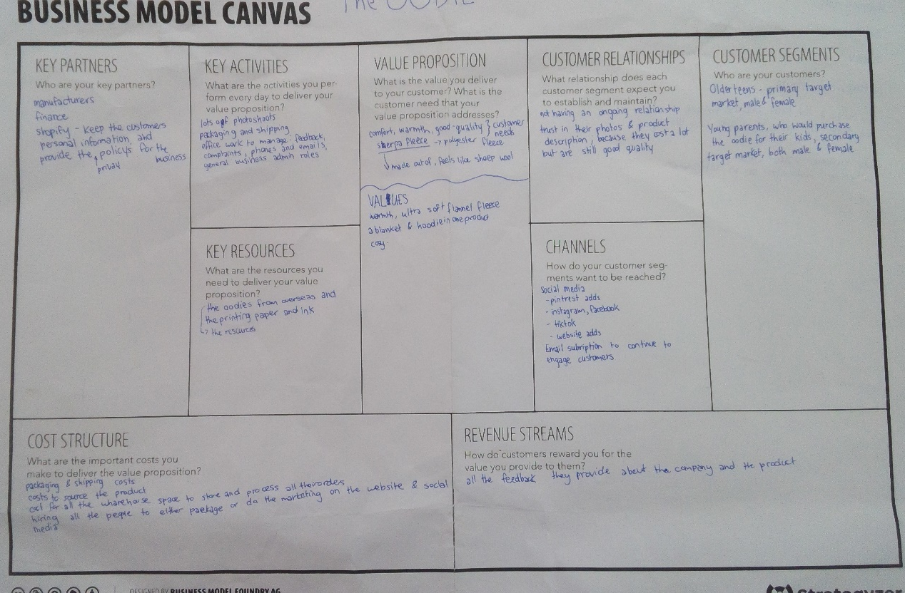

References
https://youlookfab.com/2007/05/25/the-two-seasons-of-clothing-retail/ The two seasons of clothing retail. Author: Angie, 2007. Accessed: 20/10/20
Interview, CFO of Oodie. Daniel Cadieux, 16/10/20.
https://theoodie.com/ the oodie. N/A, 2020. Accessed: 18/10/20

https://theoodie.com/ the oodie. N/A, 2020. Accessed: 18/10/20
https://youlookfab.com/2007/05/25/the-two-seasons-of-clothing-retail/ The two seasons of clothing retail. Author: Angie, 2007. Accessed: 20/10/20
Interview, CFO of Oodie. Daniel Cadieux, 16/10/20.

