Assessment Type 2 - Business Model Evaluation

Part 1

The effectiveness of decision-making and project management tools and strategies
Customer interviews (Appendix 1) were created to understand the main desires of the customer segment which assisted in the creation of my empathy map (Appendix 2). Interviews stated the primary reason customers don’t invest in sustainability is because it’s inconvenient; customers are also more willing to invest in a company that has a good intention, like replenish. This data provided the necessary insights to design a desirable product around customers biggest need being convenience. This was achieved by creating a subscription service where customers are automatically shipped their shampoo packets every month, for example, to ensure they don’t run out. The data from customer interviews showed the channels needed to interact with customers and the key activities replenish needs to undertake in order to meet and deliver the value proposition canvas (Appendix 3). Customer interviews also assisted in validating some of replenish’s riskiest assumptions (on the validation board – Appendix 4) being, customers care enough about the environment to be willing to invest in sustainable products, even at a premium price (Appendix 5). Through understanding the desires of replenish’s customers, replenish was able to design feasible products and delivery methods to suit customer desires of convenience and suit environmental goals such as purchasing products with reduced waste or recyclable materials which replenish helps accomplish that goal as all packaging is sustainable. Customer interviews, overall, were very effective as accumulated information about customers’ needs and desires helped to alter replenish’s business model to suit customer’s needs. If this process was used again, it would be more beneficial if some questions were about what social media apps are used more frequently to make online marketing more effective.

The financial analysis (Appendix 6) helped to confirm that the feasibility and desirability of the products and business design was financially possible. Performing the financial analysis provided data and confirmation that the business model was feasible. By completing the financial model, it helped identify financial needs and prioritise the fixed costs. During the first year, when financial support is limited as well as net profit, it was important that replenish limited unnecessary expenses, such as rent, in the first year to ensure the business model was still viable and that replenish would still make some profit and be financially sustainable for the following year. The financial model also helped identify selling prices and estimate how much was needed to spend on advertising and how significant of an expense the advertising was. The financial modelling was very effective as it helped make the business viable by analysing cost structure and revenue streams and ensure necessary precautions were taken to ensure the financial success of replenish.

Overall, the most effective tools used to ensure a desirable business model and one that would be viable was:
- The Value Proposition Canvas as this helped to create a desirable product as customers pains were relieved, desirable qualities were advanced and gains were created
- The Business Model Canvas helped to analyse every aspect of the business model and ensure its desirability, feasibility and viability were all existent

The original business model was a refillable shampoo and conditioner station located in grocery stores and hair salons. However, customer feedback stated that bringing in wet shampoo bottles to refill at these selected locations was an inconvenience. This model was then changed to the shampoo paper packets and steel dispensers available online. Then, thanks to collaborations, replenish iterated to what it is today suiting customers convenience desirability.

Part 2 – Risks and Opportunities in the current business model
A few financial risks have occurred in replenish’s business model due to the COVID-19 pandemic. Due to lock downs all over the world, the worldwide economy has gone into a recession. The target market for premium priced customer may be lower now than ever because customers may not be willing to spend as much due to the percentile of people being jobless due to the pandemic. Due to the restricted number of boats departing, transportation is limited due to this outbreak meaning a small business like replenish may find it difficult to compete for space on a shipping boat because larger companies may have priority. This will result in lower revenue streams as the supply may not reach the product demand. A contingency to combat this risk is using an Australian manufacturing company instead of one overseas which will increase the product delivery speed, however it’s likely that the cost will be higher, decreasing the margin.

An opportunity for replenish is releasing a new line of complementary products. This for example, could be hand soap or shower body gel sold in similar metal dispensers with similar paper packaging. This would be targeted at the same customer demographic and expectantly increase revenue streams as customers purchase multiple or all three of our product lines. Not only could replenish release complementary product lines but could also expand the customer demographic by creating a male shampoo product range which would increase customer sales and revenue streams as a brand-new gender demographic is targeted.
Another opportunity for replenish is large retail store like Myer or David Jones hearing about replenish’s products and approaching us and asking for our products to be sold in their stores. Not only will this increase sales and customers but is another step to expanding this business.

Recommendations to improve the business model
Strengthening customer relationships in order to improve customer loyalty and increase the frequency of purchasing. By sending monthly emails stating the amount of plastic pollution that has been prevented or the number of sea birds that have been saved from customers’ investments in replenish’s sustainable products can make the customers feel good, allowing them to realise how purchasing replenish’s products benefit the environment. This will then develop the customers relationship with replenish and increase customer loyalty as they know that by purchasing replenish’s products, they are benefiting the environment. This customer loyalty will expectantly boost revenue streams and increase replenish’s positive reputation. (Appendix 7 – collaboration).
Currently, the key resource used to sell replenish’s products is online for convenience sake however if a customer has not subscribed to the monthly shampoo delivery and has forgotten to order a shampoo packet, they may find themselves out of shampoo which becomes an inconvenience for them and a customer loss for replenish as they very well may purchase another brands shampoo. To prevent the customer loss, one of replenish’s key partners can be hair salons at which replenish can have an allocation in the shop to sell our paper shampoo packets, meaning customers can purchase these packets instore if their delivery has not come on time.

Part 3 – Evaluation of your skills of collaboration
Collaboration consisted of survey links and interviews distributed to a range of gender-neutral ages as well as interviews with teachers and classmates. Through customer interviews, the initial target market being females to a more narrowed target market of environmentally conscious women aged 20-50 was discovered and an understanding of their needs and wants was acquired, e.g. convenience, helping replenish to further fulfil these needs and meet the target market demographic with services. Interviews with teachers and classmates helped to further develop the initial business model as suggested improvements were made, for example, constructing the metal dispenser to suit only replenish’s shampoo packets to ensure customers can’t purchase any common shampoo and empty it into replenish’s bottle as this would lose frequent shampoo customers. These collaborations also helped to point out areas in my business model where I could improve like developing customer relationships. This was improved by sending out emails stating how much plastic pollution the customer has prevented by purchasing replenish’s products; making them feel obliged to continue buying from us because they know they’re doing something positive for the environment.

Approaching these interviews and communicating to the audience the business model, was simple as it was completed by online surveys as well as face-to-face conversations. Although customer interviews were very successful, in the future, In order to develop a deeper customer relationship, it’s important to ask the why questions – why the customer feels a certain way or why they invest in specific brands etc which will dig deeper and allow the business model to be entirely shaped to the targeted audience’s desires and interests, which will then project our revenue streams. One question I lacked during customer interviews was how the customer wanted to be reached and the most effective advertising for them whether it be social media adds, magazines, billboards etc. The channels used to reach my customers were based on educated guesses, therefore not making it reliable and has the potential to decrease my variable advertising costs effectiveness and limit customer revenue streams.

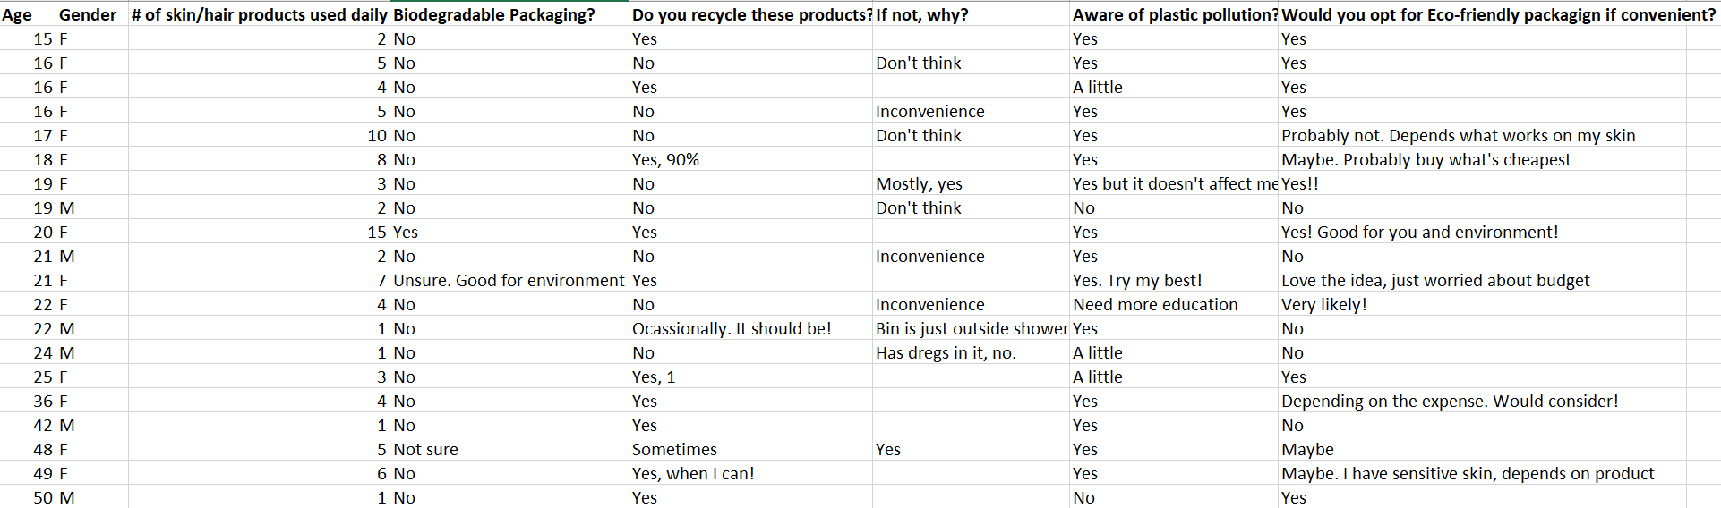
Appendix
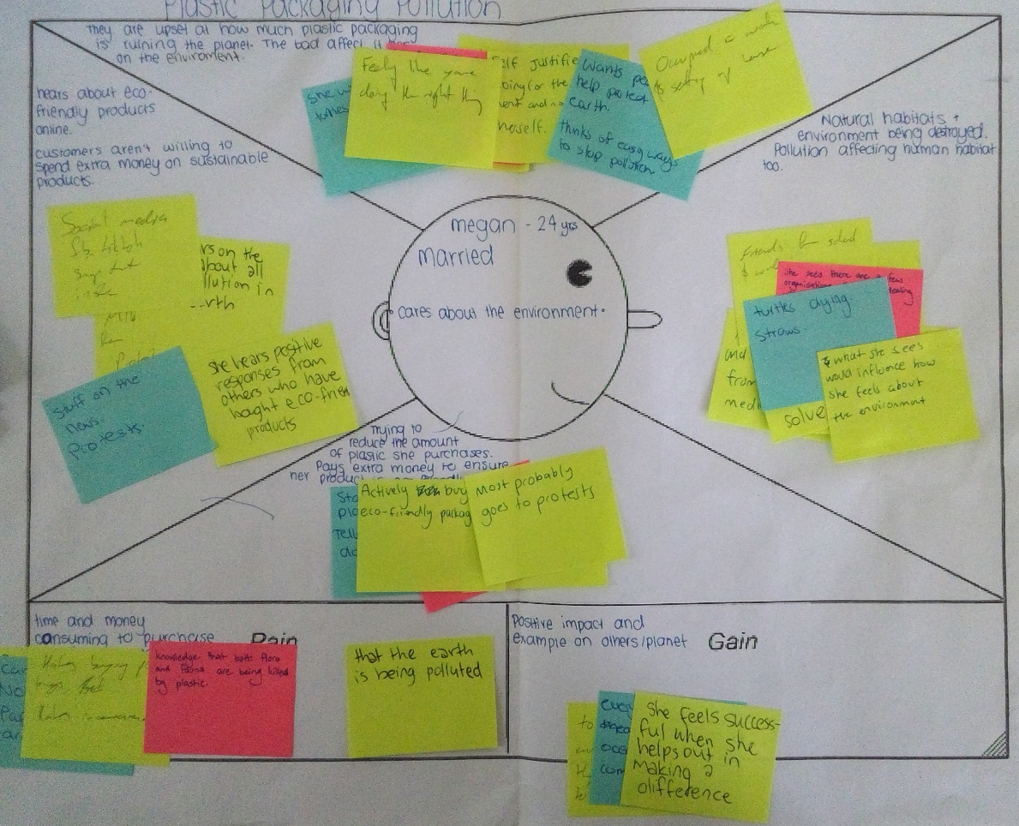
Appendix 2
Appendix 1

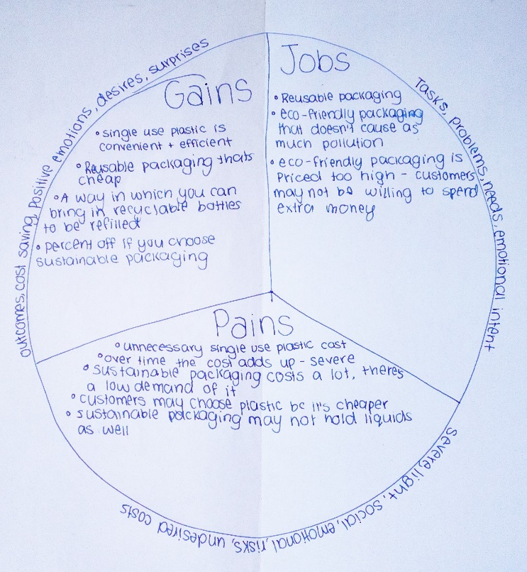
Appendix 3

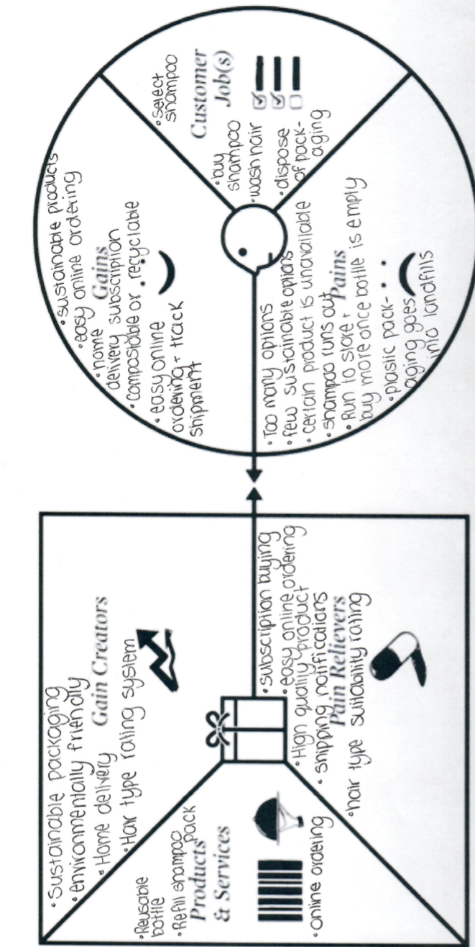
Appendix 3

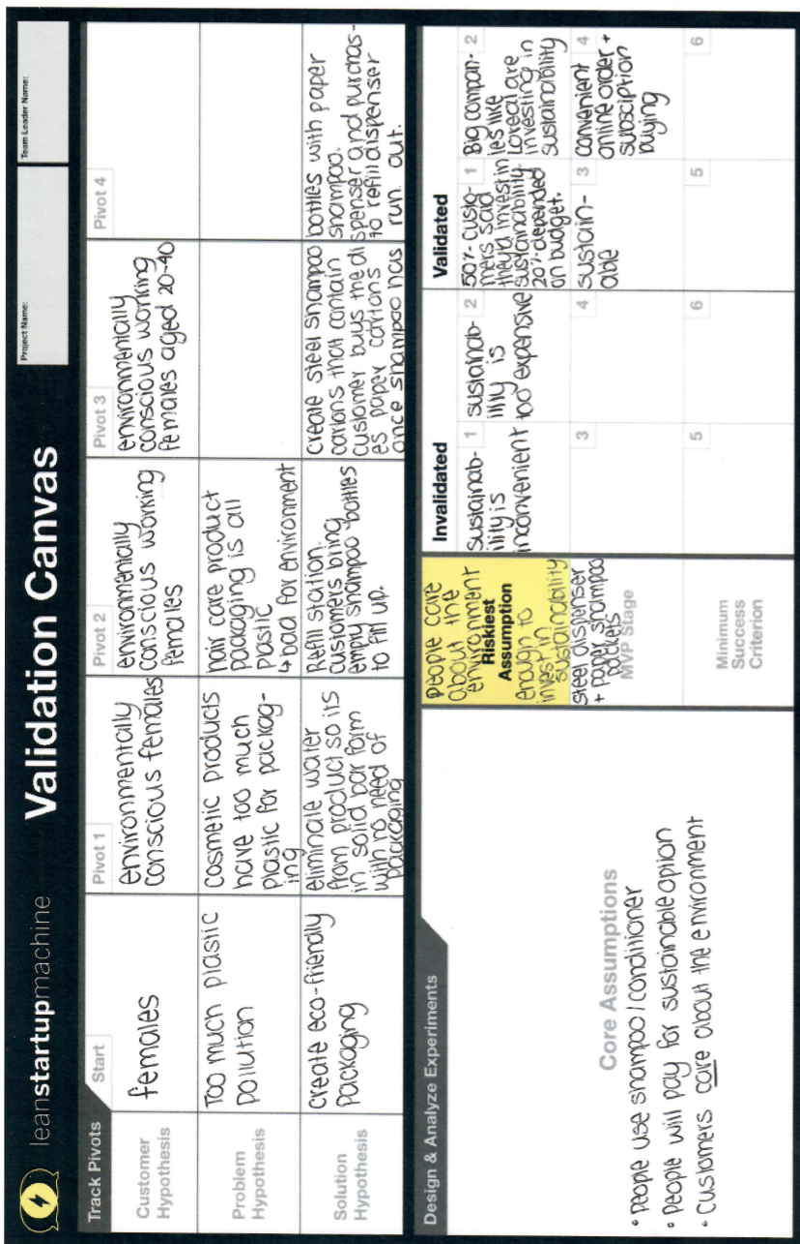
Appendix 4

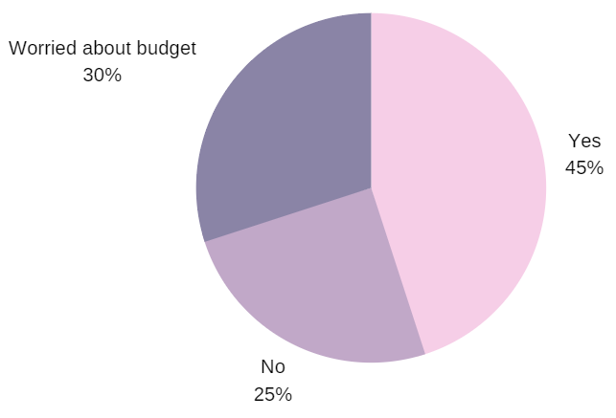
Appendix 5 – number of customers willing to invest in sustainability

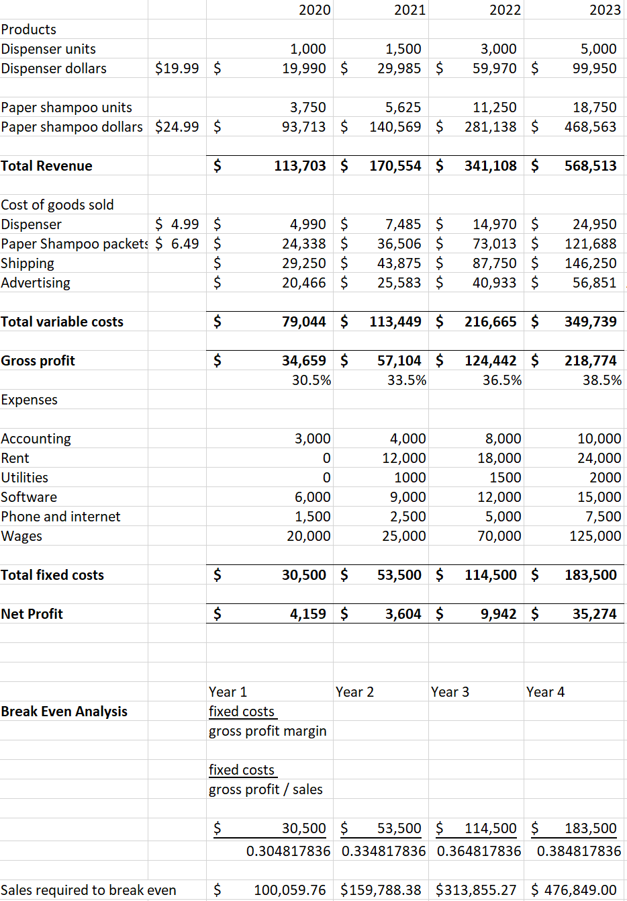
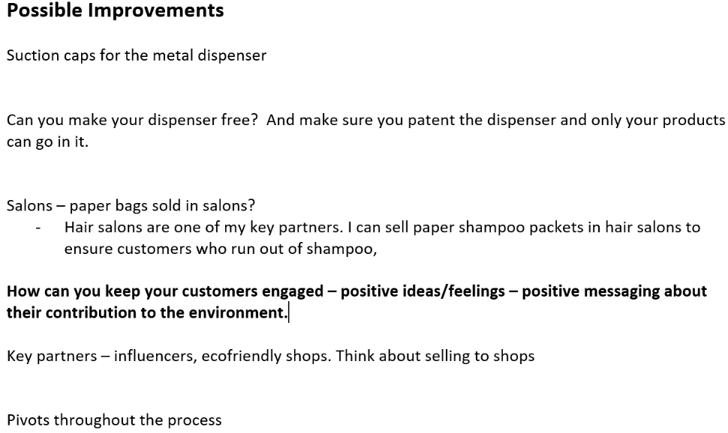
Appendix 7
Appendix 6

