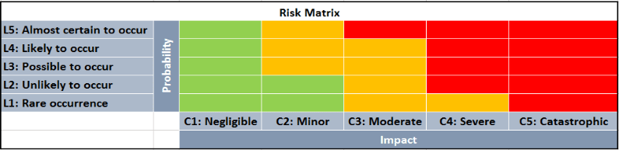
RISK MANAGEMENT REGISTER

RISK ASSESSMENT FOR ___________________
DATE _______________

Risk no. | Risk title: Name of risk | Description of Event: There is a risk that… | Cause of the Event : Because of… | Effect of the Event... With the result that: | Risk Category e.g. (PESTLE) | Probability | Impact | Risk Rating (High/ Medium/ Low) | Risk Response / Contingency plan
example | Supply of goods/materials | Suppliers may not deliver materials to site timeously | Selected goods and materials need to be sourced from overseas vendors/suppliers | Goods/materials may arrive late to site resulting in schedule delays and cost overruns | Economic | L3 | C4 | High | Locate suppliers within Queensland to ensure materials arrive on time so that construction avoiding schedule delays
1 | Brand image change - reputation | tourists will see the business as a corporate option and not tourist | changing the focus to more business tech focus | tourists will move away to other hotel chains | Political | L3 | C3 | Moderate | Advertising to tourists that ibis is still open for business to tourists
2 | Businesses not coming on board | Businesses will opt not to use our service | inconvenience | loss of future revenue | Economic | L3 | C4 | High | Trial of how it benefits business - make connection with businesses without being passive
3 |  |  | cost | loss of future revenue | Economic | L1 | C2 | Low | Continue to try and minimise costs for businesses
4 |  |  | lack of imagination or understanding | loss of future revenue | Cultural | L4 | C4 | High | Trial of how it benefits business - make connection with businesses without being passive
5 |  |  | habit | loss of future revenue | Cultural | L4 | C4 | High | Trial of how it benefits business - make connection with businesses without being passive
 | Support from Head Office | Head office will not support the change in branding | impacts on the national or international brand | we can't move ahead and need extra money to instigate the changes | Political | L3 | C3 | Moderate | Ensure benefits are shown to head office - requires research and data to suppor the shift

