Hotel industry

COVID-19 has affected every sector across the globe, and the hotel industry is among the hardest hit. Research suggests that recovery to pre-COVID-19 levels could take until 2023 or later. Like so many industries, hotels and hospitality will also see innovative shifts in the post-pandemic era.

The Ibis Hotel in Adelaide is one of the city’s busiest hotels, for both tourists and business travellers. The hotel describes its rooms as being ‘311 sleek, modern hotel rooms … and offer the perfect urban oasis for leisure and holiday travellers who want to mind their budget without giving up style and comfort’. Offered in an array of bed configurations, all accommodation showcases chic décor and a simple design enhanced by soothing neutral colour palettes, warm wood accents and original works by local artists like graffiti artist Ghostpatrol. Additional perks include the super comfortable ibis Sweet Bed, Samsung Smarthub 690 Series TV technology and plenty of charging areas for all your gadgetry.’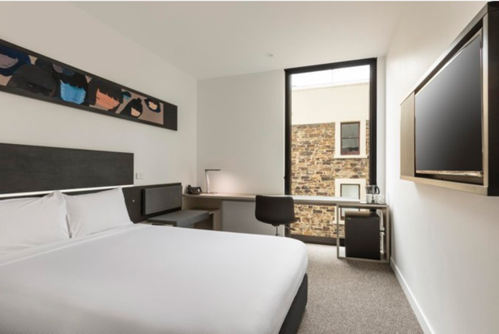

The Ibis hotel also boasts a number of other amenities that can be used by guests who are staying over, or to be hired out by businesses to host meetings. Ibis has small meeting spaces, large conference rooms and has six distinctive function spaces to accommodate a range of events.

The function venues are equipped with: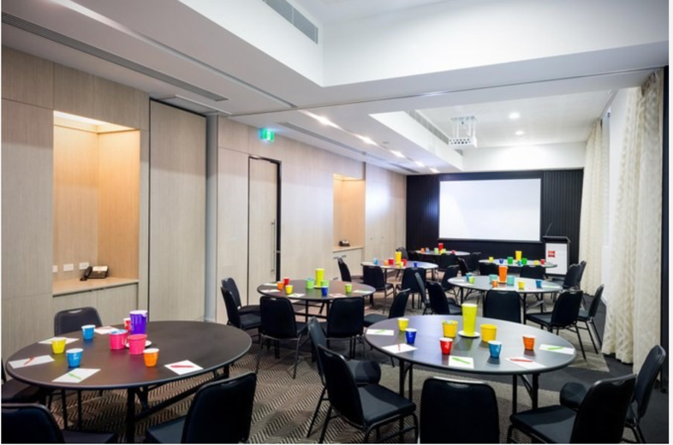
- Six unique function spaces
- Ceiling mounted screen & projector (The Engine Room / The Think Tank)
- High-definition 80-inch LCD television (The Hub / The Think Tank)
- Lectern with microphone
- Handheld wireless microphone
- Lapel wireless microphone
- Laptop with Microsoft Office
- Wireless presenter remote
- Whiteboard with markers
- Flipchart with pens and paper
- Conference wireless internet
- Group rates for event attendees staying at the hotel

You have been appointed as change management consultant by the Accor Group (owners of The Ibis hotel chain) to advise how the Ibis Adelaide Grenfell Street can transform by offering innovative products, services, or experiences to customers in response to the economic impacts currently experienced by the industry (see stats box below):

Key statistics on the hotel industry:
- 4/10 of hotel employees are still not working
- Almost 2/3rd (65%) of hotel remain at, or below 50% occupancy, seriously threatening long-term sustainability and being able to service debt obligations
- Some chains in specific market segments that employ large numbers of people are only open because of federal government employee stimulus support
- Many experienced hotel sector employees have been laid-off and are unable to secure part-time or full-time work
- Federal, State, and Local government revenues impacted

