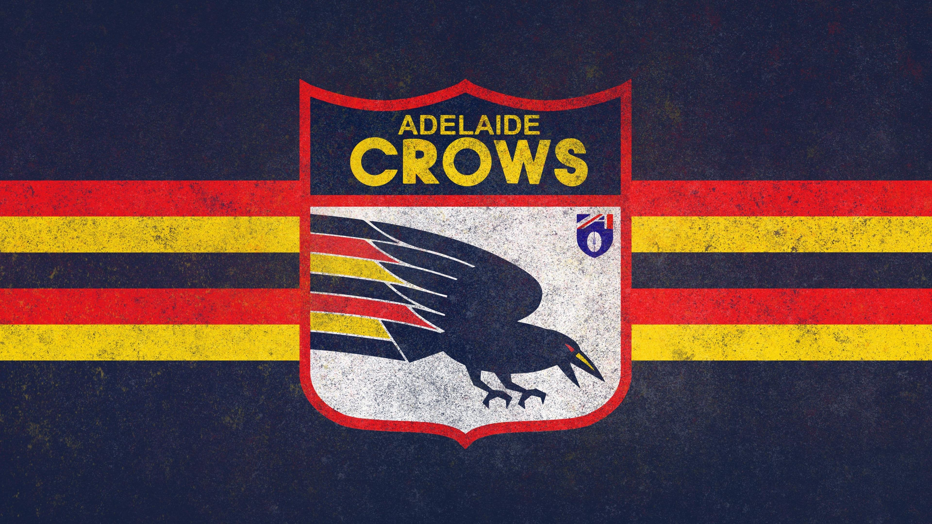
By Shem Hall
Adelaide crows consulting report

Introduction

The Adelaide crows are a sporting organisation who compete in the Australian Football League (AFL), they are located in Adelaide, south Australia and occupy the Adelaide Oval as their home ground.

The Adelaide crows have significant risks to concern potential buyers, these may include Covid-19, Reliance on team form, not placed in a marketable city, financial input required.

There are however opportunities for a potential buyer of the company, a subscription-based model, good network of sponsor, outstanding facilities, and also will make the owner money.

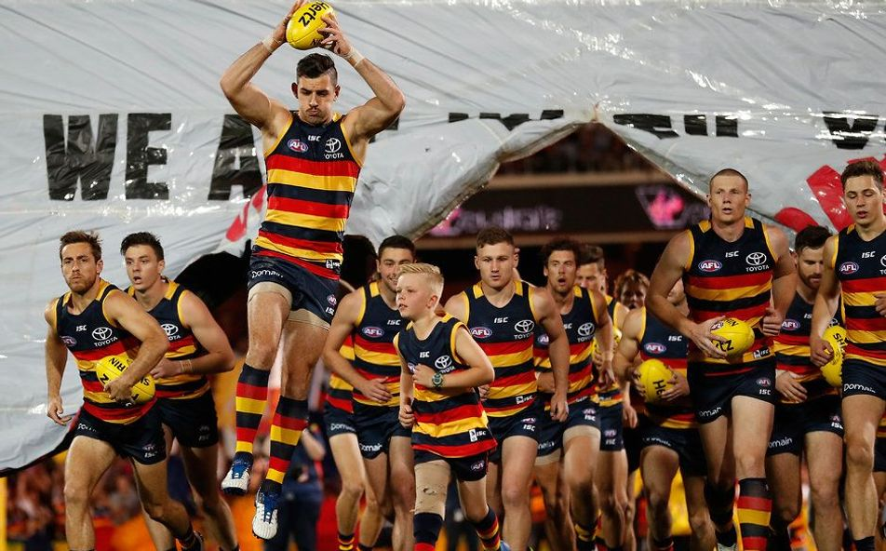
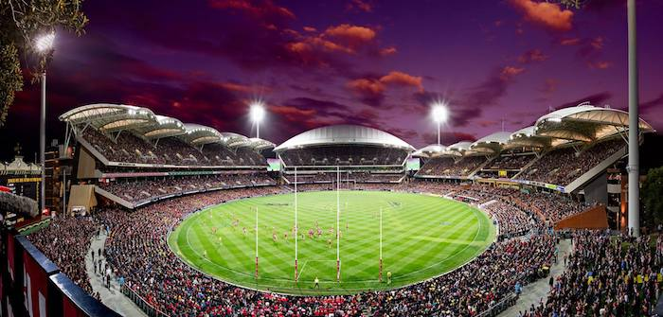
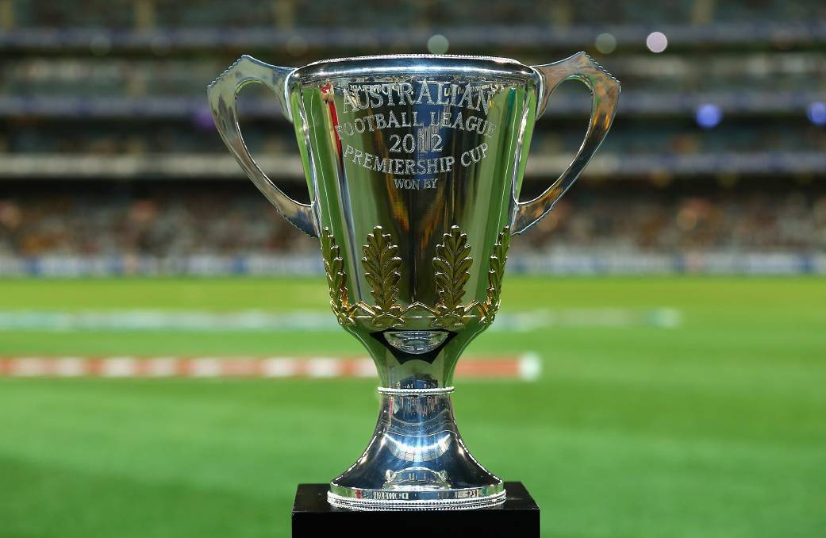

- Seasonal interest in the sport.
- Covid-19
- Lack of knowledge with sports.
- Declining population base, it is important to keep the fans coming to games.

- There is a growing focus on physical activity.
- Chances to become involved with the local community.
- Good income to come with ownership with the club.
- There are consistent advancements in club management.
- Good opportunities to expand network with club sponsors.
- Poor player behaviour, recent cases of club players breaking government law, suspended as a result.
- Coming off a historically bad year for the club.
- Covid-19, low financial gain for 2020.
- Aspect of poor club culture
S
S
- Great facilities and club house.
- Support from local Businesses.
- Large pool of dedicated volunteers.
- Strong financial base
- Great Fanbase
- Large membership group.
- High rate of fan attendance and merchandise purchase.
W
O
S
T
SWOT analysis
Risks

Covid-19 – Covid-19 is a significant risk to the Adelaide crow’s organisation, many organisations around the world where forced to cut staff and were forced to make considerable changes. The AFL was also forced to implement new rules regarding player behaviour adding more stress and difficulty to the club. In March sixteen crows’ players were fined and suspended following breaches of player conduct. Covid-19 also brings financial stressors, fans were not allowed at full capacity for the year.

Club Form – the profit that the club makes is very dependent on how the club performs. According to club financial records the club was financially strongest in 2016, 2017 & 2018 when the club was at a high level of performance. It was then observed that the club dropped profit in 2019, a year where the club was not at a high level of performance. This doesn’t create a huge issue for ownership as the clubs go through this cycle often, however it is important to be aware of this.

The club is not placed in a major marketable city, the club is based in Adelaide and does not gather similar media attention to a club that is from a more profitable city, this also means free agents are not as drawn to Adelaide as they are to bigger market clubs. Meaning the club has more difficulty in staying successful for a long period of time.

Buying the Adelaide Crows would put the purchaser at high risk as a large financial assistance would be required and expected as a new football club owner.

If the club does not make adjustments and stays straight to the line that they are taking

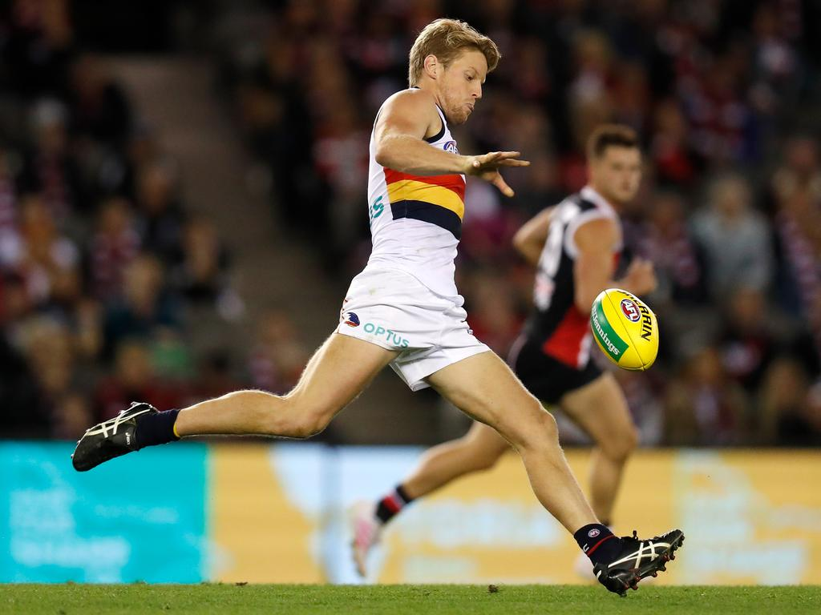
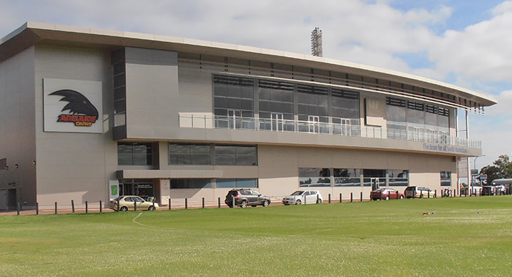

Opportunities

Working with the Adelaide crows will give the ownership a good exposure to the local community. This may be through local football leagues in south Australia, Adelaide crows fanbase, or the indigenous community, the Adelaide crows are a great steppingstone to be able to make great connections and form a good reputation within the community.

The Adelaide crows have outstanding facilities, these include; West lakes training facilities, and the Adelaide Oval which was voted best stadium in Australia this year. The Adelaide crows have ownership of west lakes however the Adelaide oval is owned by the state government, leased out to the south Australian cricket association, and also the South Australian national football league. the purchaser of the Adelaide crows would have the opportunity to work with world class facilities and become involved in hospitality as well as stadium management.

The Adelaide crows have a large list of local sponsors, leading to the crows generating $19,991,425 in 2019 and $18,559,968 in 2018, these sponsors range from large companies such as Toyota, Coca- Cola, Optus, McDonalds, etc. as well smaller local brands such as Balfours, Carlton and united breweries. Working with the Adelaide Crows allows a purchaser to branch out and develop a much larger list of contacts and network.

Working with the Adelaide crows will gain the owner/purchaser a profit at the end of the year. The owners will get a certain profit at the end of the year based on how well the club performs financially. Last year the Adelaide Crows managed to generate a total net profit of $2,685,517 in 2019 and $3,828,935 in 2018.

The Adelaide crows are a subscription based financial model; this is at an advantage for the purchaser as a subscription model is A) simpler, simplifies the business process and makes it very easy for the both consumers and the business. B) Higher customer retention, a subscription model ensure that the business is retaining a larger number of customers on a consistent basis. The model gives an opportunity from the existing customers. C) opportunities for marketing, ensuring that clients can be reached out to and engaged with on a regular basis. D) better cash flow management offers higher payment safety for your business; it assists in realising automatic online transactions to receive regular payments for the products and services sold.

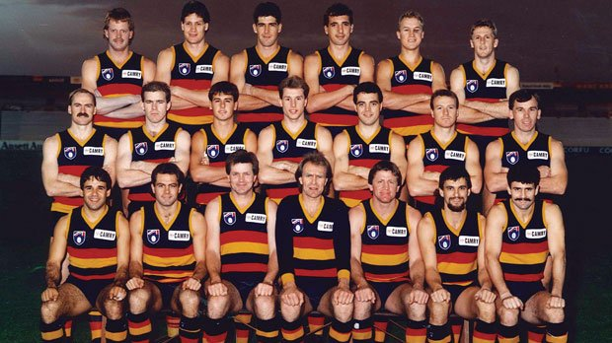

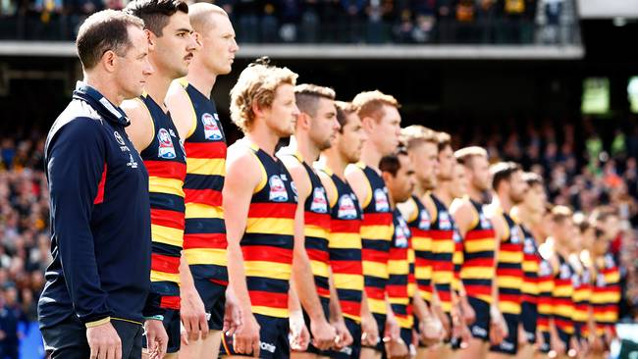

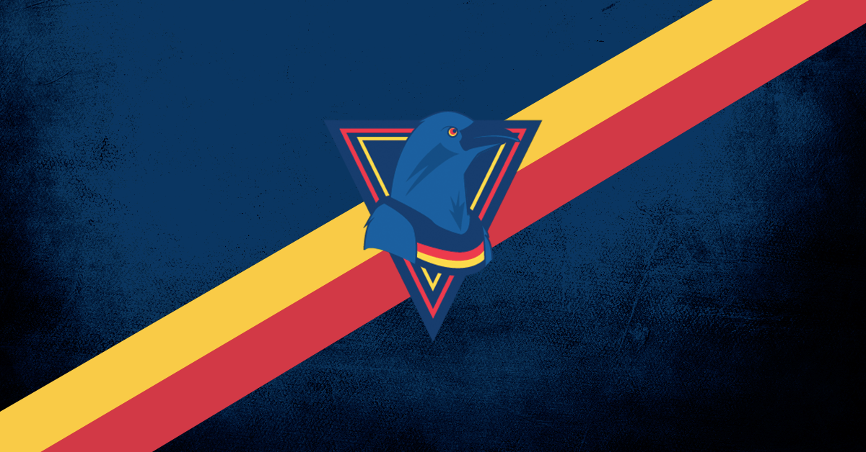

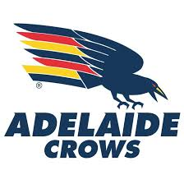
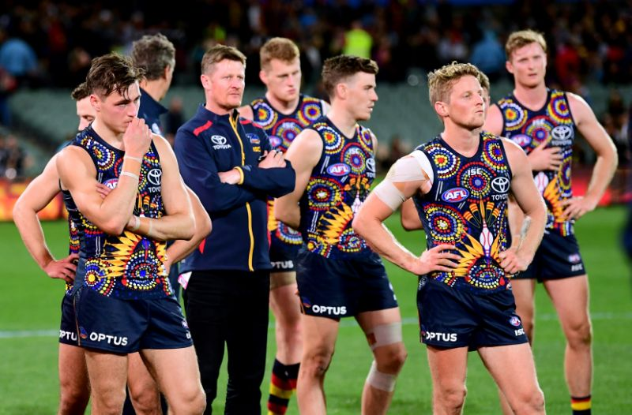

Transforming the Adelaide Crows

The Adelaide crows are not in a large media presence city, a good way a purchaser of the Adelaide crows could do to transform the business is to market and advertise heavily, the company is not commonly supported outside of south Australia. So, it is highly recommended to a potential buyer or ownership that advertising is expanded to create a larger fanbase leading to a higher number of interstate members. As the crows are eighth in the AFL for members, only managing half that the highest number currently held by west coast, also in a similar situation to the Adelaide Crows.

Transforming the Adelaide crows would also include having a deep company review into decisions made by the business and how staff and players are treated by the club, this is due to the infamous mental camp which the club made the players participate in late 2018. This camp led to players leaving and culture problems.

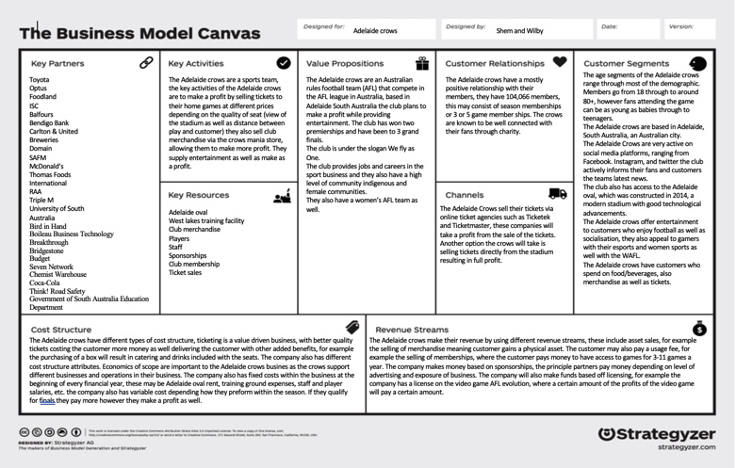
Appendix
References

Adelaide crows financial report.

2017- https://resources.afc.com.au/aflc-adel/document/2020/01/13/73b4b472-7c36-4d0e-b57d-6ecf3dc00a19/2017-Financial-Report.pdf

2018- https://resources.afc.com.au/aflc-adel/document/2020/01/13/2a8280d2-0916-4ba1-b62a-4f1cfb87fb28/2018-Financial-Report.pdf

2019- https://resources.afc.com.au/aflc-adel/document/2020/06/18/fce925d4-3a55-4040-9140 e95196ab43a6/FINC0024_2019_Financial_Report.pdf

Club rules

https://resources.afc.com.au/aflc-adel/document/2020/01/13/6d675f0e-ff03-405f-811d-baddb863db61/Constitution-of-Adelaide-Football-Club-Limited-Finalafc-1-.pdf

Membership rules

https://resources.afc.com.au/aflc-adel/document/2020/01/12/85b537b2-cfe3-48c8-827c-c778544f9a96/AFC-Membership-Rules-1-.pdf

Crows

https://www.afc.com.au/community

