Marketing and financial Plans
Business Innovation: SACE Stage 2
OneCard™
Thomas Robson

Table of Contents:
Table of Figures: 3
Executive Summary: 4
Market Analysis: 5
Industry Overview: 5
Key Competitors: 5
Growth and Trends: 6
Target Market: 7
Market Size: 7
Marketing Strategies: 8
Promotional Plan: 9
Problem Definition: 9
Establishment of Detailed Objectives: 9
Promotional Methods: 9
Pre-Testing: 9
Monitoring and Evaluation: 9
Branding: 10
Revenue Streams: 11
Conclusion: 14
Appendices: 15
Websites: 18
Reports: 18

Table of Figures:
Figure 1: Chart of Competitor Qualities 4
Figure 2: Visual Representation of Growth in the Construction Industry 5
Figure 3: Market Size Analysis 6
Figure 4: Market Demographics 6
Figure 5: Market Psychographics 6
Figure 6: The 7 P's of Marketing 7
Figure 7: Logo Logistics 9
Figure 8: Cost Structure Analysis 10
Figure 9: Separate Revenue Streams Profitability 11
Figure 10: Break Even Analysis Graph 12
Figure 11: Validation Canvas 14
Figure 12: Customer Segment 14
Figure 13: The Value Proposition Canvas 15
Figure 14: Empathy Mapping 15
Figure 15: The Business Model Canvas 16

Executive Summary:
OneCard’s business opportunity is to innovate a current induction process set by current competitors, offering a more accessible and affordable alternative than the competitors’ products. The target market is construction business managers who will then extend the app to their employees. Marketing strategies include the exploitation of the niche market, infrastructure construction services, as they are going through a steady growth. With a budget of $1200, OneCard can look to make an expected $4000 of revenue within the first month.

Market Analysis:

Industry Overview:

Key Competitors:
The graph below demonstrates the competitive advantages that OneCard’s business model presents to it’s competitors, and identifies areas of competitor weakness that OneCard aims to exploit.
 | Low: (1) | (2) | (3) | (4) | (5) | (6) | (7) | (8) | (9) | High: (10)
Quality:
Cost:
Time Efficiency:
Storage:
Accessibility and Usability:
Figure 1: Chart of Competitor Qualities
Key:
Company: | Symbol:
OneCard™:
OnlineInduction.com™:
LinkSafe™:
Rapid™:
SiteBook™:
WorkPro™:
How is OneCard different? OneCard’s competitive advantages include:
- Accessibility and Usability of Data
- High Quality
- Cost Efficiency
- Time Efficiency
- Enhanced Storage Space
These above advantages target and satisfy customer needs that separate OneCard from its competitors. This allows OneCard to have a significant competitive advantage over its competitors.

Growth and Trends:
The nice market that OneCard is expected to compete in is steadily increasing, as shown below, which allows for a sustainable business plan to be procured.
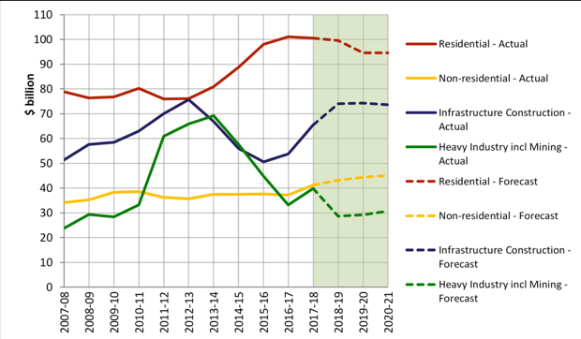
This graph also shows that OneCard needs to focus its resources and funding into the infrastructure construction industry, as it is the only area which provides evidence of an increasing market.

Figure 2: Visual Representation of Growth in the Construction Industry

This niche market is undergoing four main trends;
1. New Technologies and Integration of Technology.
2. Enhanced Storage of Data
3. Automation and Assisted Services
4. Virtual Reality.
To capitalise on these trends, OneCard will focus a majority of its budget within the app development to meet the trends that OneCard believes to be long term and sustainable. Then OneCard will entwine realistic solutions within its product in order to create a trendier product.
Through capitalising on these trends, OneCard will be able to captivate the customers within this niche market, obtaining a competitive advantage over OneCard’s competitors.

Target Market:

Market Size:
Understanding and analysing the market size is crucial for OneCard, as it allows for marketing potentials to be found and evaluated. From this, OneCard is presented with market potentials that coincide with the business model canvas.
Market Type: | Customer Count: (In Businesses)
Total Addressable Market: (TAM) | >330,000 Businesses in Australia
Serviceable Available Market: (SAM) | <143,000 Businesses in South Australia  (Current resource limitations and networking of OneCard)
Service Obtainable Market: (SOM) | 60,000 Businesses in Adelaide  (Taking into account resource limitation, budget, marketing, product quality (vs competitors)
Figure 3: Market Size Analysis
The above demonstrates the realistic market size of the target market to begin with. This niche market coincides with the business model canvas, as the size and location of the niche market in the business model canvas supports these findings.
Age: | Location: | Gender: | Income Level: | Education Level: | Family Status: | Occupation: | Ethnic Background:
18+ | SA | Any | 80,000+ | Secondary School | Any | Director/Manager of Construction Work | Any
Figure 4: Market Demographics
Personality: | Attitudes: | Values: | Interests/Hobbies: | Lifestyles: | Behaviour
Outgoing, Risk Taking, Dis-Organised, Needful | Optimistic, Positive but also Negative, as the solution makes a positive attitude. | Employee Safety, Business reputation, a profitable business, efficiency, customer relations. | Technology, Construction Work. | Modern, Sleek, High Class (although affordable) | Slightly impatient, happy, conscious, voluntary.
Figure 5: Market Psychographics
The target market, as shown through correlation of both the customer segments and the value proposition canvas, are construction business managers throughout South Australia. These people are typically more aware of their employees, and thrive with efficient business processes.

Marketing Strategies:
The 7 P’s use a customer focused approach in order to create a tactical marketing mix.

Figure 6: The 7 P's of Marketing

Promotional Plan:

Problem Definition:
OneCard’s target market is construction business owners within South Australia. The budget for this promotion is $3000, calculated to be the minimum starting budget in order to make the revenue objective. OneCard also aims to present a firm relationship with its customers, as shown in the archetypal customer of the business model canvas.

Establishment of Detailed Objectives:
- Advertisements creating a captivated target market
- Enter into a new market segment with a modified product line.
- Reduce the customer impact of competitor’s promotional methods.
- Create a 50-thousand-dollar income in the first year of sales.

Promotional Methods:
Advertising:
- Construction site fencing – Contact construction companies and offer them discounts on services within the app, provided they supply advertising on their construction fencing.
  - This will be procured by establishing firm customer relations with key companies mentioned in the business model canvas.
- E-Marketing – targets potential customers, quantitative data for analysation, low risk, low cost, targets larger audience.
- Word-Of-Mouth – demonstrates business relationships, targets potential customers, creates positive business image.
Public Relations:
- Collaborate with influencers; such as @Contractors.Of.Insta and @KrugerConstruction, by paying them to advertise the brand.
- Ensure purpose is beyond profit – Ensures positive customer relations that appeal to the target market, as shown through empathy mapping of the business model canvas.
- Personal sales – Ensures firm customer relations, appeals to target market, satisfies archetypal and potentials customers on the business model canvas.

Pre-Testing:
Testing promotions on market segments to identify the serious problems before launch. This highlights the cost effectiveness of the promotional plan, the problems of ambiguity and the customer response rate.
Monitoring and Evaluation:
The promotional methods are tested against the objectives in order to take necessary actions to fulfil marketing requirements.

Branding:
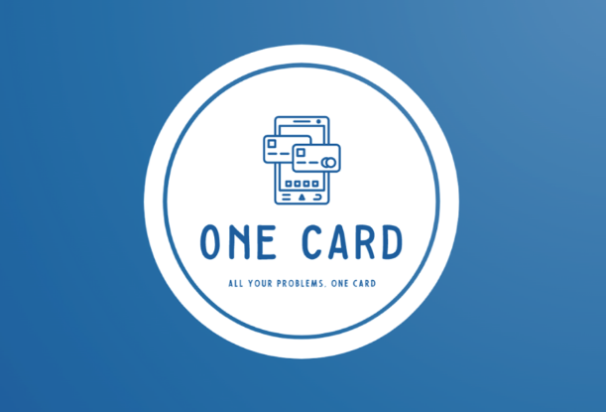
Figure 7: Logo Logistics
The brand logo instantly identifies the business purpose and identity upon first glance.
- The phone represents OneCard as a digital product.
- The clean logo design represents the clean design of the user interface.
- The cards coming out of the phone demonstrate a level of accessibility for the user.
- The slogan represents the business model that OneCard offers its customers.

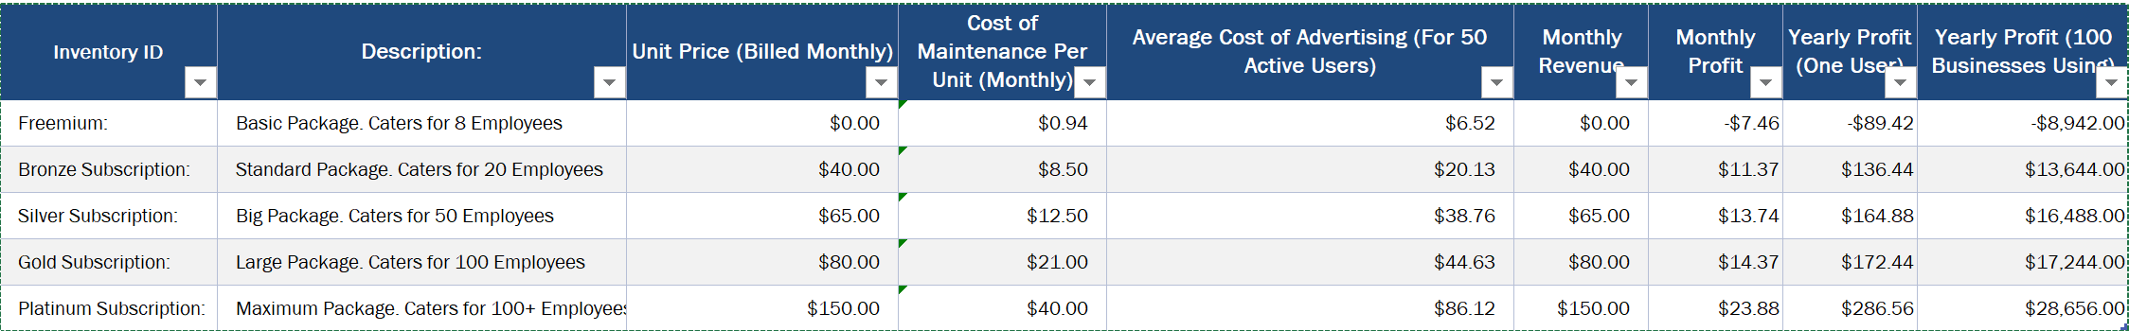
Revenue Streams:
Figure 8: Cost Structure Analysis
The above demonstrates the profit, both monthly and annually, that OneCard can safely expect to procure. This recurring revenue model allows for a more predictable estimate of the revenue stream, as the cash flow will remain consistent with recurring payments on subscriptions.
This method was shown through the business model canvas, as the value proposition canvas demonstrates the need for this revenue stream, as it optimised overall business profit.

Figure 9: Separate Revenue Streams Profitability

Figure 10: Break Even Analysis Graph

Conclusion:
To conclude, OneCard aims to provide its customers with a cheaper, more efficient process of induction that is completed through a recurring revenue model. This will ensure predictable marketing and revenue streams that allow for the breakeven point at 512 units sold to be reached and for profits to be maximised through the purchasing of variating subscriptions within the app.
WORD COUNT: 1998

Appendices:
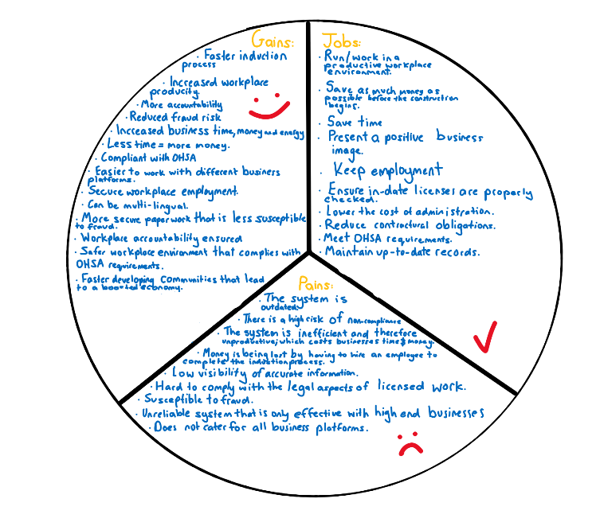
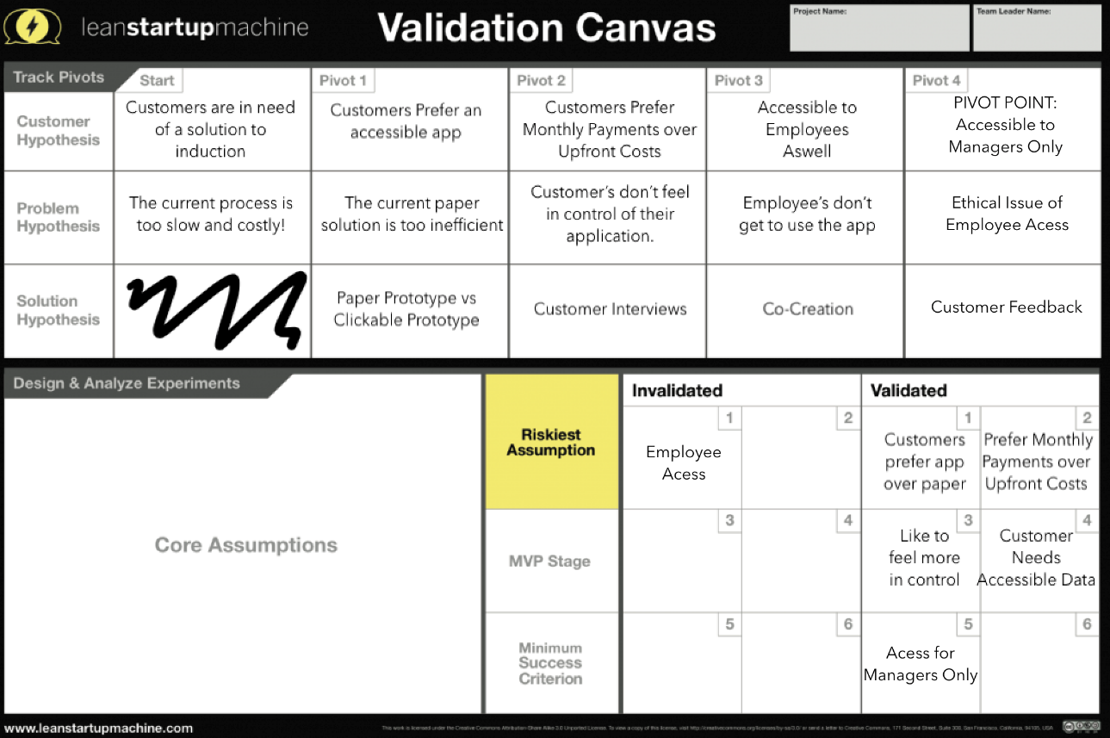
Figure 12: Customer Segment
Figure 11: Validation Canvas

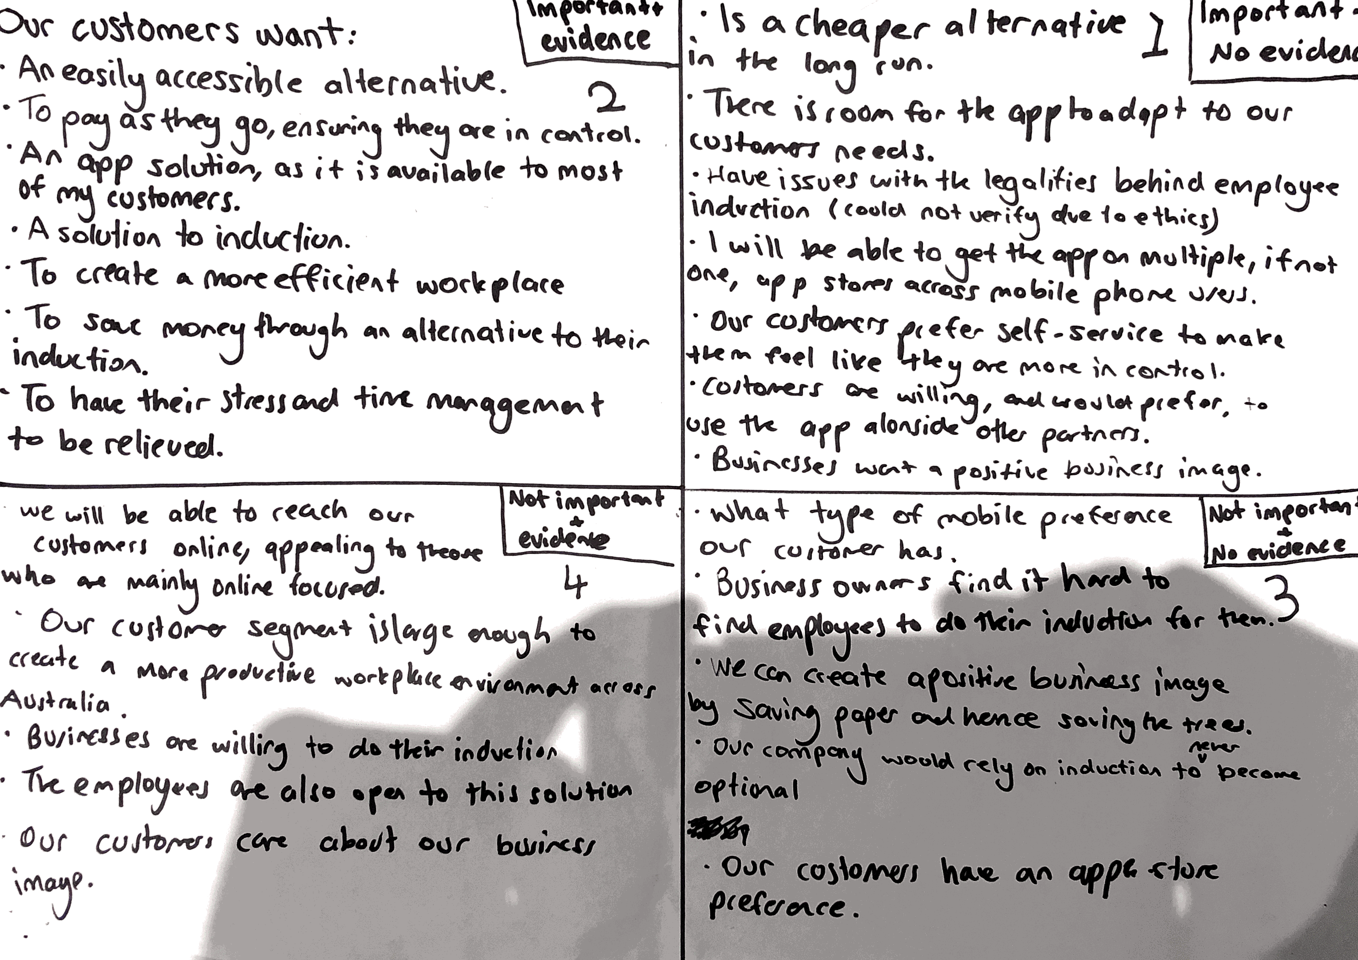
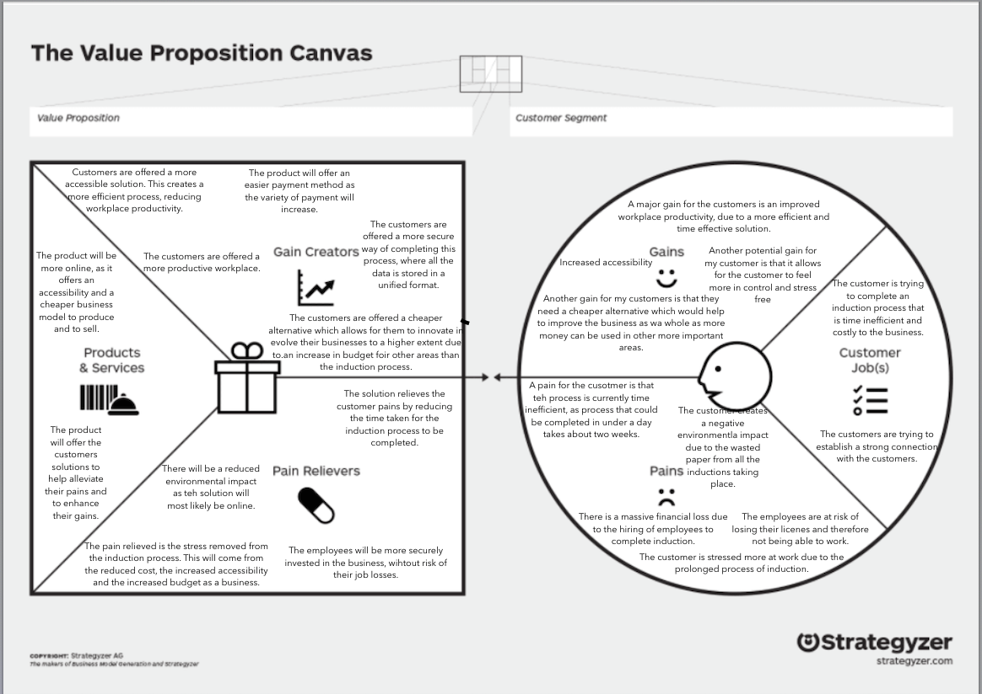
Figure 14: Empathy Mapping
Figure 13: The Value Proposition Canvas
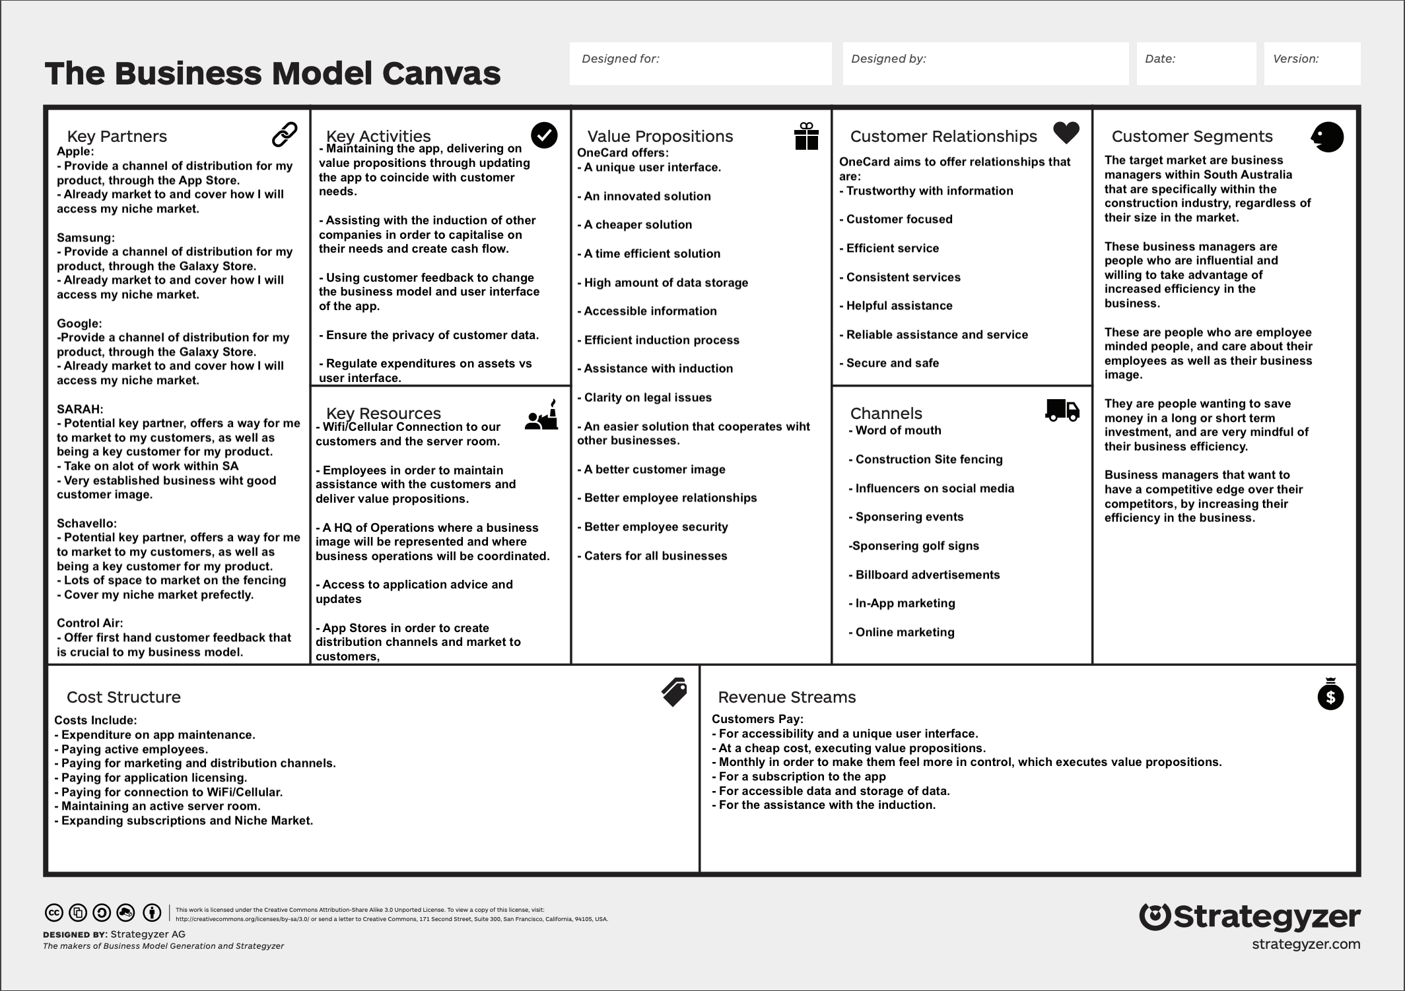
Figure 15: The Business Model Canvas
References:

Websites:
- Onlineinduction.com. 2020. https://www.onlineinduction.com/demo_induction.php [Accessed 19 May 2020].
- 2020. [online] Available at: https://linksafe.com.au/free-demo/ [Accessed 19 May 2020].
- Workforce Management https://www.rapidglobal.com/request-demo/ [Accessed 19 May 2020].
- SiteBook. 2020. Home - Sitebook. https://www.sitebook.com.au/ [Accessed 19 May 2020].
- Workpro.com.au. 2020 https://www.workpro.com.au/inductions-and-e-learning/customise-your-workpro/[Accessed 19 May 2020].
- Adelaidenow.com.au. 2020. Why SA’S Small Businesses Need A Boost. https://www.adelaidenow.com.au/business/sa-business-journal/sa-small-business-confidence-is-on-the-rise-but-red-tape-and-high-costs-remain-a-barrier-to-growth/news-story/d457731e510a5dbec0de386da79272b9 [Accessed 21 May 2020].
- 2020. [online] Available at: https://itt.abs.gov.au/itt/r.jsp?RegionSummary&region=4GADE&dataset=ABS_REGIONAL_ASGS&geoconcept=REGION&datasetASGS=ABS_REGIONAL_ASGS&datasetLGA=ABS_NRP9_LGA&regionLGA=REGION&regionASGS=REGION [Accessed 21 May 2020].
- https://www.instagram.com/contractors.of.insta/?utm_source=ig_embed
- https://www.instagram.com/K

Reports:
- Australian Intelligence Group (AI Group) [PDF] Avaliable at: cdn.aigroup.com.au/Economic_Indicators/Construction_Survey/2015/Construction_industry_profile_and_Outlook.pdf [Accessed 21/05/20]

Onlineinduction.com. 2020. https://www.onlineinduction.com/demo_induction.php [Accessed 19 May 2020].
2020. [online] Available at: https://linksafe.com.au/free-demo/ [Accessed 19 May 2020].
Workforce Management https://www.rapidglobal.com/request-demo/ [Accessed 19 May 2020].
SiteBook. 2020. Home - Sitebook. https://www.sitebook.com.au/ [Accessed 19 May 2020].
Workpro.com.au. 2020 https://www.workpro.com.au/inductions-and-e-learning/customise-your-workpro/ [Accessed 19 May 2020].
Australian Intelligence Group (AI Group) [PDF] Avaliable at: cdn.aigroup.com.au/Economic_Indicators/Construction_Survey/2015/Construction_industry_profile_and_Outlook.pdf [Accessed 21/05/20]
Adelaidenow.com.au. 2020. Why SA’S Small Businesses Need A Boost. https://www.adelaidenow.com.au/business/sa-business-journal/sa-small-business-confidence-is-on-the-rise-but-red-tape-and-high-costs-remain-a-barrier-to-growth/news-story/d457731e510a5dbec0de386da79272b9 [Accessed 21 May 2020].
2020. [online] Available at: https://itt.abs.gov.au/itt/r.jsp?RegionSummary&region=4GADE&dataset=ABS_REGIONAL_ASGS&geoconcept=REGION&datasetASGS=ABS_REGIONAL_ASGS&datasetLGA=ABS_NRP9_LGA&regionLGA=REGION&regionASGS=REGION [Accessed 21 May 2020].
https://www.instagram.com/contractors.of.insta/?utm_source=ig_embed
https://www.instagram.com/Krugerconstruction/?hl=en

