COVID-19 Economics Overview

Learning Intentions
- I will learn about what happens when economies go up and down
- I will learn about how money flows around the economy an what happens if it stops
- I will learn how to read economic indicators
- I will learn how the government can control the business cycle
- I will learn about the importance of pivoting business ideas
- I will learn about managing change towards an online working environment
- I will learn that Australia has very strong trade relations with Asia
- I will learn how to determine possible future outcomes of the COVID-19 disaster

Remembering (recalling basic facts)
- List the phases of the Business Cycle and draw them on the cycle
- Reproduce the circular flow model
- Define the following:

  - Unemployment
  - Gross Domestic Product
  - Consumer Price Index
  - Interest rates

Comprehension (understanding is the key)
- Explain how the circular flow model works to a friend by using a diagram – video your explanation
- Explain in 1 paragraph why the Government needs to inject money into the economy during a downturn/trough
- Explain why in an upturn/peak, interest rates would be likely to increase

Application (using facts to find solutions to problems)
- By using the diagrams below, demonstrate how the government would use interest rates (monetary policy) and government spending (fiscal policy) during a downturn in the business cycle

Analysis (Examining parts in relationship to the whole)

- Analyse the graphs below to give a summary of the state of the Australian economy prior to the COVID-19 outbreak. In your response you must reference at least 3 of the graphs and use all of the following terms:
  - Business cycle
  - Government spending
  - Interest rates
  - Injections
  - Leakages
This task should be completed in 400 words max
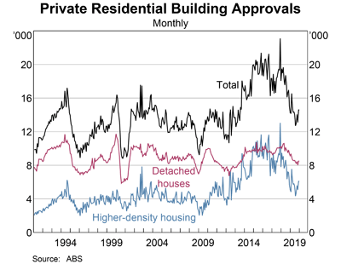
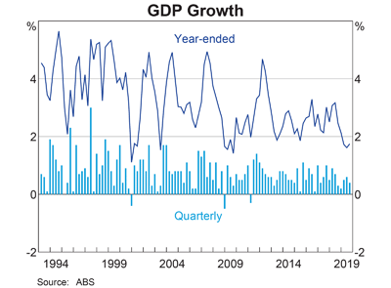

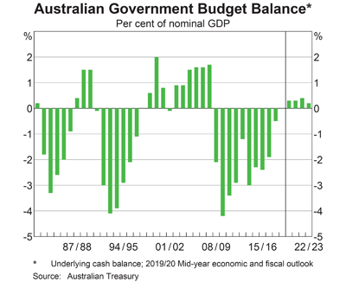
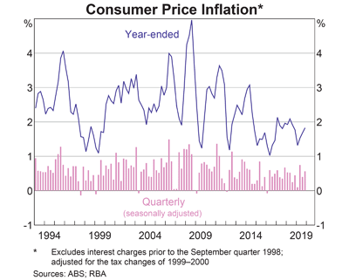

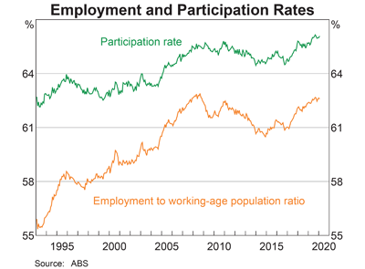
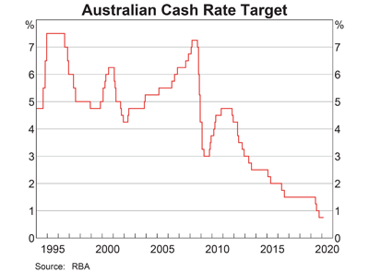

- The effect is an enormous downturn as a response to COVID-19. Use a fish bone to analyse potential economic causes of this downturn.

Evaluation (Judging the information)
- Evaluate the following statement in approximately 1 page (typed)

The government and banks have responded in a responsible way to the COVID-19 economic impacts

Be sure to reference the document on haiku titled ‘evaluating at Yr 10 level’
Creating
- Creativity Questivities
  - What would happen if a the government did not provide a stimulus package?
  - What would happen economically if COVID-19 spread through Australia at the same rates as overseas?
  - In your opinion, what poses the most difficulty in determining the right kind of economic response to a downturn?
  - Active question – make a list of questions Scott Morrison might ask of economists to determine what he should do to stimulate the economy.
Reflection
- Complete the following reflection stems and questions:
- Looking back
- How well do you think you have understood the learning intentions?
- To what extent do you think you performed at the ‘A’ band?
- I enjoyed learning this because…
- One thing I didn’t expect was…
- Before this, I did not know that…
- Doing this work made me wonder about
- Looking forward
- This has inspired me to look into…
- I need to understand this because…
- I want to find out why _________ happens so that I can…

