Thinkers Keys
(Group work)

This task is to be completed as a group at your table, discussing and recording your ideas. You will have approximately 1.5 weeks of lesson time to complete this task. You may present it in any way you think appropriate.

In order to complete this group task, the following roles must be undertaken.

Manager: Ensure all members continue to work until task is completed. The task is not done until you say so. Ensure all members are contributing in an equal way. Pay attention to how group members are feeling – are they feeling left out? You need to get them back involved. Offer praise and encouragement when appropriate and needed. Keep everyone on task.

Relater: Get the whole group to articulate how the current tasks and topics relate to content previously studied. E.g. Economies in transition, the economic problem. Your whole job is about getting people to make connections between this task and anything else that relates. E.g. work in other classes, this class, movies, songs, artwork, anything. Make the connections and get the group talking about it in the context of the activity. You don’t need to make the connections yourself, but you are responsible for getting the group to discuss it.

Questioner: You are the only member of the team that can ask questions of the teacher. You must be sure that no-one in your group already knows the answer to the question you wish to ask. You are responsible for asking the questions that move the group towards meeting the goals of the task. You need to check with the entire group for understanding. The group must come to a consensus about what questions need to be asked to the teacher, if any. You must ensure by questioning that each member has sufficiently learned the learning intentions. If you find that 1 or more group members cannot explain the material, it is your job to ensure the group comes together to help them learn it.

Critic: Your job is to take a critical look at all the work that students are presenting in your group. Look at things from alternative perspectives and give reasons for why it may not work. Your job is to get people thinking about alternatives to problems.

Thinkers Keys – The Market Mechanism

Reverse Key  List 10 things that would not use supply and demand to determine price | What if  What if the government decided that they were to set all prices? | Disadvantages  Outline 5 disadvantages of having a perfectly elastic demand curve. How could these disadvantages be overcome? | Combination  List the attributes of elasticity of Demand and Supply as well as a planned economy. Now create a better economy/society | Alphabet  Conduct an A-Z brainstorm on the market mechanism
B-A-R  How would you make this model better? (Bigger, Add, Remove)  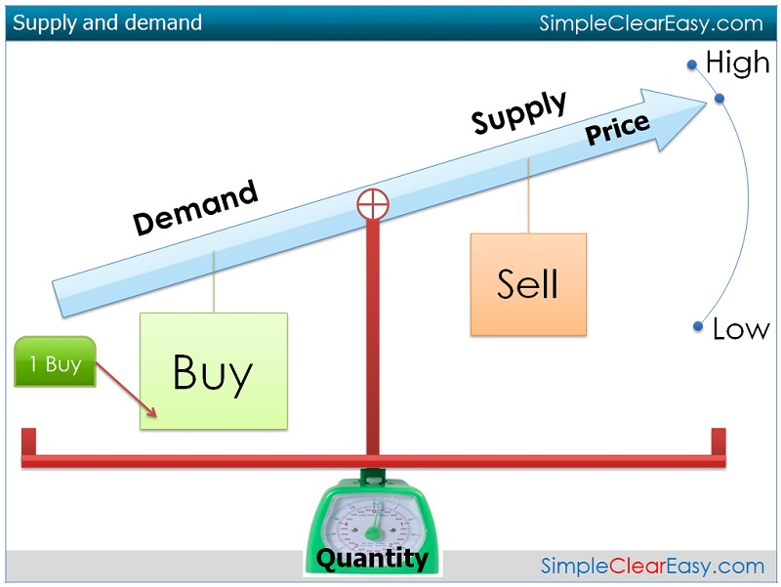 | Variations  Perfectly inelastic supply for agricultural products causes a lot of problems if there are adverse weather effects. How could you overcome this and make the product more elastic? | Picture  How might this diagram relate to the market mechanism? | Prediction  Imagine the international price of wheat decreased and wheat farmers could not survive. What do you think might be the outcome? | Different uses  How do you think the market mechanism would have operated in Ancient Israel, Russia in the 1980’s and your every day life?
Ridiculous  I can use the market mechanism in my soup. Try and justify and substantiate this statement | Commonality  Find as many areas of commonality as you can between a $5 note and a motor boat  Tip – start with characteristics of a motor boat | Question  Here’s the answer, find 5 questions that get this answer  Answer: relatively inelastic  Only use these words once:  Who, what, why, when, how | Brainstorming  Problem – My total revenue is decreasing in my farming business. What do I do?  Brainstorm as many options as possible. Use an A-Z | Inventions  Invent a new way of determining prices using a model/diagram
Interpretation  In bible times, people started eating bird poo (2 Kgs 6:25). Use economic inquiry to determine why? | Brick wall  The more people demand something, the more prices increase. Try and disprove this and find other ways of showing why price might increase | Construction  Use the contents of U. Evan’s top draw to construct a model that will solve the problem of prices rising too fast on essential goods and services | Forced relationship  How is the market mechanism like a telephone box? | Alternative  By moving people around the classroom, explain how demand and supply interact

