***Metacognitive Cycle Plan***



**1 Assess the Task**

**Fill out the Why and What - Can do a Mindmap (see below)**

The Why: What is my purpose in doing this? (entertain, inform, persuade or a mixture)

* What impact should this have on my writing? Be specific to the text at hand.

The What: What outcome am I trying to achieve? Use the Task Sheet and Rubric/PS

* Who will the audience be? (age, culture, education, ideas and values (audience context)) Be specific as possible.
* What kind of writing style, vocabulary and language techniques will suit the audience/text type (i.e. essay)? Give examples specific to task on plan page below
* Where would it be published? (It won’t actually be published but think about where it would be appropriate) - How that will impact the writing?
* What will my finished piece look like (structure (form)) – draw in diagrammatic form on plan page below

**2 Evaluate Strengths and Weaknesses**

* What parts of the Task Sheet and Rubric/PS do you understand/know?
* What is still unclear and needs following up? Follow up
* Do I need to do further reading/research? Do it

**3 Plan the Approach**

The How: What strategies do I need to use to succeed?

* Plan the structure/paragraphs – write on plan page below
* How can I make sure I can get an A on every aspect of the Rubric? – plan a separate strategy for each section
* Create a checklist/to-do list
* Are there any other tasks I need to do before I can start writing? Do them

**4 Apply Strategies**

* Do your draft

**5** **Reflect**

**Drafting**

* How successful have I been? - use Rubric/PS to assess yourself
* What do I need to do to improve the task? - Keep it, Build it, Bin it
* Ask for help - Peer Feedback (20 minute; Keep it, Build it, Bin it)

**+Whole Unit Reflection**

* What are the skills I have learned and practised in this task?
* Are the skills I have used translatable to other situations?

**Mind Map (if doing one)**



**Plan – Write on this Page**

*Example:*

**Language Elements:**

Sarcasm: Of course I love being beaten to a pulp every lunchtime. Who wouldn’t?

Stereotype: Bullies are cruel and bovine with more brawn than brains.

Irony: The thing is that that bully is the one with the problem, not me. On the surface it seems the opposite but only a deep-seated psychosis can drive one to bully.

Humour: describe how a bully really is weak, and helpless - in the head.



**Diagrammatic Form:**

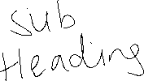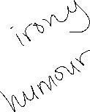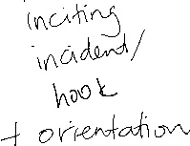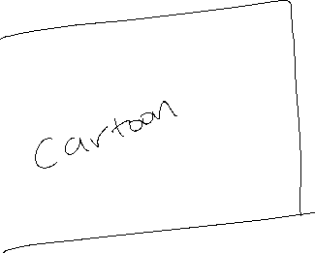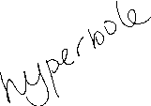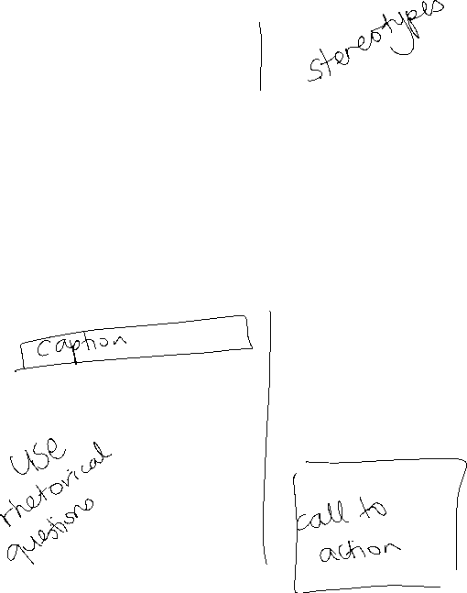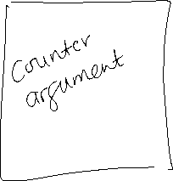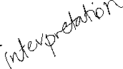

**Section/Paragraph Plan**

**Comic Plan**