Visual Narrative Assignment: The Practical One About Camera Work
Your task is to produce a very short and very simple story. The story needs: orientation/exposition, rising action, climax, resolution. It is to be 2-3 minutes long
You need to use at least 1 example of each of:
Camera shots:
- Establishing/extreme long
- Long
- Medium long
- Medium
- Medium close up
- Close up
- Extreme close up
Camera angles:
- Overhead/bird’s eye
- High
- Low
- Mid/natural
Camera movements:
- Pan
- Tilt
- Zoom
- Track
- Crane

This does NOT mean you are only able to use these things only ONCE in the film but you MUST have an example of each.
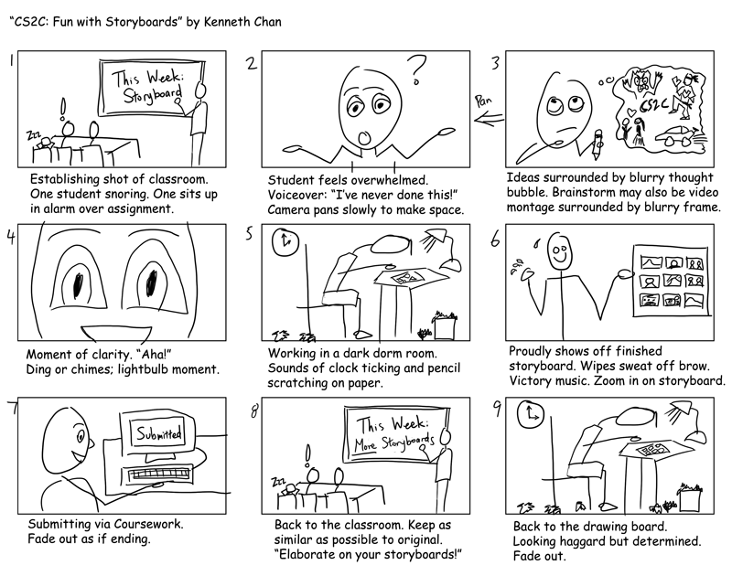
Use a storyboard to plan you story. You don’t need to draw the picture; just write the description i.e.in box: close up, natural angle; under box: Bob’s face, showing fear.

