Introduction:
Joyce Gomes-Osman, an assistant professor in physical therapy and neurology at the University of Miami’s Millar School of Medicine states, “Exercise is a really, really great thing for the brain”, it is one of the most promising non-pharmaceutical treatments to improve brain health and it has a significant impact on memory formation, capability and long-term consolidation. To gain these benefits, all that needs to be done is the physical act of exercising, which promotes neurogenesis. Neurogenesis is the physiological change in the brain through the formation of nervous tissue. Changes to the brain’s structure include: An increase in cortex thickness; Increase in neurotransmitters, chemical substances that transmit nerve impulses across the synapse; higher amount of synaptic connections; greater rate of angiogenesis, the formation and development of blood vessels; an increase in growth factors, various proteins that promote the growth, organisation and maintenance of cells. These growth factors are broadly known as neurotrophin polypeptides with specific examples being brain derived neurotrophic factor (BDNF) and Insulin-growth factor 1 (IGF-1). They are responsible for the growth and protection of neurons in the brain, however, they particularly work in the hippocampus, the centre of memory in the brain. All these factors contribute to the series of improvements in memory, mental processes and executive functions.

Neurogenesis and blood flow:
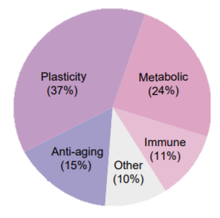
Jonathan Fields, the founder of The Good Life Project stated, “The physical state of our bodies [including the brain] can either serve or subvert the quest to create genius”. Neurogenesis is the change in the brain’s anatomy, physiology and function that comes with exercise . The process of neurogenesis consists of 4 essential components: proliferation, an increase in the number of cells; differentiation, where cells acquire specialist features; axonal path migration, the extension of neurons’ axons; maturation, becoming specialised for their specific job. Studies conducted at the National Neuroscience Institute in Singapore revealed that aerobic exercise increased neuronal proliferation which inevitably indicates the rise of BDNF and serotonin levels. BDNF correlates with an improved memory and serotonin links to an individual’s level of alertness, indicating its relation to concentration. Thus, cognitive function improves when exercise is undertaken, as well as protection from neuronal degeneration. Neuroplasticity, changes in the brain’s structure in response to environmental stimuli, is closely entwined with neurogenesis. It is also the most prevalent effect that exercise has on the brain, as seen in figure 1, indicating just how much change exercise can induce in the brain.
Figure 1: Effects of exercise on the brain

However, renewing the brain (neurogenesis) would not be as effective if it wasn’t for the exercise-induced change of maintaining efficient blood flow,. This is significant because increased cerebral blood flow does not happen globally across the brain but in specific regions such as the hippocampus. Extra blood flow to the brain allows for clearer thinking and the effect is immediate. John Medina who is the director of Seattle’s Pacific University’s Brain Centre for Applied learning states that research has consistently shown that those who exercise out perform non-exercisers in long-term memory, reasoning, attention and fluid intelligence. This all starts with an increase in the blood flow to the brain. Yet, the production of BDNF and Nerve growth factors (NGF) are also necessary for the stimulation and regulation of neurogenesis processes such as proliferation, differentiation and maturation,.

Neurotrophin polypeptides:
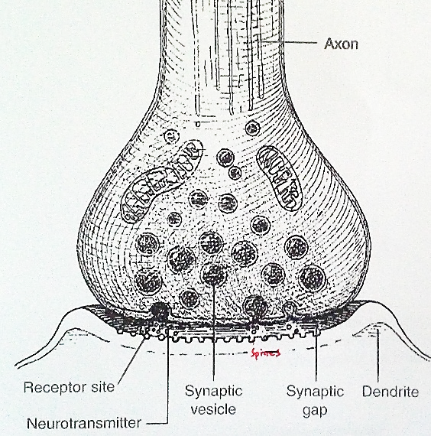
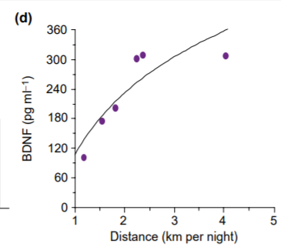
BDNF and Insulin-growth factor-1, a nerve growth factor, come under the family of neurotrophin polypeptides. Both neurotrophin polypeptides exist to support the survival of mature neurons whilst encouraging the growth, regeneration and creation of new neurons and synapses. BDNF also solidifies connections between neurons and nerve impulses to confirm reliable future firing. It completes this through myelination, the process of forming a myelin sheath around a nerve to allow nerve impulses to move quickly across the synapse. Figure 2 shows how neural impulses are carried across the synapse through synaptic vesicles. The outer coating is the myelin sheath, which assists the speed of this process. Whilst BDNF is found in varied concentrations across the brain, aerobic exercise physically starts the stimulation of producing BDNF increases BDNF expression particularly the hippocampus. This occurs through the reduction of blood sugar levels during exercise, therefore β-hyroxybutyrate is used as an alternative source of energy. Whilst being used for energy, β-hyroxybutyrate also blocks enzymes that inhibit the production of BDNF, demonstrating that these physiological changes are designed to improve levels of BDNF in response to exercise,. Furthermore, BDNF can only be expressed if BDNF mRNA is being transcripted and translated. Studies have shown that after only a few days of aerobic exercise there is a significant increase of BDNF mRNA levels in the hippocampus which can be sustained for several weeks, or longer if exercise is upheld. To emphasise this, figure 3 shows an average of the amount of BDNF produced by rats according to the distance they ran each night. It is evident that a notable amount of exercise can dramatically increase BDNF levels. An increase in BDNF mRNA leads to an increase in BDNF protein expression which is crucial for assisting the capability to learn and memorise.
Figure 2: Transfer of nerve impulses across synapse
Figure 3: The amount of BDNF produced in relation to running distance
Once BDNF is expressed it can do numerous things, one of these is assisting in the consolidation of short-term memories into long-term memories. The hippocampus holds both short-term and long-term memory, so inevitably it plays a major role in fortifying learning by converting information from working memory, the limited- capacity memory used to process the present, to long-term storage memory via electrical signals. It does this by recalling and associating a memory with other information as it moves towards long-term storage. BDNF is the factor which mediates this process, thus stating its importance in seeing the long-term benefits of exercise on the brain.
NGF acts in a similar way to BDNF because it is a neurotrophin polypeptide which improves survival of neurons in the hippocampus, however NGF also increases serotonin producing cells. A study conducted in measuring NGF showed that Olympic athletes have significantly higher levels than control individuals with associations also between higher neurotrophic factor levels and better memory performance. Insulin growth factor-1 is a specific growth factor which also assists in BDNF gene regulation, neurogenesis and protection from injury. Together all factors contribute to the mediation of new neurons, through neurogenesis, in the hippocampus which leads to a cascade effect of benefits.
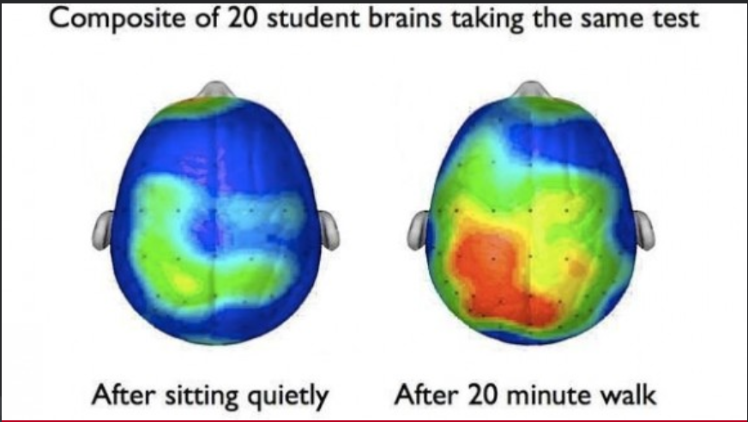
The development of neurons in the hippocampus is one of the limited number of places where the adult brain can generate new neurons on site. Exercise can physically help grow new brain cells and activate the brain, as seen in figure 4. One study saw exercising mice grow an average of 6,000 new brain cell in every millimetre of the hippocampus tissue which was sampled. These 6,000 new brain cells gives millions of opportunities for new neuronal connections to be made, leaning to happen and memories to be formed. Dr Matias Ison at the University of Leicester describes how one neuron fires to two (or more) other neurons at the exact point of learning, creating new pathways. John Medina, Director of Seattle Pacific University’s Brain centre for applied learning stated, “We have in our hands as close to a magic bullet for improving human health as exists in modern medicine, all we have to do is move”, it is really that simple.
Figure 4: Effect of exercise on the brain

The hippocampus:
The hippocampus is the area of the brain which responds most strongly to aerobic exercise as it physically increases its volume by producing more brain cells (already discussed) by up to 2 percent in one year. Exercise-induced production of more brain cells in the hippocampus leads to an increase in volume, an increase in volume results in better long-term memory formation and recall,. Typically, brain volume decreases with age, however, in a study conducted at the University of British Columbia, regular aerobic exercise appears to boost the physical size of the hippocampus. Many other studies have also seen that other parts of the brain that are involved with control thinking and memory are larger in volume in those who exercise compared to those who don’t. Dr McGinnis, an instructor in neurology at Harvard Medical school who observed these studies, declared that engaging in regular exercise of moderate intensity over a six to twelve-month period increases the volume of other selected brain regions too.

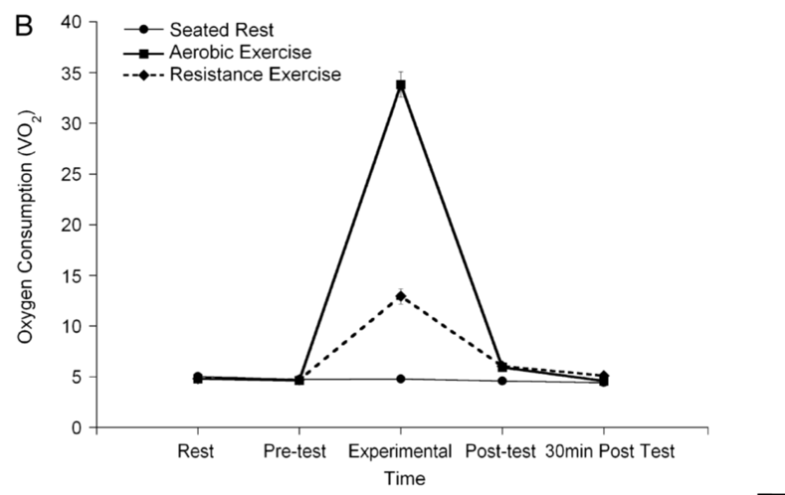
Cognition is thoroughly benefitted through an increase in oxygen and blood flow in the brain as well as chemicals which assist the health and growth of blood vessels in helping them to survive and multiply too. However, a reason why this is so prominent in the hippocampus is that exercise is the crucial factor in hyper-glycogen storage in the hippocampus. The brain goes through supercompensation allowing it to store 29-60% more glycogen than it is normally able to within 6 hours of exercise and these levels remain for up to 24 hours after exercise. The increase in glycogen comes from an increase in oxygen and can also help with the reduction of insulin resistance and inflammation in the blood stream. As seen in figure 5, a key reason why aerobic exercise is best for increasing memory function is because of the significant oxygen intake that aerobic exercise has compared to other forms of exercise. This increase of oxygen leads to the cascade of benefits already considered. Resistance exercise also requires a greater intake of oxygen than normal, however, it doesn’t lead to as good blow flow of oxygen. Therefore, the hippocampus is not impacted and benefitted as much as it is with aerobic exercise.

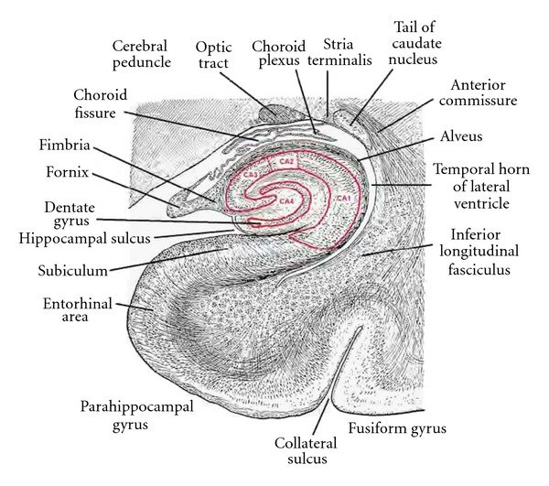
A more specific area of the hippocampus which is heavily involved with neural growth and therefore increased volume and therefore assisting to progress memory is the dentate gyrus. It is the central aspect of the hippocampus, as seen in figure 6, so is inescapably involved. Following significant evidence, it is also the most prominent area in the hippocampus for neurogenesis. When BDNF stimulates the dentate gyrus, it causes chronic net neurogenesis.

Conclusion:
Since it is evident that exercise can have a profound effect on the brain but particularly on the formation and long-term factor of memory, through increasing the production of neurons and assisting in the protection and health of the present ones, exercise should be a priority. It has also been noted that there is a strong positive correlation between physical exercise and academic achievement. Those who exercise have better attention control, as well as more fluid ability to respond to sensory, cognitive and motor events which are neuroelectric signals that assist with the allocation of attention. This has also been backed up with studies which show that students’ aerobic fitness relates to academic achievement, with those who exercised doing better on tests including reading, spelling and maths. As well as concluding a high BMI (low aerobic fitness) has a negative relation to academic achievement. Charles Hillman, director of the Neurocognitive Kinesiology Laboratory in Illinois and leader of these studies stated that the effect of exercise on achievement isn’t statistically significant, yet it is a meaningful difference. But exercise doesn’t just help the young, it also protects and reduces the risk of Parkinson’s and Alzheimer’s diseases for the older generation by up to 32%. Although, memory isn’t the only benefit from exercise, further benefits include: greater energy, mood and concentration. The importance of exercise is expressed by Mr. Hillman who said, “There’s no medicine or other intervention that appears to be nearly as effective as exercise in maintaining or even bumping up a person’s cognitive capabilities.”

Word count: 1986

Bibliography:

Books:
Doidge. N, 2007, The brain that changes itself, Penguin Books, London, pg. 80
Ivanisevic. L, Saragovi. H, 2013, Neurotrophins, second edn, Handbook of biologically active peptides, Elsevier science, Netherlands
Jensen. E, 1998, Introduction to brain-compatible learning, The brain store, San Diego, pg.60
Sousa. D, 2006, How the brain learns, Third edn, Corwin Press, California, pg.19,22,232
Suzuki.W, 2016, Healthy brain, happy life, Dey street books, US, pg. 36-37
Suzuki.W, 2016, Healthy brain, happy life, Dey street books, US, pg. 58-60
Suzuki.W, 2016, Healthy brain, happy life, Dey street books, US, pg. 116-117

Interviews:
Khan.K, 2012, Exercise and health: An interview with professor Karim Khan, Interviewed by April Cashin-Garbutt for News Medical Life Sciences 12th September, Available at: https://www.news-medical.net/news/20120912/Exercise-and-health-An-interview-with-Professor-Karim-Khan.aspx , Accessed 20th November 2018

Journal articles:
Conlay. LA, Sabounjan. LA, Wurtman. RJ, 1992, Exercise and neuromodulators: choline and acetylcholine in marathon runners, Int J Sports Med, US
Cotman. CW, Berchtold. NC, 2002, Exercise: a behavioural intervention to enhance brain health and plasticity, Vol. 25 No.6, Trends in Neuroscience, US
Liu.P, Nusslock.R, 2018, Exercise-mediated neurogenesis in the hippocampus via BDNF, Vol 12 No.52, PubMed, US national library of Medicine National institutes of Health
Liu. R, Crawford. J, Callahan. P, Terry Jr. A, Constantinidis. C, Blake. D, 2017, Intermittent stimulation of the nucleus basalis of meynert improves working memory in adult monkeys, Cell press, US
McDonald. M, Raupp.B, Jiang.W, Leung,K, Hanhauser.E, N.D, Effects of aerobic exercise and short term memory, Univeristy of Wisconsin-Madison, US
Pontifex. M, Hillman.C, Fernhall.B, Thompson.K, Valentini.T, 2008, The effect of acute aerobic and resistance exercise on working memory, Official journal of the American College of Sports Medicine, US
Soya.M, Matsui.T, Shima.T, Jesmin.S, Omi.N, Soya.H, 2018, Hyper-hippocampul glycogen induced by glycogen loading with exhaustive exercise, Springer Nature publishing AG, US
Van Praag. H, Kempermann. G, Gage. FH, 1999, Running increases cell proliferation and neurogenesis in the adult mouse dentate gyrus, National Neuroscience Institute, Singapore

Other:
Conner. M, 2016, Minds at work- increasing brainpower through exercise, Providence, Virgin Pulse, pg. 2-7
Kiernan.J, 2011, Anatomy of the temporal lobe, Vol 2012, Hindawi publishing corporation, Canada
Kezia Robinson, 2019, Survey on: Exercise and the brain, Adelaide

Video:
Exercise Medicine and Sport Sciences Initiative, 2017, Practical Neuroscience for everyday life, (online video), 2 March 2017, https://m.youtube.com/watch?v=i8p693EprOE, Accessed 5th February 2019
Suzuki.W, 2018, The brain-changing benefits of exercise, https://www.ted.com/talks/wendy_suzuki_the_brain_changing_benefits_of_exercise, Accessed 15th November 2018

Websites:
Bergland. C, 2015, The neuroscience of forming new memories, https://www.psychologytoday.com/au/blog/the-athletes-way/201507/the-neuroscience-forming-new-memories, Accessed 23rd November 2018
Borreli.L, 2015, Multitasking and the human brain: Prefrontal cortex determines concentration level during multiple activities, https://www.medicaldaily.com/mulitasking-and-human-brain-prefrontal-cortex-determines-concentration-level-during-358410, Accessed 28th February 2019
Brophy.K, 2017, What does serotonin do?, https://universityhealthnews.com/daily/depression/what-does-serotonin-do/, Accessed 16th May 2019
Cafasso.J, Sampson.S, 2017, Why do we need endorphins?, https://www.healthline.com/health/endorphins, Accessed 11th April 2019
Cohen.J, 2018, All you need to know about BDNF + natural ways to increase it, https://selfhacked.com/blog/a-comprehensive-list-of-natural-ways-to-increase-bdnf/, Accessed 3rd April 2019
Cohen. J, 2019, 9 effects of nerve growth factor (NGF) + 50 ways to increase it, https://selfhacked.com/blog/all-about-nerve-growth-factor-and-50-ways-to-increase-it/, Accessed 3rd April 2019
Dictionary.com, 2019, Angiogenesis, https://www.dictionary.com/browse/angiogenesis?s=t, Accessed 1st June 2019
Dictionary.com, 2019, Growth factor, https://www.dictionary.com/browse/growth-factor?s=t, Accessed 1st June 2019
Dictionary.com, 2019, Neurogenesis, https://www.dictionary.com/browse/neurogenesis, Accessed 1st June 2019
Dictionary.com, 2019, Neurotransmitter, https://www.dictionary.com/browse/neurotransmitter?s=t, Accessed 1st June 2019
Donnelly. L, 2014, An hour of exercise a day boost children’s concentration, https://www.telegraph.co.uk/news/health/news/11126713/An-hour-of-exercise-a-day-boost-childrens-concentration.html, Accessed 9th March 2019
Fitstyler, 2015, How exercise increases concentration, http://www.fitstyler.com.au/how-exercise-increases-concentration/, Accessed 9th March 2019
Godman. H, 2014, Regular exercise changes the brain to improve memory, thinking skills, https://www.health.harvard.edu/blog/regular-exercise-changes-brain-improve-memory-thinking-skills-201404097110, Accessed 20th November 2018
Klemm.W, 2013, Working memory executive control, https://www.psychologytoday.com/au/blog/memory-medic/201306/working-memory-executive-control-0, Accessed 3rd April 2019
LaBant. M, 2018, Effects of exercise on memory, https://www.naturalmedicinejournal.com/journal/2018-04/effects-exercise-memory , Accessed 23rd November 2018
Lear.S, 2018, How exercise can boost your brain function, http://theconversation.com/how-exercise-can-boost-your-brain-function-95506 , Accessed 21st November 2018
Martynoga.B, 2016, How physical exercise makes your brain work better, https://www.theguardian.com/education/2016/jun/18/how-physical-exercise-makes-your-brain-work-better, Accessed 21st November 2018
McNary, 2019, Exercise and its effects on serotonin & dopamine levels, https://www.livestrong.com/article/251785-exercise-and-its-effects-on-serotonin-dopamine-levels/, Accessed 11th April 2019
Mercola.J, 2016, How exercise improves your memory and cognition, https://fitness.mercola.com/sites/fitness/archive/2016/07/08/how-exercise-improves-memory.aspx, Accessed 23rd November 2018
Moore. M, 2008, Stress of modern life cuts attention span to five minutes, https://www.telegraph.co.uk/news/health/news/3522781/Stress-of-modern-life-cuts-attention-spans-to-five-minutes.html, Accessed 14th March 2019
N.A, 2016, Physical activity shown to improve attention span and focus, https://www.peteacheredu.org/2016/02/physical-activity-shown-to-improve-attention-span-and-focus/ , Accessed 22nd November 2018
N.A, 2019, Brain balance guide-The neurochemistry of focus, https://poweronpoweroff.com/blogs/longform/the-neurochemistry-of-focus, Accessed 11th April 2019
Newcastle University, 2013, Pay attention: How we focus and concentrate, https://www.sciencedaily.com/releases/2013/05/130523093319.htm, Accessed 11th April 2019
Park. A, 2018, Here’s how much exercise you need to keep your brain healthy, http://time.com/5294493/exercise-healthy-brain-aging/, Accessed 21st November 2018
Rhodes. J, 2013, Why is it that I seem to think better after exercise?, https://www.scientificamerican.com/article/why-do-you-think-better-after-walk-exercise/, Accessed 11th April 2019
Turcotte. M, 2019, The effects of exercise on serotonin levels, https://www.livestrong.com/article/22590-effects-exercise-serotonin-levels/, Accessed 11th April 2019
University of Illinois at Urbana Campaign , 2009, Physical activity may strengthen children’s ability to pay attention, https://www.sciencedaily.com/releases/2009/03/090331183800.htm, Accessed 20th November 2018

Park. A, 2018, Here’s how much exercise you need to keep your brain healthy, http://time.com/5294493/exercise-healthy-brain-aging/, Accessed 21st November 2018
Mercola.J, 2016, How exercise improves your memory and cognition, https://fitness.mercola.com/sites/fitness/archive/2016/07/08/how-exercise-improves-memory.aspx, Accessed 23rd November 2018
Bergland. C, 2015, The neuroscience of forming new memories, https://www.psychologytoday.com/au/blog/the-athletes-way/201507/the-neuroscience-forming-new-memories, Accessed 23rd November 2018
Suzuki.W, 2016, Healthy brain, happy life, Dey street books, US, pg. 58-60
Khan.K, 2012, Exercise and health: An interview with professor Karim Khan, Interviewed by April Cashin-Garbutt for News Medical Life Sciences 12th September, Available at: https://www.news-medical.net/news/20120912/Exercise-and-health-An-interview-with-Professor-Karim-Khan.aspx , Accessed 20th November 2018
Dictionary.com, 2019, Neurogenesis, https://www.dictionary.com/browse/neurogenesis, Accessed 1st June 2019
Exercise Medicine and Sport Sciences Initiative, 2017, Practical Neuroscience for everyday life, (online video), 2 March 2017, https://m.youtube.com/watch?v=i8p693EprOE, Accessed 5th February 2019
Dictionary.com, 2019, Neurotransmitter, https://www.dictionary.com/browse/neurotransmitter?s=t, Accessed 1st June 2019
Dictionary.com, 2019, Angiogenesis, https://www.dictionary.com/browse/angiogenesis?s=t, Accessed 1st June 2019
Dictionary.com, 2019, Growth factor, https://www.dictionary.com/browse/growth-factor?s=t, Accessed 1st June 2019
Ivanisevic. L, Saragovi. H, 2013, Neurotrophins, second edn, Handbook of biologically active peptides, Elsevier science, Netherlands
Cotman. CW, Berchtold. NC, 2002, Exercise: a behavioural intervention to enhance brain health and plasticity, Vol. 25 No.6, Trends in Neuroscience, US
Doidge. N, 2007, The brain that changes itself, Penguin Books, London, pg. 80
Exercise Medicine and Sport Sciences Initiative, 2017, Practical Neuroscience for everyday life, (online video), 2 March 2017, https://m.youtube.com/watch?v=i8p693EprOE, Accessed 5th February 2019
Conner. M, 2016, Minds at work- increasing brainpower through exercise, Providence, Virgin Pulse, pg. 2-7
Conner. M, 2016, Minds at work- increasing brainpower through exercise, Providence, Virgin Pulse, pg. 2-7
Suzuki.W, 2018, The brain-changing benefits of exercise, https://www.ted.com/talks/wendy_suzuki_the_brain_changing_benefits_of_exercise, Accessed 15th November 2018
Liu.P, Nusslock.R, 2018, Exercise-mediated neurogenesis in the hippocampus via BDNF, Vol 12 No.52, PubMed, US national library of Medicine National institutes of Health
Pontifex. M, Hillman. C, Fernhall. B, Thompson. K, Valentini. T, 2008, The effect of acute aerobic and resistance exercise on working memory, Official journal of the American College of Sports Medicine, US
Van Praag. H, Kempermann. G, Gage. FH, 1999, Running increases cell proliferation and neurogenesis in the adult mouse dentate gyrus, National Neuroscience Institute, Singapore
McDonald. M, Raupp.B, Jiang.W, Leung,K, Hanhauser.E, N.D, Effects of aerobic exercise and short term memory, Univeristy of Wisconsin-Madison, US
Brophy.K, 2017, What does serotonin do?,https://universityhealthnews.com/daily/depression/what-does-serotonin-do/, Accessed 16th May 2019
Rhodes. J, 2013, Why is it that I seem to think better after exercise?, https://www.scientificamerican.com/article/why-do-you-think-better-after-walk-exercise/, Accessed 11th April 2019
Godman. H, 2014, Regular exercise changes the brain to improve memory, thinking skills, https://www.health.harvard.edu/blog/regular-exercise-changes-brain-improve-memory-thinking-skills-201404097110, Accessed 20th November 2018
Pontifex. M, Hillman. C, Fernhall. B, Thompson. K, Valentini. T, 2008, The effect of acute aerobic and resistance exercise on working memory, Official journal of the American College of Sports Medicine, US
Cotman. CW, Berchtold. NC, 2002, Exercise: a behavioural intervention to enhance brain health and plasticity, Vol. 25 No.6, Trends in Neuroscience, US
Conner. M, 2016, Minds at work- increasing brainpower through exercise, Providence, Virgin Pulse, pg. 2-7
Pontifex. M, Hillman. C, Fernhall. B, Thompson. K, Valentini. T, 2008, The effect of acute aerobic and resistance exercise on working memory, Official journal of the American College of Sports Medicine, US
Conner. M, 2016, Minds at work- increasing brainpower through exercise, Providence, Virgin Pulse, pg. 2-7
Rhodes. J, 2013, Why is it that I seem to think better after exercise?, https://www.scientificamerican.com/article/why-do-you-think-better-after-walk-exercise/, Accessed 11th April 2019
Conner. M, 2016, Minds at work- increasing brainpower through exercise, Providence, Virgin Pulse, pg. 2-7
Harvard Health publishing, 2019, Exercise can boost your memory and thinking skills, https://www.health.harvard.edu/mind-and-mood/exercise-can-boost-your-memory-and-thinking-skills, Accessed 20th November 2018
Cotman. CW, Berchtold. NC, 2002, Exercise: a behavioural intervention to enhance brain health and plasticity, Vol. 25 No.6, Trends in Neuroscience, US
Liu.P, Nusslock.R, 2018, Exercise-mediated neurogenesis in the hippocampus via BDNF, Vol 12 No.52, PubMed, US national library of Medicine National institutes of Health
Ivanisevic. L, Saragovi. H, 2013, Neurotrophins, second edn, Handbook of biologically active peptides, Elsevier science, Netherlands
Cohen.J, 2018, All you need to know about BDNF + natural ways to increase it, https://selfhacked.com/blog/a-comprehensive-list-of-natural-ways-to-increase-bdnf/, Accessed 3rd April 2019
Doidge. N, 2007, The brain that changes itself, Penguin Books, London, pg. 80
Cohen. J, 2019, 9 effects of nerve growth factor (NGF) + 50 ways to increase it, https://selfhacked.com/blog/all-about-nerve-growth-factor-and-50-ways-to-increase-it/, Accessed 3rd April 2019
Sousa. D, 2006, How the brain learns, Third edn, Corwin Press, California, pg. 22
Cohen.J, 2018, All you need to know about BDNF + natural ways to increase it, https://selfhacked.com/blog/a-comprehensive-list-of-natural-ways-to-increase-bdnf/, Accessed 3rd April 2019
Mercola.J, 2016, How exercise improves your memory and cognition, https://fitness.mercola.com/sites/fitness/archive/2016/07/08/how-exercise-improves-memory.aspx, Accessed 23rd November 2018
Lear.S, 2018, How exercise can boost your brain function, http://theconversation.com/how-exercise-can-boost-your-brain-function-95506 , Accessed 21st November 2018
Liu.P, Nusslock.R, 2018, Exercise-mediated neurogenesis in the hippocampus via BDNF, Vol 12 No.52, PubMed, US national library of Medicine National institutes of Health
Mercola.J, 2016, How exercise improves your memory and cognition, https://fitness.mercola.com/sites/fitness/archive/2016/07/08/how-exercise-improves-memory.aspx, Accessed 23rd November 2018
Harvard Health publishing, 2019, Exercise can boost your memory and thinking skills, https://www.health.harvard.edu/mind-and-mood/exercise-can-boost-your-memory-and-thinking-skills, Accessed 20th November 2018
Cotman. CW, Berchtold. NC, 2002, Exercise: a behavioural intervention to enhance brain health and plasticity, Vol. 25 No.6, Trends in Neuroscience, US
Liu.P, Nusslock.R, 2018, Exercise-mediated neurogenesis in the hippocampus via BDNF, Vol 12 No.52, PubMed, US national library of Medicine National institutes of Health
Suzuki. W, 2018, The brain-changing benefits of exercise, https://www.ted.com/talks/wendy_suzuki_the_brain_changing_benefits_of_exercise, Accessed 15th November 2018
Cotman. CW, Berchtold. NC, 2002, Exercise: a behavioural intervention to enhance brain health and plasticity, Vol. 25 No.6, Trends in Neuroscience, US
LaBant. M, 2018, Effects of exercise on memory, https://www.naturalmedicinejournal.com/journal/2018-04/effects-exercise-memory , Accessed 23rd November 2018
Conner. M, 2016, Minds at work- increasing brainpower through exercise, Providence, Virgin Pulse, pg. 2-7
Conner. M, 2016, Minds at work- increasing brainpower through exercise, Providence, Virgin Pulse, pg. 2-7
Klemm.W, 2013, Working memory executive control, https://www.psychologytoday.com/au/blog/memory-medic/201306/working-memory-executive-control-0, Accessed 3rd April 2019
Sousa. D, 2006, How the brain learns, Third edn, Corwin Press, California, pg.19,22,232
Suzuki.W, 2016, Healthy brain, happy life, Dey street books, US, pg. 58-60
Cotman. CW, Berchtold. NC, 2002, Exercise: a behavioural intervention to enhance brain health and plasticity, Vol. 25 No.6, Trends in Neuroscience, US
Cohen. J, 2019, 9 effects of nerve growth factor (NGF) + 50 ways to increase it, https://selfhacked.com/blog/all-about-nerve-growth-factor-and-50-ways-to-increase-it/, Accessed 3rd April 2019
Cohen. J, 2019, 9 effects of nerve growth factor (NGF) + 50 ways to increase it, https://selfhacked.com/blog/all-about-nerve-growth-factor-and-50-ways-to-increase-it/, Accessed 3rd April 2019
LaBant. M, 2018, Effects of exercise on memory, https://www.naturalmedicinejournal.com/journal/2018-04/effects-exercise-memory , Accessed 23rd November 2018
Pontifex. M, Hillman. C, Fernhall. B, Thompson. K, Valentini. T, 2008, The effect of acute aerobic and resistance exercise on working memory, Official journal of the American College of Sports Medicine, US
Cotman. CW, Berchtold. NC, 2002, Exercise: a behavioural intervention to enhance brain health and plasticity, Vol. 25 No.6, Trends in Neuroscience, US
Sousa. D, 2006, How the brain learns, Third edn, Corwin Press, California, pg.19,22,232
Fitstyler, 2015, How exercise increases concentration, http://www.fitstyler.com.au/how-exercise-increases-concentration/, Accessed 9th March 2019
Mercola.J, 2016, How exercise improves your memory and cognition, https://fitness.mercola.com/sites/fitness/archive/2016/07/08/how-exercise-improves-memory.aspx, Accessed 23rd November 2018
Bergland. C, 2015, The neuroscience of forming new memories, https://www.psychologytoday.com/au/blog/the-athletes-way/201507/the-neuroscience-forming-new-memories, Accessed 23rd November 2018
Conner. M, 2016, Minds at work- increasing brainpower through exercise, Providence, Virgin Pulse, pg. 2-7
Martynoga.B, 2016, How physical exercise makes your brain work better, https://www.theguardian.com/education/2016/jun/18/how-physical-exercise-makes-your-brain-work-better, Accessed 21st November 2018
Mercola.J, 2016, How exercise improves your memory and cognition, https://fitness.mercola.com/sites/fitness/archive/2016/07/08/how-exercise-improves-memory.aspx, Accessed 23rd November 2018
Suzuki.W, 2018, The brain-changing benefits of exercise, https://www.ted.com/talks/wendy_suzuki_the_brain_changing_benefits_of_exercise, Accessed 15th November 2018
Martynoga.B, 2016, How physical exercise makes your brain work better, https://www.theguardian.com/education/2016/jun/18/how-physical-exercise-makes-your-brain-work-better, Accessed 21st November 2018
Lear.S, 2018, How exercise can boost your brain function, http://theconversation.com/how-exercise-can-boost-your-brain-function-95506 , Accessed 21st November 2018
Godman. H, 2014, Regular exercise changes the brain to improve memory, thinking skills, https://www.health.harvard.edu/blog/regular-exercise-changes-brain-improve-memory-thinking-skills-201404097110, Accessed 20th November 2018
Harvard Health publishing, 2019, Exercise can boost your memory and thinking skills, https://www.health.harvard.edu/mind-and-mood/exercise-can-boost-your-memory-and-thinking-skills, Accessed 20th November 2018
Harvard Health publishing, 2019, Exercise can boost your memory and thinking skills, https://www.health.harvard.edu/mind-and-mood/exercise-can-boost-your-memory-and-thinking-skills, Accessed 20th November 2018
Sousa. D, 2006, How the brain learns, Third edn, Corwin Press, California, pg.19,22,232
Godman. H, 2014, Regular exercise changes the brain to improve memory, thinking skills, https://www.health.harvard.edu/blog/regular-exercise-changes-brain-improve-memory-thinking-skills-201404097110, Accessed 20th November 2018
Soya. M, Matsui. T, Shima. T, Jesmin. S, Omi. N, Soya. H, 2018, Hyper-hippocampal glycogen induced by glycogen loading with exhaustive exercise, Springer Nature publishing AG, US
Soya. M, Matsui. T, Shima. T, Jesmin. S, Omi. N, Soya. H, 2018, Hyper-hippocampal glycogen induced by glycogen loading with exhaustive exercise, Springer Nature publishing AG, US
Harvard Health publishing, 2019, Exercise can boost your memory and thinking skills, https://www.health.harvard.edu/mind-and-mood/exercise-can-boost-your-memory-and-thinking-skills, Accessed 20th November 2018
Pontifex. M, Hillman. C, Fernhall. B, Thompson. K, Valentini. T, 2008, The effect of acute aerobic and resistance exercise on working memory, Official journal of the American College of Sports Medicine, US
Liu.P, Nusslock.R, 2018, Exercise-mediated neurogenesis in the hippocampus via BDNF, Vol 12 No.52, PubMed, US national library of Medicine National institutes of Health
Kiernan.J, 2011, Anatomy of the temporal lobe, Vol 2012, Hindawi publishing corporation, Canada
Liu.P, Nusslock.R, 2018, Exercise-mediated neurogenesis in the hippocampus via BDNF, Vol 12 No.52, PubMed, US national library of Medicine National institutes of Health
Liu.P, Nusslock.R, 2018, Exercise-mediated neurogenesis in the hippocampus via BDNF, Vol 12 No.52, PubMed, US national library of Medicine National institutes of Health
University of Illinois at Urbana Campaign , 2009, Physical activity may strengthen children’s ability to pay attention, https://www.sciencedaily.com/releases/2009/03/090331183800.htm, Accessed 20th November 2018
N.A, 2016, Physical activity shown to improve attention span and focus, https://www.peteacheredu.org/2016/02/physical-activity-shown-to-improve-attention-span-and-focus/ , Accessed 22nd November 2018
University of Illinois at Urbana Campaign , 2009, Physical activity may strengthen children’s ability to pay attention, https://www.sciencedaily.com/releases/2009/03/090331183800.htm, Accessed 20th November 2018
University of Illinois at Urbana Campaign , 2009, Physical activity may strengthen children’s ability to pay attention, https://www.sciencedaily.com/releases/2009/03/090331183800.htm, Accessed 20th November 2018
Suzuki.W, 2016, Healthy brain, happy life, Dey street books, US, pg. 116-117
University of Illinois at Urbana Campaign , 2009, Physical activity may strengthen children’s ability to pay attention, https://www.sciencedaily.com/releases/2009/03/090331183800.htm, Accessed 20th November 2018
Lear.S, 2018, How exercise can boost your brain function, http://theconversation.com/how-exercise-can-boost-your-brain-function-95506 , Accessed 21st November 2018
Suzuki.W, 2016, Healthy brain, happy life, Dey street books, US, pg. 116-117
Conner. M, 2016, Minds at work- increasing brainpower through exercise, Providence, Virgin Pulse, pg. 2-7
Harvard Health publishing, 2019, Exercise can boost your memory and thinking skills, https://www.health.harvard.edu/mind-and-mood/exercise-can-boost-your-memory-and-thinking-skills, Accessed 20th November 2018
Moore. M, 2008, Stress of modern life cuts attention span to five minutes, https://www.telegraph.co.uk/news/health/news/3522781/Stress-of-modern-life-cuts-attention-spans-to-five-minutes.html, Accessed 14th March 2019

