To what extent has history shaped the social and political relationship between Japan and South Korea?
The research conducted, focused on how history has influenced the modern-day political and societal relations between Japan and South Korea, and to what extent it has been influenced. The research topic was dissected into two key research areas consisting of, “what historical factors influenced the societal and political relations between these two nations?” and, “to what extent have the historical factors influenced the political and societal relations between them?”. Additionally, the influence of America has been considered to broaden the variables that could impact this topic.

Extent of historical influence on the polItical relationship between Japan and south korea
To understand the reasoning behind the complex status of the political relationship between Japan and South Korea, historical events and many other political factors must be taken into consideration. The main factors consist of:
- Ancient Wars, Imperial occupation, and War crimes
- Influence of America during the cold war era
- Ideals of current politicians

Ancient Wars, Imperial occupation and War crimes
Korean and Japanese military tensions initiated during 1592-1598 due to the Imjin war as confirmed by Kallie Szczepanski, a Ph.D. graduate of Asian histories, as she states “The initiation of Korean-Japanese conflicts can be traced back to the Imjin war”, thus, becoming the first Japanese invasion of Korea . The Imjin war significantly impacted Korean Japanese political relations as it triggered the turning point of political trust, creating further military tensions throughout history . Although Japan resulted in defeat, it cultivated a militarist and expansionist culture within Japan, hence, increasing national interest in dominating throughout east Asia. This aggressive militarist culture, alongside the imperialist mindset, led Japan to annex the Korean peninsula from 1910-1945. Throughout annexation, the Japanese conscripted over 5.4 million Koreans to forcibly work in military industries, resulting in over 800 thousand mortalities. Furthermore, Korean surnames, language, and culture were prohibited and replaced with Japanese counterparts . Not only did the Japanese censor Korean culture and society, but Japan also decimated natural environments by: deforesting over 50% and damaging over 80% of forests, causing the extinction of native tigers and replacing native plantation with Japanese flora . Moreover, Japanese occupation resulted in many wartime atrocities such as: the enslavement of the Korean people, forced prostitution, labour camps, and experimental testings on humans .
The Japanese government planned to utilise the ‘rising sun’ flag for the upcoming 2020 Olympics, sparking controversy and political debate. The Korean government stated that, due to the flag’s utilisation as a Japanese superiority symbol during the occupation of Korea, the government would retaliate by boycotting the Tokyo Olympics. This political debate as of now has been unresolved, hence displaying the great extent of the negative impact historical influences have on Korean Japanese political relations.

Influence of America during cold war era
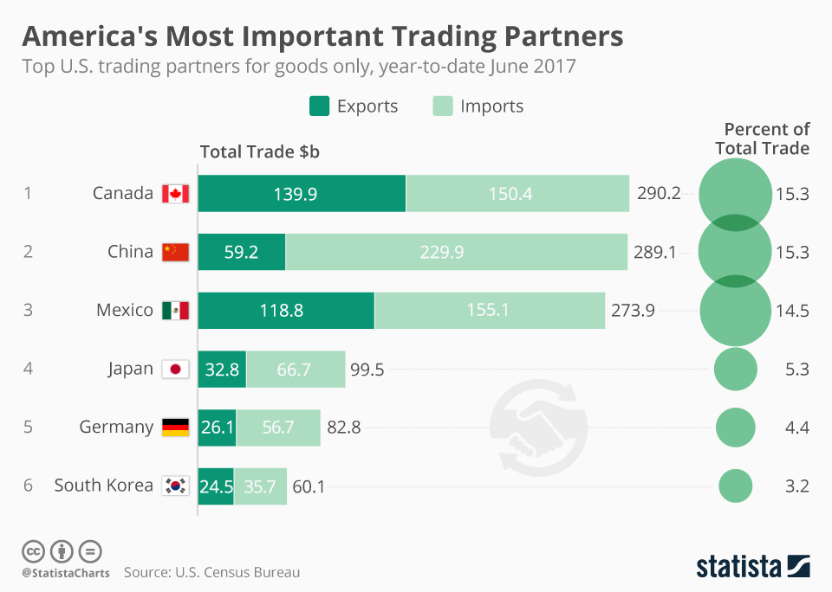
Although the Cold War era was a brief section in history, according to David Hundt, a professor in international relations at Deakin University, the American influence of Japanese Korean relations was immense, as an external factor. This was due to America’s rush to rebuild east Asian relations to create economic powerhouses. Furthermore, they created a foothold in East-Asian politics to enforce a democratic influence to compete with the uprising communist influence, from Soviet-Russia, during the cold-war era . This led to an apology on Japan’s behalf, to accelerate the process of rebuilding bilateral ties. Thus, there is still debate in Korea whether a formal apology was made for the brutal military occupation due to America’s forcing of political cooperation between Japan and Korea, and as Hundt states, “Japan’s efforts to make up for the past lacked democratic legitimacy”.
Figure 1: America’s most important trade partners

U.S influences have greatly impacted political relations due to numerous signings of treaties to benefit the economic position of the U.S. Figure 1 depicts the importance of Korea and Japan as trade partners, within the top 10 biggest trade partners, to the U.S hence, why the U.S prioritised trilateral trade relations to construct large economies in the East-Asian region. However, Japan’s economic status, post-WWII, led America to prioritise the further industrialisation in Japan hence, the creation of trade treaties favourable to the Japanese government. This led to current political debates, between both nations, of the legitimacy of treaties due to the implications of the U.S initiative to gain economic benefits from both nations

ideals by the current politicians
The current Japanese president, Shinzo Abe, is affiliated with the ultra-right-wing group, Nippon Kaigi . This group supports extremist views such as: revitalisation of the Imperial military; they deny past war crimes, most infamously the ‘rape of Nanjing’; and the reversion of post-WWII restrictions . Denial of large-scale war crimes, exemplified by the denial of the ‘rape of Nanjing’, is especially problematic to Koreans as it expresses Japan’s willingness to create divergent realities to historical recounts, including war crimes committed within Korea. As professor Setsu Kobayashi, a former Nippon Kaigi member and a leader in Japanese constitutional expertise, states, “They’re thinking about Asia before the war when Japan was the leader of Asia. They want to repeat that. They openly say that” . On the contrary, the current Korean president, Moon Jae In, asserts very liberal left-wing policies and ideals. Exemplars can be seen in: his war-time repercussion repayment initiatives, his advocation of freedom of speech in media and his methodology of solving political issues, substantiated by his response to the trade war crisis, as president Moon states: “I offer to join hands if Tokyo chooses dialogue” .

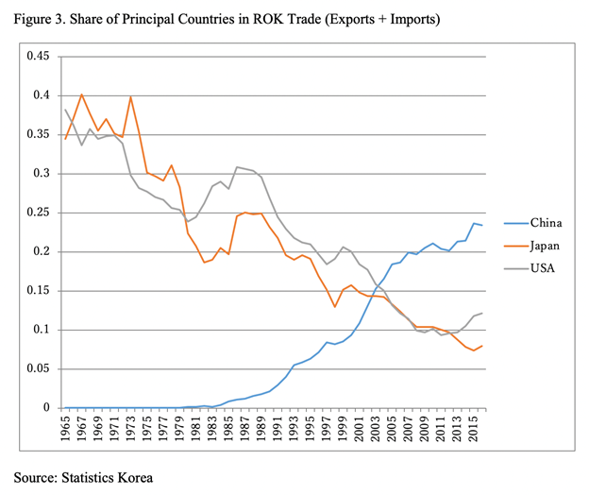

Figure 3: Diagram of how exports and imports have decreased
Due to the divergent values of each presidential administration, clashes of political disagreement have converged into a trade-war crisis based on war reparation demands. Moon’s administration affirms the existence of war-crime victims whilst Abe denies all claims, and in retaliation has orchestrated the removal of Korea off the free trade partners whitelist Furthermore, Abe has stated that “war reparation appeals must be upheld under international and universal standards”, implying that Korea’s appeals were irrational and illegitimate. As seen in fig.3, trade exports and imports have continually depreciated due to trade restrictions and bans, which in turn, has led governments of both parties to discuss the legality of certain trade restrictions based on the WTO regulations. These trade disputes have furthered the deterioration of the political cooperation, as neither can rationally converse without breaking into heated dispute hence, the diverging politics have immensely affected the current political relations negatively. Furthermore, war crimes committed against China have relevancy within Korea’s context as they exemplify Japan’s lack of acknowledgement of the most significant of war crimes, denying over 300 thousand people massacred, hence suggesting that Japan’s view on war crimes within Korea are insignificant.

Extent of historical influence on the societal relationship between Japan and south korea
Significant historical influences on societies include:
- Personal experience
- Censorship within the education systems
- Cultural values

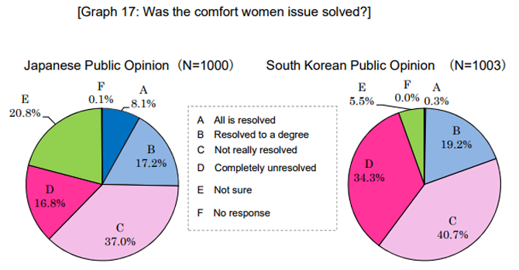
Personal experience
Figure 4: Public opinion on whether the comfort women issue has been resolved.
With over 800 thousand Koreans killed due to forced labour and work conditions and an additional 200 thousand enslaved as prostitutes, the older Korean population remains with personal trauma from the occupation by Japan. Whether it be a family or personal account from that era, such as stories from Kim Bok-Dong a ‘comfort woman’ survivor, depictions of the brutal Japanese occupation are common . Furthermore, the combination of Japanese denial of war crimes and the absence of a formal apology escalated the issue further by increasing frustration of the Korean people exemplified by Kim Huk-Sun, a comfort women survivor, when she states, “I am the very evidence alive; why does Japan say they have no evidence? Bring back my youth!” As seen in figure 4, over 8% of the Japanese population view the ‘comfort women’ issue as completely resolved. In contrast, 0.3% of the Korean population views the issues as resolved. As shown by contradicting statistics, victims within Korea perceive that Japanese society has marginalised the significance of their statements, thus, creating further societal tensions.
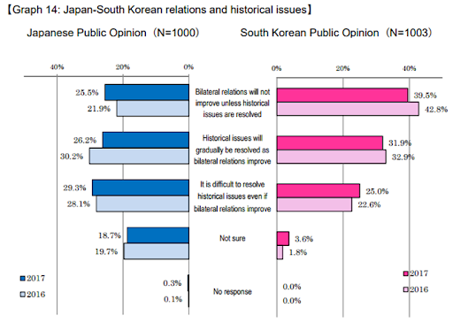
Figure 5: Opinions of how resolving historical issues will improve relations
The lack of Japanese societal acknowledgement and understanding of personal recounts of Korean victims, over 25% of both nation’s societies believe that historical issues will prove to be difficult to resolve even if bilateral political relations strengthen, seen in figure 5. Lack of acknowledgement of personal accounts has proven to further deteriorate bilateral relations, due to Koreans viewing the Japanese society as unsympathetic. Furthermore, over a million Koreans have surpassed the age of 80, hence, large sectors of the Korean population have been directly affected by imperial rule. Even without the consideration of intergenerational storytelling, informing their children about wartime atrocities, over 1/50th of the population has extremely negative views on Japan .

CenSorship within the education system
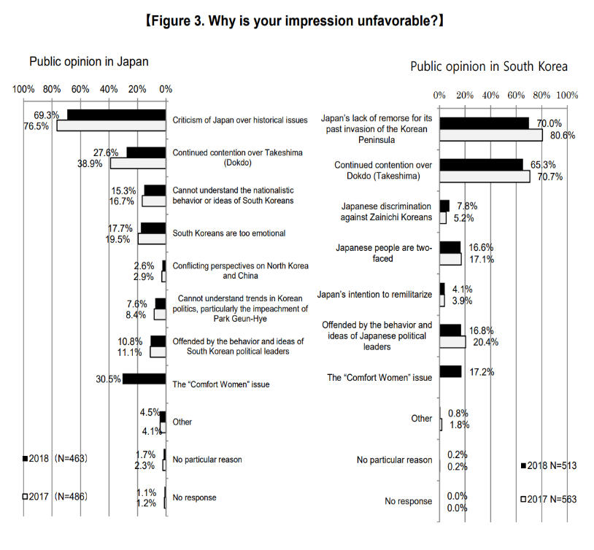
According to professor Yurita Makito, a Japanese education systems expert, the Japanese government has implemented an inexplicit version of WWII history. This includes: vague descriptions of the Nanjing massacre, the absence of the comfort women issues and portraying a standpoint that Japan was a non-aggressive defensive country throughout the war . Makito’s statement is substantiated by AsianBoss, a politics YouTube channel, as an interviewed Japanese student stated, “We only briefly covered Japan’s contribution in WWII, much of the textbook was focussed on the Edo period of Japanese history”. In contrast, according to Suh Yong-Hee, a Korean education systems expert, Korean textbooks explicitly describe Japanese war crimes and occasionally exaggerates the seriousness of some topics .
Figure 6: Japanese Korean public opinion poll ’

Fig.1 displays the effect of educational manipulation within both nations. Over 70% of negative Korean views, on Japan, are based on historical events, whilst the Japanese negatively view Koreans equally based on their historical view of Japanese behaviour. Additionally, they negatively view each other due to the ‘comfort women’ issues and the sovereignty debate over the Dokdo/Takeshima islands. These statistics effectively display the manipulation of education as narratives of history, used to support claims over political issues, cannot be correct simultaneously . The divergent narratives have created extensive societal debates, as both societies claim the other is ‘brainwashed’ and uneducated, hence, negatively influencing the societal relationship to a great extent .

Cultural values
Both societies extensively display nationalism and patriotism to convey their loyalty to their respective nations . Korean’s are characteristically patriotic, stemming from their identity crisis, due to imperialist censorship of Korean culture. The Japanese also are patriotic, however, two patriotic nations with contradicting ideals and cultural values lead to societal tension. For instance, Koreans value their history of oppression and this can be seen in their persistence in their protests for war-time reparations, however, the Japanese value their societal image as an honest, kind and passive society . Korea’s globalising and advertising of war-crimes committed by Japan during WWII, caused the defacement of the Japanese public image. This has greatly influenced the societal relationship as the cultural values of each society has led them to protest and counter-protest each other with boycotts and anti-Korean and anti-Japanese sentiments. Furthermore, the ‘cultural wall’ has limited the ability to sympathise due to the conservative aspects of society. There’s minimal communication between the two nations, hence, halting any progressive initiatives to improve bilateral relations.

Conclusion
Through the utilisation of a diverse range of sources, the conclusion is made that the current political and societal relations, between Japan and Korea, have been greatly impacted due to historical influences mainly due to two underlying factors, war and the unwillingness, of Japan, to accept accountability of their actions. The Japanese government’s refusal to acknowledge the past has not only gradually enraged the general society of South Korea, especially the first-hand victims, it’s also motivated them to boycott Japan entirely to convey their patriotism. Due to the lack of historical education, Japanese society has felt victimised and in-turn retaliated with counter-protests and boycotts. This has led the governments to intervene and take sides, evidently supporting the political standpoints of their people, hence extreme political tensions have arisen based on historical influences.
1985– Word Count

REFERENCE LIST
Allison Hilary, 2016, The fall and rise of South Korea’s forests, https://www.researchgate.net/publication/321496830_The_fall_and_rise_of_South_Korea's_forests (accessed 24/05/2020)
ASIA PACIFIC, 2019, Anti-Japan banners in Seoul taken down after public outcry, https://www.aljazeera.com/news/2019/08/anti-japan-banners-seoul-public-outcry-190806084314476.html (accessed 24/05/2020)
Asian-Boss, 2018, How Do Koreans Feel About Japan?,https://www.youtube.com/watch?v=PLOi-PsY9ZE&t=259s (accessed 7/03/20)
Asian-Boss, 2018, Howe do the Japanese Feel About SouthKorea? ,https://www.youtube.com/watch?v=KNIStfey8oU&t=610s (Accessed 8/03/20)
AsianBoss, 2018, Life As a “Comfort Woman”: story of Kim Bok-Dong https://www.youtube.com/watch?v=qsT97ax_Xb0 (accessed 20/05/2020)
BIOGRAPHY.COM, 2019, Japanese Internment Camp survivors: In Their Own Words, https://www.biography.com/news/japanese-internment-survivors-stories-75th-anniversary-photos (accessed 24/05/2020)
Blakemore Erin, 2017, Why South Korea’s National Archive Uprooted 12 Japanese Trees, https://www.smithsonianmag.com/smart-news/why-south-koreas-national-archive-uprooted-12-japanese-trees-180962462/ (accessed 29/04/2020)
Blakemore Erin, 2018, How Japan Took Control of Korea, https://www.history.com/news/japan-colonization-korea, (accessed, 11/05/2020)
Brazinisky Gregg, 2019, How Japan’s failure to atone for past sins threatens the global economy, https://www.washingtonpost.com/outlook/2019/08/11/how-japans-failure-atone-past-sins-threatens-global-economy/ (accessed 21/05/2020)
Britannica, 2020, Yi Sun Shin, https://www.britannica.com/biography/Yi-Sun-shin (accessed, 13/05/2020)
Brody Howard, 2015, United States Responses to Japanese Wartime Inhuman Experimentation after World War II: National Security and Wartime Exigency, https://www.ncbi.nlm.nih.gov/pmc/articles/PMC4487829/ (accessed 24/05/2020)
Carney Mathew, 2015, Nippon Kaigi: The ultra-nationalistic group trying to restore the might of the Japanese Empire, https://www.abc.net.au/news/2015-12-02/nippon-kaigi-and-the-rise-of-nationalism-in-japan/6994560 (accessed, 18/04/2020)
Cartwright Mark, 2019, The Japanese Invasion of Korea 1592-98, https://www.ancient.eu/article/1398/the-japanese-invasion-of-korea-1592-8-ce/ (accessed 1/04/2020)
Cortazzi Hugh, 2016, Japan’s image and culture, https://www.japantimes.co.jp/opinion/2016/12/23/commentary/japan-commentary/japans-image-culture/#.XsoSkmgzaUk (accessed 29/04/2020)
Diaz Joanna, 2018, Negotiating the “comfort women” issue in the 21st centuryhttps://isdp.eu/negotiating-the-comfort-women-issue-in-the-21st-century/ (accessed, 2/05/2020)
Dudden Alex, 2019, Japan’s rising sun flag has a history of horror, https://www.theguardian.com/commentisfree/2019/nov/01/japan-rising-sun-flag-history-olympic-ban-south-korea (accessed 12/03/20)
Dyfed Loesche, 2017, America’s Most Important Trading Partners, https://www.statista.com/chart/10942/americas-most-important-trading-partners/ (accessed 28/05/2020)
EAI, 2017, The 5th Japan-South Korea Joint Public Opinion poll, http://www.genron-npo.net/en/opinion_polls/archives/5363.html (accessed 28/05/2020)
EAI, 2018, Korean-Japanese Public Opinion Poll http://www.eai.or.kr/main/english/program_list01.asp?code=54) (accessed 17/02/2020)
Eck Tom, 2019, The legacy of nationalism in Korea,https://www.lowyinstitute.org/the-interpreter/legacy-nationalism-korea (accessed 23/04/2020)
FAS, 2000, East Asia and the United States: Current Status and Five-Year Outlook, https://fas.org/irp/nic/east_asia.html (accessed 03/04/2020)
Goh-Da-Sol. 2019, Anti-Korean sentiment thriving in Japan, https://asiatimes.com/2019/09/anti-korean-sentiment-is-thriving-in-japan/ (accessed 9/04/2020)
Gordon Bill, 2000, Japan’s March Toward Militarism, http://wgordon.web.wesleyan.edu/papers/jhist2.htm, (accessed 18/05/2020)
Hawley Samuel, 2003, “THE IMJIN WAR”, http://www.samuelhawley.com/imjinarticle1a.html (accessed, 20/03/2020)
Helo Ari, 2016, Letting Go of Narrative History : The Linearity of Time and the Art of Recounting the Past, https://journals.openedition.org/ejas/11648 (accessed 12/05/2020)
Herinksen Thomas, 2017, US has regained foothold as leader in East Asia, https://thehill.com/blogs/pundits-blog/foreign-policy/349113-us-has-regained-foothold-as-leader-in-east-asia (accessed 27/02/2020)
History.com, 2009, Cold War History, https://www.history.com/topics/cold-war/cold-war-history (accessed 23/03/2020)
https://www.newstatesman.com/world/asia/2019/05/shinzo-abe-and-rise-japanese-nationalism (accessed 08/03/2020)
Hundt David, 2020, Aspects that have shaped the Korean/Japan relations, Interviewed by Daniel Kim
Japantimes, 2010, The annexation of Korea, https://www.japantimes.co.jp/opinion/2010/08/29/editorials/the-annexation-of-korea/#.XsJZlmgzaUk (accessed, 18/05/2020)
Johnson Jesse, 2019, Nearly half of South Koreans would back North in war with Japan, while 40% ‘have no idea’, https://www.japantimes.co.jp/news/2019/11/08/national/politics-diplomacy/nearly-half-south-koreans-back-north-vs-japan/#.XsoTFmgzaUk (accessed 22/05/2020)
Junya Nishino, 2015, Japan’s Security Relationship With the republic of Korea, https://csis-prod.s3.amazonaws.com/s3fs-public/170401_Japan_ROK_0.pdf?jz3COYNovbBS2I2GlA8kOFxsWWmSxzt1, (accessed 4/03/20)
Kan Kimura, 2019, Explaining South Korea’s Sharp Shift in 2018 towards Japan, http://www.theasanforum.org/explaining-south-koreas-sharp-shift-in-2018-toward-japan/ (accessed 28/05/2020
Kim Andrew, 2019, Patriotism can be dangerous, but South Korea shows it’s necessary, http://www.campustimes.org/2019/11/10/patriotism-can-be-dangerous-but-south-korea-shows-its-necessary/ (accessed 24/05/2020)
Kim Sung-Woo, 2016, War and ‘War Effects’:Post-war Choson Economy in 17th Century after Imjin War of 1592, https://apebh2014.files.wordpress.com/2014/02/sung-woo.pdf (accessed 15/04/2020)
Kim, Catherine, 2019, The escalating trade war between South Korea and Japan, explained, https://www.vox.com/world/2019/8/9/20758025/trade-war-south-korea-japan (accessed 18/03/20)
Lee Andy, 2018, Japan’s Uncomfortable Past, https://www.mironline.ca/japans-uncomfortable-past/ (accessed 28/05/2020)
LUMEN, N/A, Korea under Japanese Rule, https://courses.lumenlearning.com/boundless-worldhistory/chapter/the-koreas/ (accessed 20/05/2020)
Lynch Karen, 2016, WTO and the rules of global trade, https://www.americanexpress.com/us/foreign-exchange/articles/world-trade-organization-rules-for-international-trade/ (accessed 28/05/2020)
Matsuda Takuya, 2019, Geopolitics redux: explaining the Japan-Korea dispute and its implications for great power competition, https://warontherocks.com/2019/11/geopolitics-redux-explaining-the-japan-korea-dispute-and-its-implications-for-great-power-competition/ (accessed 18/03/2020)
MATSUKI Kunitoshi, 2017, Japan’s Annexation of Korea, http://www.sdh-fact.com/essay-article/314/ (accessed 12/03/2020)
Mehta Aaron, 2019, Tension between South Korea and Japan could hurt US goals in the pacific, https://www.defensenews.com/global/asia-pacific/2019/08/15/tension-between-south-korea-and-japan-could-hurt-us-goals-in-the-pacific-and-china-is-watching/ (accessed, 21/04/2020)
Miller Jacob, N/A, 23 Photographs of the Japanese Occupation of Korea and the Liberation, https://historycollection.co/23-photographs-japanese-occupation-korea-liberation/ (accessed 20/05/2020)
Moon Jae-In, 2020, 2020 New Year’s address by President Moon Jae-In https://english1.president.go.kr/BriefingSpeeches/Speeches/741 (accessed 21/05/2020)
NEWSWORLD, 2012, Tigers of Korea 100 Years Ago, https://bigcatrescue.org/tigers-of-korea-100-years-ago/ (accessed 4/03/2020)
O’Dwyer Shaun, 2019, The Rise of Nationalism in Korea, https://www.japantimes.co.jp/opinion/2019/09/23/commentary/japan-commentary/korean-nationalism-comfort-women-issue/#.XsoH22gzaUk (accessed 5/02/2020)
Oi Mariko, 2013, What Japanese history lessons leave out, https://www.bbc.com/news/magazine-21226068 (accessed, 24/02/2020)
Osaki Tomohiro, 2018, Abe Rejects Seoul’s New Call For Apology on ‘Comfort Women Issue’.https://www.japantimes.co.jp/news/2018/01/12/national/politics-diplomacy/abe-rejects-kangs-new-apology-call-comfort-women-issue/#.XugSZEUzbD4 (accessed 3/03/20)
Panda Ankit, 2017, A Liberal Triumphs in South Korea: Who is Moon Jae In, https://thediplomat.com/2017/05/a-liberal-triumphs-in-south-korea-who-is-moon-jae-in/, (accessed, 13/05/2020)
POLITICS, 2019, Japan’s neighbours closely watch Abe’s policies after election, https://asia.nikkei.com/Politics/Japan-s-neighbors-closely-watch-Abe-s-policies-after-election (accessed 21/05/2020)
Pollmann Mina, 2015, Why Japan’s Textbook Controversy is Getting Worse, https://thediplomat.com/2015/04/why-japans-textbook-controversy-is-getting-worse/ (accessed 16/02/2020)
Ray Michael, 2020, Moon Jae In, https://www.britannica.com/biography/Moon-Jae-In (accessed 20/05/2020)
Roy Denny, 2015, Does It Matter Whether Japan Says Sorry for its Wartime Behaviour?, https://foreignpolicy.com/2015/08/13/does-it-matter-whether-japan-says-sorry-for-its-wartime-behavior-shinzo-abe-world-war-2-china-south-korea/ (accessed 8/03/2020)
RSM, 2012, War and Women’s Human Rights Museum, https://rockandseoulmusings.wordpress.com/tag/kim-hak-sun/ (accessed 27/05/2020)
Rummel R.J, 2014, Statistics of Japanese Democide Estimates, Calculations, and Sources, https://www.hawaii.edu/powerkills/SOD.CHAP3.HTM (accessed 28/04/2020)
Seijiro Takeshita, 2020, Fighting Anti-Japanese Bias in the Global Media, https://www.nippon.com/en/in-depth/a06503/fighting-anti-japanese-bias-in-the-global-media-%E2%80%94-my-lonely-crusade.html (accessed 12/05/2020)
Sik Hong Cho, 2006, Food and Nationalism, http://www.kjis.org/journal/view.html?uid=85&page=&pn=mostread&sort=publish_Date%20DESC&spage=&vmd=Full (accessed 8/04/2020)
Solis Mireya, 2012, Order from chaos,https://www.brookings.edu/blog/order-from-chaos/2017/10/25/rescuing-u-s-economic-strategy-in-asia/ (accessed 8/04/2020)
Stack Liam, 2018, Korean War, a ‘Forgotten’ Conflict That Shaped the Modern World, https://www.nytimes.com/2018/01/01/world/asia/korean-war-history.html (accessed 3/03/2020)
Stockton Richard, 2019, Inside Japan’s World War II-Era Reign Of Terror, https://allthatsinteresting.com/japanese-war-crimes (accessed 17/03/2020)
Suh Yonghee, Yurita Makito, Lin Lin, Metzger Scott, 2013, Collective Memories of the Second World War in History Textbooks from China, Japan and South Korea, https://files.eric.ed.gov/fulltext/EJ1149771.pdf (accessed 30/03/20)
Surak Kristen, 2019, Abe and the rise of Nationalism, https://www.afr.com/world/asia/abe-and-the-rise-of-japanese-nationalism-20190604-p51uh7 (accessed, 25/04/2020)
Suzuku Sotaro, 2019, Boycott Japan: How young South Koreans keep the anger alive, https://asia.nikkei.com/Spotlight/Comment/Boycott-Japan-How-young-South-Koreans-keep-the-anger-alive (accessed 21/03/2020)
Swicord Ellen, 2019, The United States Needs Japan and South Korea to Make Up, https://thediplomat.com/2019/10/the-united-states-needs-japan-and-south-korea-to-make-up/ (accessed 24/03/2020)
Szczepanski Kallie, 2018, The Imjin War, https://www.thoughtco.com/kallie-szczepanski-194968 (accessed 18/05/2020)
theJapantimes, 2018, A tale of those swayed by a Japanese anti-Korean fake news blog, https://www.japantimes.co.jp/news/2018/07/23/national/social-issues/tale-swayed-japanese-anti-korean-fake-news-blog/#.Xsn10WgzaUk (accessed, 24/05/2020)
TheJapanTimes, 2019, South Korea’s Moon Jae-In offers to ‘join hands’ with Japan if Tokyo chooses dialogue, https://www.japantimes.co.jp/news/2019/08/15/national/politics-diplomacy/south-koreas-moon-jae-offers-join-hands-japan-tokyo-chooses-dialogue/#.XsXudWgzbD4 (accessed 20/05/2020)
Tolbert David, 2017, Japan’s Apology to South Korea Shows What Public Apologies Should (Not) Do, https://www.huffpost.com/entry/japans-apology-to-south-k_b_9111566 (accessed 13/02/2020)
Tully David, 2018, Can Young Japanese and South Koreans Bridge the Gap?, https://www.thechicagocouncil.org/publication/can-young-japanese-and-south-koreans-bridge-gap (accessed 24/05/2020)
Woods Kathleen, 2001, Examining the Japanese History Textbook Controversies, https://spice.fsi.stanford.edu/docs/examining_the_japanese_history_textbook_controversies (accessed 15/05/2020)
Yon-se Kim, 2020, Number of Koreans aged over 80 up 1 million, http://www.koreaherald.com/view.php?ud=20200112000047 (accessed 20/05/2020)
Yoshifumi Tawara, 2017, What is the Aim of Nippon Kaigi, https://apjjf.org/2017/21/Tawara.html (accessed, 25/04/2020)

Mehta Aaron, 2019, Tension between South Korea and Japan could hurt US goals in the pacific, https://www.defensenews.com/global/asia-pacific/2019/08/15/tension-between-south-korea-and-japan-could-hurt-us-goals-in-the-pacific-and-china-is-watching/ (accessed, 21/04/2020)
Britannica, 2020, Yi Sun Shin, https://www.britannica.com/biography/Yi-Sun-shin (accessed, 13/05/2020)
Diaz Joanna, 2018, Negotiating the “comfort women” issue in the 21st centuryhttps://isdp.eu/negotiating-the-comfort-women-issue-in-the-21st-century/ (accessed, 2/05/2020)
Blakemore Erin, 2018, How Japan Took Control of Korea, https://www.history.com/news/japan-colonization-korea, (accessed, 11/05/2020)
Mehta Aaron, 2019, Tension between South Korea and Japan could hurt US goals in the pacific, https://www.defensenews.com/global/asia-pacific/2019/08/15/tension-between-south-korea-and-japan-could-hurt-us-goals-in-the-pacific-and-china-is-watching/ (accessed, 21/04/2020)
Hundt David, 2020, Aspects that have shaped the Korean/Japan relations, Interviewed by Daniel Kim
Surak Kristen, 2019, Abe and the rise of Nationalism, https://www.afr.com/world/asia/abe-and-the-rise-of-japanese-nationalism-20190604-p51uh7 (accessed, 25/04/2020)
Panda Ankit, 2017, A Liberal Triumphs in South Korea: Who is Moon Jae In, https://thediplomat.com/2017/05/a-liberal-triumphs-in-south-korea-who-is-moon-jae-in/, (accessed, 13/05/2020)
Hawley Samuel, 2003, “THE IMJIN WAR”, http://www.samuelhawley.com/imjinarticle1a.html (accessed, 20/03/2020)
Szczepanski Kallie, 2018, The Imjin War, https://www.thoughtco.com/kallie-szczepanski-194968 (accessed 18/05/2020)
Cartwright Mark, 2019, The Japanese Invasion of Korea 1592-98, https://www.ancient.eu/article/1398/the-japanese-invasion-of-korea-1592-8-ce/ (accessed 1/04/2020)
Kim Sung-Woo, 2016, War and ‘War Effects’:Post-war Choson Economy in 17th Century after Imjin War of 1592, https://apebh2014.files.wordpress.com/2014/02/sung-woo.pdf (accessed 15/04/2020)
Gordon Bill, 2000, Japan’s March Toward Militarism, http://wgordon.web.wesleyan.edu/papers/jhist2.htm, (accessed 18/05/2020)
Japantimes, 2010, The annexation of Korea, https://www.japantimes.co.jp/opinion/2010/08/29/editorials/the-annexation-of-korea/#.XsJZlmgzaUk (accessed, 18/05/2020)
MATSUKI Kunitoshi, 2017, Japan’s Annexation of Korea, http://www.sdh-fact.com/essay-article/314/ (accessed 12/03/2020)
Rummel R.J, 2014, Statistics of Japanese Democide Estimates, Calculations, and Sources, https://www.hawaii.edu/powerkills/SOD.CHAP3.HTM (accessed 28/04/2020)
Allison Hilary, 2016, The fall and rise of South Korea’s forests, https://www.researchgate.net/publication/321496830_The_fall_and_rise_of_South_Korea's_forests (accessed 24/05/2020)
NEWSWORLD, 2012, Tigers of Korea 100 Years Ago, https://bigcatrescue.org/tigers-of-korea-100-years-ago/ (accessed 4/03/2020)
Blakemore Erin, 2017, Why South Korea’s National Archive Uprooted 12 Japanese Trees, https://www.smithsonianmag.com/smart-news/why-south-koreas-national-archive-uprooted-12-japanese-trees-180962462/ (accessed 29/04/2020)
Brody Howard, 2015, United States Responses to Japanese Wartime Inhuman Experimentation after World War II: National Security and Wartime Exigency, https://www.ncbi.nlm.nih.gov/pmc/articles/PMC4487829/ (accessed 24/05/2020)
Stockton Richard, 2019, Inside Japan’s World War II-Era Reign Of Terror, https://allthatsinteresting.com/japanese-war-crimes (accessed 17/03/2020)
Dudden Alex, 2019, Japan’s rising sun flag has a history of horror, https://www.theguardian.com/commentisfree/2019/nov/01/japan-rising-sun-flag-history-olympic-ban-south-korea (accessed 12/03/20)
Matsuda Takuya, 2019, Geopolitics redux: explaining the Japan-Korea dispute and its implications for great power competition, https://warontherocks.com/2019/11/geopolitics-redux-explaining-the-japan-korea-dispute-and-its-implications-for-great-power-competition/ (accessed 18/03/2020)
History.com, 2009, Cold War History, https://www.history.com/topics/cold-war/cold-war-history (accessed 23/03/2020)
Stack Liam, 2018, Korean War, a ‘Forgotten’ Conflict That Shaped the Modern World, https://www.nytimes.com/2018/01/01/world/asia/korean-war-history.html (accessed 3/03/2020)
Hundt David, 2020, Aspects that have shaped the Korean/Japan relations, Interviewed by Daniel Kim
Herinksen Thomas, 2017, US has regained foothold as leader in East Asia, https://thehill.com/blogs/pundits-blog/foreign-policy/349113-us-has-regained-foothold-as-leader-in-east-asia (accessed 27/02/2020)
Tolbert David, 2017, Japan’s Apology to South Korea Shows What Public Apologies Should (Not) Do, https://www.huffpost.com/entry/japans-apology-to-south-k_b_9111566 (accessed 13/02/2020)
Swicord Ellen, 2019, The United States Needs Japan and South Korea to Make Up, https://thediplomat.com/2019/10/the-united-states-needs-japan-and-south-korea-to-make-up/ (accessed 24/03/2020)
Dyfed Loesche, 2017, America’s Most Important Trading Partners, https://www.statista.com/chart/10942/americas-most-important-trading-partners/ (accessed 28/05/2020)
Solis Mireya, https://www.brookings.edu/blog/order-from-chaos/2017/10/25/rescuing-u-s-economic-strategy-in-asia/
Roy Denny, 2015, Does It Matter Whether Japan Says Sorry for its Wartime Behaviour?, https://foreignpolicy.com/2015/08/13/does-it-matter-whether-japan-says-sorry-for-its-wartime-behavior-shinzo-abe-world-war-2-china-south-korea/ (accessed 8/03/2020)
FAS, 2000, East Asia and the United States: Current Status and Five-Year Outlook, https://fas.org/irp/nic/east_asia.html (accessed 03/04/2020)
Yoshifumi Tawara, 2017, What is the Aim of Nippon Kaigi, https://apjjf.org/2017/21/Tawara.html (accessed, 25/04/2020)
Carney Mathew, 2015, Nippon Kaigi: The ultra-nationalistic group trying to restore the might of the Japanese Empire, https://www.abc.net.au/news/2015-12-02/nippon-kaigi-and-the-rise-of-nationalism-in-japan/6994560 (accessed, 18/04/2020)
POLITICS, 2019, Japan’s neighbours closely watch Abe’s policies after election, https://asia.nikkei.com/Politics/Japan-s-neighbors-closely-watch-Abe-s-policies-after-election (accessed 21/05/2020)
Carney Mathew, 2015, Nippon Kaigi: The ultra-nationalistic group trying to restore the might of the Japanese Empire, https://www.abc.net.au/news/2015-12-02/nippon-kaigi-and-the-rise-of-nationalism-in-japan/6994560 (accessed, 18/04/2020)
Ray Michael, 2020, Moon Jae In, https://www.britannica.com/biography/Moon-Jae-In (accessed 20/05/2020)
TheJapanTimes, 2019, South Korea’s Moon Jae-In offers to ‘join hands’ with Japan if Tokyo chooses dialogue, https://www.japantimes.co.jp/news/2019/08/15/national/politics-diplomacy/south-koreas-moon-jae-offers-join-hands-japan-tokyo-chooses-dialogue/#.XsXudWgzbD4 (accessed 20/05/2020)
Moon Jae-In, 2020, 2020 New Year’s address by President Moon Jae-In https://english1.president.go.kr/BriefingSpeeches/Speeches/741 (accessed 21/05/2020)
Kan Kimura, 2019, Explaining South Korea’s Sharp Shift in 2018 towards Japan, http://www.theasanforum.org/explaining-south-koreas-sharp-shift-in-2018-toward-japan/ (accessed 28/05/2020
Brazinisky Gregg, 2019, How Japan’s failure to atone for past sins threatens the global economy, https://www.washingtonpost.com/outlook/2019/08/11/how-japans-failure-atone-past-sins-threatens-global-economy/ (accessed 21/05/2020)
Junya Nishino, 2015, Japan’s Security Relationship With the republic of Korea, https://csis-prod.s3.amazonaws.com/s3fs-public/170401_Japan_ROK_0.pdf?jz3COYNovbBS2I2GlA8kOFxsWWmSxzt1, (accessed 4/03/20)
Osaki Tomohiro, 2018, Abe Rejects Seoul’s New Call For Apology on ‘Comfort Women Issue’.https://www.japantimes.co.jp/news/2018/01/12/national/politics-diplomacy/abe-rejects-kangs-new-apology-call-comfort-women-issue/#.XugSZEUzbD4 (accessed 3/03/20)
Lynch Karen, 2016, WTO and the rules of global trade, https://www.americanexpress.com/us/foreign-exchange/articles/world-trade-organization-rules-for-international-trade/ (accessed 28/05/2020)
Kim, Catherine, 2019, The escalating trade war between South Korea and Japan, explained, https://www.vox.com/world/2019/8/9/20758025/trade-war-south-korea-japan (accessed 18/03/20)
AsianBoss, 2018, Life As a “Comfort Woman”: story of Kim Bok-Dong https://www.youtube.com/watch?v=qsT97ax_Xb0 (accessed 20/05/2020)
Suh Yonghee, Yurita Makito, Lin Lin, Metzger Scott, 2013, Collective Memories of the Second World War in History Textbooks from China, Japan and South Korea, https://files.eric.ed.gov/fulltext/EJ1149771.pdf (accessed 30/03/20)
Sik Hong Cho, 2006, Food and Nationalism, http://www.kjis.org/journal/view.html?uid=85&page=&pn=mostread&sort=publish_Date%20DESC&spage=&vmd=Full (accessed 8/04/2020)
Lee Andy, 2018, Japan’s Uncomfortable Past, https://www.mironline.ca/japans-uncomfortable-past/ (accessed 28/05/2020)
Miller Jacob, N/A, 23 Photographs of the Japanese Occupation of Korea and the Liberation, https://historycollection.co/23-photographs-japanese-occupation-korea-liberation/ (accessed 20/05/2020)
BIOGRAPHY.COM, 2019, Japanese Internment Camp survivors: In Their Own Words, https://www.biography.com/news/japanese-internment-survivors-stories-75th-anniversary-photos (accessed 24/05/2020)
RSM, 2012, War and Women’s Human Rights Museum, https://rockandseoulmusings.wordpress.com/tag/kim-hak-sun/ (accessed 27/05/2020)
Lee Andy, 2018, Japan’s Uncomfortable Past, https://www.mironline.ca/japans-uncomfortable-past/ (accessed 28/05/2020)
EAI, 2017, The 5th Japan-South Korea Joint Public Opinion poll, http://www.genron-npo.net/en/opinion_polls/archives/5363.html (accessed 28/05/2020)
EAI, 2017, The 5th Japan-South Korea Joint Public Opinion poll, http://www.genron-npo.net/en/opinion_polls/archives/5363.html (accessed 28/05/2020)
LUMEN, N/A, Korea under Japanese Rule, https://courses.lumenlearning.com/boundless-worldhistory/chapter/the-koreas/ (accessed 20/05/2020)
Yon-se Kim, 2020, Number of Koreans aged over 80 up 1 million, http://www.koreaherald.com/view.php?ud=20200112000047 (accessed 20/05/2020)
Tully David, 2018, Can Young Japanese and South Koreans Bridge the Gap?, https://www.thechicagocouncil.org/publication/can-young-japanese-and-south-koreans-bridge-gap (accessed 24/05/2020)
Suh Yonghee, Yurita Makito, Lin Lin, Metzger Scott, 2013, Collective Memories of the Second World War in History Textbooks from China, Japan and South Korea, https://files.eric.ed.gov/fulltext/EJ1149771.pdf
Pollmann Mina, 2015, Why Japan’s Textbook Controversy is Getting Worse, https://thediplomat.com/2015/04/why-japans-textbook-controversy-is-getting-worse/ (accessed 16/02/2020)
Oi Mariko, 2013, What Japanese history lessons leave out, https://www.bbc.com/news/magazine-21226068 (accessed, 24/02/2020)
Woods Kathleen, 2001, Examining the Japanese History Textbook Controversies, https://spice.fsi.stanford.edu/docs/examining_the_japanese_history_textbook_controversies (accessed 15/05/2020)
Asian-Boss, 2018, Howe do the Japanese Feel About SouthKorea? ,https://www.youtube.com/watch?v=KNIStfey8oU&t=610s (Accessed 8/03/20)
Suh Yonghee, Yurita Makito, Lin Lin, Metzger Scott, 2013, Collective Memories of the Second World War in History Textbooks from China, Japan and South Korea, https://files.eric.ed.gov/fulltext/EJ1149771.pdf
Asian-Boss, 2018, How Do Koreans Feel About Japan?,https://www.youtube.com/watch?v=PLOi-PsY9ZE&t=259s (accessed 7/03/20)
: Asian-Boss, 2018, Howe do the Japanese Feel About SouthKorea? ,https://www.youtube.com/watch?v=KNIStfey8oU&t=610s (Accessed 8/03/20)
EAI, 2018, Korean-Japanese Public Opinion Poll http://www.eai.or.kr/main/english/program_list01.asp?code=54) (accessed 17/02/2020)
Seijiro Takeshita, 2020, Fighting Anti-Japanese Bias in the Global Media, https://www.nippon.com/en/in-depth/a06503/fighting-anti-japanese-bias-in-the-global-media-%E2%80%94-my-lonely-crusade.html (accessed 12/05/2020)
Helo Ari, 2016, Letting Go of Narrative History : The Linearity of Time and the Art of Recounting the Past, https://journals.openedition.org/ejas/11648 (accessed 12/05/2020)
theJapantimes, 2018, A tale of those swayed by a Japanese anti-Korean fake news blog, https://www.japantimes.co.jp/news/2018/07/23/national/social-issues/tale-swayed-japanese-anti-korean-fake-news-blog/#.Xsn10WgzaUk (accessed, 24/05/2020)
ASIA PACIFIC, 2019, Anti-Japan banners in Seoul taken down after public outcry, https://www.aljazeera.com/news/2019/08/anti-japan-banners-seoul-public-outcry-190806084314476.html (accessed 24/05/2020)
Goh-Da-Sol. 2019, Anti-Korean sentiment thriving in Japan, https://asiatimes.com/2019/09/anti-korean-sentiment-is-thriving-in-japan/ (accessed 9/04/2020)
Surak Kristin, 2019, Shinzo Abe and the rise of Japanese nationalism, https://www.newstatesman.com/world/asia/2019/05/shinzo-abe-and-rise-japanese-nationalism (accessed 08/03/2020)
Eck Tom, 2019, The legacy of nationalism in Korea,https://www.lowyinstitute.org/the-interpreter/legacy-nationalism-korea (accessed 23/04/2020)
O’Dwyer Shaun, 2019, The Rise of Nationalism in Korea, https://www.japantimes.co.jp/opinion/2019/09/23/commentary/japan-commentary/korean-nationalism-comfort-women-issue/#.XsoH22gzaUk (accessed 5/02/2020)
Cortazzi Hugh, 2016, Japan’s image and culture, https://www.japantimes.co.jp/opinion/2016/12/23/commentary/japan-commentary/japans-image-culture/#.XsoSkmgzaUk (accessed 29/04/2020)
Kim Andrew, 2019, Patriotism can be dangerous, but South Korea shows it’s necessary, http://www.campustimes.org/2019/11/10/patriotism-can-be-dangerous-but-south-korea-shows-its-necessary/ (accessed 24/05/2020)
Suzuku Sotaro, 2019, Boycott Japan: How young South Koreans keep the anger alive, https://asia.nikkei.com/Spotlight/Comment/Boycott-Japan-How-young-South-Koreans-keep-the-anger-alive (accessed 21/03/2020)
Johnson Jesse, 2019, Nearly half of South Koreans would back North in war with Japan, while 40% ‘have no idea’, https://www.japantimes.co.jp/news/2019/11/08/national/politics-diplomacy/nearly-half-south-koreans-back-north-vs-japan/#.XsoTFmgzaUk (accessed 22/05/2020)

