QUESTION DEVELOPMENT:
What is minimalism? – 04/01/20
The reason that I chose this topic is because minimalism is something that I want to incorporate into my life and learn more about. This question is a very general overall starting point that would have a very broad answer.
How can minimalism affect an individual’s life? – 04/01/20
This question is slightly more refined and to the point of the effect of minimalism on someone’s life when they decide to incorporate it into their lifestyle. This question, however, is still rather open for many answers because everyone’s life is different so minimalism can be adapted to their life in various ways.
How can a minimalist lifestyle affect an individual’s mental wellbeing? – 08/01/20
The last question wasn’t clear about what form of minimalism was being projected to the individual. There are many different things that can be classified as minimalist, such as art and designs to a person’s lifestyle. This adjustment helped clarify what kind of minimalism would be affecting the individual.
To what extent is a minimalist lifestyle positive for the environment? – 30/01/20
Instead of ‘how can a minimalist lifestyle affect…’, saying ‘to what extent’ already covers how minimalism affects a person, but also adds the factor of a measurement of its affect. Including the word ‘positive’ cancels out the research for how minimalism is negative because there wouldn’t be much information there and so it wouldn’t be worth covering in-depth. Researching the positive effects of the minimalist lifestyle to the environment would have more solid facts to find to put behind it rather than an individual’s mental wellbeing which isn’t able to be measured.
Compared to the average Australian lifestyle, how much of a positive effect does the minimalist lifestyle have on the environment? – 30/01/20
This question includes something to compare the minimalist lifestyle to, so that it has something solid to put it against instead of being potentially compared to every lifestyle in the world. The Australian lifestyle also is comparable to the other first-world country lifestyles, so that it is relevant for not just Australians but can be compared to other lifestyles, such as the average American lifestyle.
Compared to the average Australian lifestyle, what effect does the minimalist lifestyle have on the environment? – 30/01/20
Saying ‘what effect’ rather than narrowing it down to only the positive effect, means that the lifestyles aren’t presumed to only have positive effects and it will show another light on how they are negative compared to the other, because they can’t both be fully positive.
What effect does the minimalist lifestyle have on the environment? – 10/02/20
Comparing the minimalist lifestyle to the average Australian lifestyle means that a lot of the research also will go into what an average Australian lifestyle looks like which would be super time consuming when it itself isn’t the focus of the research. Changing the question so the focus of the question is the minimalist lifestyle means that it will be more in detail of that lifestyle which is the purpose of the question anyway.
How is the minimalist lifestyle more environmentally sustainable than a regular consumerist lifestyle? – 18/03/20
Comparing the minimalist lifestyle to a regular consumerist lifestyle will assist in demonstrating how the minimalist lifestyle is different in any way, showing whether it has a positive or negative effect, relative to another lifestyle. Using the words “more environmentally sustainable” rather than just generally, what the effect of the lifestyle on the environment is, gives it a better answer to the question of whether minimalism as a lifestyle has a positive or negative environmental effect.

Method for Annotating Sources:
Red = reliability, bias, disagrees with another source
Orange = key minimalism lifestyle facts
Yellow = effects on environment
Green = agrees with another source
Blue = word definitions
Purple = source details
Pink = key Australian lifestyle facts
Source Sorting Structure:
Source details: (author/s, organisation, source title, date published, source type, URL)
Author background:
Validity: (too simple, too complex, relevance to question, importance of information to research)
Reliability: (yes/no, why? bias?)
Key points: (separate to different aspects of question)

USEFULNESS AND LIMITS OF DIFFERENT SOURCE TYPES:
Type of source: Websites/blogs/articles (secondary)
When in my research development should I apply this source: During the basic background research to get a knowledge for the terms and surface information of the topic.
Where to find these sources: These are simple sources that can be found in a basic Google search on the topic as they won’t appear in the search results in Google Scholar. They are generally the first ones that appear as they are the simplest sources that cover the surface of the topic. Some of these sources also link to each other or have multiple sources coming from the same author or organisation.
Usefulness: This source is to understand the vocabulary of the topic of minimalism and other titles for minimalism. These sources are easy to find the basic points that arise in the topic and usually short so lots of them can be looked over in a short amount of time to see the similarities.
Limitations: They aren’t very in-depth in their information and will include lots of invalid information on other information about the minimalist lifestyle that I don’t need. They the majority aren’t very reliable as they are written by people with small knowledge about the topic. There are some that are written by minimalists themselves so that adds to the reliability of the information, however, information about the environmental impacts of minimalism can’t be surely reliable as they wouldn’t generally have a background in that subtopic.
Type of source: Research paper (primary/secondary)
When in my research development should I apply this source: After the basic background research and getting into the more in-depth research leading up to the final outcome.
Where to find these sources: Google Scholar is an effective way to find these sources, as well as looking at the references at books and other research papers in the topic.
Usefulness: This source gives in-depth information in the topic and more reliable information to support their points.
Limitations: Finding the valid information in the middle of the research paper and highlighting was is irrelevant takes a little more time but the information is still so important that it is worth it. If they are online (pdf) using the ‘find’ tool and searching for valid key words helps to spot the relevant section.

Type of source: Journals/books (primary/secondary)
When in my research development should I apply this source: After the basic background research and getting into the more in-depth research leading up to the final outcome.
Where to find these sources: Some of the more common or popular books on the topic can be found at local libraries, but some good ones would be found on the State Library website. Since some of these books might take some time to find or arrive at the library, searching for them early in the research development will help me keep up with them as I need them.
Usefulness: Books that are written by minimalists will give first-hand information about the subject of the minimalist lifestyle and can do in detail accurately. Journals and books can provide lots of details and more in-depth information that sources such as web articles.
Limitations: Books or journals can include bias if they only focus on one side of the argument and leave out the information about what opposing factors there are on the topic. They also sometimes include information that is irrelevant to the research and it can be hard to find the information that is valid, but looking at chapter titles and, if it is online, searching for valid key words using the ‘find’ tool makes it easy to find the chapters or pages that will be useful.
Capabilities:
Over the course of the research project, I plan to develop my capability of literacy and creative & critical thinking.
I will develop my literacy skills by considering both perspectives, where minimalism can positively and/or negatively affect the environment, and by selecting and analysing valid primary and secondary sources to develop my research. Having both primary and secondary sources is very important for my research development as showing facts to support my answer of the effects of minimalist lifestyle on the environment can’t be solely supported by paragraphs summarised from other research sources.
I will also develop my creative and critical thinking skills by organising the information gained from a variety of sources used over the course of my research development and using them to build my understanding of the minimalist lifestyle and its effects on the environment.
Gantt Chart: |  | Refine topic & question | Plan research processes | Research |  |  | Comparison chart of notes | Folio | Outcome | Evaluation
 |  |  |  | Minimalism | Sustainability | Consumerism
T1 | W1-2
 | W3
 | W4-6
 | W7-8
 | W9-10
 | W11
Holidays
T2 | W1-2
 | W3-4
 | W5-6
 | W7
 | W8
Use of Primary and Secondary Sources:
Using both primary and secondary sources for my research development is crucial because the information about sustainability will need to have hard evidence to back it up which is best shown in primary sources such as surveys and statistics. However, researching the minimalist lifestyle and the regular consumerist lifestyle would be best researched in secondary sources, and researching some primary sources for the consumerist lifestyle to show some more statistics and how they line up with a sustainable level.
YOUTUBE VIDEOS - SOURCE ANALYSIS EXAMPLES:

Source details: Mat & Danielle - Exploring Alternatives, What is Minimalism & How It Can Change Your Life, 26/11/17, YouTube Video, https://www.youtube.com/watch?v=6XqhR8cY4Bw – Secondary Source
Validity: This video was created to teach people interested in learning what minimalism is and what parts of your life will be affected by it. This video is relatively simple in the information that it gives but it is a great starting point for my research finding the areas of a person’s life that minimalism can affect before adventuring into the why.
Reliability: Yes, this source is reliable information for researching how it can affect a person’s life because the people who created the video are minimalists themselves so they have personal experience with minimalism in their lives and are sharing how they have found minimalism affecting their personal lives. However, it wouldn’t be a core source to use to back scientific evidence of how minimalism can affect a person.
Key points:

Definition of minimalism:
- Simplifying life down to essentials
- Fresh start for people to explore other lifestyles to see what suits them best
Becoming minimalist:
- Takes months or years to apply minimalism to life
- Ongoing process to adjust it to individual’s life
What minimalism affects:
- Physical space: decreases clutter, identifies essentials and what brings value to person’s life, reduces habits of bringing in new stuff
- Time management: identifies priorities, minimize schedule, reduces overwhelmed feeling
- Finance: more aware of spending, reduces unnecessary purchases, saves money
What can minimalism lead to:
- Alternative lifestyles, e.g. van life

Source details: Jenny Mustard, 4 Reasons I’m Not A Minimalist!, 06/08/17, YouTube Video https://www.youtube.com/watch?v=rxYyqsk2KdI – Secondary Source
Validity: This source shows that minimalism doesn’t look the same for everyone and even if someone lives as a minimalist, there can still be parts in their life that don’t fit under the ideal ‘minimalist rules.’ It isn’t very detailed, but it does put a different perspective on parts of minimalism that I can look further into, so this source is useful in that aspect.
Reliability: Yes, this video was created by someone who has tried to live a minimalist life, but she sees where she doesn’t seem to match up with other minimalists, and she explains why minimalism principles don’t only apply to that lifestyle.

Key points:
Definition of minimalism:
- Not less, but simpler/calmer
- Societies reaction to extreme maximalism (materialism)
Principles of minimalism:
- Eco-friendliness
- Responsible use of resources and money
- Minimalist isn’t the only lifestyle that promotes those qualities

Capabilities development: I have developing my creative and critical thinking skills as I have organised relevant information that I have extracted from these sources. I have used these simple secondary sources to begin my research starting by learning very basic knowledge around what the minimalist lifestyle is and start to grow a picture of what things are commonly pointed out in each source and look for a more in-depth explanation on it, maybe in a primary source. I have also begun using an organisation method for collecting notes from sources and organising it in a simple and easy to understand way so that I can see from each of my sources how my research and knowledge has developed.
Limitations: These sources don’t have too much detail to them so they will only give me the idea of what minimalism is about and not give me too many facts about what is involved in a minimalist lifestyle specifically. However, this is a good starting point to have because I don’t have any background knowledge in the subject, and these are the sources that I’m looking at for the basic background knowledge. These sources won’t be useful for the main part of my knowledge development in the topic or for gaining important and crucial information, but they are useful for the beginning of my research development.
ONLINE ARTICLE – SOURCE ANALYSIS EXAMPLES:
Source details: OECD, OECD Work On Environment, 2018, http://www.oecd.org/env/OECD-work-on-environment-2017-2018.pdf - Secondary Source
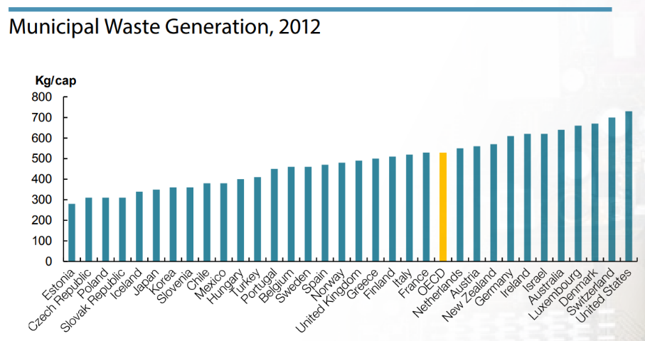
Validity: This source is purposed to explain what the OECD does and what it promotes for countries to use for their sustainability policies. It also lists the statistics to compare what countries do consume compared to what this organisation recommends that they should. This source is valid in explaining how sustainable average lifestyles in countries are compared to what they ideally should be (according to what this organisation recommends). I can use this information to compare with what the minimalism lifestyle promotes with what this organisation promotes other countries to apply to how they run things.
Reliability: The information provided to the organisation about these countries was most likely controlled by those countries. That means that they could alter the information given to give themselves a better reputation or they could not have the resources to properly calculate the correct information and therefore provide an inaccurate answer. These are all possible and could have happened to this source. However, this organisation involves may different countries aiming to promote sustainable economic growth policies for countries, so it should be too easy for false information to be used in their resources.
Skills development: Analysing data in different forms is a very useful skill to have. In this source I practiced the skill of analysing data from a graph of statistics. Being able to understand visual representations of data and make conclusions from it is very important because it visually shows the relationship between the data. An example of analysing the data in this format is in the chart above. It shows the list of countries above the OECD recommendations and shows the extent of the difference between the data. Comparing the data on the graph for the United States and the OECD recommendation shows a great distance between them rather than countries like France and the Netherlands where they are shown to be close to the OECD recommendation.
Key points:
- OECD is working for a cleaner world economy
- The principal aim of the OECD is to promote policies for sustainable economic growth and employment. “sustainable economic growth” = growth that balances economic, social and environmental considerations (OECD definition)
- OECD is developing policies that motivate and encourage waste prevention, minimisation and recycling. Promoting transition towards a circular economy to improve resource productivity and support green growth. (p26)
Knowledge development: I have learnt while analysing this source that there seems to be a constant pattern with the types of countries that appear above the list of the OECD recommendations. They seem to consistently be wealthier countries. This could be showing that there is a pattern between wealthier countries and their waste generation. If their waste generation is higher that means that how much they consume would also be higher. This links back to my research question in that I need be able to show that the regular consumerist lifestyle is very excessive, and this source does that in showing how much excess waste is generated from it.
Further research: Since there is a consistency of wealthier countries being above the line, there could be a link between countries that bring in more income and whether that increases their consumerist rates, which would be most likely. Doing further research into other sustainability guidelines and show how countries, especially countries that support the consumerist lifestyle, compare to those different recommendations to look for any consistency of information being shown. The recommendations for this source could be too strict or too lenient so looking at other recommendations as well will help build a better picture of what countries are consistently above or below.

DOCUMENTARY/FILMS – SOURCE ANALYSIS EXAMPLES:
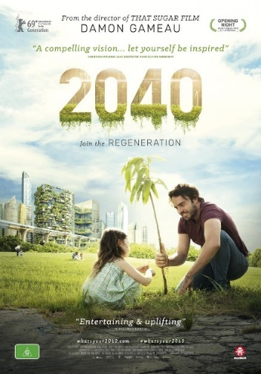
Source details: 2040 (2019), [video] Australia: Damon Gameau – Primary Source
Source type: Documentary/Film
Author background: Damon Gameau is an Australian actor who has started speaking up about environmental problems that need to be changed and hence he went and made this documentary to show that and find out more about it and what we can do. They aren’t a known expert in the topics addressed in the film, but he has gotten himself involved in it which has led to him finding other people to join him in the documentary who are experts. He would have more connections to people, being an actor, and that would give him an advantage of making it well known.
Validity: This source is very good for giving information about what things need to be changed and examples of how to change it, by exploring the things that exist now and how we can use them to build a more sustainable future. Some of these things work alongside minimalism principles so it is relevant for my research showing that these environmental healing actions being taken are linkable with minimalist actions. It goes into details of how these practices work and why they are better than other ‘normal’ practices. It also gives lots of information about how damaging current practices are in the world, to what scale they are damaging and showing the multiple things they are damaging. This is very valid information for developing the answer to the consumerist lifestyle aspect of my research question.
Reliability: This documentary included lots of interviews with people that have specific backgrounds in different things to understand what we’re doing wrong in different areas of life in environmental terms and what we should be doing or could do to fix it. This means that the information given is reliable because the information is from people who are experts in those areas, however, some of the things that they said that could have been biased since it was single experts for most of the fields that were discussed in the documentary. Something that one of those experts said could be their own opinion and other experts in the same field may disagree with them.
Skills development: In this documentary, I developed my skill of analysing sources with information in many different formats. This film had many ways of presenting its information. It used animations, graphs, visuals, interviews and text on the screen. Being able to understand the information being presenting through all these different formats was an essential skill to continue to develop as the information given continued to explain the things that were relevant for my research. It had some information that it would also begin to explain then come back to later and build on again, so being able to understand and order that in my analysis and notes was very important.
Knowledge development: I have built on my knowledge from this source some statistics about how much carbon we release into the atmosphere and about what time it began to change, the Industrial Revolution. It also spoke about equilibrium needed between us taking resources out of the environment and those being replaced in a balanced sense. An expert that was interviewed explained how damaging ploughing up the dirt constantly is for the atmosphere and the dirt. Currently (information from 2019) is more damaging than fossil fuels. This will help me discuss how the regular consumerist lifestyle causes these things that are damaging for the environment, and how minimalism helps to reduce these effects.
Key findings | Further research
Since the Industrial Revolution we have been over releasing the carbon in the world tipping off the balance. We need to take carbon and release carbon back into the world so that it stays balanced (keeps at equilibrium) but releasing too much or extracting too much can both be damaging. | Explore how much damage over releasing carbon causes and the link between carbon emissions and consumerism. This would be crucial for showing how some of the differences between a minimalist lifestyle and a regular consumerist lifestyle make a difference in their effect on the environment. This would then help show which one is a more environmentally sustainable lifestyle.
Carbon dioxide parts per million (PPM) has gone up by 40% since Industrial Revolution and that has caused increase in temperature. This increase in carbon dioxide in the air has made the oceans 30% more acidic. This impacts biodiversity. Increased temperature means more intense weather. | Look for other sources that support these statistics. This would be used to show how consumerism effects the environment which can then be contrasted with the minimalist lifestyle, if and how that would be different.
It is impossible to maintain using the resources that we are using in the quantity especially. We need to change for a sustainable future, using different resources, how much we consume and how we extract and use it. | Investigate further into how much we consume and what the factors are that we need to change specifically for a sustainable future. Also investigate further into how crucial resources are currently being used and treated.
DOCUMENTARY/FILM – SOURCE ANALYSIS EXAMPLES CONT…
Source details: Ruth Hessey, 2011, Waste Not [film] [online], www.wastenot.org.au, Australia: Total Environment Centre – Primary Source
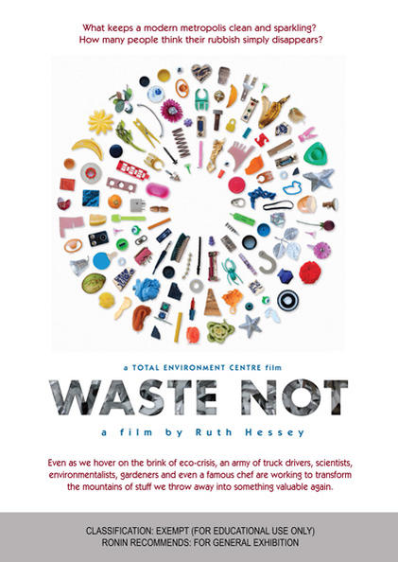
Source type: Documentary/Film
Validity: This source is useful for providing me information about how much consumption waste is created by Australians to include in my regular consumerist lifestyle part of my outcome, but to find information about how the minimalist lifestyle principles come in aren’t so easy to get from this source so that part wouldn’t be of much help to me. In the film, showing the better way to consume can be contrasted to more sustainable lifestyle and that can be compared with the minimalist lifestyle and the consumerist lifestyle.
Reliability: This source was created by Ruth Hessey, the communications director of the Total Environment Centre which is an organisation that assists Australian’s live a more environmentally aware and positive lifestyle. It gives information like how sustainable different electricity companies are depending on different aspects of them like their carbon emissions, their support of green energy, etc. This makes this source very reliable as it has been created by an organisation with a background of sustainability as well as many different people were interviewed in this film about things that they would know well themselves being in the positions that they are.
Knowledge development: I have discovered that the USA and Australia are the two top leading countries for the amount of domestic waste generated per person. In these countries high wastage and consumption is promoted as the way to personal growth. Bisso Revigo, Team Leader of Global Renewables and originally from Sudan, said that where he is from, they keep things and don’t throw anything away, but when he came to Sydney, Australia, he says that he sees things like TVs and clothes being thrown away every day. In this country everything is seen as very disposable so people overconsume and then throw it away without thinking about where it is going, how much effort and energy was put into it, and if it could be repurposed or passed on. Ben Kusto, Team Leader of Waste Services City of Sydney, said that a lot of people would be ignorant of what happens to their trash after it is taken from their garbage bins. They must subconsciously think that it just disappears. All the things that are thrown out into landfills are resources that we are running out of; we can’t keep digging into the ground to get things we need to reduce what we are taking out are start bringing the cycle back around and not making it finish at the landfill.
Key findings | Further research
James Bradfield Moody, Executive Director Development, CSIRO, Co Author of The Sixth Wave – For us to change to be more sustainable, we need more innovation, science and technology to do that. | Compare how effective lifestyle changes are and improved technology in the same regular consumerist cycle. Lifestyle change could possibly go under the innovation heading.
Andre Muhammad, Artist, Recycler – People don’t pass things on, they just throw it out instead. Buy things that they don’t need and then the next week throw it out. | This could be a common belief/principle that comes with consumerism; disposability. This would show the difference in the minimalist and consumerist lifestyle.

Capabilities development: I have developed my literacy skills by using primary sources to gather information. This helps the development of my research in having a variety of sources that I use to build knowledge and an answer for my research question. The first documentary, 2040, has interview with experts giving explanations of different practices around the world, along with statistics about the environmental effects of those and other current practices. That is valid for my research question and this information is crucial for answering it. This next documentary, Waste Not, has lots of statistics that I can use to build the big picture of a regular consumerist lifestyle to show how the minimalist lifestyle principles can reduce those statistics to a more sustainable level.

RESEARCH PAPERS – SOURCE ANALYSIS EXAMPLES:
Source details: Barton, Katherine M., 2015, Pomona Senior Theses, "Listening to the Quiet Revolution: The Implications of Voluntary Simplicity for a Sustainable Society", http://scholarship.claremont.edu/pomona_theses/125 - Secondary Source
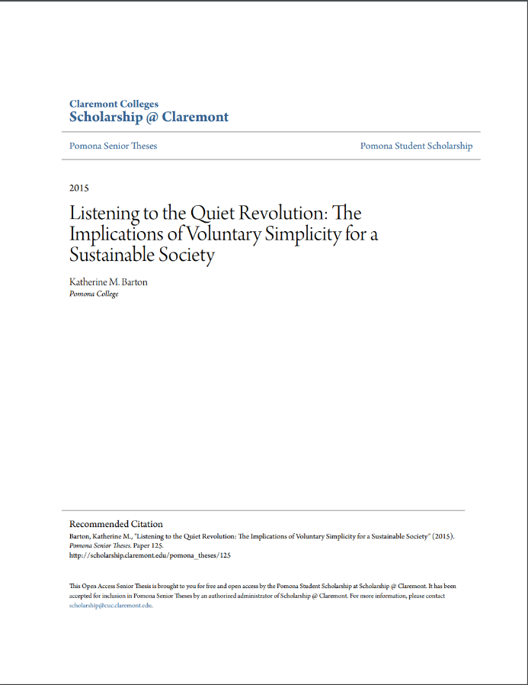
Validity: This source is very relevant to my question and has lots of information on the topic. It will be very useful for my gaining understanding and coming closer to answering my research question. It shows the connection between the minimalist lifestyle (or voluntary simplicity) and a sustainable society. This would assist in showing how minimalism is closer to being environmentally sustainable than a regular consumerist lifestyle.
Reliability: This source has many good sources to support every point and fact that they say in the thesis. It was read by Dr. Zayn Kassam (thesis advisor) and Dr. Richard Hazlett, so they would have checked that the information presented was good quality and accurate before it being published. Also, the author of the thesis was, Katherine Barton, a student at Pomona College working towards her Bachelor of Arts degree in the department of Environmental Analysis. She graduated in 2015, so the information that she would have gained from that course is very recent and would be very relevant today.
Skills development: Drawing connections between the minimalist lifestyle and environmental sustainability is a skill that I’ve been working on through this project. Through this source it was a source where I could really see that there is a connection between minimalism (or voluntary simplicity) and the aspects of it that link with ideal sustainable life choices that I have found in other sources. At the beginning of my research I was solely looking into how minimalism simply has sustainability principles incorporated in it and them as motivations to minimalism, but there is more to it than that when I started practicing this skill of drawing the connections between aspects of an ideal sustainable lifestyle and the minimalist lifestyle.
Key points: | Further research:
Voluntary simplicity movement – group of people reducing consumption for philosophical reasons.  Some people use voluntary simplicity just because it requires less effort. | Investigate to see if the philosophical reasons are relevant to the environment and an individual’s impact on it. Relevant reasons could be as follows: reducing environmental footprint, trying to move organisations to more sustainable productions, etc.
Voluntary simplicity term can be interpreted differently and used in a shallow way. | If there are many different definitions of voluntary simplicity, looking at other sources like research papers would most likely cover the different interpretations and have them in detail.
In the 1990s people started becoming worried about consumerism and between 1990 and 1996, 19% of Americans made a voluntary lifestyle change. | The state of the environment became a big concern in around the ‘90s when it became more well-known on the media, so that could be what the link is between concern about consumerism and environmentalism.
Voluntary simplicity holds a promise for a future sustainable society. | If that lifestyle really does hold that potential, that means that some of the factors of the voluntary simplicity lifestyle or minimalist lifestyle must be like an ideal sustainable lifestyle. That would help in seeing a connection between minimalism and it being more connected to environmental sustainability than the regular consumerist lifestyle.

Knowledge development: I have learnt that the minimalist lifestyle (voluntary simplicity) has been developing for a reasonable time. It hasn’t just begun in the past few years, but it has been going for a few decades at least. That is at least the time where it has been a big enough group for it to be noticed. People could have been living this lifestyle for a while before but where in such a small number that they weren’t noticed, and it wasn’t recorded of them practicing it. Also, the focused point of voluntary simplicity is the reduction of consumption. That is the main thing that is the difference between the regular consumerist lifestyle, where consumerism is a large part of it while the minimalist lifestyle puts in a large effort to reduce consumption.
Capabilities development: I have developed my literacy skills by using secondary sources to gather a lot more variety of information together in one place. In this source particularly it was useful for having information both about voluntary simplicity and sustainability. It showed the links between both and the different perspectives there are to voluntary simplicity. This wouldn’t be in a primary source; that would more likely just focus on one perspective on voluntary simplicity in detail, but this source investigates multiple which is very useful for my research development.
RESEARCH PAPERS – SOURCE ANALYSIS EXAMPLES CONT…
Source details: Elgin, D., Mitchell A., The Co-Evolution Quarterly, 1977, Voluntary Simplicity, http://www.duaneelgin.com/wp-content/uploads/2010/11/voluntary_simplicity.pdf - Secondary Source
Author background: Duane Elgin is an American author, speaker and media activist who has created books, videos and articles on the topics of sustainability, global trends, conscious evolution, media activism and the living universe. He has received a Bachelor of Arts from the College of Idaho in 1966, a Master of Business Administration from the Wharton School of the University of Pennsylvania in 1968, and a Master of Arts in economic history from the University of Pennsylvania in 1969.
Arnold Mitchell was a social scientist and consumer futurist who worked for SRI International, an American non-profit scientific research institute. Because of his background, and that he found voluntary simplicity an important lifestyle to investigate makes the thought that this lifestyle must have something in it that would be positive for the environment or at least be going in the right direction.
Validity: This source is very useful for the development of my research because it explains how voluntary simplicity can impact the movement to sustainable living and therefore, a healthy Earth. This very important for addressing how the minimalist lifestyle is linked to a more environmentally sustainable future. The more links shown with this, the more I will have to support that the minimalist lifestyle is better environmentally. It also shows a link between the consumerist lifestyle and major negative impacts on the environment which is something I also need to support that in part of my answer.
Reliability: This source was created in 1977 but the general idea of voluntary simplicity wouldn’t have drastically changed since that time. However, the impact level of voluntary simplicity could be very different now than it would have been back in the 1970s with overall consumption levels rising. The authors of this source have a great background in sustainability and consumerism which are very important fields to have experience in for this topic. From the evidence, this source is highly reliable as it would be unlikely for it to have any bias since a lot of it is shown to be based on facts they have provided.
Key points | Further research
Traces back to the counterculture (lifestyle with attitudes opposing the prevailing social norm) movement of the 1960s. | Look into the origins of minimalism and the causes of it to appear and develop.
Knowing about your environmental impact is a cause for people to turn to voluntary simplicity. | Look into the reasons that people convert to the minimalist lifestyle and see if there is a big connection with sustainability.
The reason it isn’t picking up as much speed is because people are lacking the realization and knowledge to. | But now more people are becoming aware of the state of the world’s environment and climate change so this information could have changed and could have a large impact on the minimalist movement.

Source details: Alexander, S., The Voluntary Simplicity Movement: Reimagining the Good Life Beyond Consumer Culture, 2011, https://ssrn.com/abstract=1970056 or http://dx.doi.org/10.2139/ssrn.1970056 - Secondary Source
Author background: Samuel Alexander is a lecturer and researcher at the University of Melbourne and teaches the course ‘Consumerism and the Growth Economy: Critical Interdisciplinary Perspectives.’ He also is the co-director of the Simplicity Institute a researcher at Melbourne’s Sustainable Society Institute. He has written many books on the subject with other people (e.g. Carbon Civilisation and the Energy Descent Future, Simple Living in History: Pioneers of the Deep Future). He also released a documentary in 2016 – A Simpler Way: Crisis as Opportunity, and runs a blog: www.simplicitycollective.com
Validity: This source is very valid in that it has a good explanation of what voluntary simplicity (or minimalism) is and the environmental factors related to it. This is very important for being able to explain what minimalism is in my answer and what it effects as a result of what it involves.
Reliability: This source is very reliable because it is written by someone who has a great background in the subject, has worked with other people on the topic and has a lot of great sources to support what he presents. It would be unlikely that any of the information in the source would be his own opinion because the information is explained through lots of evidence from other surveys, statistics and research studies.
Capabilities development: In sources, Voluntary Simplicity and The Voluntary Simplicity Movement: Reimagining the Good Life Beyond Consumer Culture, I have developed my literacy skills by finding information from different perspectives as these sources considering the environmental factors related to minimalism from the perspective of people with experience in consumerism and sustainability. They would be very experienced in the knowledge of both topics and use that to show the connects with a less consumerist lifestyle and how that relates to environmental sustainability.
Knowledge development: I gained a stronger understanding of the connection between consumerism and sustainability and how that can be applied to a regular consumerist lifestyle and a less consumerist lifestyle, the minimalist lifestyle. It also shows the environmental factors that are affected by both lifestyles but demonstrates which lifestyle would have the lesser negative effect.
Key points | Further research
Lifestyles that reduce consumption, like minimalism, will be essential to lead to a sustainable future. | Look into more sources that support this statement with more evidence behind the claim.
Unsustainable consumption and production have a major negative impact on the environment. | Look for statistics to support this statement.
BOOKS - SOURCE ANALYSIS EXAMPLES:
Source details: Tanya Ha, 2011, Greeniology 2020: Greener living today, and in the future – Secondary Source
Validity: This source is valid for me because it shows what things would have to happen in someone’s lifestyle to be more ecofriendly and can compare that to the minimalist lifestyle to see if similar things show up in both. This could help determine whether minimalism is a more ecofriendly lifestyle.
Reliability: This source isn’t created by a qualified expert in the knowledge of the field but by someone who would have a lot of experience in the area. As well as using her own knowledge, she uses other sources to support the points that she makes in her book, however, the opinions in this book are hers and could have some bias in them.
Key points:
Important values for a more sustainable future: | Compare with my minimalism knowledge:
A strong sense of responsibility (being intentional with things). | The minimalist lifestyle supports the value of being intentional with things like with purchases and uses of things (e.g. minimizing the number of things needed by finding things with multiple functions).
A high regard for simple living. | The minimalist lifestyle is an example of a simple living.
An intellectual interest in sustainability issues and a desire for smarter living habits. | One of the reasons for people to convert to a more minimalist lifestyle is because of sustainability reasons. They want to decrease their negative environmental impact or are trying to get a better understanding of the environment.

Actions needed for better sustainability: | Compare with my minimalism knowledge:
Clothing being something that we all buy is something that is very polluting in its production so buying less in this case is one way to reduce your environmental impact. | In minimalism reducing clothing items is something that would commonly happen because of the lifestyle. The first thing that you find when researching minimalism is minimizing your clothing consumption.
Make better use of material resources. | Minimalism does this in minimizing the things that we consume and therefore reducing the amount of material resources we produce and use then throw out.
Source details: IUCN, UNEP and WWF, 1991, Caring for the Earth: A strategy for sustainable living, Volume 5 – Secondary Source
Validity: This source is about the principles of sustainable living and goes into them in detail. This is very important for my research development in improving my understanding of sustainability. It also gives a strategy how to incorporate sustainable living into the world right now. It involves actions the government, organisations and consumers around the world should be doing. Most importantly for my research I need to focus on the consumers and their actions. It also gives a lot of information about the inequality of consumers and the environmental damage from the consumerist habits of people in different areas across the world. This is useful in understanding which lifestyles have a more negative environmental impact and why.
Actions needed for better sustainability: | Compare with my minimalism knowledge:
Everyone should be taking responsibility for their impacts on nature by conserving ecological processes and the diversity of nature and use any resource frugally and efficiently ensuring their use of renewable resources is sustainable. | Minimalism does this in minimizing consumption of resources. Using resources efficiently and frugally by having less of them and having ones with multiple purposes.
Acting locally (in small groups or individually) isn’t enough, we need to act globally (a majority). | Minimalism is a movement where the number of people involved is increasing. It wouldn’t have a big enough effect in small numbers so many people would need to adopt it for it to have an evident effect.

Relevant principles of sustainability: | Compare with my minimalism knowledge:
Conserve the Earth’s vitality and diversity (conserve life-support systems, conserve biodiversity, ensure that uses of renewable resources are sustainable). | Minimizing consumption and production prevents extra damage to the environment which helps to conserve the Earth’s vitality and diversity.
Minimize the depletion of non-renewable resources; keep within the Earth’s carrying capacity. | Minimizing consumption helps stay in the Earth’s capacity & reduces the amount of non-renewable resources being used.
Change personal attitudes and practices. | Minimalism is a change of lifestyle (practices) caused by a change of attitude.
RESEARCH ORGANISATION CHART:
Minimalist lifestyle |  | Sustainability | Consumerist lifestyle
Principles/values
Definitions
Misconceptions
What it can/does involve
What it leads to (long term/majority consequences)
Facts
History
What’s holding it back
Causes/Driving forces
Skills development:
During my research, I’ve used this chart to bring all my research notes together so that I can use them in an effective why when creating the outcome. This means that I can see the summary of the important information that I need from many sources, while keeping track which sources the information is from. This makes referencing a lot easier and less time consuming. This also means that I don’t need to look at the different notes from the many sources that I analysed and can simply look at them all together and see the different sources that support each other in their information.
This way of organising my notes also will help me in writing my outcome by having the comparison between the similarities of the minimalist lifestyle and the aspects of sustainability compared to the consumerist lifestyle and sustainability.
Capabilities development: Using this organisation chart demonstrates the creative and critical thinking capability I have focused on throughout this project. This chart helping me by improving time management, keeping notes organised and using a large range of sources to get the information that I need. Besides this chart, I also used another organisation method for the separate sources while analysing them so that I could easily find the information that I got from those sources and have a lot of information about the source with it in an ordered way. This source is shown on Page 1 under the heading ‘Source Sorting Structure.’
Reference list:
Alexander, S., The Voluntary Simplicity Movement: Reimagining the Good Life Beyond Consumer Culture, 2011, https://ssrn.com/abstract=1970056 or http://dx.doi.org/10.2139/ssrn.1970056
Alexander, S., Ussher, S., 2012, The Voluntary Simplicity Movement: A Multi-National Survey Analysis in Theoretical Context, http://simplicityinstitute.org/pub/The-Voluntary-Simplicity-Movement.pdf
Barton, K., "Listening to the Quiet Revolution: The Implications of Voluntary Simplicity for a Sustainable Society" (2015). Pomona Senior Theses. Paper 125., http://scholarship.claremont.edu/pomona_theses/125
Dietz, S., Neumayer, E., 2004, Genuine savings: a critical analysis of its policy-guiding value. International journal of environment and sustainable development, pp. 276-292, DOI: 10.1504/IJESD.2004.005076 http://eprints.lse.ac.uk/16699/
Elgin, D., Mitchell A., The Co-Evolution Quarterly, 1977, Voluntary Simplicity, http://www.duaneelgin.com/wp-content/uploads/2010/11/voluntary_simplicity.pdf
Gameau, D., 2019, 2040, [video] Australia
Geiger, S., Otto, S., Schrader, U., 2018, Mindfully Green and Healthy: An Indirect Path from Mindfulness to Ecological Behavior, https://doi.org/10.3389/fpsyg.2017.02306
Grooten, M. and Almond, R., WWF, 2018, Living Planet Report - 2018: Aiming Higher, Switzerland.
Ha, T., 2011, Greeniology 2020: Greener living today, and in the future
Hamilton, C., Denniss, R., 2005, Affluenza: When Too Much Is Never Enough [book]
Hessey, R., 2011, Waste Not [film] [online], www.wastenot.org.au, Total Environment Centre
IUCN, UNEP and WWF, 1991, Caring for the Earth: A strategy for sustainable living, Volume 5
Ivanova, D., Stadler, K., Steen-Olsen, K., Wood, R., Vita, G., Tukker, A., Hertwich, E., 2016, Environmental Impact Assessment of Household Consumption, https://doi.org/10.1111/jiec.12371
Karunungan, R., 2017, Climate Tracker, Minimalism Trend: Will It Save The Planet?, http://climatetracker.org/minimalism-trend-will-it-save-the-planet/
Kennedy, G., 2007, Ontology of Trash, An: The Disposable and Its Problematic Nature [book]
Klein, Naomi, 2014, This Changes Everything: Capitalism vs. The Climate, https://warwick.ac.uk/fac/arts/english/currentstudents/undergraduate/modules/fulllist/special/litenvironecol/syllabus19-20/naomi-klein-this-changes-everything-capitalism-vs-the-climate.pdf
Lesser, S., Roudabush, J., 2015, Minimalism in A Consumerist Society, https://nanopdf.com/download/research-paper-5afacf5bc311e_pdf
OECD, OECD Work On Environment, 2018, http://www.oecd.org/env/OECD-work-on-environment-2017-2018.pdf
Renner, M., 2004, State of World, Chapter 5 - Moving Towards a Less Consumptive Economy, www.greeneconomics.net/StateOfWorld-2004.pdf
Simply by Christine, 2019, Minimalism for Beginners [video]
Statista, 2019, Average family size in the US 1960-2018, https://www.statista.com/statistics/183657/average-size-of-a-family-in-the-us/
Stiglitz, J., Sen, A., Fitoussi, J., 2011, Report of the commission on the measurement of economic performance et social progress: Chapter 3 – Sustainable Development and Environment [online]
Wright, L., 2020, DW, Can a minimalist mindset help save the planet?, https://www.dw.com/en/can-a-minimalist-mindset-help-save-the-planet/a-51733322

