Research Project: Outcome

Question: To what extent and effect does instructional building, using Lego Education, benefit children aged 6-16 diagnosed with Autism Spectrum Disorder (ASD) during Lego Therapy sessions?

Overview
According to Ramalho et al., “Lego Therapy is a therapeutic model created in the United States by Daniel LeGoff, a neuropsychologist, to promote social skills in individuals with ASD”. However, the effectiveness of Lego Therapy is dependent on varying factors, such as the specific type of Lego used, different therapeutic methods and the age of the participant. Lego Therapy is a therapeutic method that was developed in 2004 and is currently being conducted in Adelaide with children diagnosed with ASD. Since Lego Therapy was introduced, further research has been undertaken to establish how it can be used more effectively to improve results. Today, new techniques, such as Lego Education have been created to strengthen the results of the therapy sessions.

What is Autism Spectrum Disorder (ASD)?
Autism Spectrum Disorder (ASD) is a neurodevelopment disorder that affects a child’s ability to maintain relationships, communicate and build motor skills. According to Professor Pammi Raghavendra, “nearly 40% of children and adolescents on the autism spectrum experience mental health issues such as social anxiety and difficulties with interactions, which has a significant effect on everyday participation, including attending school, meeting friends, and using public transport.” Children with ASD often lack social skills as playing with others can be particularly challenging for them. They often spend time playing by themselves or in parallel play. Common practices used to increase social skills in children with ASD include reading stories socially and playing games to practice skills such as winning, losing and turn-taking. Group activities are beneficial for providing opportunities for interaction and communication. This is used in Lego Therapy as children are placed into groups of three, promoting interactions with each other and associative play. Lego Therapy sessions can help children with ASD feel calm and relaxed as they are doing something they enjoy, know what to expect and what is expected of them.

What is Lego Therapy?
Lego Therapy was first created by Daniel LeGoff after he observed children with Autism develop a love for Lego. However, even before Dr LeGoff noticed this connection, two nursing students realised how Lego Therapy built social skills while observing children with autism who were working together in silence to help each other. According to the Indian Journal of Health and Wellbeing, “Lego therapy is a treatment of various disorders such as depression, childhood, children, children's fears, behaviour problems that stem from anxiety, enuresis, nail-biting, lying, each of them has a specific role, but the most important role is for aggression, hyperactivity, attention deficit, etc.” Therapy sessions can involve up to 24 weeks of 60 to 90 minutes sessions helping children with Autism develop their social skills. Individual progression can occur weekly by moving to more difficult and challenging Lego sets, which involve working in groups of three collaboratively. While children play with Lego, extra skills they can develop include the promotion of fine motor skills, teamwork, increased creativity, problem-solving, and persistence. Lego Therapy is a therapeutic method that involves the instructional building of Lego sets to improve social skills in children with Autism throughout weekly sessions. Therapy sessions are highly structured and each child plays a specific role within a small group scenario.

What is Lego Education?
Lego Education is a more challenging form of instructional building, involving Lego bricks and digital tools to create machines that can move. Through Lego Education, children follow the same instructional steps used with Lego, however, they also have the opportunity to engage in creative robotics and programming. The table below is used to provide clarification between standard Lego bricks used in therapy sessions and Lego Education.
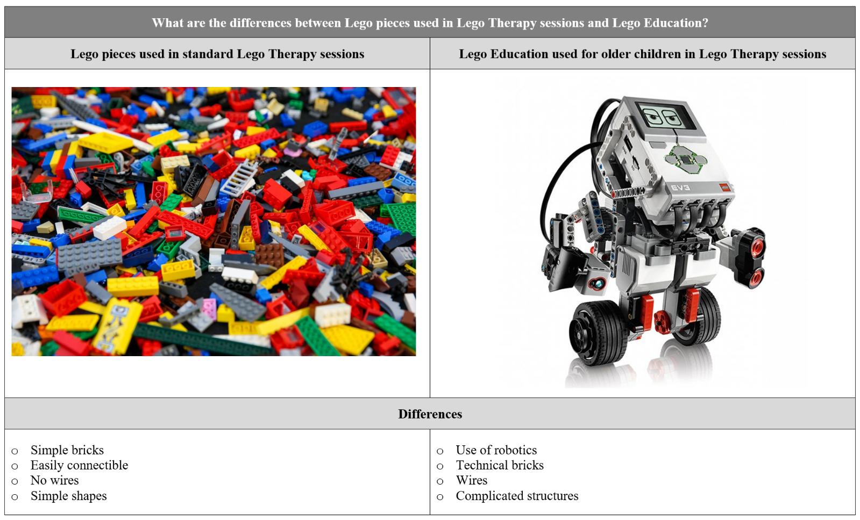

What is Instructional Building and how does it help during Lego Therapy Sessions?
Instructional building is when a set of instructions is followed from start to finish, sequentially to complete a pre-designed Lego object which develops problem-solving skills and critical thinking. Lego can also be built creatively, using imagination, which develops fine motor skills and creativity. Instructional building is incorporated into Lego Therapy sessions to support the development of socials skills for children with ASD. In Lego Therapy sessions, children are separated into groups of three, with a social division of labour where each person is given a specific role to complete the Lego set by following instructions. The first child is instructed with the role of an ‘engineer,’ who describes instructions and bricks to the other participants. The second is a ‘supplier,’ who locates bricks for each step of the instructions. The final participant is the ‘builder,’ who connects the bricks provided to complete the Lego set. Instructional building is effective as when participants are separated into groups of three, they have a shared experience through collaboration and interaction, further developing their engagement and communication skills. Another advantage of using instructional building is it allows the children to switch roles, so their interest is kept while allowing them to achieve different skills. Participants must follow a set of rules to optimise Lego Therapy sessions and to assist with behavioural conduct and social conventions. To aid this, an adult will accompany the group to remind the children if they acting negatively or require assistance. Furthermore, therapists, such as speech, occupational and behavioural, collaborate to maximise the effectiveness of the therapeutic method. Overall, the effect of using the instructional building is that it allows children to develop their socials skills, along with other skills, through collaboration, primarily through the initial factor that Lego builds on a child’s natural interest, motivating them to participate.

What effect does Lego Education have in Lego Therapy sessions?
To improve and enhance Lego Therapy sessions, a Flinders University team of professors are currently researching the benefits of using Lego Education, utilising advanced Lego bricks to build robots. Group activities become more challenging and not only do they provide new ways to improve social skills, but they also sharpen scientific knowledge, curiosity and build engineering minds. Students develop theories, solve problems, develop theories, draw conclusions and communicate solutions. Lego Education also creates the opportunity for children to collaborate, as they build these complex structures while improving their storytelling. In speaking of the future of Lego Therapy, Professor Raghavendra from Flinders University states that “despite promising findings with younger children, the use of Lego Therapy to improve anxiety and social skills for teenagers with autism has not yet been investigated extensively.” Further research is needed to enhance the effectiveness of Lego Education with teenagers. Overall, the use of Lego Education in Lego Therapy is important as it gives children with autism the opportunity to develop problem-solving skills through their hands-on experiences with more complex Lego.

What is the age range of 6-16 appropriate for Lego Therapy sessions?
For over 15 years, Lego Therapy sessions have been conducted using a varying age range of children, such as 7-15 , 5-16 , 6-16 , 6-11 , 5-16, and 6-16 . Calculating the average age bracket, the average minimum age is 5.8, while the maximum age is 15, however, Lego Education seeks to provide challenges for all year levels, such as early primary, primary and secondary which aligns with the age bracket for Lego Therapy sessions. Lego Therapy is targeted at children to build social communication skills, which are a vital role in children’s ability to form functional peer relationships, social learning and reduce isolation. Essentially, this is preparing children for real-life challenges. As the children work with each other, they are more likely to interact verbally with each other, become less aloof and show improvement in social skills. Lego Therapy provides promising results in children as they learn to play co-operatively with a toy that they are likely to enjoy. Therapy sessions would be less effective with adults involved, as Lego generally does not appeal to them as much as it does to children. Overall, even though age range may vary, the important factor is that Lego Education is being used to in Lego Therapy sessions to help children with autism improve their social skills early so they are prepared to build social relationships in the future.

To what extent and effect does Lego Therapy provide for children diagnosed with Autism Spectrum Disorder?
Lego Therapy sessions aim to build and strengthen children’s skills required to initiate, build and strengthen their friendships. This is accomplished through the method of instructional building, using roles of a supplier, engineer and builder. Emma Connell, a Speech Pathologist at Autism SA says simply, “it’s about providing individuals with the tools to make friends.” When children engage in Lego Therapy sessions, their social skills are developed, in addition to a variety of other skills. These additional skills include social behaviour, language and communication, shared attention, dialogue, exchange, planning, motor skills, reasoning, collaboration, turn-taking, cooperation, sharing, eye contact, creativity and critical thinking. Lego is a popular toy which children with ASD enjoy playing with. Hence, the effectiveness of the therapy sessions is increased as children are motivated and engaged in therapy sessions, making them more enjoyable to participate in. According to Sally Lindsay, “Lego Therapy has the potential to improve social and communication skills and ASD related behaviours.”

While Lego Therapy still needs to be further developed, the results shown over the past 16 years show that Lego Therapy is a viable solution to assisting children with ASD. As seen in Figures 1 through to 5, Lego Therapy shows improvements in each measuring scale compared to the Social Use of Language Program (SULP), which teaches children social skills such as eye contact and listening. These measuring scales were used to determine how effective therapy sessions are, by comparing where a child original score was to their result and development. In each graph, results of Lego Therapy are promising as positive changes were shown from the child’s original scores, showing that the therapy sessions were effective. These results conclude that Lego Therapy is a viable therapeutic method that can be implanted in sessions for children with ASD. Overall, Lego Therapy involves collaborative Lego play for school-aged children in school and clinical environments to improve social skills in children with ASD.
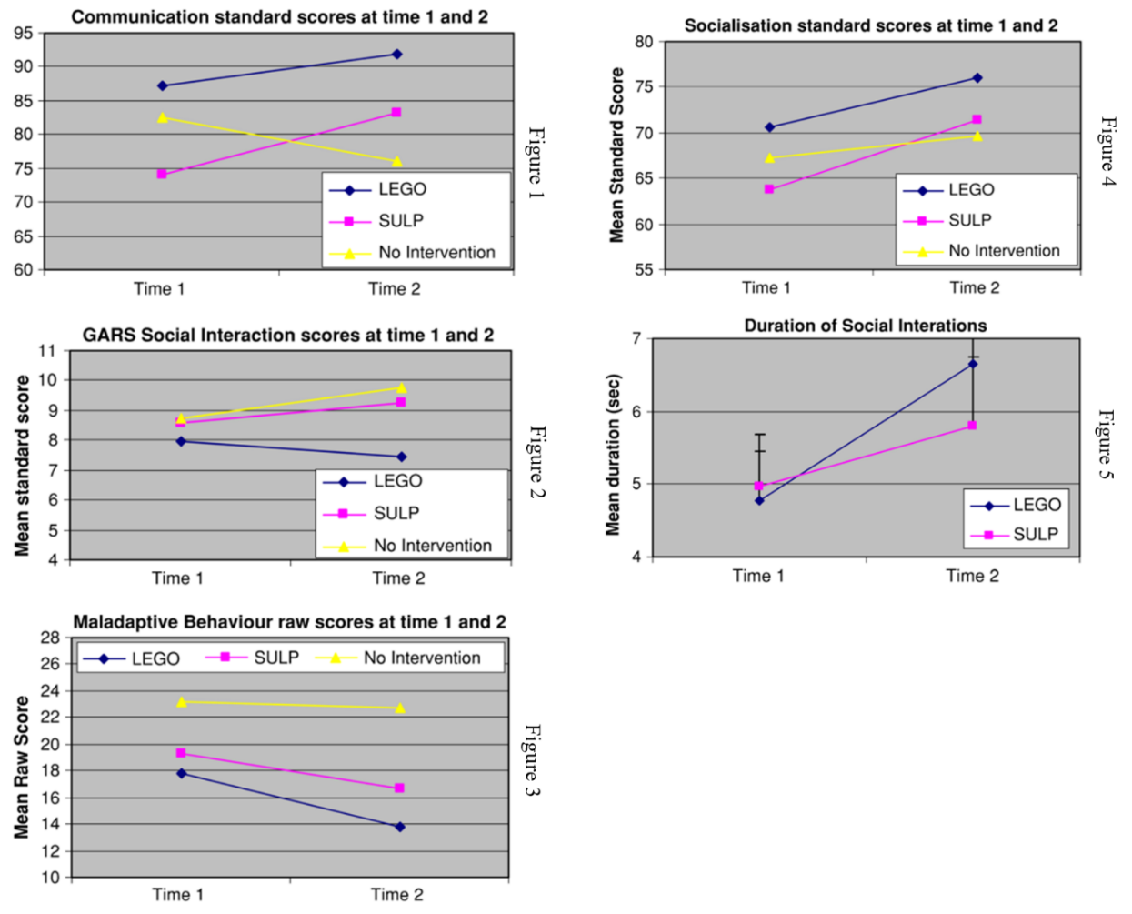

Figures 1, 2, 3, 4 and 5

Conclusion
Autism Spectrum Disorder is a condition that affects how a person thinks, feels, interacts with others, and experiences their environment. Interactions are vital to an individual’s mental health, as when isolated from others, children are more at risk of experiencing mental health issues. Lego Therapy aims to provide children with the opportunity to build social skills, which allows themselves to build and maintain meaningful friendships and engage with the community. Lego Education benefits children with ASD by building skills through more advanced instructional building and it allows children to communicate, collaborate and build on their critical thinking and is more advantageous than just using normal Lego bricks. Lego Therapy is ideal for children aged 6-16 as skills are developed to prepare them for adulthood. Factors such as the type of Lego are important, as Lego Education may be too advanced for younger children, so the therapy sessions would be ineffective. Moving onto more challenging tasks as skills are developed is the main principle of Lego Therapy. This enables further enhancement of social skills and improves the effectiveness as children age. In summary, Lego Therapy is a method used to aid children with ASD, aged 6-16, in stimulating their verbal and non-verbal communication behaviour, problem-solving and attention skills and, most importantly, social interactions.

Word Count: 1816

Interviews:
Connell, Emma. 2020. Interviewed by William Bailye, 21 April 2020.
Penna, Nancy. 2020. Interviewed by William Bailye, 22 April 2020.
Hobbs, David. 2020. Interviewed by William Bailye, 19 March 2020.
King, Kate. 2020. Interviewed by William Bailye, 28 April 2020.

Videos:
Bryony Rust. 2019. What is Lego Therapy? https: //www .youtube.com/watch?v=qrl9XKKouos (accessed 10 April)
ABC Australia. 2019. How Lego Therapy can be a massive win for kids with Autism. https://www.youtube.com/ watch?v=AyfVCkBBaso (accessed 20 March)
Lego Club IW. Lego Therapy- Dr Gina Owens. https://www.youtube.com/watch?v=1SVqfOSSzjs&feature=emb_logo (accessed 5 April)
Michelli Freitas. Entravista com Daniel LeGoff. https://bricks-for-autism.co.uk/about-lego-therapy/ (accessed 15 March)
7 News. 2019. Successful Adelaide Autism Lego Therapy Trial Set to Expand. https://www.youtube .com/watch?v=i6G-OE7ADoQ (accessed March 2)

Websites:
Rudy, Lisa. 2019. Lego Therapy for Children with Autism. Very Well Health. https://www.verywellhealth.com/lego-therapy-for-children-with-autism-4169865 (accessed 13 March)
Autism SA. 2019. Lego Club. Autism SA. https://www. autismsa.org.au/Media/Default/MarComm/Lego%20Club% 20Flyer %202019 .pdf (accessed 27 January)
Lego. 2020. Lego Education. Lego. https://education .lego.com/en-au (accessed 17 January)
Packham, Amy. 2016, Lego-Based Therapy: How Colourful Bricks Are Helping Kids with Autism Improve Their Social Skills, HUFFPOST. https://www.huffingtonpost.co.uk/entry/lego-based-therapy-children-with-autism-social-skills_uk _5721efb9e4b06bf544e15ddf (accessed 16 January

Watts, Sarah. 2019. Lego Therapy Builds Confidence in Patients with MS and Autism. Brain and Life. https://www.brainandlife.org/articles/lego-therapy-builds-confidence-in-patients-with-ms-and-autism/ (accessed 20 March)
Milic, Sophie 2019. LEGO® could provide building blocks to better mental health for autistic teenagers. Flinders University. https://blogs.flinders.edu.au/caring-futures-institute/2019 /12/ 20/lego-could-provide-building-blocks-to-better-mental-health -for-autistic-teenagers/ (accessed 24 January)
Anglicare SA. 2019. Lego builds new skills for children with Autism. Anglicare SA. https://anglicaresa.com .au /lego-builds-new-skills-for-children-with-autism/ (accessed 19 March)
Meixner, Sophie. 2019. How Lego Therapy can be a massive win for kids with Autism and their families. ABC News. https://www.abc.net.au/news/2019-08-04/lego-the r apy-helps-build-skills-for-kids-with-autism/11337688 (accessed 20 March)
Bricks for Autism. 2020. About Lego Therapy. Bricks for Autism. https://bricks-for-autism.co.uk/about-lego-ther ap y/ (accessed 15 March)
Lego Education. 2020. Build Student’s Skills for any Challenge. Lego Education. https://education. lego.com /en-au/secondary/intro (accessed 18 May).
Raising Children. 2018. Lego Therapy. Raising Children. https://raisingchildren.net .au/autism/ ther apies-guide/lego-therapy (accessed 17 January)
Autism Spectrum. 2020. What is Autism? https://www.autismspectrum.org.au/about-autism/what-is-autism (accessed 20 January)

Journals:
Amy, Altman. Janeen, Esber. 1995. Lego Therapy. Journal of Psychosocial Nursing and Mental Health Services. (accessed 7 March)
Rahnama, Fatemeh. Hamedi, Maryam. Sahraei, Fatemeh. Parto, Effat. 2014. Effectiveness of Play Therapy (Lego Therapy) on Behaviour Problems in Children. Indian Journal of Health and Wellbeing. (accessed 24 March)
Varley, Danielle. Wright, Barry. Cooper, Cindy. Marshall, David. Biggs, Katie. Ali, Shehzad. Chater, Tim. Coates, Elizabeth. Gilbody, Simon. Gomez de la Cuesta, Gina. Kingsley, Ellen. Le Couter, Ann. McKelvey, Anne. Shepherd, Neil. Teare, Dawn. 2019. Investigating Social Competence and Isolation in children with Autism taking

in Lego-based therapy clubs in School Environments. BMJ Open. (accessed 28 March)
Peckett, Helen. MacCallum, Fiona. Knibbs, Jacky. 2016. Maternal Experience of Lego Therapy in families with children with autism spectrum conditions; What is the impact on family relationships? Autism. (accessed 2 April)
LeGoff, Daniel. 2004. Use of Lego as a Therapeutic Medium for Improving Social Competence. Journal of Autism and Developmental Disorders. (accessed 11 April)
Lindsay, Sally. Hounsell, Kara. Cassiani, Celia. 2016. A Scoping Review of the Role of Lego Therapy for Improving Inclusion and Social Skills among Children and Youth with Autism. Disability and Health Journal. (accessed 4 April)
Owens, Gina. Granader, Yael. Humphrey, Ayla. Baron-Cohen, Simon. 2008. Lego Therapy and the Social Use of Language Programme: An Evaluation of Two Social Skills

Interventions for Children with High Functioning Autism and Asperger Syndrome. Springer Science & Business Media. (accessed 27 March)
Ramalho, Naiade Cristina Pereira. Sarmento, Stella Maria de Sa. 2017. Lego Therapy is an Intervention in Autism Spectrum Disorders: An Integrative Literature Review. REVISTA CEFAC. (accessed 2 March)
Huskins, Bibi. Palman, Annamiek. Lourens, Tino. 2014. Improving Collaborative Play Between Children with Autism Spectrum Disorders and Their Siblings: The Effectiveness of a Robot-Mediated Intervention Based on Lego® Therapy. Springer. (accessed 13 March)
Andras, Miranda. 2012. The value of LEGO® Therapy in promoting social interaction in primary-aged children with autism. Bild. (accessed 15 April)
Brett, Elinor. 2013. Lego Therapy: Developing social competence in children with Asperger syndrome through collaborative Lego play. Exeter. (accessed 22 March)

Ramalho, Naiade Cristina Pereira. Sarmento, Stella Maria de Sa. 2017. Lego Therapy is an Intervention in Autism Spectrum Disorders: An Integrative Literature Review. REVISTA CEFAC. (accessed 2 March)
LeGoff, Daniel. 2004. Use of Lego as a Therapeutic Medium for Improving Social Competence. Journal of Autism and Developmental Disorders. (accessed 11 April)
Penna, Nancy. 2020. Interviewed by William Bailye, 22 April 2020.
Milic, Sophie 2019. LEGO® could provide building blocks to better mental health for autistic teenagers. Flinders University. https://blogs.flinders.edu.au/caring-futures-inst itu te/2019/12/20/lego-could-provide-building-blocks-to-better-m ental-health-for-autistic-teenagers/ (accessed 11 March)
LeGoff, Daniel. 2004. Use of Lego as a Therapeutic Medium for Improving Social Competence. Journal of Autism and Developmental Disorders. (accessed 11 April)
Ramalho, Naiade Cristina Pereira. Sarmento, Stella Maria de Sa. 2017. Lego Therapy is an Intervention in Autism Spectrum Disorders: An Integrative Literature Review. REVISTA CEFAC. (accessed 2 March)
Milic, Sophie 2019. LEGO® could provide building blocks to better mental health for autistic teenagers. Flinders University. https://blogs.flinders.edu.au/caring-futures-inst itu te/2019/12/20/lego-could-provide-building-blocks-to-better-m ental-health-for-autistic-teenagers/ (accessed 11 March)
Connell, Emma. 2020. Interviewed by William Bailye, 21 April 2020.
Lego Club IW. Lego Therapy- Dr Gina Owens. https://www.youtube.com/watch?v=1SVqfOSSzjs&feature=emb_logo (accessed 5 April)
Amy, Altman. Janeen, Esber. 1995. Lego Therapy. Journal of Psychosocial Nursing and Mental Health Services. (accessed 7 March)
Rahnama, Fatemeh. Hamedi, Maryam. Sahraei, Fatemeh. Parto, Effat. 2014. Effectiveness of Play Therapy (Lego Therapy) on Behaviour Problems in Children. Indian Journal of Health and Wellbeing. (accessed 24 March)
Ramalho, Naiade Cristina Pereira. Sarmento, Stella Maria de Sa. 2017. Lego Therapy is an Intervention in Autism Spectrum Disorders: An Integrative Literature Review. REVISTA CEFAC. (accessed 2 March)
Scots College. 2020. How can playing with Lego benefit your son's education. Scots College. https://www.tsc.nsw.edu.au/tscnews/eight-educational-benefits-of-playing-with-lego (accessed 10 May)
Lego Education. 2020. Build Student’s Skills for any Challenge. Lego Education. https://education. lego.com /en-au/secondary/intro (accessed 18 May).
LeGoff, Daniel. 2004. Use of Lego as a Therapeutic Medium for Improving Social Competence. Journal of Autism and Developmental Disorders. (accessed 11 April)
Scots College. 2020. How can playing with Lego benefit your son's education. Scots College. https://www.tsc.nsw .edu.au /tscnews/eight-educational-benefits-of-playing-with-lego (accessed 10 May)
Peckett, Helen. MacCallum, Fiona. Knibbs, Jacky. 2016. Maternal Experience of Lego Therapy in families with children with autism spectrum conditions; What is the impact on family relationships? Autism. (accessed 2 April)
Lindsay, Sally. Hounsell, Kara. Cassiani, Celia. 2016. A Scoping Review of the Role of Lego Therapy for Improving Inclusion and Social Skills among Children and Youth with Autism. Disability and Health Journal. (accessed 4 April)
Ramalho, Naiade Cristina Pereira. Sarmento, Stella Maria de Sa. 2017. Lego Therapy is an Intervention in Autism Spectrum Disorders: An Integrative Literature Review. REVISTA CEFAC. (accessed 2 March)
Rudy, Lisa. 2019. Lego Therapy for Children with Autism. Very Well Health. https://www.verywellhealth.com/lego-therapy-for-children-with-autism-4169865 (accessed 13 March)
LeGoff, Daniel. 2004. Use of Lego as a Therapeutic Medium for Improving Social Competence. Journal of Autism and Developmental Disorders. (accessed 11 April)
Peckett, Helen. MacCallum, Fiona. Knibbs, Jacky. 2016. Maternal Experience of Lego Therapy in families with children with autism spectrum conditions; What is the impact on family relationships? Autism. (accessed 2 April)
Rudy, Lisa. 2019. Lego Therapy for Children with Autism. Very Well Health. https://www.verywellhealth.com/lego-therapy-for-children-with-autism-4169865 (accessed 13 March)
Lindsay, Sally. Hounsell, Kara. Cassiani, Celia. 2016. A Scoping Review of the Role of Lego Therapy for Improving Inclusion and Social Skills among Children and Youth with Autism. Disability and Health Journal. (accessed 4 April)
Milic, Sophie 2019. LEGO® could provide building blocks to better mental health for autistic teenagers. Flinders University. https://blogs.flinders.edu.au/caring-futures-inst itu te/2019/12/20/lego-could-provide-building-blocks-to-better-m ental-health-for-autistic-teenagers/ (accessed 11 March)
King, Kate. 2020. Interviewed by William Bailye, 28 April 2020.
Lego Education. 2020. Build Student’s Skills for any Challenge. Lego Education. https://education. lego.com /en-au/secondary/intro (accessed 18 May
Rudy, Lisa. 2019. Lego Therapy for Children with Autism. Very Well Health. https://www.verywellhealth.com/lego-therapy-for-children-with-autism-4169865 (accessed 13 March)
Varley, Danielle. Wright, Barry. Cooper, Cindy. Marshall, David. Biggs, Katie. Ali, Shehzad. Chater, Tim. Coates, Elizabeth. Gilbody, Simon. Gomez de la Cuesta, Gina. Kingsley, Ellen. Le Couter, Ann. McKelvey, Anne. Shepherd, Neil. Teare, Dawn. 2019. Investigating Social Competence and Isolation in children with Autism taking in Lego-based therapy clubs in School Environments. BMJ Open. (accessed 28 March)
Peckett, Helen. MacCallum, Fiona. Knibbs, Jacky. 2016. Maternal Experience of Lego Therapy in families with children with autism spectrum conditions; What is the impact on family relationships? Autism. (accessed 2 April)
Ramalho, Naiade Cristina Pereira. Sarmento, Stella Maria de Sa. 2017. Lego Therapy is an Intervention in Autism Spectrum Disorders: An Integrative Literature Review. REVISTA CEFAC. (accessed 2 March)
Owens, Gina. Granader, Yael. Humphrey, Ayla. Baron-Cohen, Simon. 2008. Lego Therapy and the Social Use of Language Programme: An Evaluation of Two Social Skills Interventions for Children with High Functioning Autism and Asperger Syndrome. Springer Science & Business Media. (accessed 27 March)
Lindsay, Sally. Hounsell, Kara. Cassiani, Celia. 2016. A Scoping Review of the Role of Lego Therapy for Improving Inclusion and Social Skills among Children and Youth with Autism. Disability and Health Journal. (accessed 4 April)
LeGoff, Daniel. 2004. Use of Lego as a Therapeutic Medium for Improving Social Competence. Journal of Autism and Developmental Disorders. (accessed 11 April)
Owens, Gina. Granader, Yael. Humphrey, Ayla. Baron-Cohen, Simon. 2008. Lego Therapy and the Social Use of Language Programme: An Evaluation of Two Social Skills Interventions for Children with High Functioning Autism and Asperger Syndrome. Springer Science & Business Media. (accessed 27 March)
Watts, Sarah. 2019. Lego Therapy Builds Confidence in Patients with MS and Autism. Brain and Life. https://www.brainandlife.org/articles/lego-therapy-builds-confidence-in-patients-with-ms-and-autism/ (accessed 20 March)
Bryony Rust. 2019. What is Lego Therapy? https: //www .youtube.com/watch?v=qrl9XKKouos (accessed 10 April)
Lego Club IW. Lego Therapy- Dr Gina Owens. https://www.youtube.com/watch?v=1SVqfOSSzjs&feature=emb_logo (accessed 5 April)
Connell, Emma. 2020. Interviewed by William Bailye, 21 April 2020.
Lindsay, Sally. Hounsell, Kara. Cassiani, Celia. 2016. A Scoping Review of the Role of Lego Therapy for Improving Inclusion and Social Skills among Children and Youth with Autism. Disability and Health Journal. (accessed 4 April)
ABC Australia. 2019. How Lego Therapy can be a massive win for kids with Autism. https://www.youtube.com/ watch?v=AyfVCkBBaso (accessed 20 March)
Ramalho, Naiade Cristina Pereira. Sarmento, Stella Maria de Sa. 2017. Lego Therapy is an Intervention in Autism Spectrum Disorders: An Integrative Literature Review. REVISTA CEFAC. (accessed 2 March)
7 News. 2019. Successful Adelaide Autism Lego Therapy Trial Set to Expand. https://www.youtube .com/watch?v=i6G-OE7ADoQ (accessed March 2)
Milic, Sophie 2019. LEGO® could provide building blocks to better mental health for autistic teenagers. Flinders University. https://blogs.flinders.edu.au/caring-futures-inst itu te/2019/12/20/lego-could-provide-building-blocks-to-better-m ental-health-for-autistic-teenagers/ (accessed 11 March)
Lindsay, Sally. Hounsell, Kara. Cassiani, Celia. 2016. A Scoping Review of the Role of Lego Therapy for Improving Inclusion and Social Skills among Children and Youth with Autism. Disability and Health Journal. (accessed 4 April)
LeGoff, Daniel. 2004. Use of Lego as a Therapeutic Medium for Improving Social Competence. Journal of Autism and Developmental Disorders. (accessed 11 April)
Lego Education. 2020. Build Student’s Skills for any Challenge. Lego Education. https://education. lego.com /en-au/secondary/intro (accessed 18 May).
Lindsay, Sally. Hounsell, Kara. Cassiani, Celia. 2016. A Scoping Review of the Role of Lego Therapy for Improving Inclusion and Social Skills among Children and Youth with Autism. Disability and Health Journal. (accessed 4 April)
Milic, Sophie 2019. LEGO® could provide building blocks to better mental health for autistic teenagers. Flinders University. https://blogs.flinders.edu.au/caring-futures-inst itu te/2019/12/20/lego-could-provide-building-blocks-to-better-m ental-health-for-autistic-teenagers/ (accessed 11 March)
Owens, Gina. Granader, Yael. Humphrey, Ayla. Baron-Cohen, Simon. 2008. Lego Therapy and the Social Use of Language Programme: An Evaluation of Two Social Skills Interventions for Children with High Functioning Autism and Asperger Syndrome. Springer Science & Business Media. (accessed 27 March)
Autism Spectrum. 2020. What is Autism? https://www.autismspectrum.org.au/about-autism/what-is-autism (accessed 20 January)
Connell, Emma. 2020. Interviewed by William Bailye, 21 April 2020.
Brett, Elinor. 2013. Lego Therapy: Developing social competence in children with Asperger syndrome through collaborative Lego play. Exeter. (accessed 22 March)
Connell, Emma. 2020. Interviewed by William Bailye, 21 April 2020.
Lego Education. 2020. Build Student’s Skills for any Challenge. Lego Education. https://education. lego.com /en-au/secondary/intro (accessed 18 May).
Hobbs, David. 2020. Interviewed by William Bailye, 19 March 2020.

