Summary of Research Question
The question which I investigated during research project was titled, what effect does quantum computing have on computing applications, and why? I found quantum computers have not caused many new computer applications but have mostly expanded the already existing applications to a new complexity. The reason for this expansion in complexity is due to quantum computers amazing superposition state, which causes the qubits to be a one and a zero at the same time allowing for a large amount of data to be processed at the same time. The research processes which I used to find information were mainly going to libraries and reading and finding articles and websites related to my topic. I also found scientific researchers in the field of quantum computing and gained contact with them to find additional credible information. My reason for choosing this topic was because of my interests in electronics and physics.
150 words

E1

Internet searching:
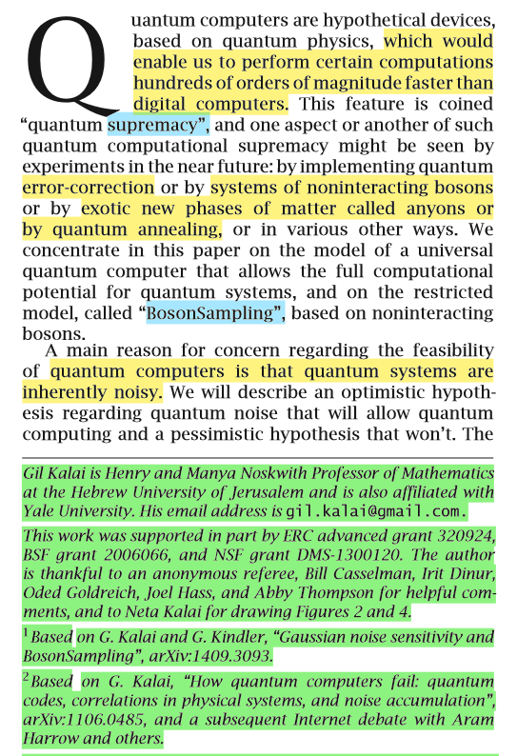
An advantageous process which I undertook early in my research was finding out more about my topic generally through internet searches. This included breaking up my topic and using different search phrases and using searching techniques like quotes. Initial internet searches consisted of question like, “What are quantum computers, and to find the meaning of complex scientific words such as, “quantum supremacy definition”. Later in my research, I could use internet searching to find very useful sources, an example of this was, “Quantum computer companies”, which resulted in finding sources from quantum computing businesses ,, which I found very useful for answering my question. often these sources had very meritorious authors. One of the challenges with this process was the need to filter out a lot of the sources which were Inappropriate to my topic or not reliable. Although this was rather overwhelming at times, this process was still very useful as I gained many great sources which outweighed the inadequate ones.

Annotation
Another helpful process which I undertook throughout my research project was annotating my sources. I did this digitally, downloading each source, and then highlighting key findings, and writing notes about the reliability, as is shown in Figure 1. This was a useful process to assist me in answering the question, as when I looked at a source, I could instantly pick out the important parts, and could see any bias or important terminology. The weakness with this process was to get the key information, I had to open the sources, and this meant I found it difficult to find any cross references. Another process which would have enhanced the process of annotating would have been to record all the key findings within a separate document, as I then could have compared the information a lot more proficiently. This process was useful, albeit limited, however I am still glad I undertook this process, as it certainly helped me to understand the topic, and to efficiently write my outcome.
Figure 1

Watching Videos
Another process which I undertook while researching was watching online videos. These consisted of either videos of interviews, talks about the technology or educational videos. The best example of this was an educational video entitled Quantum computers – fully explained! , which I watched multiple times. The video not only auditorily explained the information very clearly, but also matched the information with visual animations. This helped me to answer the research question, as I gained a better grasp of the research topic. The only weakness to this process of watching videos was it took a lot of time to watch the video, and I could not annotate like I did in a written source. I overcame this challenge by writing down the time when there was useful information displayed, and then I could quickly refer to that time to re-analyse the information. I also took notes during watching the video, which helped me to stay focused, and filter out the valid information.

E2

Separation of research question
An initial challenge I had when starting to research my topic was the sense of being overwhelmed by information and couldn’t understand any of it. To overcome this challenge, I decided to split up my research into separate areas, and work on them separately, as this would provide me with the opportunity to compare the sections and come to conclusions based upon different areas. This decision was good, as it led to me understanding my overall question a lot better, since I had to evaluate what section my information was connected to. This decision did have a negative impact, since it meant I wasn’t researching the exact topic, so I had to check the validity of the sources with the research question to make sure they were still useful. This decision helped me answer my research question, as I could cover the question more thoroughly in separate parts, than I would have otherwise if I had kept it together, focussing on different angles, and then joining each part to fully answer the question.

Discontinuing pursuit of interviewees
During my early research stages, I tried to interview some quantum physicists over email, but most of them did not reply. I had two options, either I could continue to email the physicists, or I could leave the interview, and just use the information which I had already collected, including sources which one of my interviewee’s had emailed me. I decided to discontinue emailing the interviewees, and just used the questions which I had created to do further research into my topic. Looking back, I think this decision was not the most beneficial to answering the question, since I couldn’t get answers to my specific question, which would have resulted in a clearer understanding of the topic. I think the choice which I made was socially considerate, since the home country of my interviewee’s was in a state of crisis from COVID 19. This decision led to my outcome having fewer primary sources, as I couldn’t get the personal view on my question which an interview would have given, thus weakening the validity of my research outcome.

Overcoming conflicting information
During the writing of my outcome, I came across minor differences of opinions between sources, and this caused some disruption to the flow of the question. To overcome this, I had to decide which source was the most reliable, and I did this by reviewing the sections which I had written during my collection of sources, additionally studying the language features and validity. These decisions added merit to my answer, as I strengthened the result of my research by analysing further, but since I am not a professional in the area of quantum physics, I am an unsuitable judge of what are the real answer to these small differences. As a result, some of the details throughout the research answer are of poor quality, but I discounted this, as the differences were minor enough to not make a large difference to the overall question. The consequences of this decision were that question was answered efficiently without any confusing complications of small differences which I deemed were invalid, but since these points could be important, they could have created weakness within my questions answer.

E3

Low merit due to insufficient credibility
My research outcome was compiled through a combination of many sources, each analysed thoroughly to gain information relevant to the question, and to investigate the usefulness of the sources. Even though this process creates a positive environment for a true representation of the research questions answer, it was not possible for me to produce this degree of accuracy, since the topic is not my specialized area of knowledge. Because of this, my research outcome may contain poor choice of technical language and could contain weaknesses for which I am not aware. This reduces the merit of my research outcome, which decreases its usefulness as a source for other researchers.

Inadequate answer due to low time and size constraints
Another potential problem which my research question may contain is a lack of depth, since I didn’t have enough time to fully research the intricate details. Another factor which increases the inadequacy of the answer is the size constraint, since I couldn’t express all the information which I had collected throughout my research. Because of this lack of depth, my research outcome will probably not be very useful to any universities or large organisation, but it would be useful to anyone who is trying to gain an understanding of the uses of quantum computers. This source may also be valuable for convincing those people who don’t think quantum computers are going to be useful at all, since my answer has strong proofs about the quantum computers applications, even if it might have less depth concerning the technicalities of why quantum computers have changed computing applications.
Due to the second constraint mentioned above, the maximum size of my outcome, I had to condense the information which I had found into very succinct sentences. My report does not go on any tangents, and just focusses on the information which I thought it needed to contain, for the question to be answered appropriately. This increases the usability of this research for those who are wanting answers specific to my research question.

Overall Judgment
I judge my outcome to be a useful source with relevant and reliable information. The research outcome would not be so useful for higher order researchers, since I don’t have the knowledge or background to provide accurate details about the topic or use appropriate language. The research report would still be useful for those who are wanting a clear and concise overview of what quantum computers are used for, and how they are so advanced when comparing them to classical computers.
word count: 1468

Reference List:

Dagogo Altraide, 2019, YouTube, Quantum computers – fully explained!, https://www.youtube.com/watch?v=PzL-oXxNGVM ,[Accessed 6 April 2020]
D-wave systems, 2020, meet D-wave, https://www.dwavesys.com/our-company/meet-d-wave ,[Accessed 2 June 2020]
D-wave systems, 2020, Quantum computing How D-Wave systems work,
Gil Kalai, 2016, Notices of the AMS, “The Quantum Computer Puzzle”, Vol 63, Number 5, Pg. 1
https://www.dwavesys.com/quantum-computing ,[Accessed 4 June 2020]

D-wave systems, 2020, meet D-wave, https://www.dwavesys.com/our-company/meet-d-wave ,[Accessed 2 June 2020]
D-wave systems, 2020, Quantum computing How D-Wave systems work, https://www.dwavesys.com/quantum-computing ,[Accessed 4 June 2020]
Gil Kalai, 2016, Notices of the AMS, “The Quantum Computer Puzzle”, Vol 63, Number 5, Pg. 1
Dagogo Altraide, 2019, YouTube, Quantum computers – fully explained!, https://www.youtube.com/watch?v=PzL-oXxNGVM ,[Accessed 6 April 2020]

