Research Project
Choosing a topic:
I used a mind map to determine what topic I was most interested in researching. Out of all the Topics, colour therapy appealed to me the most, so I decided to base my question on this. Out of the subtopics of colour therapy, I was unsure of which to choose, to narrow down my topic, so some initial research was needed. I then created a mind map specific to Colour therapy, in which I chose 2 subtopics that interested me. I then endeavoured to combine these 2, to create my question.

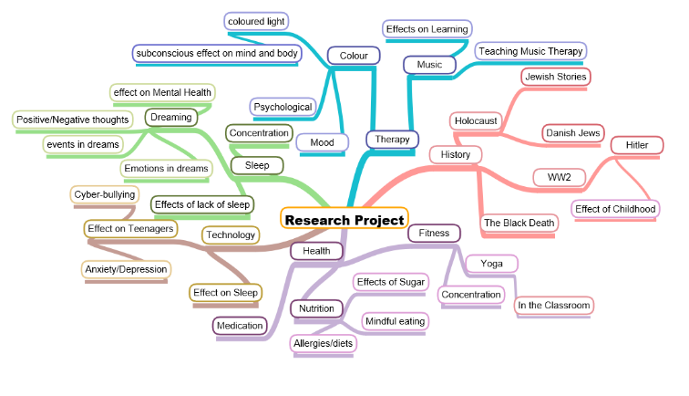

PMI on Colour Therapy
Plus: | Minus: | Interesting:
This topic is very relevant to those around me as colour choices are a big part of daily life, so understanding how colour affects us can be beneficial to myself and others around me. This will then make my findings on this topic useful. | I know very little about this topic, so a lot of primary research would need to be done in order to understand deeper sources.  After doing some initial research, I found that there are many sources about this topic, but many of them are not reliable and do not have in depth information. Finding in-depth information, therefore, could be hard to find and may require a lot of searching. | This is not a widely known topic, which will make it interesting to research. This may mean that it is difficult to find a lot of sources but will also mean I will gain a lot of useful information, that isn’t common.

Refining the Question:
6/01/2019 - To what Extent does Colour Effect the Mood of the Person?
After reading some sites on the internet, there seemed to be simple answers as to how each colour affects mood. Therefore, this question isn’t useful as it needs to be more in depth.
6/01/2019 - What is the relationship between the Human Body and Colours, and can this heal the body in any way?
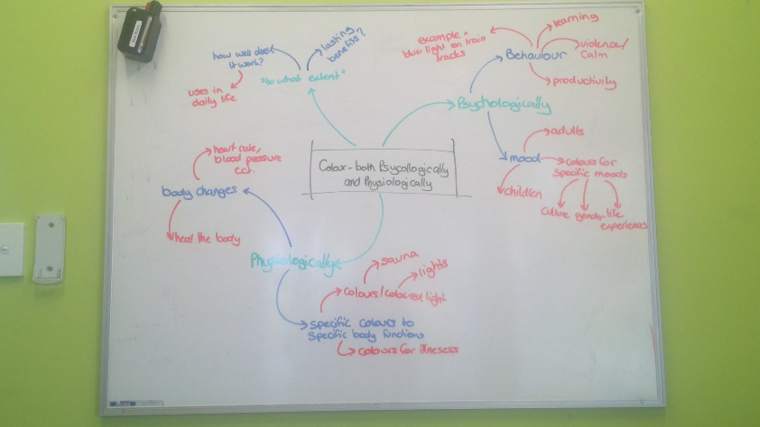
This question is definitely wider than the one above but I think it would be difficult do define what the relationship between the human body and colours is. I’m also not overly interested in how colour can heal but more the effects of could on humans in general (ie. Mood, learning, behaviour ect.)
14/01/2019 - To what extent does Colour affect a child’s productivity, learning and Behaviour?
After doing some preliminary research, I found that there is a lot of information on colour therapy and its effects on people in general, but very little specifically on children or on colour effecting productivity and learning Because of this, I decided to broaden my topic slightly in order to be able to find a reasonable number of sources.
15/02/2019 - To what extent can colour improve physical and emotional health?
This question is specific to 2 sections of colour therapy and its particularly looking at how colour therapy can improve the body. I also added “to what extent” because there might be a limit to how far colour effects the body.
26/02/2019 – To what extent does the body respond to colour psychologically and physiologically?
After research, I found the physical and emotional are known as psychological and physiological. This would make my question more direct and formal, by using the correct language. I kept the question wide as from my preliminary research, I found very little information on this topic, so I needed to keep my question wide so that I would have enough information.
I used the mind map above to sort out all the different aspects of my topic so that I wouldn’t miss anything, and to see different aspects I could research. This also helped me to see how broad/narrow my topic was and whether it would be achieved.

I created a Gannt chart above to make sure that I kept on track with my research project and to clearly structure the next 2 terms. I decided that it was important to find interviewee’s as early as possible to ensure that I can find a suitable time for both the interviewee and I. I aim to finish all my research with a draft of my folio by the end of the holidays so that I have around 3 weeks to refine my folio.

Primary sources I plan to use:
Primary sources will be extremely useful in gathering first-hand information that is specific to my research as well as being able to see the opinion of a professional. I will be able to see how Colour therapy is used in real life, however, it will have to be thoroughly checked for biased information.
Interviews/Surveys:
I plan to interview a number of people in order to receive some relevant information. Some people I can interview are colour therapists, regular customers to colour therapists and researchers. I can do this by finding colour therapists and researches online, providing that they have experience in this area so that they are reliable. I can then find regular customers from the colour therapists and interview them. I will need to interview multiple people so that I have a balanced view on my topic and so that I have something to fall back on if some professionals are not willing to have interviews.
I will start by emailing these people to ask their permission for an interview and then talk to them face to face wherever possible. If this is not possible, because they live in another state or country, I can email the questions to them. The interview questions for a colour therapist will go as following:
Case Study:
I plan to do a case study on various people at different ages on their emotional response to colour. It would be very difficult to test the physical aspect as I don’t have the equipment for this kind of testing. Therefore, I will focus only on the emotional aspect in my case study.
My case study will be given to different age levels so it will be modified, depending on the age level. I plan to tell the candidate about a specific situation and then they must state the colour (out of 3 given) that most relates to the situation. The 3 colours will be 2 contrasting colours and 1 colour from the middle of the 2. This will prove whether certain colours can relate to different emotions and a graph can be created, showing the correlation between the emotion and the most common colour.
Secondary Sources I plan to use:
Secondary sources are easily available and time-saving, as the research has already been carried out by a researcher but can be difficult to find valid and reliable information.
Books:
I could find a lot of information about colour therapy in books that I could get from the State Library data base or online books. I would need to check the validity of book before I use it so that I don’t waste unnecessary time reading it. I need to be careful that I don’t spend time finding information that doesn’t completely relate to my topic.
Secondary sources/websites:
Online sources will be very useful for background information, but I would need to thoroughly check them for reliability and validity. Good sources will give me a lot of relevant information that will give me good background information for other sources.
Capabilities:
Aspects of the Literacy Capability: | How it will be developed:
Communicating with a range of people in a variety of contexts. | Interviewing and case study on different cultures, genders, ages and looking at their different perspectives, developing my skill at communicating to different types of people.
Using language with clarity, accuracy and suitable to the context and purpose | writing out interview questions and case study forms. These require accurate language that must be suited to the occasion i.e. Using formal language, using words specific to colour therapy.
Accessing, analysing, and selecting appropriate secondary and primary sources | Using only reliable sources, analyse sources with validity, purpose, cross – referencing, challenges and opportunities, leads and key findings. This will develop my skills in critically analysing all my information, both secondary and primary.
Understanding and using different types of texts | Using a variety of sources and understanding their limitations and strengths including website, speech, newspaper article, film, reports, e-book and interview.
I aim to develop the literacy capability as this will become a capability that will be used often in the workplace. I will develop this by:

RESEARCH:
Internet Source:
Cherry K (2018) Colour Psychology: Does it Affect How you feel, https://www.verywellmind.com/color-psychology-2795824 accessed 12/03/2019
Key Findings:
- Colours in the red area of the colour spectrum are known as warm colours and these evoke emotions ranging from feelings of warmth and comfort to anger and hostility.
- Colours in the blue area of the colour spectrum are often calming but can also evoke feelings of sadness.
- Physiological effects include:
- Red – stimulate the body and mind to increase circulation
- Yellow – stimulate the nerves, purify the body
- Orange – increase energy levels, heal the lungs
- Blue – sooth illness, treat pain
- Indigo- alleviate skin problems
- Colour can affect performance as the study found that seeing the colour red before taking an exam, actually hurt test performance.
- Zena O’Connor says “many of these claims lack substantiation in terms of empirical support, exhibit fundamental flaws (such as casual oversimplification and subjective validation), and may include factoids presented as facts. In addition, such claims often refer to outdated research without referring to current research findings.” – when looking at other sources, this finding must be kept in mind to make sure the findings are reliable.
Leads:
- Effect of colour of drugs: systematic review of perceived effect of drugs and of their effectiveness see: https://www.ncbi.nlm.nih.gov/pubmed/8991013
- Installing blue-coloured street lights can reduce crime in those areas see: https://www.seattletimes.com/nation-world/blue-streetlights-believed-to-prevent-suicides-street-crime/
Reliability:
Kendra Cherry has some reliability as she has a Master of Science in education and a Bachelor of Science in psychology, showing that the information she has written about could be based on the information she learnt in her courses, but after reading through the source, the article seems to have opinion-based arguments and is written very informally.
Also, the source is part of a blog, so the purpose could be to entertain, making this source less reliable. The source, however, was written recently, making the information up to date. The source, also gives both points of view, of whether colour can affect our bodies or not which shows this website is not bias.
Overall, this source will still need to have considerable backing from other sources to be trusted.
Usefulness/Purpose:
Even though this source is not very reliable, it gave helpful background information to my topic. The source was easy to read, with clear headings and provided research to back-up its claims which I could then follow up. This source gave me an idea of what type of information to look for and how to go about it, as well as giving interesting information that I can use to do further research. The purpose of this source was mainly to gain background information for the rest of my research.
Validity:
This source is very relevant to my research as the source gives both the physiological and psychological responses to colour, which is the extent of my research question. The source didn’t go into a lot of detail for the psychological response, but it gave a summary on each colour that I can look further into.

Aspects of the Literacy Capability: | How it was Developed:
Accessing, analysing, and selecting appropriate secondary and primary sources | This source required some analysing to find the reliability of the source, and so researching on the author and purpose of the website was needed, developing my skill at analysing the source. This was done through writing notes, looking at the validity, cross-referencing with other sources and following leads. The source (a website, secondary source) was appropriate for the purpose as it was used to gain background information to my topic.
Understanding and using different types of texts | This was developed as the source was used for a specific purpose. I had to understand the limitations and strengths of the source before I used it, developing my literacy capability:  Limitation of source: relatively unreliable as websites are generally written for entertainment rather than facts.  Strengths: easy information to find and read – gave a lot of background knowledge.
Source (journal): Jacobs K (1972) The Effects of the Four Psychological Primary Colours on GSR, Heart Rate, and Respiration Rate, (Master’s Thesis), Retrieved from: https://thekeep.eiu.edu/cgi/viewcontent.cgi?article=4906&context=theses accessed 22/03/2019
Key Findings:
- GSR = Galvanic Skin Response – when we are emotionally roused, the electrical conductivity of our skin subtly changes
- Autonomic nervous system and visual cortex were significantly less aroused during blue than during red or white light.
- Greater relaxation, less anxiety and hostility, during blue; more tension and excitement during red exposure.
- Systolic blood pressure, palmar skin conductance, respiration rate, and frequency of eye blinks, were significantly lower during blue than during red or white light.
- Red was found to be more arousing than white and white was found to be more arousing than blue.
- Psychiatric patients displayed a lessened reaction to colour than the normal subject.
- There was an absence of a significant effect on heart rate as a function of either red or blue hues.
- Results of various sources:
  - GSR = greater GSR change with red than blue (Gerard 1958)
  - GSR = order of increasing GSR change – Blue, red, yellow, green (Smith 1958)
  - GSR = greater GSR change with red than green (Wilson 1966)
  - Heart rate = insignificant change (Gerard 1958)
  - Respiration = respiration increased with red and decreased with blue when compared to white light (Gerard 1958)
- Red is usually found to be more arousing than the other hues when GSR is used as the dependent variable
- It was found that the most arousing colour was red, followed by green and yellow with blue being the least arousing of the four colours.
- Table of number of subjects that responded to colour:
Reliability:
This source has medium reliability as the author of the master’s thesis, Jacobs K, is relatively reliable as the source is very balanced, showing different views and opinions on each topic. this source, however, is less reliable as it was written in 1972, so some of the information is out of date and so the research needs to be considered with more recent research for it to be reliable.
Usefulness/purpose:
This source was not completely useful as only part of the source applied to my topic. This source, however, gave a lot of information on the physiological effects of colour, which answers my question, greatly benefiting my research.
Validity:
Only half of the source was valid to my research as most of the source was analysing previous studies. This allowed me to find more research on my topic but gave very little information about the psychological responses to colour. At the end of the source, it described a study that took place with gave very valid information. Overall, this source had medium validity.
Development of knowledge and skills:
Aspects of the Literacy Capability: | How it was Developed:
Accessing, analysing, and selecting appropriate secondary and primary sources | For this source, I started to develop the skill of looking for key words throughout the source, in order to not waste time in reading parts of the source that did not apply to my research. Only part of the source was valid so I had to only read the parts in-depth that applied and so analysing and selecting appropriate parts of the source was developed.
To find this source, I needed to understand how to use different technology, such as ProQuest, Google Scholar and the State Library of South Australia’s Database. I had to learn how each site worked and their benefits, developing my ability to use different types of technology.
Source (journal): Gaines, K. S, Curry, Z. D. (2011). The inclusive classroom: The effects of colour on learning and behaviour, Journal of Family and Consumer Sciences Education, 29(1), 46-57.
Key Findings:
- Physiological effects of colour include blood pressure, eye strain and brain development. For example, exposure to red can cause the heart to beat faster, an increase in blood pressure, and a heightened sense of smell. In contrast to this, blue can cause a slower pulse rate, lower body temperature and a reduced appetite.
- Psychological responses to colour can include changes in mood and attention.
- When a human sees colour, a hormone can be released from the brain which effects moods, mental clarity and energy level when colour enters the eyes.
- Findings have shown that changes in the colour environment resulted in a drop-in blood pressure and reduced aggression in blind children, as well as sighted.
Reliability:
The author, Kristi Gaines is extremely reliable as she has several degrees, including Doctor of philosophy, and Master of Science, as well as a number of awards and honours, including the interior Design Educator’s Council Service Recognition Award and Texas State Board of Health Services Award of Excellence, as well as writing a number of journal articles and books. Zane Curry is an Associate Professor Emeritus at Texas Tech University, so he also would give reliable information. This source is also written relatively recently (2011) so it has recently discovered information. Therefore, this research paper can be used as a reliable source of information that can be compared to other sources.
Usefulness/Purpose:
This source was very useful in gaining information for both physiological and psychological effects of colour. This source was also very reliable, so the information can be trusted and used in my outcome.
Validity:
The source had some invalid information, but most of it was extremely valid and very useful, on both psychological and physiological responses to colour.
Leads:
The source gave a table with sources and findings that can be followed up to find more information on my topic. This was extremely useful as I could then follow up on specific body functions for specific colours and find more information on their results.

Comparison & contrast of 2 sources: | Source 1 | Source 2
Source: | The Inclusive Classroom: The effects of Colour on Learning and Behaviour Journal of Family and Consumer Sciences Education | Colour Psychology: Does it Affect how you Feel
Similarities: | - Psychological responses include mood and attention  - Red can cause the heart to beat faster and increase blood pressure. | - Colour can evoke feelings from warmth to sadness  - Red stimulates the body and mind and increases circulation
Differences: | - Blue can cause a slower pulse rate, lower body temperature and a reduced appetite | - Blue can sooth illness and treat pain
Reliability: | Source 1 shows that blue can slower pulse rate, lower body temperature and reduce appetite and each of these things can be proven and shown to be true. Source 2 shows that blue can sooth illness and treat pain but this is a difficult to measure and could be hard to prove. Also, looking at source 1’s reliability, the authors are a lot more credible and knowledgeable about this subject compared to Source 2’s authors. Therefore, source 1 will be relied upon, above source 2.
Interviews:
I sent a number of interviews to professionals on Colour therapy and this is the questions I asked for each interviewee.
Dear__________
I am a year 12 student from Heritage College and I am undertaking a research project. The topic of my research project is based on the benefits of colour therapy, both emotionally and physically. I would really appreciate it if you could please answer the following questions to assist me with my research:
This was just to introduce myself to the person of who I am and why I wanted to ask questions. I also explained my topic so that they knew what type of information I was looking for and respond with relevant answers.
Do you think the body will respond to colour? Please explain.
An introductory question that will help me understand their view on this topic. This will also help me appreciate the interviewees perspective on this topic, helping me to see any bias in their answers.
To what extent do you think colours can affect our mood and emotions? Is it Long lasting?
This is a part of my research question, so it is important I ask this. I added “to what extent” as I have found in my research that the emotions from colours may not be permanent. This question will help me find more information on the extent of colour therapy.
Do you think colour can physically affect the body, or is it just an emotional response?
It is an argument as to whether colour can physically affect the body or if it is only an emotional response so I wanted to see their opinion on this topic before I asked further questions. This will again show me their perspective on this issue and therefore help me develop the literacy capability of understanding other’s viewpoints. This question will lead into the next question.
If so, what body functions can specific colours effect?
This is more of a factual question rather than opinion based, hopefully giving some proven answers that will be very beneficial to my research.
How do you think can colours be used as a useful tool in a person’s life?
This question is to find out how colours can be used in society and the relevance of this research question.
Purpose:
The purpose of interviewing professionals was to find opinions and first hand information on colour therapy, and it also helped me to see whether this concept is actually used as a form of therapy and gain opinions and ideas from people who use this every day.

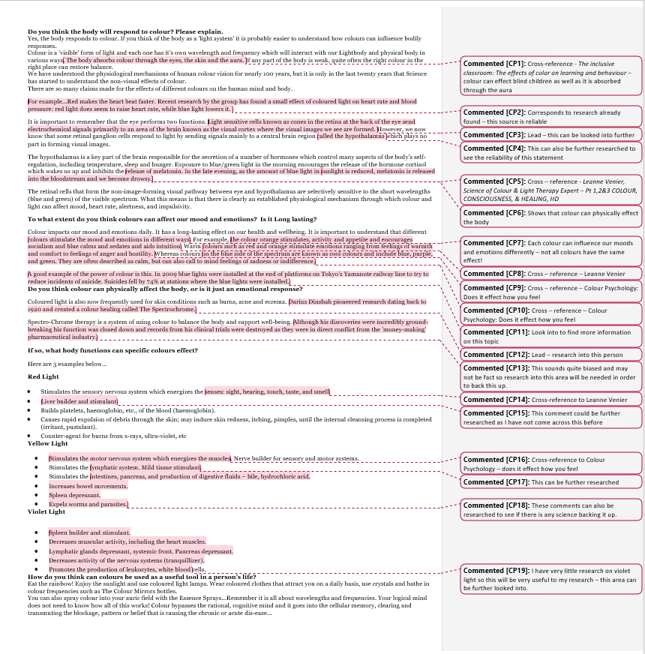
Source (interview) - Crawford H (2019) interviewed by Caitlin Peronace, 15/04/2019
Key Findings:
- The colour orange stimulates, activity
- The colour red energises all the senses – sight, hearing, touch, taste and smell
- The body can absorb colours through the eyes, skin and aura
- The performs 2 functions: cones in the retina sends electrochemical signals from the brain where visual images are formed but also the eye have retinal ganglion cells that respond to light by sending signals to the hypothalamus.
- The hypothalamus controls hormones, which control’s many aspects of the body’s self-regulation, including temperature, sleep and hunger.
Reliability:
Hayden can be a trusted source as he is a qualified Practitioner of Vibrational Medicine as well as provides advanced training in Usui Reiki and Pythagorean Numerology in which aspects of colour therapy are included. Because he is not specifically a colour therapist, some of his information may need to be cross-referenced to other sources as his career includes several other remedies as well.
Usefulness/Purpose/Validity:
This interview was extremely useful to my research as he gave me a lot of relevant and valid information that matches with my previous research, as well as giving me some further ideas that can be researched. The purpose of this interview was to gain primary research from a professional that uses this type of therapy and can physically see the benefits of it. All information was valid as he answered specific questions, which were relevant to my research. That meant that I could find answers to my question in specific ways, making this form of research very useful to my research project.
Leads:
- Blue lights were installed on train tracks – this can be looked into further to see how effective this was.
Knowledge and Skills developed:
This interview could not be conducted face to face, so technology was needed to ask Hayden the questions. Outlook was used and using this form of email was developed as I needed to communicate effectively with him. Features from Outlook were used, such as ‘high importance.’
Capabilities Developed:
Aspects of the Literacy Capability: | How it was developed:
Using language with clarity, accuracy and suitable to the context and purpose | This aspect of the literacy was further developed when I needed to learn to write to him in a professional manner, so that he would take my email seriously.

Case Study
For my case study, I chose 5 main moods to ask the participants and this was based on findings from other sources so that for each area, there was an expected colour. These were asked in different ways, depending on the age. For age 13 – adults (image 1) and age 7-12 (image 2) a story was created to help the participant feel and understand the emotion before they decided what colour most associated with the emotion. I also created coloured cards for the children aged 7-12 so that the child didn’t have to visualise the colour and to make the questions a lot simpler. For ages below 7, I created a chart (image 3) that the child could colour in the colour that suited that emotion. This made it easier for a child to distinguish between emotions, rather than scenarios. I used 6 colours for each child which they could choose from.

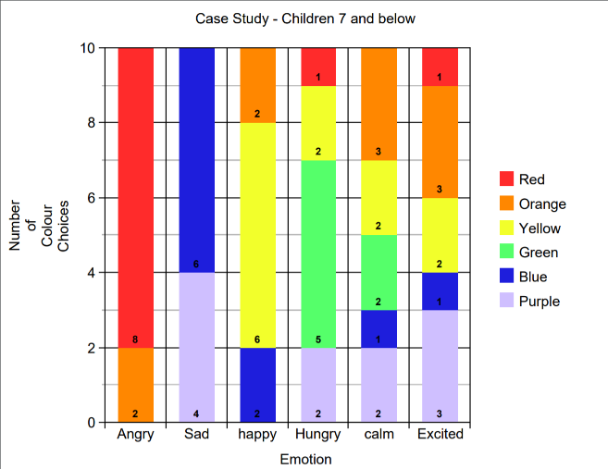
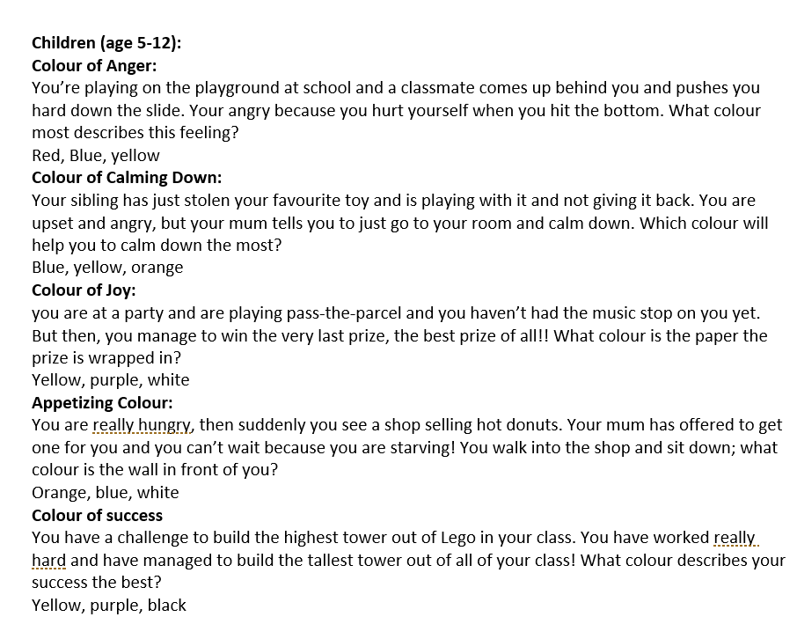
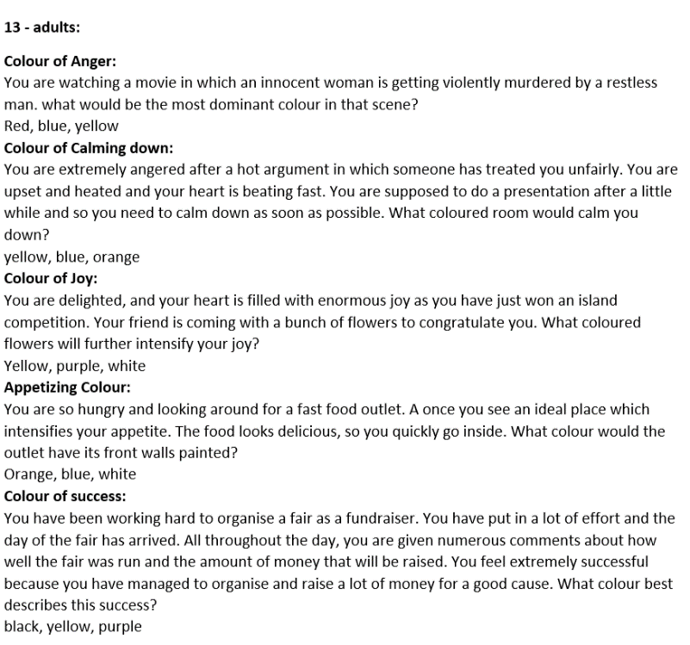
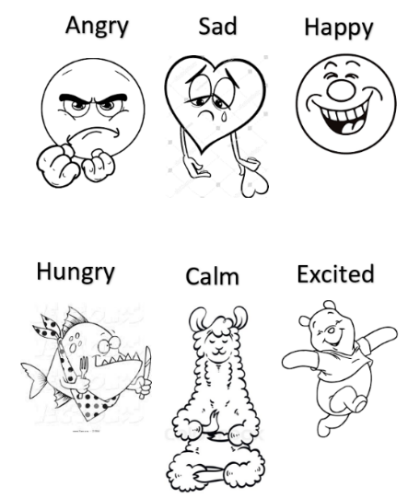
Ethical considerations:
12 - Adults
Children 7-12
Children below 7
This case study did not require any personal feelings, so this meant it was ethical, but because I used children as part of my case study, I did not ask for their names or take any photos of them while they were doing the case study. This meant that everything was anonymous, and photos were only taken of their work after it was completed.
Key Findings of case study:
- Colour of Anger – the most common colour the participants noted was red in all three groups. Orange was also used in all other cases, except for one where yellow was noted. associated with violence and anger and this fits in with my research so far, in that warm colours are often associated with violence and anger.
- In the children 7 and below, blue and purple were the only colours used for sadness, fitting with my research in that cooler colours are often associated with sadness (contrast to warm colours and anger) while excited had a range of different colours, purple, blue, yellow, orange and red (not included in the other age groups)
- Colour of Calming down – as seen in the graph all children below 7 used purple, blue, green, yellow and orange while Blue was used in the other age groups, except for in 2 cases, yellow was used. The younger age group could have found it difficult to grasp the emotion calm as it is a mature emotion, so this could be why there was no specific colour used.
- Colour of Joy – yellow was used in all the adult and children’s category. In the children below 7, orange and blue was also used. In my research, I have found that yellow is the most associated colour with joy, matching my results.
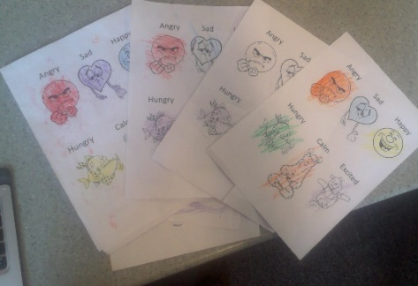
- Appetizing Colour – in the adult’s category, orange was consistent with all respondents. In the Children below 7, green, purple, yellow and red were used, with green being the most common colour. The expected colour was orange and this matched the adults category, but unexpectedly, green was the most common colour in children below 7.
- Colour of Success – purple was consistent throughout all the adult while one 9-year-old used yellow, consistent with my research.
Knowledge and Skills Developed:
Learning to use technology such as excel was needed and developed when creating the graph as I have never used this type of software before. Also, communicating the information in an appropriate way was needed and certain graphs were used to make this successful.
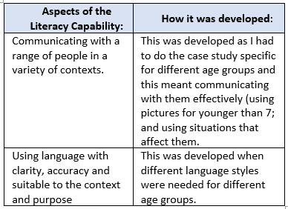
Throughout this case study, I developed the skill of problem solving because I found it very difficult to get answers from different age groups, as well as different gender’s and cultures. To overcome this, I used our school community as people for my case study and during lunch time asked as many people as I could to be involved in the case study. This meant I could find as many different types of people as I could and get a substantial amount of responses. This was also a very new research method that I have not tried before. I gained a lot of new information by doing some ‘hands-on’ research, but I had to do some research into the best way to conduct a case study, and I have now started to develop this skill. Next time I need to do a case study, I will try to start the process earlier so that I have time to find more people to do the case study for me, making the results more reliable.
Reliability:
This case study cannot be fully trusted because it was only done by a year 12 student, so other research will need to be used to back it up, but it did give useful information that can be cross-referenced to research already found. If key findings are backed up with another source, this case study could be very useful for my outcome, especially if the information can be depicted in a graph.
ANALYSING KEY FINDINGS:
I realized that I needed to put together all my key findings and sort out all my key findings as I had done a lot of research. To do this, I collected all my key findings and highlighted all the information into Psychological aspects and physiological aspects. This helped me to see the balance between the two topics and whether I needed to do additional research on one of the topics. This meant that I could also see which information was valid and what was not as well as cross-reference between
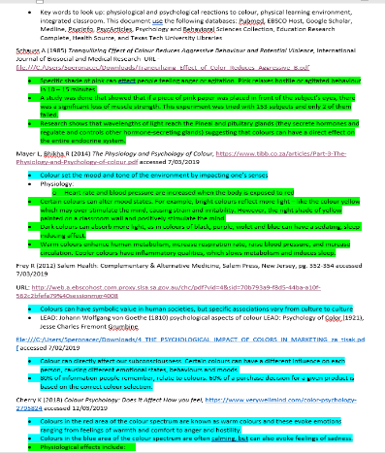
the sources.
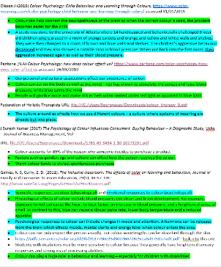
Cross Referencing:
This method also helped me to cross reference between sources and see information that is similar between the sources. This meant that I could easily see which information extremely reliable as similar information was used throughout other sources. Also, the less reliable sources could still be used if information from them was backed up by other sources, which in turn will make my outcome more reliable.
Leads:
Throughout the research process, I followed up on leads as many sources had references for their information, that I could then follow up. By going through my key findings again, I could make sure I had followed up on all the leads, developing my skill of critically and logically looking through my notes and analysing them for leads, validity and cross references.
Development of Knowledge and Skills:
Throughout this process of refining and organising my key points, I started to develop critical thinking skills. I already had some skills in this area from previous researching and analysing but I developed this further when I needed to go through my information and take out all irrelevant findings and sources. A lot of information was not need or invalid, and other information had already been found in other sources.

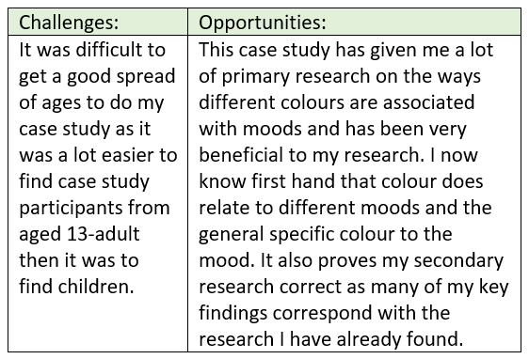
What Next:
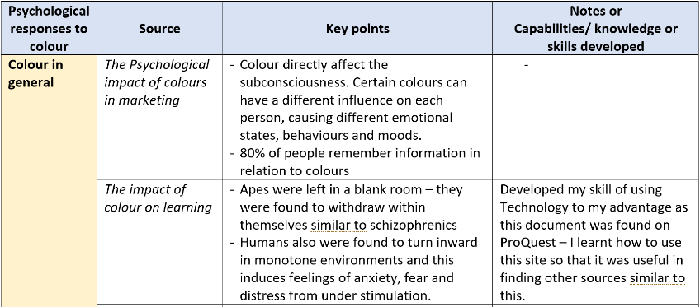
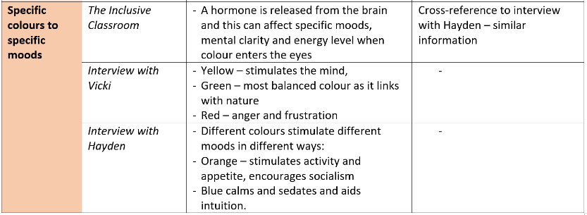
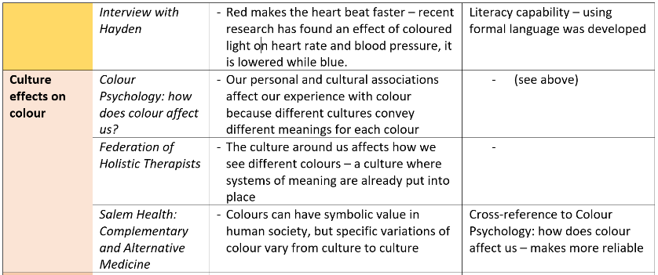
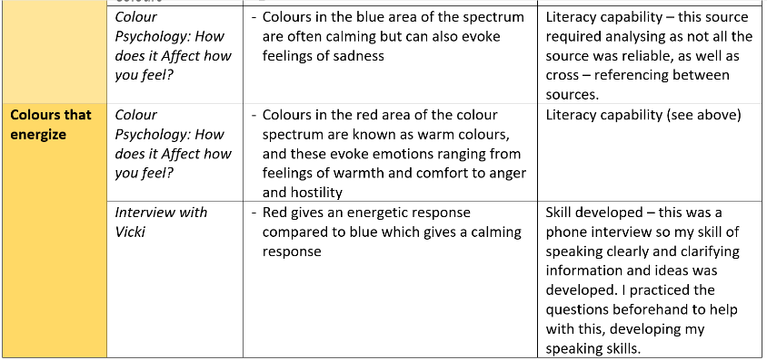
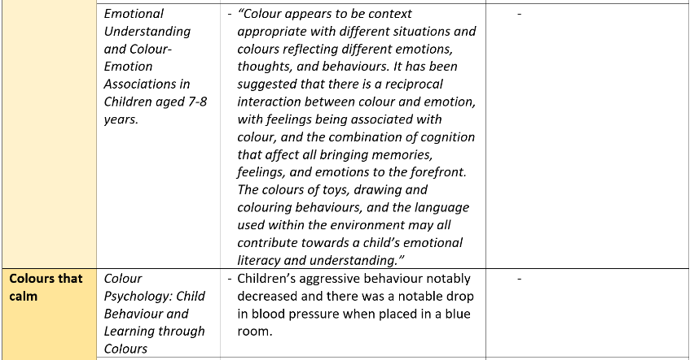
I then put all my key points into 2 tables – psychological responses and Physiological responses with the source to make my information clearer for my outcome (see table below). I also put all my information under headings so that I could sort all my information. I then went through and wrote notes, capabilities or knowledge and skills developed for each source and this helped me to see the benefits of each source and cross-references between other sources (see pictures below of the Psychological graph).
4 Main Areas of the Capability and How it was Developed:
Aspects of the Literacy Capability: | How it was developed:
Communicating with a range of people in a variety of contexts. | 5/03/2019 – I had to develop the skill of communicating with various professionals by emailing them. This was difficult as very few interviewees got back to me and so I had to learn more effective ways of communicating, so instead I tried ringing people as much as I could, and this seemed more effective.  2/05/2019 – I needed to communicate effectively with 7-year-olds and younger when doing my case study. I needed to learn how to explain to them each emotion in simple language with situations that they could relate to, so this experience developed my skill at communicating effectively with this age group verbally.
Using language with clarity, accuracy and suitable to the context and purpose | 8/04/2019 – This capability was developed when writing out case studies to different ages. This developed my understanding as to what type of language to use for different ages and the best ways to communicate to different ages through different scenarios and language, depending on their context.  5/03/2019 – When emailing Valerie, a colour therapist, I developed the literacy capability as I needed to use language specific to colour therapy as she was a professional in this field. This helped her to take the email more seriously as correct language was used.  22/03/2019 – While reading through the thesis (one of my sources) I found it very difficult to understand because of the formality and medical terms from the text. This meant looking up words and terms if I didn’t understand, and I found my understanding of words and confidence in using them started to grow by the end of the analysis of the Thesis.
Accessing, analysing, and selecting appropriate secondary and primary sources | 10/02/2019 – I developed the literacy capability when I learnt how to use the state library database, which then allowed me to use other databases like pro-quest etc. This allowed me to find other sources, both primary and secondary.  14/04/2019 – throughout the research project I have been developing the skill of analysing sources effectively. This has been developed by reading the ‘research project guide,’ helping me to effectively analyse each source for reliability, key findings and validity.
Understanding and using different types of texts | 13/04/2019 – a new text, documentary, was used as part of my research, and this developed my skill of using different types of texts because I had to find out the limitations and positives of this type of source to use it effectively.

Psychological responses table
This is an example of the psychological research I found. I did the same for physiological key findings and this helped me to put all of my information into paragraphs for my outcome.

Bibliography:
Secondary Source:
Internet Sources:
Cherry K (2018) Colour Psychology: Does it Affect How you feel, https://www.verywellmind.com/color-psychology-2795824 accessed 12/13/2019
Mayer L, Bhikha R (2014) The Physiology and Psychology of Colour, https://www.tibb.co.za/articles/Part-3-The-Physiology-and-Psychology-of-colour.pdf accessed 7/03/2019
Olesen J (2019) Colour Psychology: Child Behaviour and Learning through Colours, https://www.color-meanings.com/color-psychology-child-behavior-and-learning-through-colors/ accessed 31/01/2019
Pantone (N.D) Colour Psychology: How does Colour Affect us? https://www.pantone.com/color-psychology-how-does-color-affect-us accessed 13/04/2019
Pahmer A (2003) How does Colour affect Blood Pressure, http://cssf.usc.edu/History/2003/Projects/S0317.pdf accessed 28/03/2019
Journal:
Federation of Holistic Therapists (1999) Colour Therapy, International Therapists November, Issue 31, accessed 26/03/2019
Frey R (2012) Salem Health: Complementary & Alternative Medicine, Salem Press, New Jersey, pg. 352-354 accessed 7/03/2019
Gauguin P (2003) Psychological Effects of Colour, Pearson Prentice Hall, pg. 35-45 accessed 2/05/2019
Hunjet A, Vuk S (2017) The Psychological Impact of Colors in Marketing, International Journal, Vallis Aurea, Volume 3, accessed 7/02/2019
J Suresh Kumar (2017) The Psychology of Colour Influences Consumers’ Buying Behaviour – A Diagnostic Study, Ushs – Journal of Business Management, Vol 16, accessed 7/03/219
Ou L, Luo M, Woodcock A, Wright A (2003) A Study of Colour Emotion and Colour Preference Part 1: Colour Emotions for Single Colours, University of Derby, Vol 29, pg. 232-240, accessed 13/04/2019
Schauss A (1985) Tranquilizing Effect of Colour Reduces Aggressive Behaviour and Potential Violence, International Journal of Biosocial and Medical Research, pg 218 – 221, accessed 23/02/2019
Research Papers:
Kaya N, Epps H (2004) Relationship between Colour and Emotion: A Study of College Students, University of Georgia accessed at: https://www.academia.edu/3880952/RELATIONSHIP_BETWEEN_COLOR_AND_EMOTION_A_STUDY_OF_COLLEGE_STUDENTS
Thorstenson C, Elliot A, Pazda A, Perrett D, Xiao D (2017) Emotion-Color Association in the Context of the Face, Rochestor, NY, accessed at: https://core.ac.uk/download/pdf/96709320.pdf
Thesis:
Jacobs K (1972) The Effects of the Four Psychological Primary Colours on GSR, Heart Rate, and Respiration Rate, (Master’s Thesis), Retrieved from: https://thekeep.eiu.edu/cgi/viewcontent.cgi?article=4906&context=theses accessed 22/03/2019
Books:
Hari, A (2012) Magic Therapy of Colours, V&S Publishers pg 44-48
Primary Sources:
Interviews:
Badams D (2019) interviewed by Caitlin Peronace, Adelaide, 11/04/2019
Crawford H (2019) interviewed by Caitlin Peronace, Adelaide, 15/04/2019
Lorry C (2019) interviewed by Caitlin Peronace, Adelaide, 7/04/2019
Vicki (2019) interviewed by Caitlin Peronace, Adelaide, 11/04/2019
Case study:
Anonymous (2019) Case study by Caitlin Peronace, Adelaide 2/05/2019 (10 participants)
Grainger L (2019) Case study by Caitlin Peronace, Adelaide, 1/05/2019
Manser K (2019) Case Study by Caitlin Peronace, Adelaide, 1/05/2019
Nelson P (2019) Case Study by Caitlin Peronace, Adelaide, 2/05/2019
Peronace A (2019) Case Study by Caitlin Peronace, Adelaide 2/05/2019
Peronace E (2019) Case Study by Caitlin Peronace, Adelaide 2/05/2019
Peronace H (2019) Case Study by Caitlin Peronace, Adelaide 2/05/2019
Thiele J (2019) Case Study by Caitlin Peronace, Adelaide 2/05/2019
Thiele S (2019) Case Study by Caitlin Peronace, Adelaide 2/05/2019
Videos:
Colour Therapy: The Secret to Healing Your Body (2018) Video, Numerologist (online) https://www.youtube.com/watch?v=HhBP4NtTOcU accessed 13/04/2019
Leanne Venier, Science of Colour & Light Therapy Expert – Pt 1,2&3 COLOUR, CONSCIOUSNESS, & HEALING, HD (2013) Leanne Venier (online) https://www.youtube.com/watch?v=MaH6LOLdJTo accessed 15/04/2019

