**SACE Capabilities**

How they apply to the research project:

D4 Understanding and development of one or more capabilities.

A grade - Thorough and informed understanding and development of one or more capabilities.

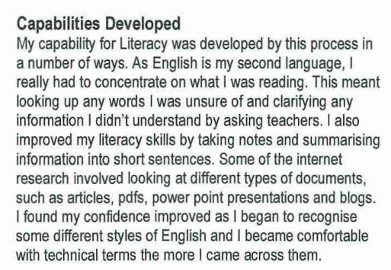

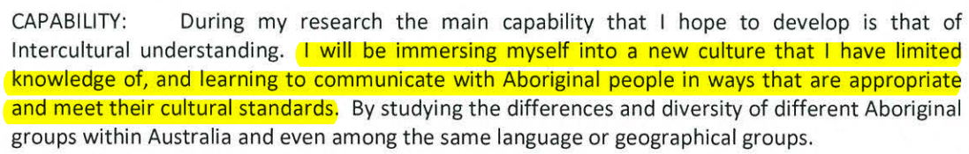

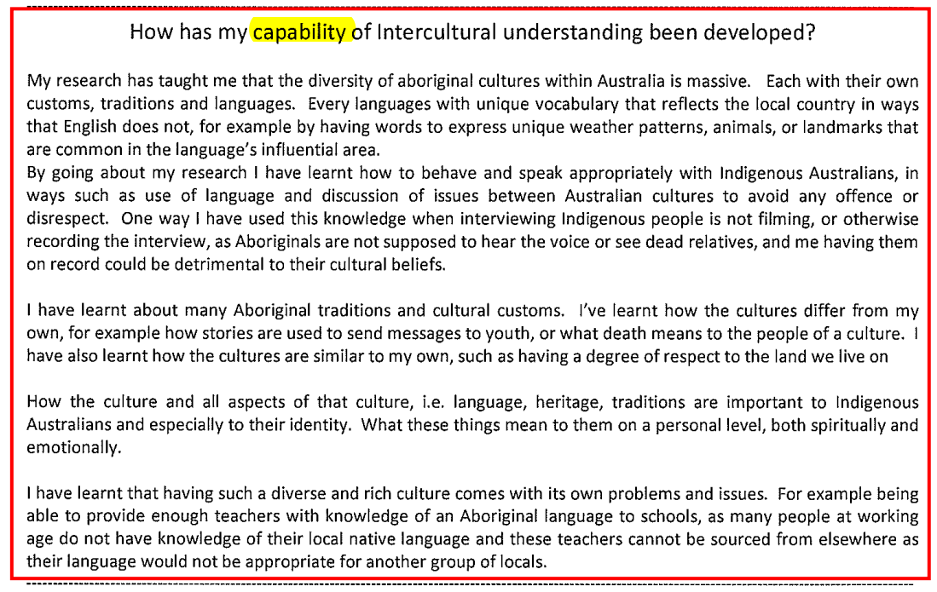

The capabilities comprise an integrated and interconnected set of knowledge, skills, and understandings that students develop and use in their learning through SACE subjects.

Students develop their ‘capabilities’ when they apply knowledge and skills confidently, effectively and appropriately in changing circumstances in their learning at school.

There are seven capabilities that underpin the SACE:

* literacy
* numeracy
* information and communication technology capability
* creative and critical thinking
* personal and social capability
* ethical understanding, and
* intercultural understanding.

This set of seven capabilities, which have as their basis the Australian Curriculum General Capabilities, will be referred to in the SACE as the ‘Capabilities’.

The development of these capabilities in students should be purposeful because they

The purpose of the capabilities is to develop in students the knowledge, skills, and understandings to be successful learners, confident and creative individuals, and active and informed citizens. The relationship of the capabilities and their central purpose can be illustrated in the following way:

Diagram demonstrating how the seven capabilities all contribute to students being successful learners, who are confident and creative, and individual and active informed citizens.

| Capabilities | Organising Elements | Possible Contextual Applications |
| --- | --- | --- |
| Literacy | * text knowledge * visual knowledge * word knowledge * grammar knowledge * comprehending texts * composing texts. | * literacy and learning * social communication * workplace communication * social practices * power of language * understanding: * context, audience, purpose * representation * language * media * languages * first language * journalism * visual literacy * presentation * debate |
| In Research Project you develop your capability for literacy by, **for example**:   * communicating with a range of people in a variety of contexts * asking questions, expressing opinions, and taking different perspectives into account * using language with increasing awareness, clarity, accuracy, and suitability for a range of audiences, contexts and purposes * accessing, analysing, and selecting appropriate primary and secondary sources * engaging with, and reflecting on, the ways in which texts are created for specific purposes and audiences * composing a range of texts – written, oral, visual, and multimodal * reading, viewing, writing, listening, and speaking, using a range of technologies * understanding that different text types, such as a website, speech, newspaper article, film, painting, data sets, reports, set of instructions, interview, have their own distinctive stylistic features * understanding the relationships between literacy, language, and culture. | | |
| Numeracy | * estimating and calculating with whole numbers * recognising and using patterns and relationships * using fractions, decimals, percentages, ratios and rates * using spatial reasoning * interpreting statistical information * using measurement. | * numeracy and learning * understanding and using: * numerical data * budgets * workplace skills * financial literacy * data analysis * proportional reasoning * predictive skills * scale * modelling * critical numeracy * spatial awareness * relationships, comparisons, similarities |
| In Research Project you develop your capability for numeracy by, **for example**:   * communicating ideas to a range of audiences, using appropriate language and representations, such as symbols, tables, and graphs * analysing information displayed in a variety of representations and translating information from one representation to another * justifying the validity of the findings, using everyday language, when appropriate * applying skills in estimating and calculating to solve and model everyday problems using thinking, written and digital strategies * interpreting information given in numerical form in diagrams, maps, graphs, and tables * visualising, identifying, and sorting shapes and objects in the environment * understanding patterns and relationships when solving problems * understanding spatial and geographical features and relationships * interpreting and incorporating statistical information that requires an understanding of the diverse ways in which data are gathered, recorded, and presented. | | |
| Information and Communication Technology Capability | * investigating with ICT * communicating with ICT * creating with ICT * managing and operating ICT * applying social and ethical protocols and practice when using ICT. | * local, national, international communication * multimodal literacies * social media * responsibility * ethical protocols * graphical representation * access to: * news * information * data * technology in work places |
| In Research Project you develop your capability for information and communication technology by, **for example**:   * understanding how contemporary information and communication technologies affect communication * critically analysing the limitations and impacts of present technologies * considering the implications of potential technologies * communicating and sharing ideas and information to collaboratively construct knowledge and digital solutions * defining and planning information searches of a range of primary and secondary sources when investigating research questions * developing an understanding of hardware and software components, and operations of appropriate systems, including their functions, processes, and devices * applying information and communication technology knowledge and skills to a range of methods to collect and process data, and transmit and produce information * learning to manage and manipulate electronic sources of data, databases, and software applications * applying technologies to design and manage projects. | | |
| Critical and Creative Thinking | * inquiring, identifying, exploring and organising information and ideas * generating ideas, possibilities and actions * reflecting on thinking, actions and processes * analysing, synthesising, and evaluating information. | * thought and reasoning * inquiry * ideation * knowledge and understanding * learning and metacognition * application of skills * accessing, organising, using information * problem-solving * imagination * creativity * enterprise * resourcefulness * entrepreneurship * research literacy * collaborative thinking |
| In Research Project you develop your capability for critical and creative thinking by, **for example**:   * thinking critically, logically, ethically, and reflectively * learning and applying new knowledge and skills * accessing, organising, using, and evaluating information * posing questions and identifying and clarifying information and ideas * developing knowledge and understanding of a range of research processes * understanding the nature of innovation * recognising how knowledge changes over time and is influenced by people * exploring and experiencing creative processes and practices * designing features that are fit for function (e.g. physical, virtual, textual) * understanding the place of creativity in learning, the workplace, and community life * understanding entrepreneurial enterprise * reflecting on, adjusting and explaining their thinking and identifying the reasons for choices, strategies, and actions taken. | | |
| Personal and Social Capability | * self-awareness * self-management * social awareness * social management. | * personal identity * personal goals * resilience, self-esteem, self-efficacy, well-being * interaction * work, employment, vocation, occupation * managing relationships * participation in the workplace * volunteerism * decision-making * contribution to teams * contribution to groups * family * community * social life * shared rights and obligations |
| In Research Project, you develop your capability for personal and social understanding by, **for example:**   * developing a sense of personal identity * reviewing and planning personal goals * understanding and exercising individual and shared obligations and rights * participating actively and responsibly in learning, work, and community life * establishing and managing relationships in personal and community life, work, and learning * developing empathy for and understanding of others * making responsible decisions based on evidence * working effectively in teams and handling challenging situations constructively * building links with others, locally, nationally, and/or globally. | | |
| Ethical Understanding | * understanding ethical concepts and issues * reasoning in personal decision-making and actions * exploring values, rights and responsibilities. | * social issues * ethics * perspectives * beliefs * integrity * right and wrong * freedom * truth * principles * social values * dilemma * fairness * social justice * government * politics |
| In Research Project you develop your capability for ethical understanding by**, for example**:   * understanding and discussing ethical concepts and issues * considering ethical and safe research processes, including respecting the rights and work of others, acknowledging sources, and observing protocols when approaching people and organisations * appreciating the ethical and legal dimensions of research and information * reflecting on personal ethics and honesty in experience and decision-making * exploring ideas, rights, obligations, and ethical principles * considering workplace safety principles, practices, and procedures * developing ethical sustainable practices in the workplace and the community * inquiring into ethical issues, selecting and justifying an ethical position, and understanding the experiences, motivations and viewpoints of others * debating ethical dilemmas and applying ethical principles in a range of situations. | | |
| Intercultural Understanding | * recognising culture and developing respect * interacting and empathising with others * reflecting on intercultural experiences and taking responsibility. | * civil society * globalisation * international integration * community * local, national, global citizenship * openness, respect * responsibility * ideology * meaning-making * diaspora * public, private * multiple identities * group and national identities * culture * language * diversity |
| In Research Project, you develop your capability for intercultural understanding by, for example:   * identifying, observing, analysing and describing characteristics (e.g. group memberships, traditions, values, religious beliefs, ways of thinking) of their own cultural identities and those of others * recognising that culture is dynamic and complex and that there is variability within all cultural, linguistic, and religious groups * learning about and engaging with diverse cultures in ways that recognise commonalties and differences, create connections with others, and cultivate mutual respect * developing skills to relate to and move between cultures * acknowledging the social, cultural, linguistic and religious diversity of a nation, including those of Aboriginal and Torres Strait Islander societies in Australia * recognising the challenges of living in a cultural diverse society and of negotiating, interpreting, and mediating difference. | | |