Using Google Effectively
- Use plenty of keywords: use as many keywords as you need—the more the better.
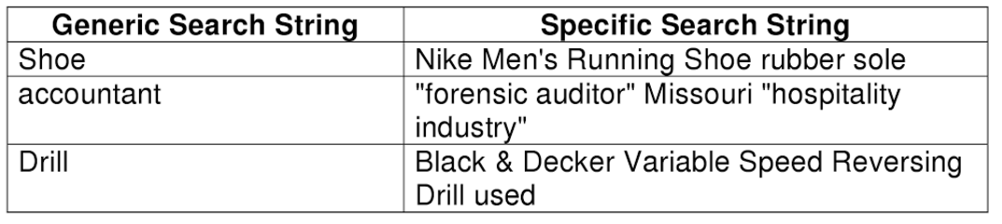

- Make sure you pick the right key words: What words would an ‘expert’ in your subject use?
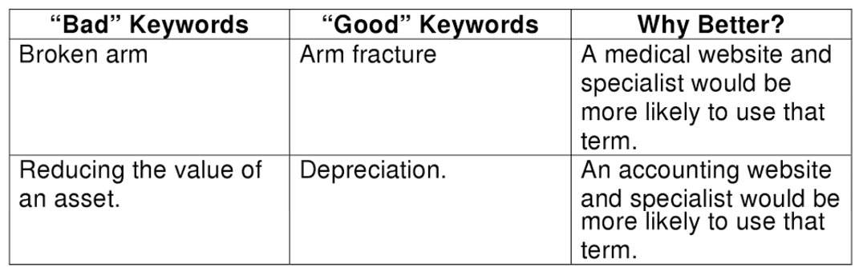
Try other words: What synonyms can I think of for my topic?
a) Words that change by region (e.g Thong in Aus. Vs. Jandal in Nz.)
b) British vs. American Spelling (color vs. colour)
c) Formal vs. informal (Jack Kennedy vs. John Kennedy)

- Refine your search – You can use certain symbols or words in your search to make your search results more precise.
Search a specific site: Put site: before the URL of a website to search only that website. The example will search for any mention of Iran on the ABC news site. site:abc.net.au/news/Iran
Search for a specific file type: This allows you to refine your search to one type of file e.g PDF, ppt, doc, mp3 etc. Put filetype: the type of file you want and your key words. filetype:pdf “I have a dream” transcript
Search for an exact match: This refinement allows you to search for exact words and phrases. Put the exact phrase you would like to find in quotation marks. “I have a dream” speech

Block words: Exclude words from your search to weed out irrelevant information. Put a minus sign in front of word or words you want to exclude. Jaguar speed –car
Wildcards: Put a * in your word or phrase where you want to leave a placeholder. For example, "largest * in the world".
Other tips:
-Press the control and F key to bring up a search bar on any document, pdf or webpage. You can then search for your keyword on that document/page. This saves you having to skim the whole thing to find the section that is relevant to you.
-Try google scholar for more academic results (more suitable for students in years 10-12) https://scholar.google.com.au

