Japan Under the Shoguns – Lesson 2

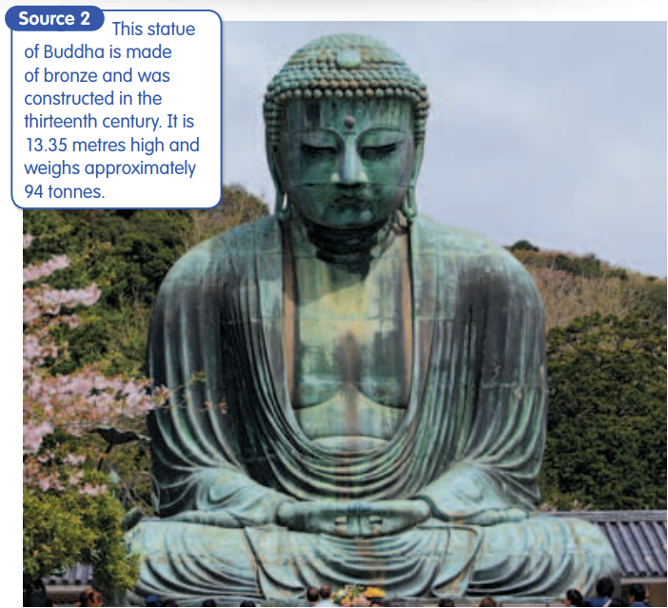
Japanese museums, temples and shrines preserve many relics that tell us about Japan’s past. The most precious items are listed as National Treasures. These could be buildings, sculptures, paintings, documents, artefacts or even people.
Architecture
A lot can be learned about Japan’s past by examining surviving buildings. Their construction techniques, materials and designs give us valuable information about architecture, technology and the way people lived. Some of the oldest buildings are in the cities of Nara, Kamakura and Kyoto. These three cities were centres of government at various times in Japan’s history. They were also religious centres that built shrines for Japan’s ancient Shinto faith, great Buddhist temples and pagodas.
Arts and crafts
Many examples of Japanese arts and crafts survive today, and these provide a great deal of evidence of life in Japan over the centuries. Paintings often provide detail of the way of life of all classes of people, as well as the clothing they wore and the buildings in which they lived. Many famous events in Japanese history have also been depicted in artworks of the time. Crafts such as origami, printmaking and pottery can also give us insights into Japanese life in past centuries.

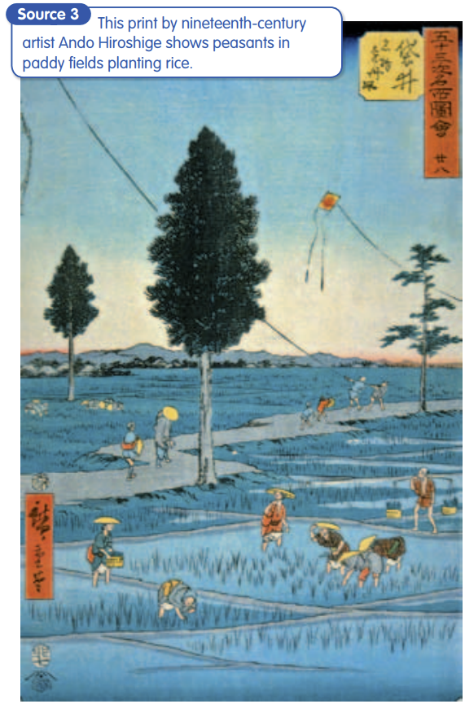
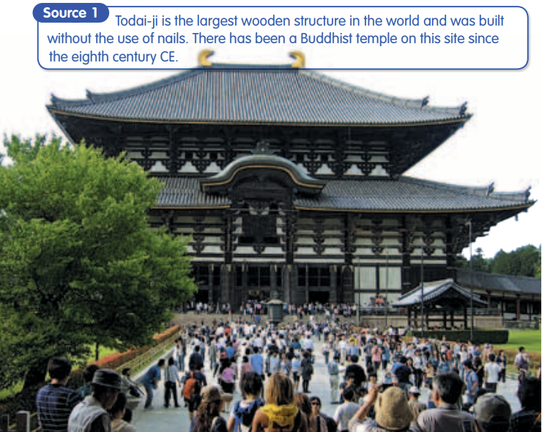

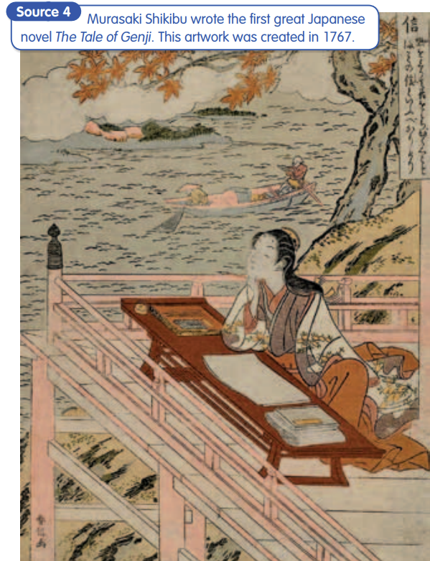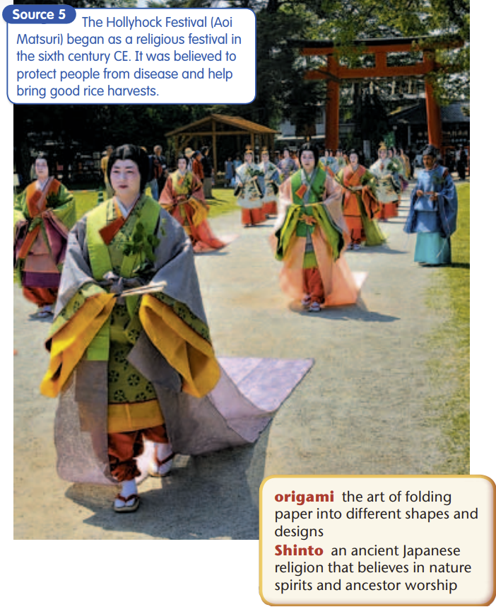
Traditions and festivals
Many traditional festivals and religious ceremonies are still practised in Japan today. Some of these have not changed for many hundreds of years so can provide valuable information about the way of life of Japanese people in past centuries.
Literature
Many great works of early Japanese literature also survive, and these reveal many aspects of life in the past. Murasaki Shikibu, sometimes known as Lady Murasaki, was the author of the first great Japanese novel, The Tale of Genji, written over 10 years between 1000 and 1010 CE. Although this is a work of fiction, it provides us with a great deal of information about the life of the wealthy and influential aristocrats of this time.

- What can Source 1 tell us about the importance of religion in traditional Japanese society? What is the unique technology used in the construction of this temple?
- Study Source 2 . This statue was cast in bronze. Use your dictionary or an encyclopaedia to find out more about the words ‘cast’ and ‘bronze’.
a. What two metals make up the alloy bronze?
b. Draw and label a sketch of the casting process to explain how this statue was made.
c. What conclusions can you draw about the metalworking skills of craftsmen in the Kamakura period?
- Examine Source 3 and answer the following questions:
a. What does this source tell us about farming methods used in Japan in the past?
b. Describe the typical clothing worn by Japanese peasants at this time.
c. What other activity can you see in this source? What might this tell us about traditional Japanese leisure activities?
- Examine Source 4 . How can we tell that Murasaki Shikibu was a member of the wealthy classes?
- Carefully examine Source 5 . The costumes used in the Aoi Matsuri procession are copies of garments that no longer exist. What historical evidence could modern designers use to find out what the original clothing looked like?

