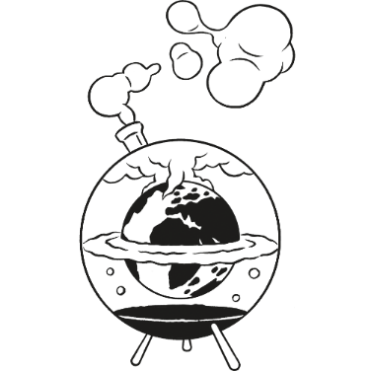
Science as a Human Endeavour Task
The purpose of this task is to investigate Science as a Human Endeavour
by summarising an article and discussing its connections to SHE.

Task instructions:
- Search for “climate change” or another topic of Global Systems on
https://www.kidsnews.com.au/
Choose an article which has a Quick Quiz (scroll to the bottom of the article to check).
Write down the reference for this article using the correct format.
Referencing example
Larson, C 2020 ‘Antarctica’s hottest day ever recorded’, KidsNews, https://www.kidsnews.com.au/weather/antarctica-records-hottest-ever-day/news-story/11d597b9bb9bb85839b03197aa1d28f5, accessed 27 April 2020

_________________________________________________________________________________________________________________________________________________________________________________________________________________________________

- Read and/or listen to the article, then answer the Quick Quiz:

Question 1: _________________________________________________________________ ___________________________________________________________________________
___________________________________________________________________________
Question 2: _________________________________________________________________ ___________________________________________________________________________
___________________________________________________________________________
Question 3: _________________________________________________________________ ___________________________________________________________________________
___________________________________________________________________________
Question 4: _________________________________________________________________ ___________________________________________________________________________
___________________________________________________________________________
Question 5: _________________________________________________________________ ___________________________________________________________________________
___________________________________________________________________________

- Describe how each of the four SHE concepts is shown (if relevant) in the article:
- Communication and Collaboration: ___________________________________________
______________________________________________________________________________________________________________________________________________________
- Development: ____________________________________________________________
______________________________________________________________________________________________________________________________________________________
- Influence: _______________________________________________________________
______________________________________________________________________________________________________________________________________________________
- Application and Limitation: _________________________________________________
______________________________________________________________________________________________________________________________________________________

The key concepts of Science as a Human Endeavour are:
Communication and Collaboration
- Scientists share discoveries with other scientists around the world
- Scientists compare results with experiments done in the past
- Scientists help governments make decisions
- Scientists work for companies to research new ideas
Development
- New theories are based on evidence from many subject areas
- New technologies improve scientific methods and measurements
- New evidence replaces theories and changes methods
Influence
- Fields of science (e.g. biology, chemistry, physics) relate to each other
- People’s culture determines the way they accept and use science
Application and Limitation
- Science can solve problems and answer questions
- Science can explain patterns and predict what might happen
- Science can cause unexpected consequences
- Science can be uncertain and lead to more questions

