DESIGN AND TECHNOLOGY WITHOUT A WORKSHOP?

The Question
What if you had to learn about Design and Technology but you couldn’t use the workshop? You are about to have a technology learning experience that will teach you that technology is everywhere, and we engage with it every day.
The Design Process
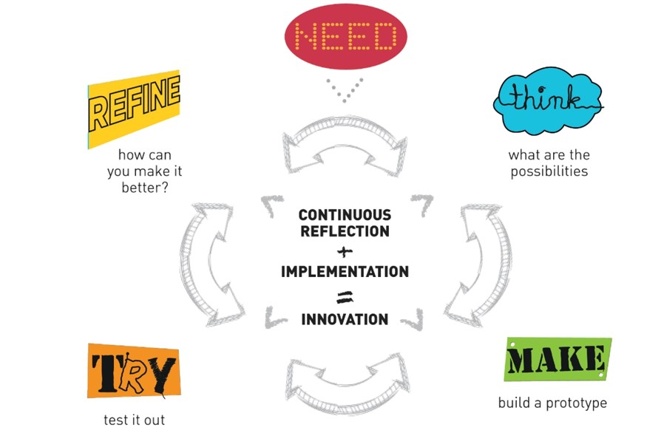

A continuous cycle which helps us work through ideas and helps us create new and exciting solutions to meet a need.
The design process can be applied to any problem that you may encounter. This thinking can be applied to most problems.

Task
Look around your home and find a piece of technology that is used in your home, this item may be something very simple or it could be something more complex. Our task is to look at the chosen item and consider the questions set out below.
The Australian Design and Technology curriculum requires students to develop their skills and knowledge of existing products and how they were made and how they might look in the future.
(The best way to complete this task is to save your own copy of this document as you will be adding images as part of the task)

Questions
- What is the product that you have chosen called?

Insert an Image Here

- How is the designed product used in your home?

- Who uses the product most in your house?

- Look at the product and list the different materials used in the manufacture (making) of the product?
(BE CAREFUL IF THE PRODUCT IS PLUGGED IN TO POWER TURN IT OFF FIRST)

- Where was the product made?

- Every product that we have today was originally designed by someone, if you can find out who designed the first of your chosen product and find images that show how the product has developed over the years. (a good example of product development over time would be the vacuum cleaner. Insert your own examples)
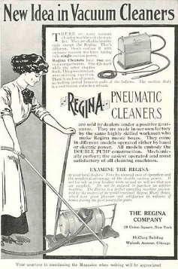
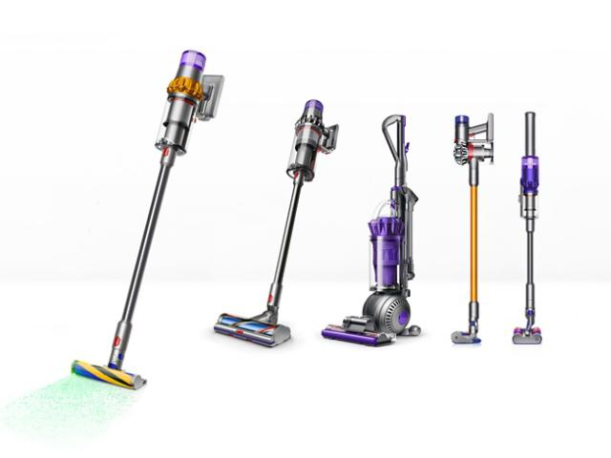

- Using the design thinking process above, think about how your chosen product could be improved in the future. What features or functions would you like to see added to the product?

- When this product gets old and stops functioning in a useful way it will have to be thrown out. Is the product you have chosen able to be recycled or reused?

When you task is complete, Email your written work to your teacher.

