Design and Technology Minecraft House Design

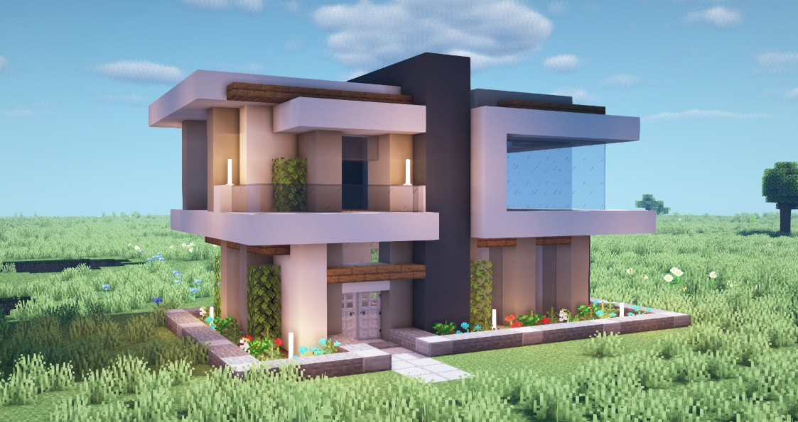
Learning Intention: The Australian Curriculum requires students to” consider the ways characteristics and properties of technologies can be combined to design and produce sustainable designed solutions to problems for individuals and the community, considering society and ethics, and economic, environmental and social sustainability factors.”

Task
You are to design a home using Minecraft that will meet the following criteria:
- Provide a family with all of the amenities expected in homes like the one you live in.
- Must have separate bedrooms, bathroom and kitchen space.
- Must have at least 2 sustainable technologies incorporated in the design.
Once your design is complete open a word document and write an evaluation of your design. You can take some screen grabs by using press the F2 key to take a screenshot. The screenshot will be saved to a particular Minecraft folder — you can find it by searching for ". minecraft\screenshots" on your computer.
Use your screen shots to illustrate an evaluation of your design, the points to cover in the evaluation are:
- Explain your design and some of its features.
- How is your design sustainable and energy efficient.
- Did you find the task difficult or easy, explain which parts of the task challenged you the most.
- If you repeated the task what would you change in your next design?

