YEAR 7 Computer Aided Design Task
Learning Intention:
Use Computer Aided Design software to design a structure to shelter at least 2 adults and one child. This shelter should be suitable for transport to an area which has been affected by a natural disaster. The building should be able to store its own water supply and generate its own power. This task will build skills using basic CAD software such as Google SketchUp.
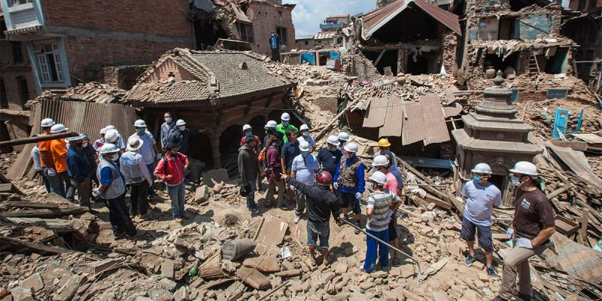

Task
- Investigate recent natural disasters that have led to many people being made homeless. Write a paragraph describing the event and how many people were displaced. (150 words)
- Look at existing emergency shelter designs and critique (tell what is positive or negative) about the design you feel is best. (100 words)
- Use Google Sketch up or other CAD software to draw your designed shelter including interior fittings.
- Evaluate your design and the process you went through to produce your design. (200 Words)

Curriculum Link:
- Investigate the ways in which products, services and environments evolve locally, regionally and globally and how competing factors including social, ethical and sustainability considerations are prioritised in the development of technologies and designed solutions for preferred futures (ACTDEK029 )

- Analyse ways to produce designed solutions through selecting and combining characteristics and properties of materials, systems, components, tools and equipment (ACTDEK034)

