Crepes Suzette Created by Laurent Branover Cuisine: French Serves 4

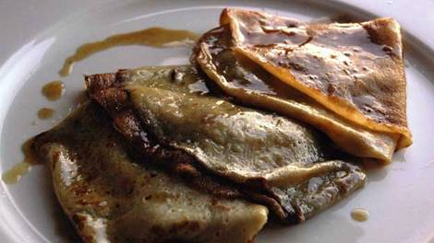
Ingredients
Crêpe
1 1/3 cup plain flour
350ml milk
2 egg
2 tbsp. caster sugar
Pinch salt
Suzette butter
80g butter, softened
2Tblsp caster sugar
2 orange, juicedPreparation
Crêpe
In a large bowl combine the flour, salt and sugar and make a well in the centre.
Whisk the egg and the milk together and slowly add to the flour until the mixture is very smooth and runny.
You can now leave it to rest while you make the Suzette butter.
Suzette butter
Combine butter and sugar and stir until smooth, add the orange juice and combine well.
To cook crêpes
Heat a large frying pan over a medium heat.
Add a small amount of butter (about 1/2 tsp.) to the frying pan, when it has melted add a ¼ cup of crêpe mixture, tilting the pan to coat it evenly. Cook the crêpe until golden at the edges and turn to cook other side.
Continue with this process until all the batter is used.
Assembly
Heat your pan over a low heat, add 2 tbsp. of Suzette butter and when it melts (no colour), place a crêpe in the pan. Cover both sides of the crêpe in the butter and fold it in four, put it on your plate.
Add some more of the Suzette butter and do the same for all your crêpes. Pour any extra melted Suzette Butter over your plate of crêpes.

