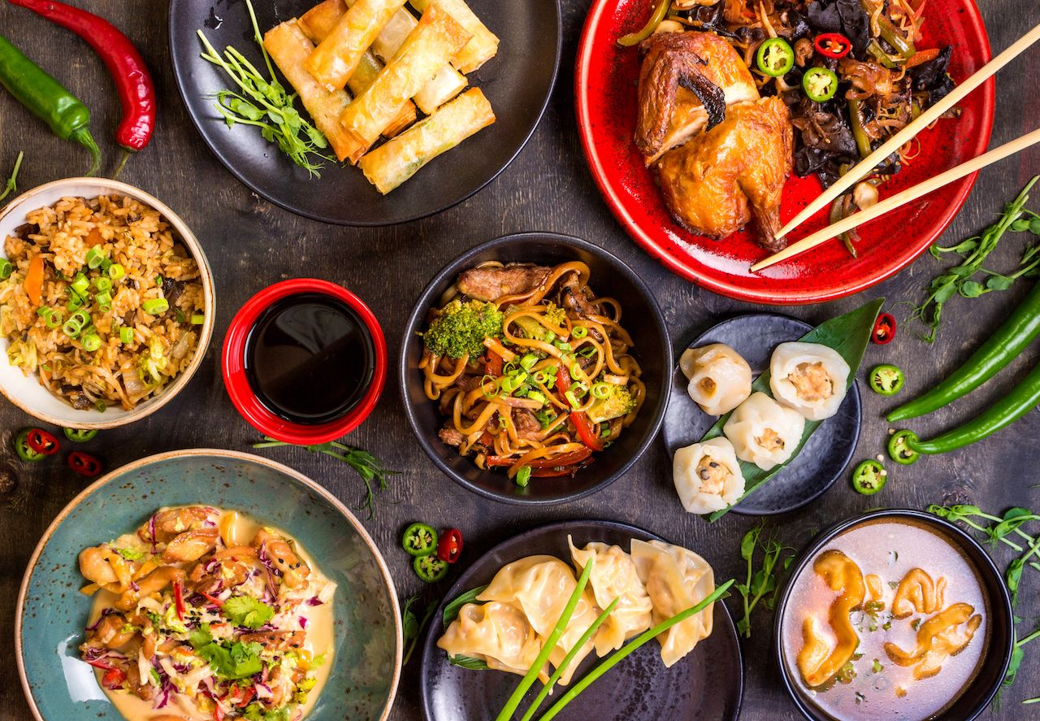
Tastes of the World
Product Design Assignment

Design Brief
You are an employee of a start-up food business hoping to break into the competitive Adelaide food scene. Your job is to create a range of cultural based food products that will be suitable to sell to members of the Adelaide community. In pairs you must make, refine and package one of these food products. As part of your role you will be required to research, design, create and justify your decisions to help ensure the success of your business.
The product you decide to make will need to be made in a 90 minute lesson and you should attempt to challenge your skill level, whilst working safely with the appropriate tools and equipment.

Constraints and considerations (Individual)

Considerations (flexible factors that allow the product to be changed/modified) | Constraints (inflexible factors that must comply to the design brief)

Investigation (400 – 500 words) (Individual)
Investigate factors that influence the design of products for food businesses; use the following questions to guide your investigation. (Remember to reference your information)

- A brief outline of county chosen
- What are some typical ingredients and dishes from this country, how are these ingredients typically prepared and why?
- What types of changes have people made to your chosen countries food to suit the Australian market, and why has this change been made?
- What are the legal requirements for packaging and labelling food in Australia?
- What other issues do people working in the food industry need to consider when producing food products, and why?

Market Research (Individual)
Look at the example foods provided and make observations on what types of food products available, how are they packaged etc
Product | Is the packaging appealing and why? | Is the product clearly marked with information? | Is the product traditional or is it an Australian fusion of the product?

What did you notice from your observations which will be useful when developing your product range? Explain Why?

Inspiration Board (Individual)
For those who don't already know, an inspiration board (sometimes referred to as a mood board or an idea board) is a collage of annotated images meant to kick-start your imagination.
Your board must include pictures, information, materials and or any other relevant ideas.

Final Product Design and Pitch (as a group)
Based on your inspiration board sketch and label your final design idea including the following details:
- Recipe
- What specific details or features will be included
- Packaging
- Labelling, including nutritional information and storage
- Colours
- Presentation idea
- Any other necessary details

You will need to present this to the class for feedback and then make the necessary changes to your product based on the feedback that was given

Justification of Design (200 words minimum) (Individual)
Justify why you have chosen to make this product, use the following to help guide your explanation:
Why have you decided to make this type of product? Reasons could included:
- Look
- Country and Ingredients
- Target Audience
- Purpose
- Techniques used/ skill level
- Packaging
- Colours/presentation
- Time management

Practical (as a group)
You are to make your final practical product with all your modifications and present at the end of the double lesson (90minutes)
Complete a food order and time plan to be handed up with your recipe 1 week before the practical application.

Evaluation (400-500 words) (Individual)
Use the following questions to guide your evaluation of the assignment:

- Did your final product range meet the criteria that you identified in your criteria for success? Why/Why not?
- How does your product range compare to a commercially produced equivalent?
- What did your do well in the practical and why?
- What didn’t go so well for you in the practical and why?
- Was your planning sufficient? Were you able to follow your steps easily or did you have difficulty following them? Explain.
- If you were to make these products again what changes would you recommend and why?

Year 9/10 Product Design Assessment Criteria
 | WA | AE | E | BE | WB
Investigation/Market Research | comprehensive explanation of how people working in design and technologies occupations consider:  - factors that impact on design decisions  - the technologies used to produce products, services and environments | detailed explanation of how people working in design and technologies occupations consider:  - factors that impact on design decisions  - the technologies used to produce products, services and environments | explanation of how people working in design and technologies occupations consider:  - factors that impact on design decisions  - the technologies used to produce products, services and environments | description of how people working in design and technologies occupations consider:  - factors that impact on design decisions  - the technologies used to produce products, services and environments | statements about how people working in design and technologies occupations consider:  - design decisions  - the technologies used to produce products, services and environments
Pitch | comprehensive and effective communication and documentation of design ideas | effective communication and documentation of design ideas | communication and documentation of design ideas | partial communication and documentation of design ideas | fragmented communication of design ideas
Design | creation of a sophisticated designed solution, with discerning creation, adaption and refining of their design ideas | creation of a effective designed solution, with informed creation, adaption and refining of their design ideas | creation of a designed solution; as well as adapting and refining of their design ideas | creation of some of a designed solution, with some consideration given to adapting design ideas. | Limited creation of a designed solution.
Justification | discerning justification of decisions | informed justification of decisions | justification of decisions | Statements of decisions | Partial statement of decisions
Practical Techniques | proficient production of high quality designed solutions suitable for the intended purpose by selecting and using appropriate technologies skilfully and safely | effective production of high quality designed solutions suitable for the intended purpose by selecting and using appropriate technologies skilfully and safely | production of high quality designed solutions suitable for the intended purpose by selecting and using appropriate technologies skilfully and safely | guided production of designed solutions for the intended purpose by selecting and using technologies safely | guided production of designed solutions for a purpose by using technologies safely
Practical Management | application of sequenced production and management plans when producing designed solutions:  - making discerning adjustments to plans when necessary  working independently and collaboratively | application of sequenced production and management plans when producing designed solutions:  - making informed adjustments to plans when necessary  working independently and collaboratively | application of sequenced production and management plans when producing designed solutions:  - making adjustments to plans when necessary  working independently and collaboratively | use of production and management plans when producing designed solutions:  - making adjustments to plans  working collaboratively | use of plans when producing designed solutions
Evaluation | use of detailed criteria for success to make a discerning evaluation of:  - their ideas  - designed solutions  - processes | use of detailed criteria for success to make an informed evaluation of:  - their ideas  - designed solutions  - processes | use of detailed criteria for success to make an evaluation of:  - their ideas  - designed solutions  - processes | use of detailed criteria for success to make a partial evaluation of:  - their ideas  - designed solutions  - processes | use of detailed criteria for success to make a fragmented evaluation of:  - their ideas  - designed solutions  - processes

