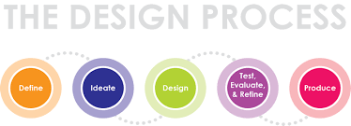

The Need – Problem (Something that requires a designed solution)

Design Brief (A short statement that guides the designer providing specifications and constraints it should not restrict creative solutions)

Possible Solutions (Based on existing similar products/solutions)
Positives

Negatives

IMAGE HERE

Positives

Negatives

IMAGE HERE

IMAGE HERE
Positives

Negatives

Conclusion: What I have learnt from considering existing solutions.
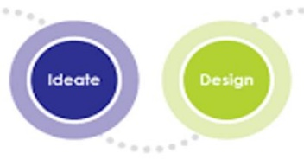

The Solution
Intention

Investigate the How to?
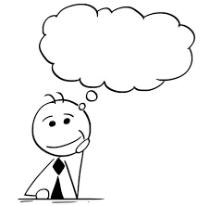
Specifications (size, style, colour etc)

Joining Methods (fixing, joints, adhesives, welds)

Materials (type of timber/metal/plastic/composite)

Finishes (paint, wax, polish)

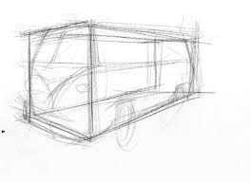
Drawings and Prototypes
Sketches

Working Drawings?
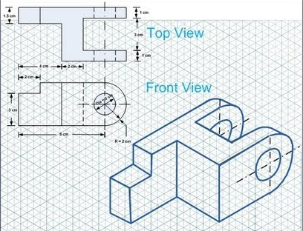
These are drawings which include all the detail required to produce the product designed. Information will include all dimensions in millimetres and annotations providing explanations of features not shown.
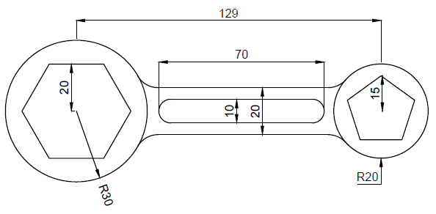

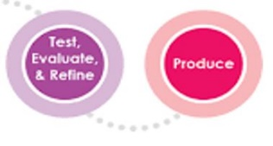
What components are required to create my design? (Cutting / Component list.)

CUTTING AND COSTING

NAME: _ _ _ _ _ _ _ _ _ _ _ _ _ _ _ _ _ _ _

PROJECT: _ _ _ _ _ _ _ _ _ _ _ _ _ _ _ _ _

PART | NUMBER | MATERIAL | LENGTH | WIDTH | THICKNESS | PRICE | UNIT | COST
TOTAL

Production and Modifications
The making process is an integral part of the design process as you test, prototype and refine your ideas. During this process you may need to revisit the planning and drawing steps to refine and modify the product. A record should be kept as evidence of your thinking and problem solving. It’s useful to take images of your progress.

Evaluation
This is the time to reflect on your product and the process and consider the following questions. Use an electronic document if you choose to expand on the evaluation.
What changes would be made to the process and product if you were to repeat this project?
The most challenging steps were..
The most rewarding step in this project was..
Did the completed project meet the design brief?
Describe the project, what was produced?
