DESIGN AND TECHNOLOGY
AUSTRALIAN INVENTIONS THAT HAVE CHANGED THE WORLD

Learning Intention: To consider how inventors and designers have made a huge impact on our world by thinking outside of the box and utilising the design process to create products that have had a major impact on society.
Task
Australia is a relatively small nation when measured against the population numbers of other countries but our “can do” spirit has led to some of the most important advances in science and technology seen globally.
Your task is to look at on invention or design that has had a significant impact on the world we live in. Remember that when we talk about a product it can be something physical that you can hold an interact with or it can be a system eg software.
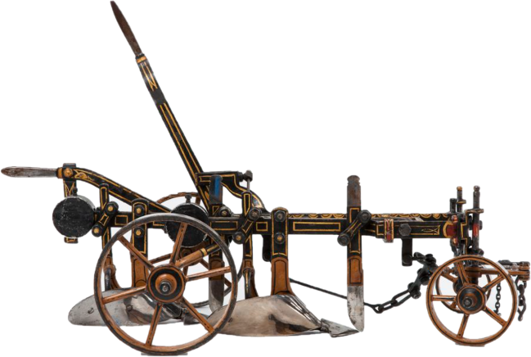
To start you off here is a list of Australian inventions that you may choose to research:
- The black box
- Cochlear Implants
- Spray on skin
- Google Maps
- Hills Hoist
- The pacemaker
- WiFi
The products and systems listed above are just a few, you may want to research another Australian product as there are many more ground-breaking Australian inventions.
Your response should be around 500 words and can be submitted as a Word document or PPT presentation.
Points that must be included:
- Who created the product, was it an individual or a group?
- When and how long had they worked on the idea?
- Describe the product and its function and impact on our world.
- Is the product still being used today?
- How has the product evolved/improved over the years since its invention?
- Does this product impact your own personal life and how?
- Are there any improvements that could improve the product in the future?

