Heritage College Design and Technology
Joining Techniques – Timber

Screws and Nails
Screws:
Can be used as a permanent or semi-permanent fastener. They provide a join that is stronger than nailing and can be removed without further damaging the timber. The spiral thread turns its way into the wood firmly embedding itself in the wood fibres providing significant holding power. Screws are produced in a wide range of sizes and thread and head configurations to suit specific applications.
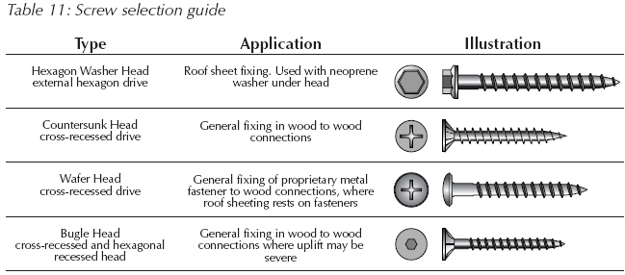
http://www.timber.net.au/images/stories/trusses/trusses_table_11.jpg
Nails:
Most nails are made of mild steel wire. Nails can also be coated to prevent rusting and in some cases they are made from materials like copper which allow them to be used for special applications such as boat building.
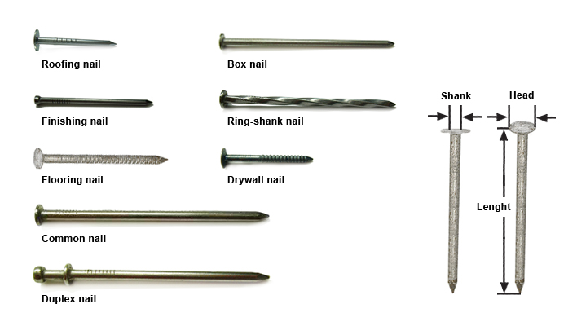
Nails are ordered by length and diameter in millimetres and can be purchased by weight. Nails have a wide range of head shapes which suit different applications.

Holding Power
Both nails and screws provide a holding force which allows timber to be joined effectively. The ability of a nail or screw to provide a strong join is dependent on the techniques used and the properties of the timber being joined.
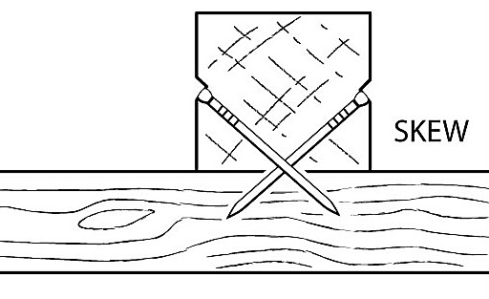
Both types of timber fixings require the fibres of the timber to apply pressure to the screw or nail to ensure there is a holding force. To maximise the holding force nails can be driven into the work at angles, this is often referred to as “skew nailing’ and in cases where a bullet head nail may “pull through’ the timber a flat head nail should be used.
Screws also require correct selection and technique to ensure the holding power is maximised. When screwing into softwoods a clearance hole should be drilled in the top timber element which allows the shank of the screw to pass through with minimal interference. In Hardwoods a clearance hole is required as well as a pilot hole in the bottom timber element. The pilot hole should be drilled to match the “minor” diameter of the screw allowing the thread to bite.
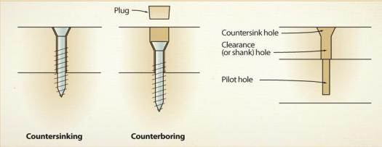
If correct technique is used the head of the screw will provide a clamping force against the timber maximising the holding power of the screw.

https://www.canadianwoodworking.com/get-more/common-wood-screw

