Heritage College Design and Technology
Year 10 Woodworking Adhesives

- Give the full name of PVA Adhesive.
- How many surfaces of a joint must be covered when using PVA?
- What method should be used to remove excess PVA from timber?
- What happens if PVA glue is not completely removed from a timber surface which is to be polished?
- List 6 characteristics of PVA glue.
- What does the term “cross linking” refer to in PVA adhesives?
- Explain the main feature of contact adhesives.
- List two characteristics of contact adhesives
- What are the main applications for contact adhesives?
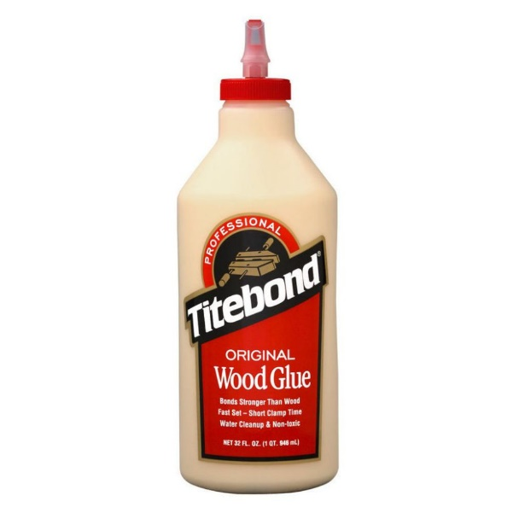
- Name two types of adhesives which are set by chemical reaction?
