When utilising solid timber in a woodworking project there a generally limitations in the width of the materials available for the construction of components such as table tops. This limitation can be overcome by joining boards edge to edge.
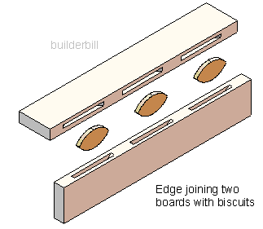
Some of the most common widening joints are Butt Joints, Dowelled Butt Joints, Tongue and Groove, Groove and Feather, Rebate Joint and Butt Plate Joints.
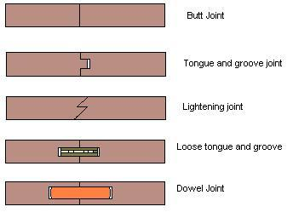

Butt Joints
The edges of butt joints are square, butted together and glued in place. Butt joints are used to join a number of narrow boards to produce a wide board. Many table tops are made in this way.
Dowelled Butt Joints
A similar joint to a standard butt joint but added strength is provided by inserting dowels. Biscuit jointing can be a simpler substitute to using dowels if a biscuit cutter is available.
Tongue and Groove Joint
A tongue on one piece of timber fits into a groove on the second piece of timber to form this joint. This type of joint is common in solid timber flooring and match board paneling products.
Groove and Feather
A groove is produced in the edge of each board to be joined and a strengthening feather (thin piece of material) is inserted to lock the boards together. This joint is used in flooring and benchtop construction.
Rebate Joints
The edges of each board are rebated. This provides a larger surface area for adhesive bonding giving extra strength to the joint.

