Heritage College Design and Technology
Year 10 Woodworking Adhesives

Adhesives are bonding agents. The wide range of adhesives includes some which will bond dissimilar as well as similar materials.
PVA (Polyvinyl Acetate)
PVA is generally a white plastic emulsion which is clear when dry. It can be purchased in plastic bottles, tubes and in bulk containers. Some PVA adhesives have added chemical compounds which react to create a stronger bond, these PVA adhesives are commonly referred to as cross linking or compounded PVA.
A plastic squeeze bottle is generally the ideal container for storage and application. For large surfaces it is more convenient to use a spreader or brush to ensure even coverage. The adhesive can be applied to only one surface but the surfaces must be brought together while the PVA is still wet.
Excess glue must be wiped away immediately with a damp cloth otherwise any surface finish applied will show any remaining glue as a dull white spot on the surface. A reasonably strong joint will result after 20-45 minutes depending on the surfaces and rate of drying, a full strength bond may take 12-24 hours. Light clamping is advisable in the initial 20-45 minutes.
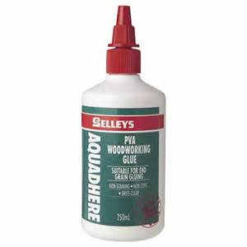
Characteristics of PVA
- Used Cold
- No mixing is required
- Non-toxic
- Has gap filling properties
- Poor water resistance
- Will keep indefinitely in a sealed container
- Does not stain and dries clear
- Heat will soften PVA
- Not recommended for high strength permanent loads
- Suitable for porous surfaces only
Other Woodworking Adhesives
Woodworkers can call on a number of different adhesive types to join timber projects. Contact adhesives are useful for joining dissimilar materials and laminated finishes. Epoxy or chemical set glues are extremely strong and can also be used to join materials such as wood and metal together. Adhesives that use chemical set techniques often consist of a two-part reaction using a hardener or catalyst which react and create a fast setting bond. Examples of epoxy or chemical set glues would include products like Araldite and Cyanoacrylate flash glues.

