Year 10 Metalwork Lathe Operations

1. When using the metal lathe, safety glasses are needed when?
A. While turning pieces at high speeds
B. While turning pieces at slow speeds
C. Only when starting the machine
D. During all lathe operations

2. A Metal lathe is only used for turning metal?
A. True
B. False

3. A manufacturing process, typically conducted on a lathe, whereby a visually-attractive diamond-shaped (criss-cross) pattern is cut or rolled into metal is called .
A. Facing
B. Knurling
C. Tapering
D. Threading

4. While knurling, extra amounts of lubrication should be used?
A. True
B. False

5. Check the boxes that are correct. The lathe performs what kind of functions.
A. Sanding
B. Knurling
C. Welding
D. Cutting
E. Drilling
F. Extruding
G. Bending

6. The lathe uses a _ _ _ _ _ to hold the material.

7. What two types of chucks can be used to hold material while working with the lathe?

8. You should remove all baggy clothing, jewlery and tie long hair up out of the way.
A. True
B. False

9. Always remove the _____________________ before engaging the lathe.
A. Safety guard
B. Cutting tool
C. Chuck wrench
D. Metal chips

10. NEVER try and stop the lathe from moving with your hands.
A. True
B.False

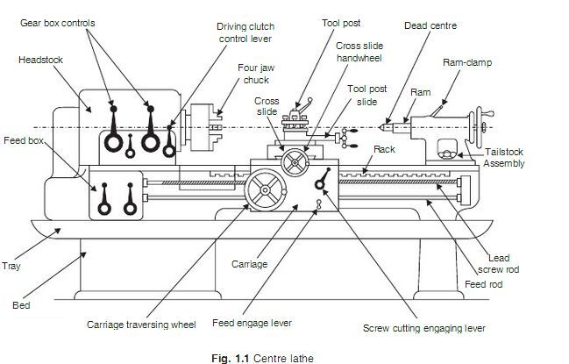

A typical Metal Centre Lathe: Label the missing parts.
- Tool Post 5. Tailstock Assembly
- Carriage 6. Chuck
- Carriage Traversing Lever 7 Cross Slide
- Headstock 8 Dead Centre

Explain the following basic Lathe operations. (At least a sentence is required for each.)
- Parallel Turning
- Facing
- Taper Turning
- Knurling
- Parting Off

