

**Heritage College Design and Technology**

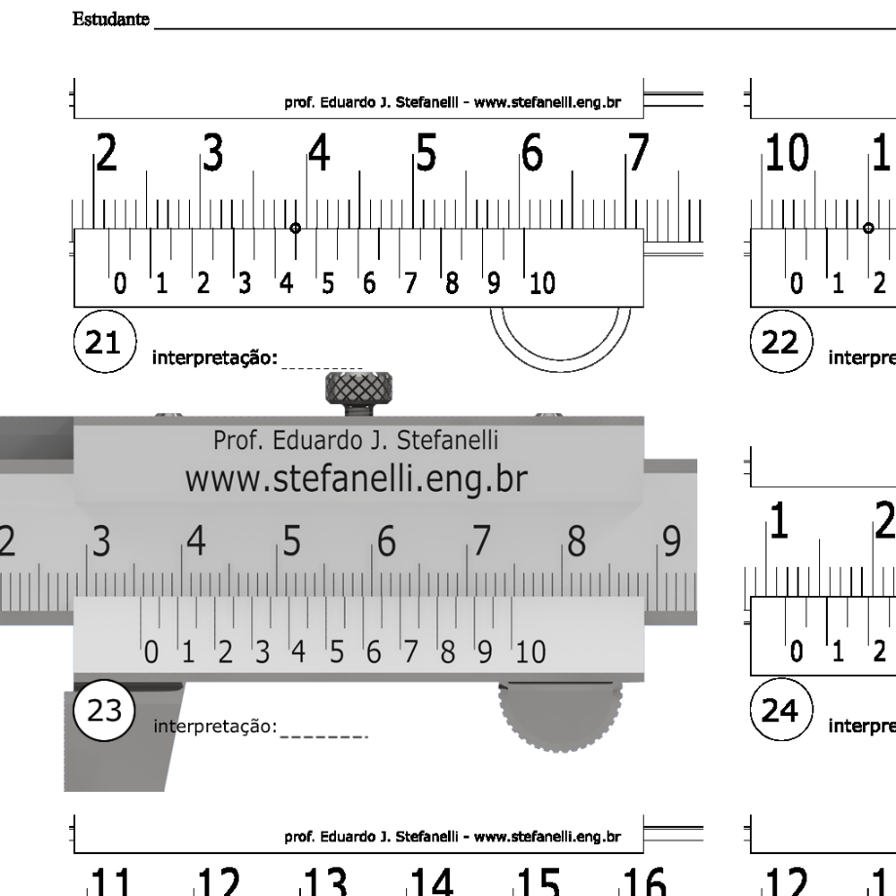**Using Graduated Measuring Devices**

Vernier’s often have both Metric and imperial graduations. The Metric graduations are usually on the bottom. The slide section is graduated in 0.01 mm increments.

**Vernier Caliper**

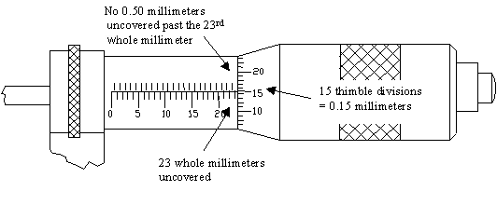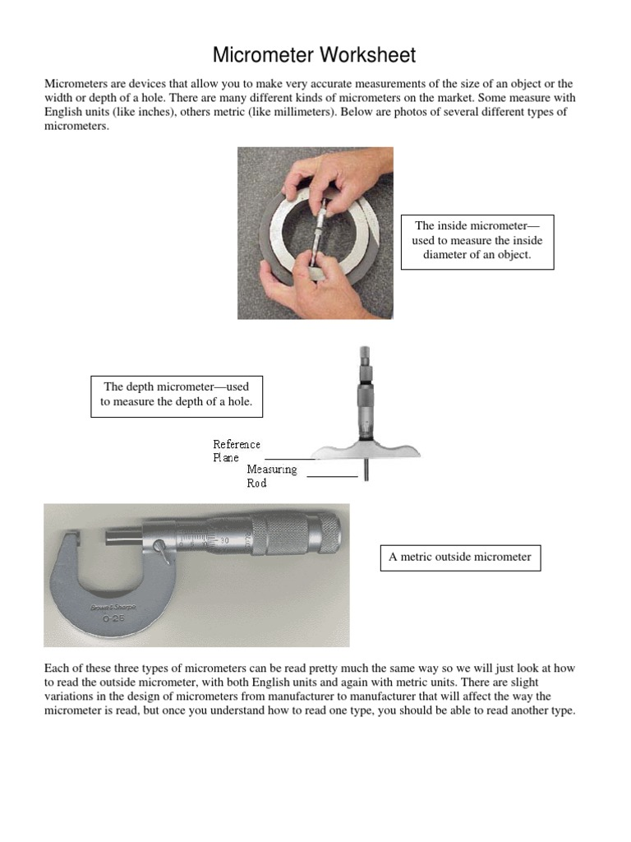

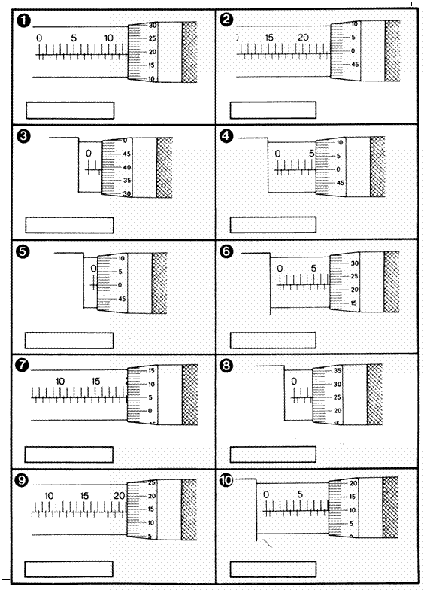

Fill in the measurement shown on the Micrometers below.