Heritage College Design and Technology
Using Constraints in Assemblies
Learning Intention: Students will use this tutorial to aid assembly construction in Autodesk Inventor.
- -After creating the separate parts in Inventor and saving them, open a new assembly and use the place icon to bring components into the assembly. Use the right click to orient the parts ready for constraining.
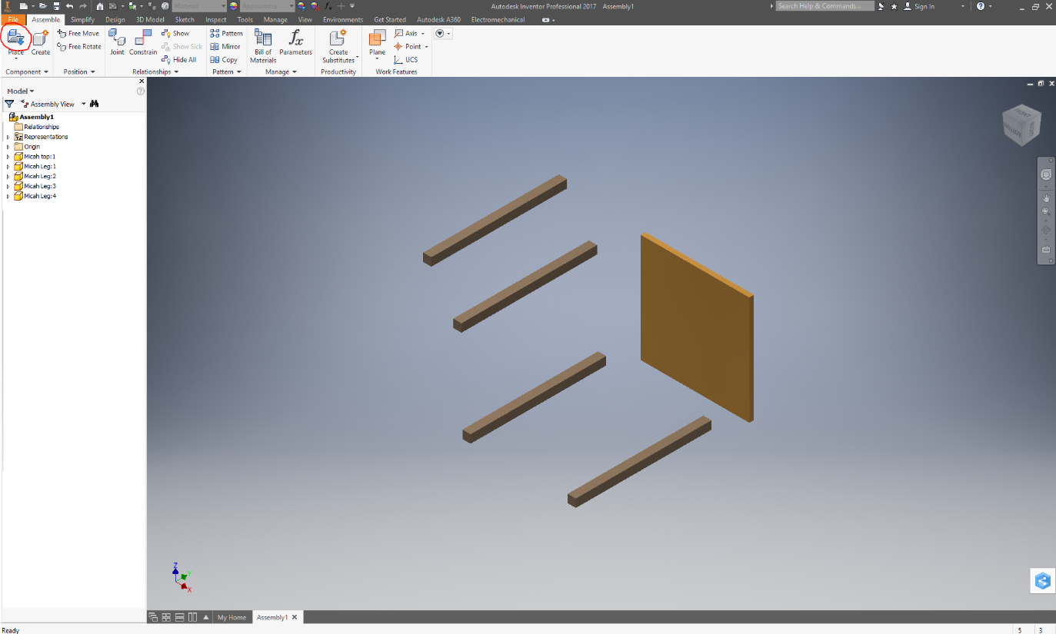
- Right click on the first part you placed into the space (this will usually be a major component that the other components fit into) and click on Grounded. This will anchor this part and allow you to constrain other parts to it without it moving.
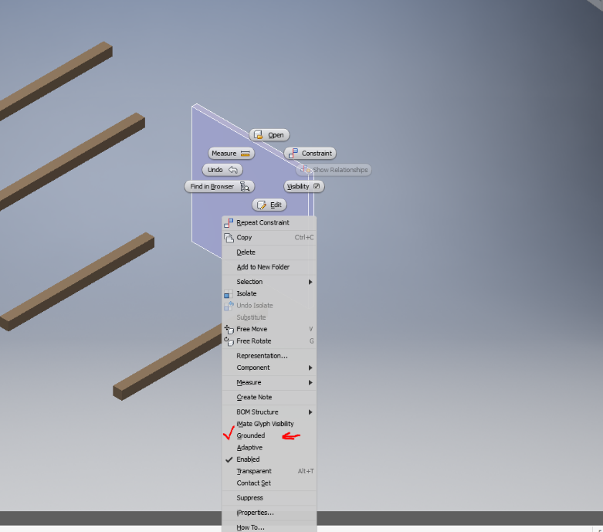

- Now select the simple constraint icon and select the edges that you would like to join together. Your first constrain number 1 and the first solution as shown. We will select the edges highlighted
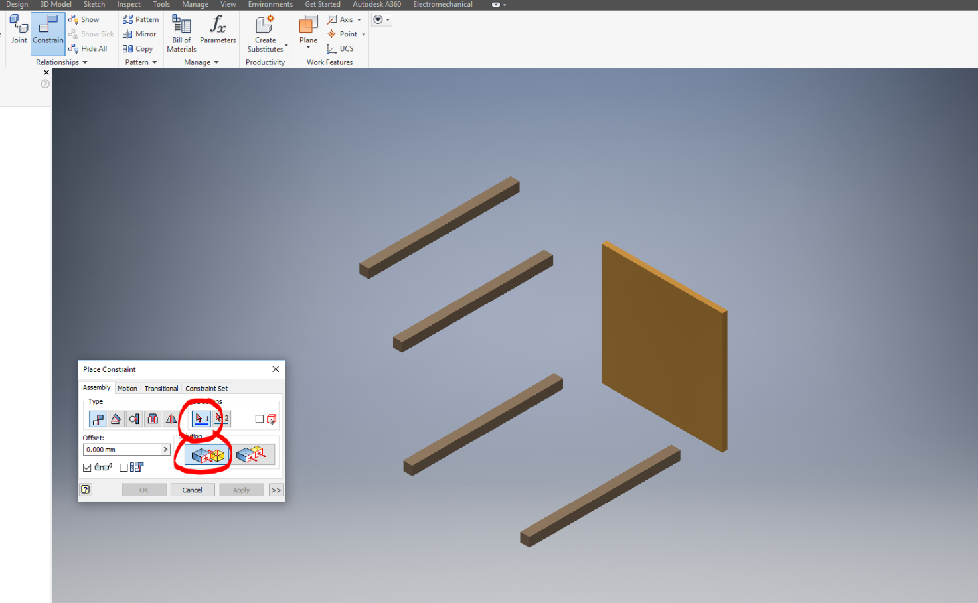
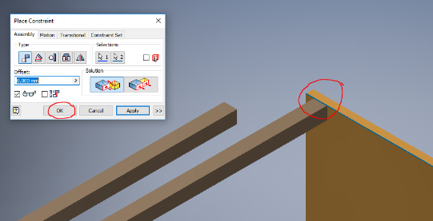
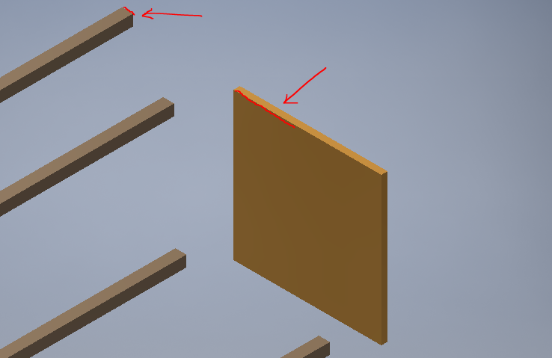
After clicking on both of the edges they will snap together as shown.

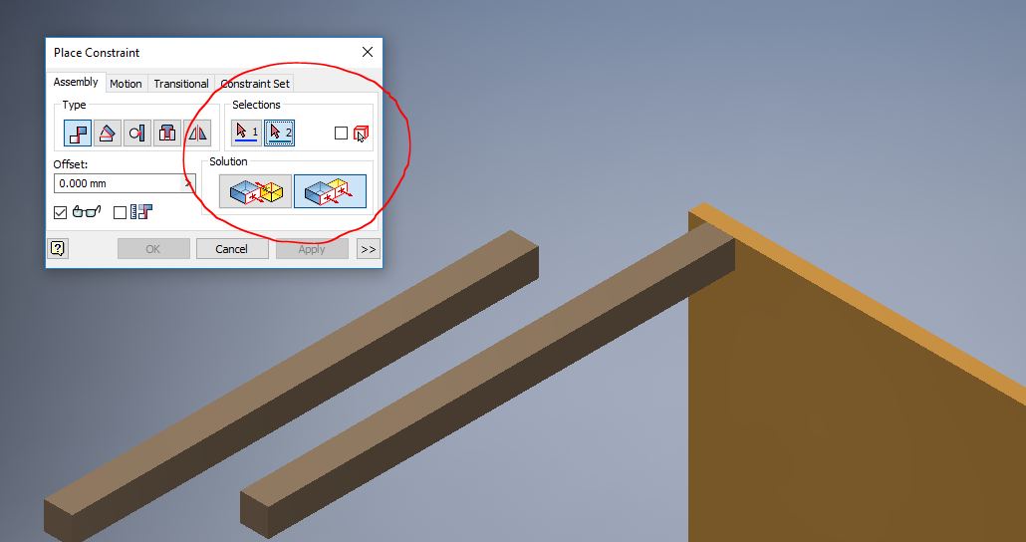
- To place this 15mm in from each edge we will use the number 2 constraint and the flushing solution.

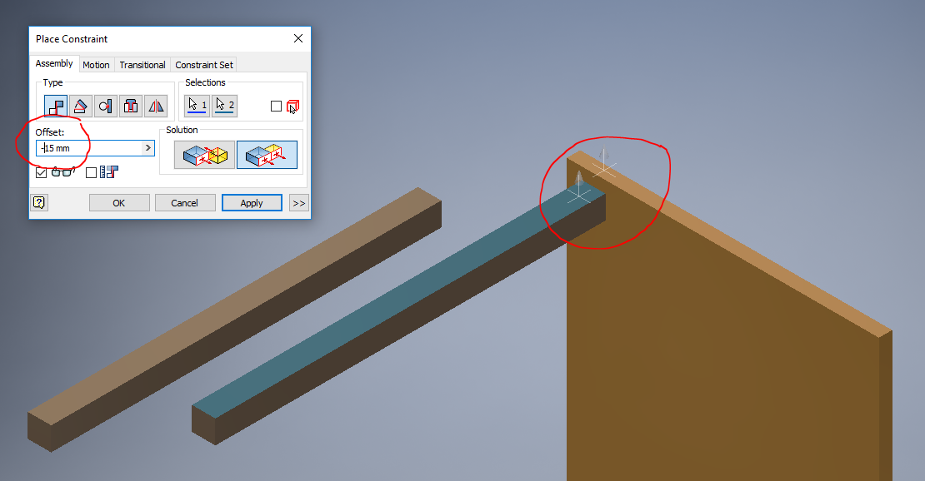
Click on both faces that you wish to flush as shown and type in the offset that is needed in this case minus 15 mm. Repeat this for each of the legs and offset from each edge by the desired amount.

If you have completed these steps you will be able to assemble your design using the constraint commands. You will need to think of which edges to constrain together to achieve the desired outcome in each case. Remember if you get it wrong hit the back arrow icon and try something different.

