Heritage College Design and Technology

Cabinet Construction Skills Task
Wall Mounted Cabinet
Context and Need Statement
You are required to explain the need for which you will be designing and making your wall mounted cabinet.
- In this task the need is set by the teacher within the context of allowing students to demonstrate skills such as:
- Reading a working drawing
- Machining materials safely accurately and efficiently.
- Constructing the designed piece.
- Inclusion of at least one design feature of your choice.
Design Brief
In this statement you will write what you will do in response to the need set out above.
- This brief is set by the teacher but your next project will be completed to your own brief based on your need statement.
- Construct a cabinet to design specifications, demonstrating the skills set out above.

Investigation
Supply the following facts and information.
- The basic size of your door is: Height…………. Width……………. Depth to specification.
- Three design ideas for your cabinet. This may include door design, storage and internal or external decorative features.
- Type of door e.g. solid, match board inset.
- Type of finish to be applied

Design Development

- Draw a pictorial or isometric view of your cabinet to show your design idea. This drawing does not need to be dimensioned but should include appropriate shading etc. (CAD can be used).
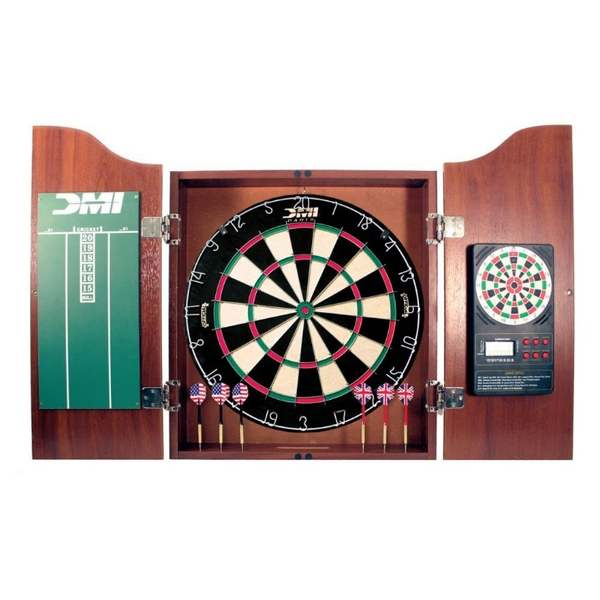
- Prepare a costing and cutting list for the project.

