Specialised Skills Applications Task 1
Hall Stand

Learning Intention
Students will produce a hall table under guided instruction from their teacher as well as orthogonal drawings.
The project will use a range of tools, machines and power tools. This skills task should give students a range of skills needed to produce their designed product. Students will evaluate the table against the drawings and example.
Assessment: 2021 Performance Standards
Producing 1
Evaluating 1
Task
Produce a solid timber hall stand utilising machine jigs and furniture construction techniques. The project allows students to demonstrate the development of skills and knowledge to produce and evaluate the product safely and efficiently.
Evidence will consist of a finished product and evaluation of the product and process undertaken.
(500 Words)
Constraints/Specifications
- The product will be constructed from drawings supplied.
- Machined and constructed to specification.
- Solid timber jointing techniques – dowel, mortise and tenon, bix, Kreg. As drawn in Skills Task 2.

Focus Areas
- Selection of appropriate timber

- Safe and Effective use of Machinery

- Joints – Alignment and fit

- Fit and finish prior to polishing

DUE DATE: Week 2 Term 2

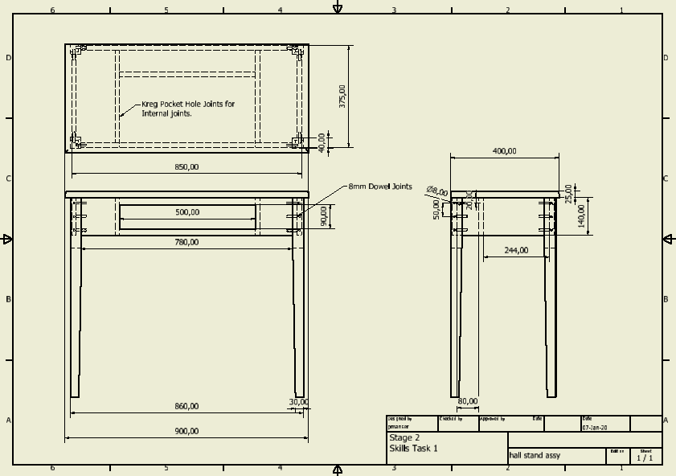
Performance Standards for Stage 2 Design, Technology, and Engineering
- | Investigation and Analysis | Design Development and Planning | Production | Evaluation
A | Comprehensive and insightful analysis of the design features of products, processes, materials, systems, and/or production techniques.  Purposeful research and critical analysis of ethical, legal, economic, and/or sustainability issues. | Insightful and comprehensive communication of design concepts. using relevant technical language and visual representations.  Insightful and thorough planning, development, testing, and validation of design concepts and procedures. | Highly proficient application of skills, processes, procedures, and techniques to create a solution.  Comprehensive development of solutions to technical problems that arise during the solution realisation. | Comprehensive and insightful evaluation of the solution features, realisation process, and/or response to issues.
B | Thoughtful and well-considered analysis of the design features of products, processes, materials, systems, and/or production techniques.  Detailed research and well-considered analysis of ethical, legal, economic, and/or sustainability issues. | Thoughtful and well-considered communication of design concepts, using relevant technical language and visual representations.  Well-considered planning, development, testing, and validation of design concepts and procedures. | Proficient application of skills, processes, procedures, and techniques to create a solution.  Thoughtful development of solutions to technical problems that arise during the solution realisation. | Well-informed and detailed evaluation of the solution features, realisation process, and/or response to issues.
C | Considered analysis of the design features of products, processes, materials, systems, and/or production techniques.  Research and some analysis of ethical, legal, economic, and/or sustainability issues. | Clear communication of design concepts, using technical language and some visual representations.  Competent planning, development, testing, and validation of some design concepts and procedures. | Competent application of skills, processes, procedures, and techniques to create a solution.  Development of solutions to technical problems that arise during the solution realisation. | Considered evaluation of the solution features, realisation process, and/or response to issues.
D | Identification of the design features of products, processes, materials, systems, and/or production techniques.  Some description of information about ethical, legal, economic, and/or sustainability issues. | Basic communication of design concepts, using some technical language.  Some planning and development of design concepts and/or procedures. | Basic application of some skills, processes, procedures, and techniques to create a solution.  Some endeavour to develop solutions to technical problems that arise during the solution realisation. | Some description of the solution features, realisation process, and/or response to issues.
E | Attempted identification of the design features of products, processes, materials, systems, and/or production techniques.  Some accessing of information about ethical, legal, economic, and/or sustainability issues. | Superficial and simplistic communication of design concepts.  Limited use of information to plan design concepts. | Limited application of emerging skills.  Attempted development of a solution to a technical problem. | Emerging recognition of the solution features, realisation process, and/or response to issues.

