DESIGN AND TECHNOLOGY WITHOUT A WORKSHOP?

The Question
What if you had to learn about Design and Technology but you couldn’t use the workshop? You are about to have a technology learning experience that will teach you that technology is everywhere, and we engage with it every day.
The Design Process
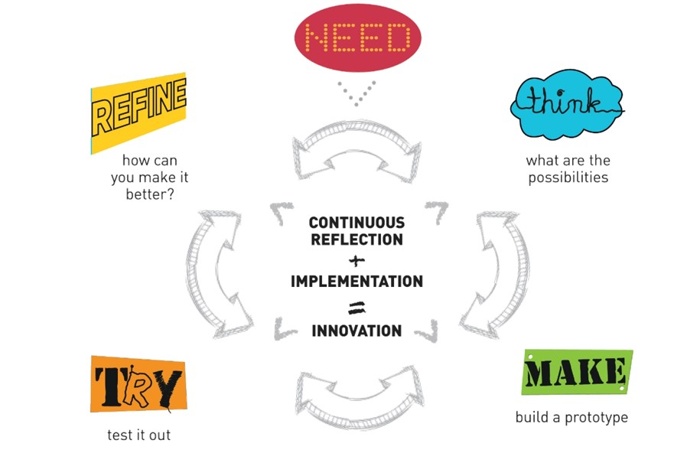

A continuous cycle which helps us work through ideas and helps us create new and exciting solutions to meet a need.
The design process can be applied to any problem that you may encounter. This thinking can be applied to most problems.

Task
During your time learning outside of school the same process can be applied to almost any project that you can imagine. This gives us lots of freedom to demonstrate our understanding whilst doing something that really interests us an.
Your task is to take on a project and use the process above:
Find a need or problem, keep it simple as you don’t have a lot of time.
- Think about and research the possibilities that may lead to a solution for your problem.
- Record your research and think about ways that you can improve or change the solutions to suit your need.

- Test your ideas by building part of your solution or even by making a prototype of the finished product

- Once you have tested the concept and found that it will work you can build the final product. If your tests reveal problems with your design, return to the thinking and refining stages. Once you have made modifications return to finish the product.
- Evaluate your finished product.

RESEARCH
Compare the product that you need to things that already exists that may help or solve your need. Critique the positive and negative aspects of the design you are looking at and make a judgement as to whether the existing product would suit your need.

------------------------------------------------------------------------------------------------------------------------------------------------------------------------------------------------------------------------------------------------------------------------------------------------------------------------------------------------------------------------------------

Product 1

------------------------------------------------------------------------------------------------------------------------------------------------------------------------------------------------------------------------------------------------------------------------------------------------------------------------------------------------------------------------------------------

Product 2

------------------------------------------------------------------------------------------------------------------------------------------------------------------------------------------------------------------------------------------------------------------------------------------------------------------------------------------------------------------------------------

Product 3

Evaluation Questions
- What did you make……why?

- How did you make it, what tools, materials and processes were involved? (see table format below)

- Which parts of the process were more difficult?

- Which parts of the process were easier?

- How did your finished product compare to the original plan?

- If you had the opportunity to repeat the project, what would you change and why?

Example table to record the making process.
Tools | Materials | Process
Tape Measure &  Pencil | Paper | Take measurements to create rough sketch with dimensions.
Tenon Saw | 140 x 19 mm Pine | Cutting materials to length

When you task is complete, Email your written work to your teacher.

