Activity
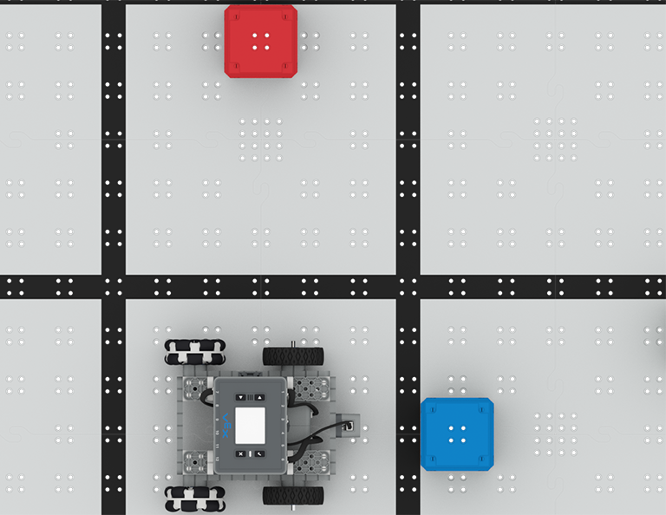 | At a Distance  Use the Distance Sensor to avoid cubes!

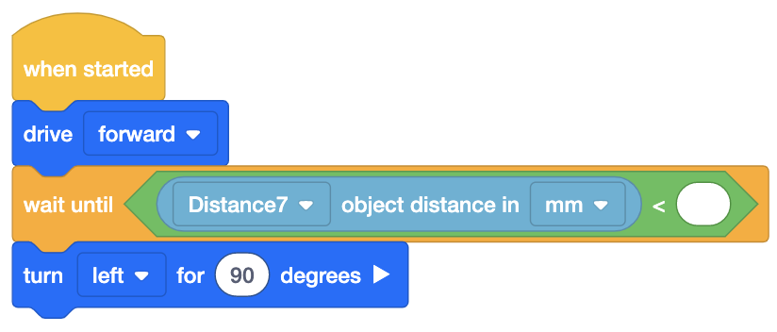
Step by Step
- Build the BaseBot and attach a Distance Sensor to the front plate. Open VEXcode IQ, open the BaseBot (Drivetrain 2-motor) template, and configure the Distance Sensor. Set up the Field by using Connector Pins to secure 2 cubes to the Tiles as shown in the above image.
- Build the code shown in the image to get started.
- The Distance Sensor reports the numbered distance between an object and the Sensor. When an object is closer to the Distance Sensor, the reading will be a smaller number. In order to stop driving before an object, the BaseBot must wait until the Distance Sensor reading is less than a designated amount. Add the parameters in the <Less than> block to stop driving before touching the cube.
- Start by having the BaseBot face a cube on the Field, as shown in the above image. Download and run the project to test.
- Add additional [Drive] and [Turn for] blocks to continue driving to the second cube and stop before touching the cube.
‘LEVEL UP’  - Swerving - Pin more cubes to the Field Tiles. Can you drive while avoiding them? | Pro Tips  - Printing the Distance Sensor reading using the [Print] block may help you better understand what values the sensor is reporting.  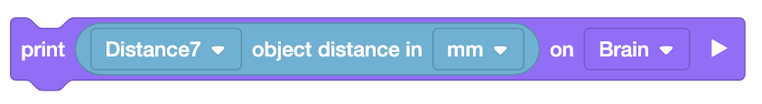
Standard: CSTA ( 2-AP-11) Algorithms and Programming- Create clearly named variables that represent different data types and perform operations on their values.

