Activity
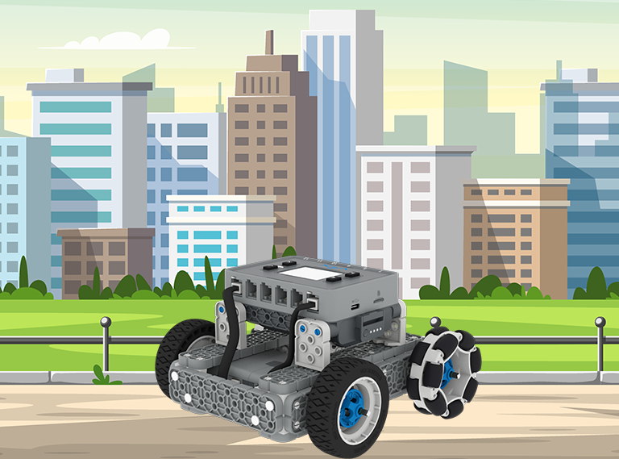 | BaseBot Driver  Navigate a city maze using the Controller. First, build the city, then drive in it!
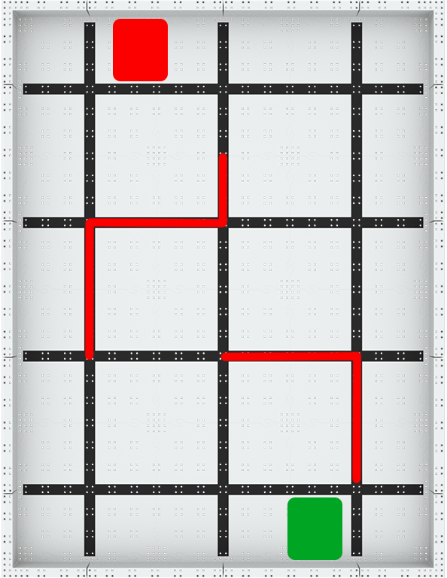

Step by Step

- Build the BaseBot and pair your Controller.
- Build a city on an IQ Field using classroom items. Tape a red square and a green square to the Field to show the start and stop locations. The red lines represent where classroom items should go to represent buildings or other city structures. Use the image on the right as an example.
- Run the Driver Control program on the IQ Brain, and use the Controller to navigate through your city.
- Start at the green square and end on the red square.
- Then, open the BaseBot (Drivetrain 2-motor) template in VEXcode IQ and add blocks to have the BaseBot autonomously navigate the city instead of using the Controller. Which is faster? Which is more accurate?

‘LEVEL UP’  - Add Sensors - Use these build instructions to add sensors to your BaseBot. Add colors to your maze and code it to navigate the city based on the colors detected by the Optical Sensor! | Pro Tips  - Drive Control Options - Experiment with different driver configurations to find the one that works best for you. Do you prefer Tank Drive, Right Arcade, Left Arcade, or Split Arcade?  - Use [Comment] blocks to organize your code!
Standard: CSTA (2-AP-17) Modularity - Create procedures with parameters to organize code and make it easier to reuse.

