Activity
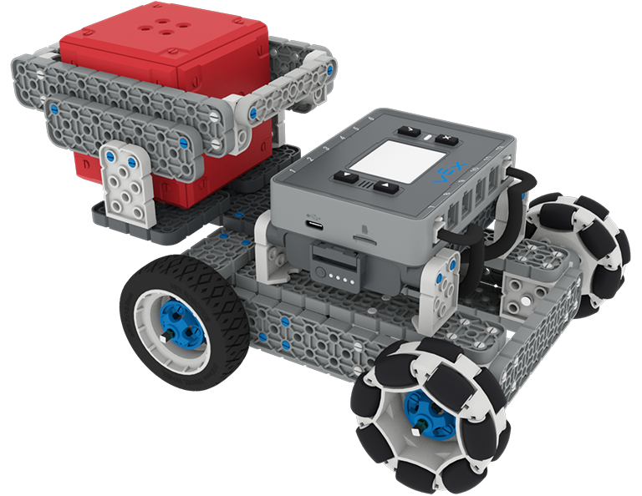 | Build a Wagon!  Create an addition to the BaseBot to carry an IQ Cube up an inclined plane!

Step by Step

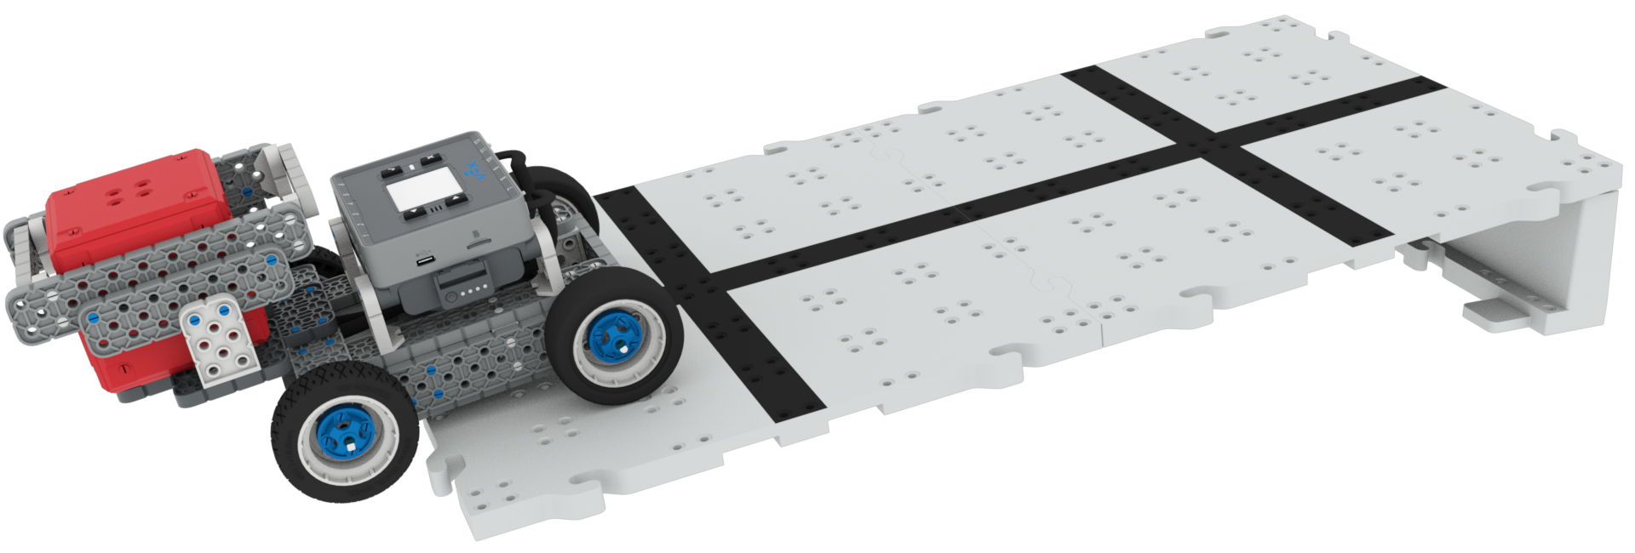
- Build the BaseBot, then create an addition so that it can carry a cube.
- Create an inclined plane with pieces in the VEX IQ Kit or classroom materials.
- Code the BaseBot to drive up the inclined plane in VEXcode IQ.
- Experiment with different wheel combinations to find one that will enable your BaseBot to carry the cube up the inclined plane without slipping.

‘LEVEL UP’  - Add weight - Add more weight to the wagon and see test the wheel combinations.  - Steeper incline - Make the inclined plane higher, and see how this affects the BaseBot’s ability to carry the cube . | Pro Tips  - Do some research on the Center of Gravity  - Does it help you plan your design?
Standard: NGSS MS-PS2-2 Motion and Stability: Forces and Interactions - Plan an investigation to provide evidence that the change in an object’s motion depends on the sum of the forces on the object and the mass of the object.

