Activity
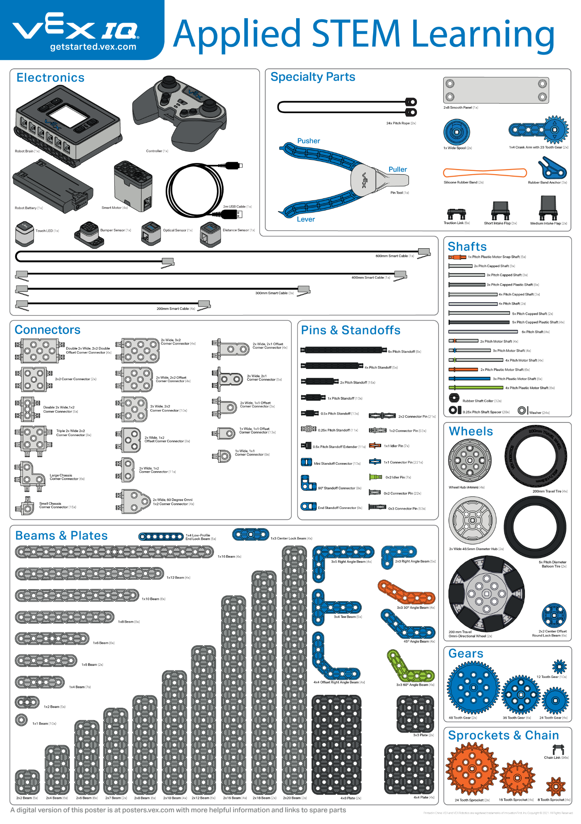 | Can You Name That Part?  It is very helpful to know the name of a part from your VEX IQ Kit and the category of parts the part is found. This game will help with both.

Step by Step
- Find a classmate to play the game with.
- Select a part from your VEX IQ Kit. Ask your opponent what the name of the part is and the category it comes from. Your opponent cannot use the poster to look up the answer.
- Award one point for the correct category and two points for the correct part name. Provide the correct response for any wrong answer. Use the Parts Poster as a reference.
- Return your part to the kit. Now it is your opponent's turn to select a part and ask you the questions.
- The first person to collect 21 points is the winner.
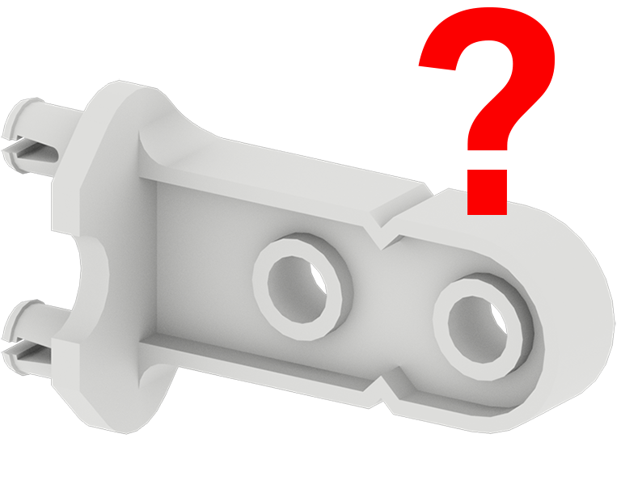
- Can you think up another game to help identify the parts in the VEX IQ kit?

Student: ”What is the name of this part and what category is it found in?”
Answers: Part name - Offset Corner Connector = 2 points
Category - Connectors = 1 point

‘LEVEL UP’  - Ask a 3rd question: What is the size of the part? This question will be worth three points. | Pro Tips  - Parts also have specific part numbers which help identify each part.
Standard: ISTE (3) IKnowledge Constructor- 3a: Students plan and employ effective research strategies to locate information and other resources for their intellectual or creative pursuits.

