Activity
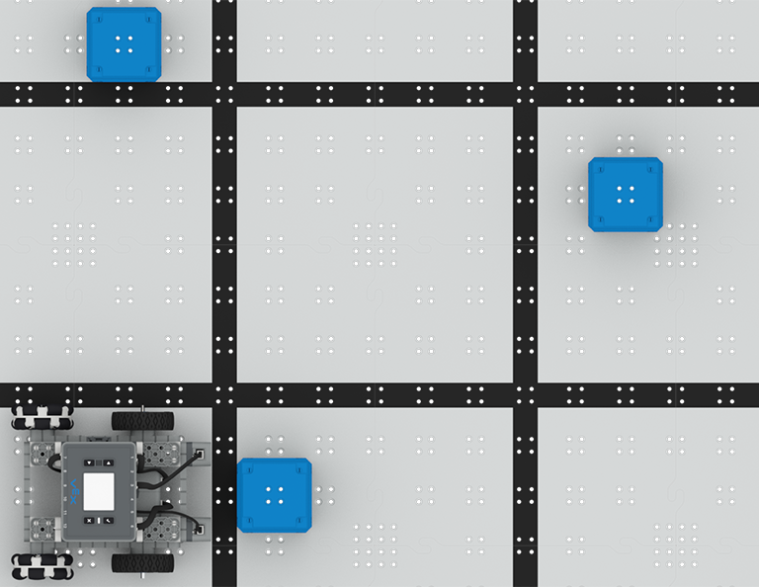 | Color Sensing  Use the Optical Sensor to travel from cube to cube!

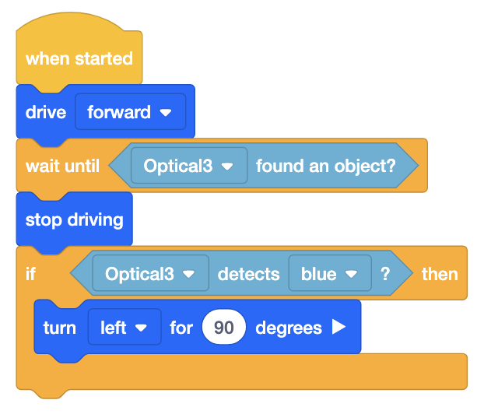
Step by Step
- Build the BaseBot and attach an Optical Sensor to the front plate. Open VEXcode IQ and make sure to configure the Optical Sensor. Set up the Field by using Connector Pins to secure 3 blue cubes to the tiles.
- Build the code shown in the image to the right. Download and run the project.
- Add additional Drivetrain blocks to navigate to the next two cubes.
‘LEVEL UP’  - Mix it Up! - Pin different color cubes to the tiles. How will this affect the code? | Pro Tips  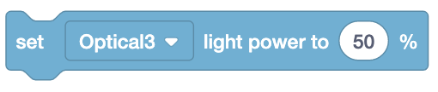  - The Optical Sensor uses light to detect color. Use the [Set optical light] block to increase the brightness of the LED for more accurate color detection.
Standard: CSTA (2-AP-11) Algorithms and Programming- Create clearly named variables that represent different data types and perform operations on their values.

