Activity
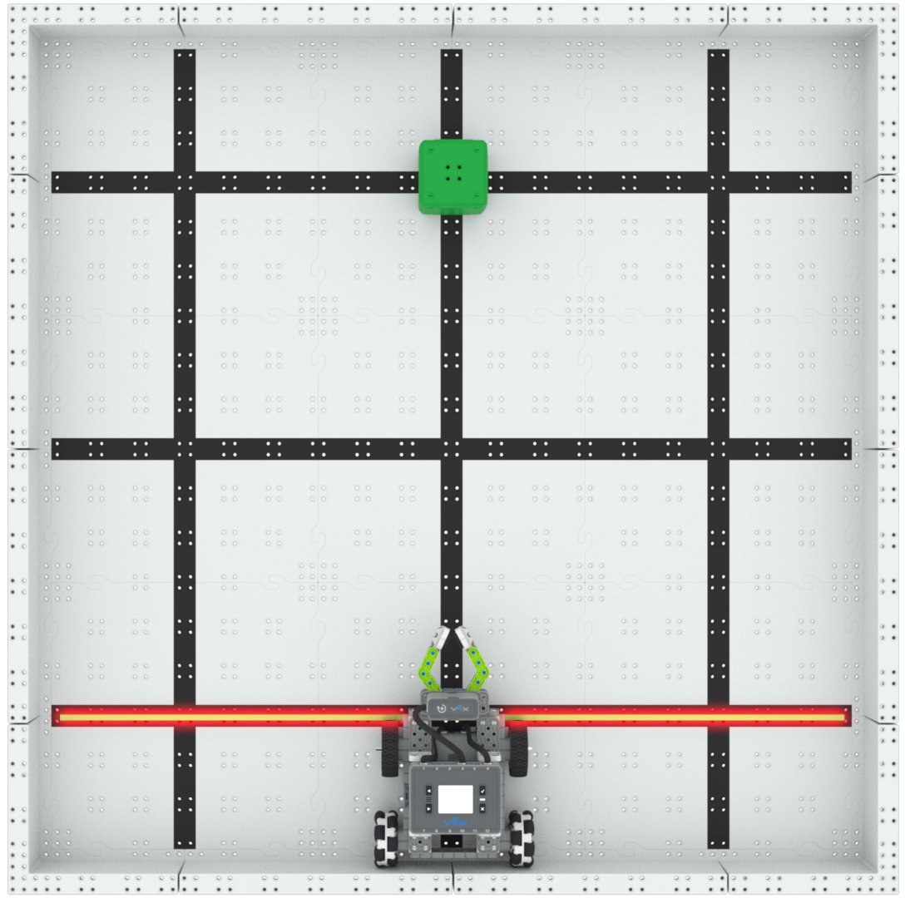 | Forward, Lift, Reverse  Which direction is faster when moving an object?

Step by Step
- Build the Simple Clawbot and set up a Field that is 3’x3’ and includes the Field Walls. Using colored tape, like orange, mark the first black horizontal line going across the bottom of the Field. The area below the line will be considered the “Home” zone, as shown in the image above.
- Set one cube of any color on the cross at the top of the Field.
- Place the Simple Clawbot, with its back Omni wheels touching the back wall, anywhere along the back wall.
- Use the Driver Control Program to drive the Simple Clawbot forward, pick up the cube, and then drive in reverse back to the “Home” zone.
- Record the time of the Simple Clawbot moving forward and reverse. Which is faster?
‘LEVEL UP’  - Start Location - Change the starting location of the Simple Clawbot along the back wall and determine how that changes the recorded times.  - Obstacle - Place an object, like a pulley, that the Simple Clawbot will have to drive around to complete the task. | Pro Tip  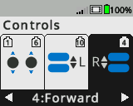  - Adjust the R button from forward to reverse on the Brain to determine which direction is easier to use.
Standard: ISTE- Empowered Learner - Students use technology to seek feedback that informs and improves their practice and to demonstrate their learning in a variety of ways.

