Activity
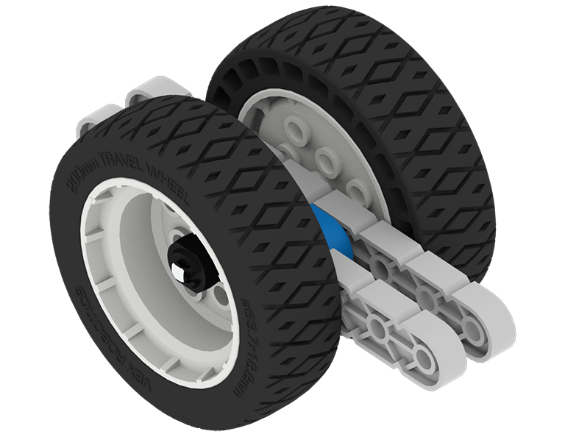 | Get a Grip  Whether your robot is pulling something, pushing something, or climbing something, the more grip your tires have the better. This activity will help you test the grip of your different VEX IQ tires!

Step by Step
- Build a wheel test cart.
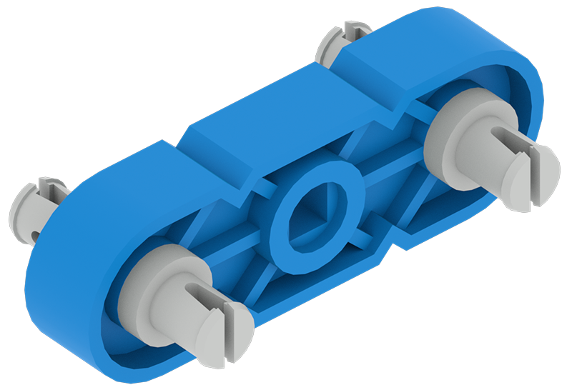 | 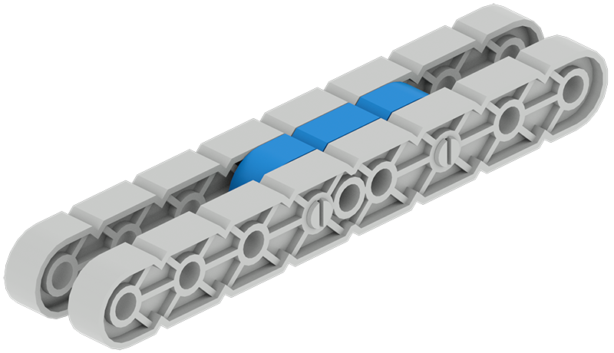 | 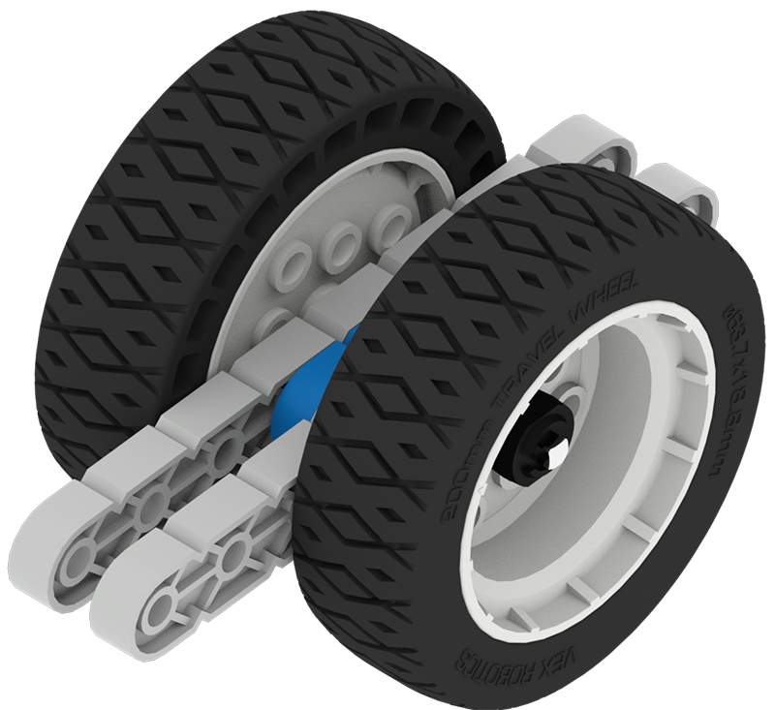
Insert the double side of a 1x2 Connector Pin into each end hole of a 1x3 Center Lock Plate. | Attach a 1x8 Beam in the middle to each side of the Center Lock Plate. | Insert a 4x Pitch Shaft through the square hole of the Center Lock Plate. Add the wheels to test with Shaft Collars onto the Shaft.
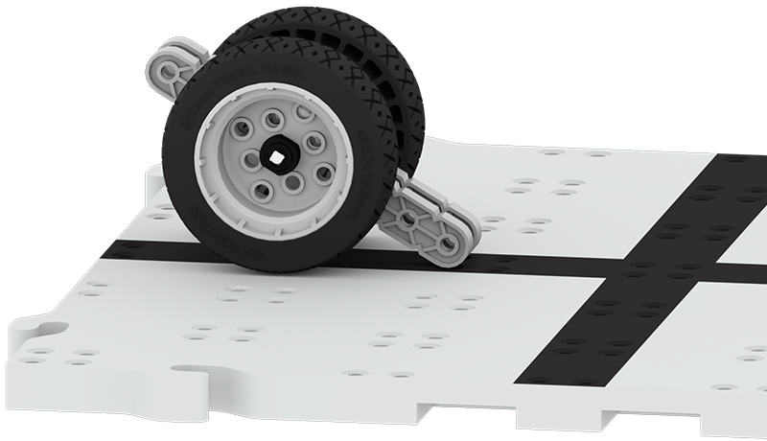
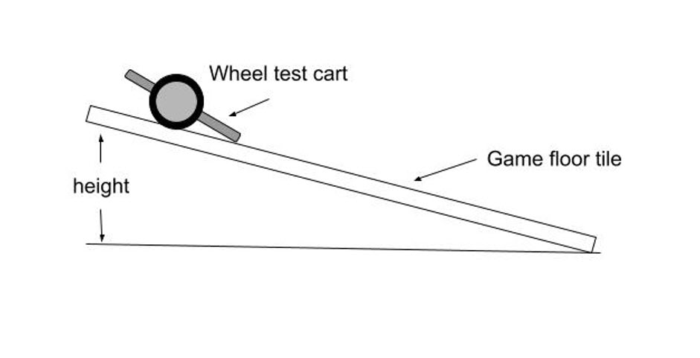
- Place the wheel test cart on the edge of a field tile. Gently lift the edge of the tile to create a ramp. Lift until the wheels lose their grip and begin to slide. Measure the height of the ramp. Test another set of wheels. Which wheels have the most grip (highest ramp height)?

- Do you think the surface of the ramp will change the tire’s grip? Design a test for this, such as taping sand paper or aluminum foil on the field tile.
‘LEVEL UP’  - Design a wheel cart to test four wheels. | Pro Tips  - The amount of grip is known as the coefficient of friction.
Standard: NGSS MS-PS2-2: Plan an investigation to provide evidence that the change in an object's motion depends on the sum of the forces on the object and the mass of the object.

