Activity
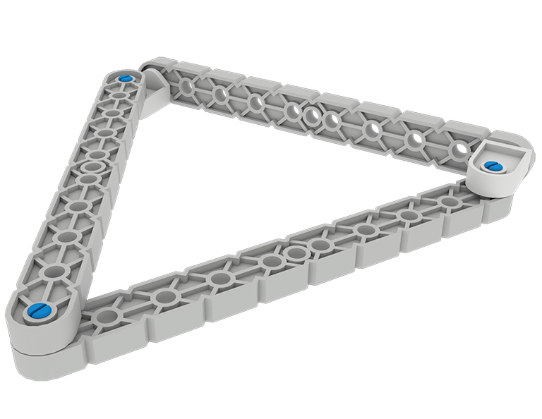 | Get in Shape  VEX IQ connectors allow you limitless options to connect beams and plates. Can you get your parts in shape?

Step by Step
- Using at least 2 connectors, build a set of rails out of plates and/or beams.
- Using at least 2 connectors, build a triangle out of plates and/or beams.
- Using at least 4 connectors, build a rectangle out of plates and/or beams.
- Using at least 6 connectors, build a cube out of plates and/or beams.

‘LEVEL UP’  - Challenge a classmate to see who can make a shape the quickest.  - Using connectors, plates and/or beams build an octagon shape. | Pro Tips  - Rails are useful in supporting both sides of wheel, gear, and sprocket shafts.  - Triangles are useful in supporting robot towers.  - An octagon shape can be used for a holonomic drivetrain called an “x-drive.”
Standard: CCSS.MATH.CONTENT.5.G.B.3: Understand that attributes belonging to a category of two-dimensional figures also belong to all subcategories of that category. For example, all rectangles have four right angles and squares are rectangles, so all squares have four right angles.

