Activity
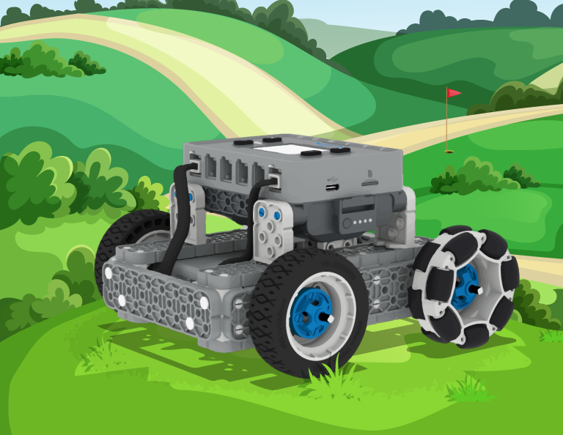 | Golf Course Mower  Code your BaseBot to drive over the entire golf course, while avoiding the sandpits!
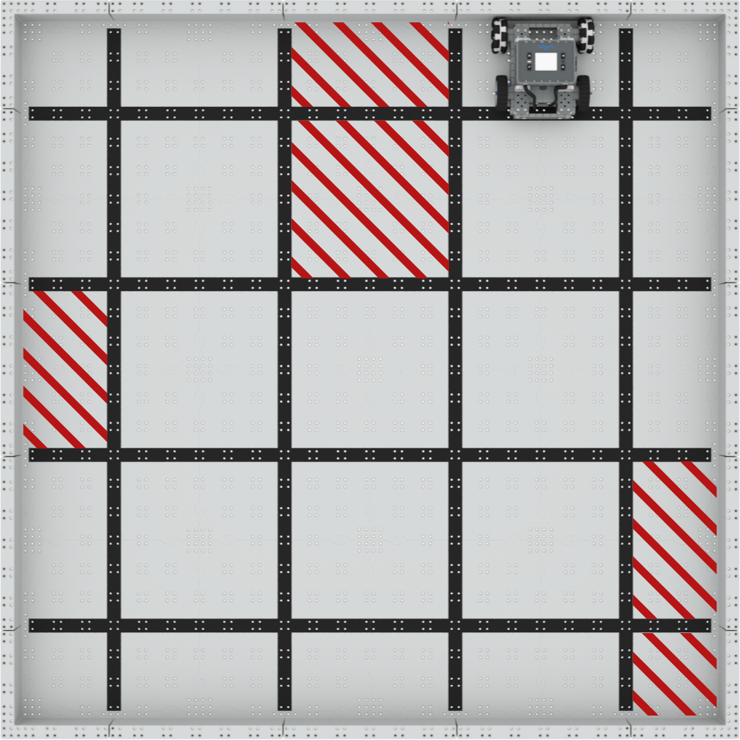

Step by Step

- Build the BaseBot and set up a 4’x4’ field as shown on the right. The marked areas are the sandpits. Mark the sandpits with pieces from the IQ Kit or other classroom materials.
- Open the BaseBot (Drivetrain 2-motor) template in VEXcode IQ, and create a project that has the BaseBot drive over all of the unmarked areas over the field which represents grass.
- Avoid the sandpits! If your BaseBot drives into a sandpit you must start again from the beginning.
- Start the BaseBot in the location shown in the image to the right. Download and run your project to test. Make changes to your project as needed and test again.
- Try starting from different areas. How fast can you drive around the entire course?
‘LEVEL UP’  - Add a Bumper Switch! - code your BaseBot to back up and turn when it touches a wall on the course.  - Add a ramp - use a binder or other classroom material to create a ramp on the golf course that the BaseBot needs to travel across as it mows the grass. | Pro Tips  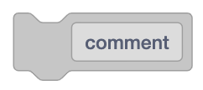  - Use [Comment] blocks to organize your code!
Standard: CSTA (2-AP-17) Modularity - Create procedures with parameters to organize code and make it easier to reuse.

