Activity
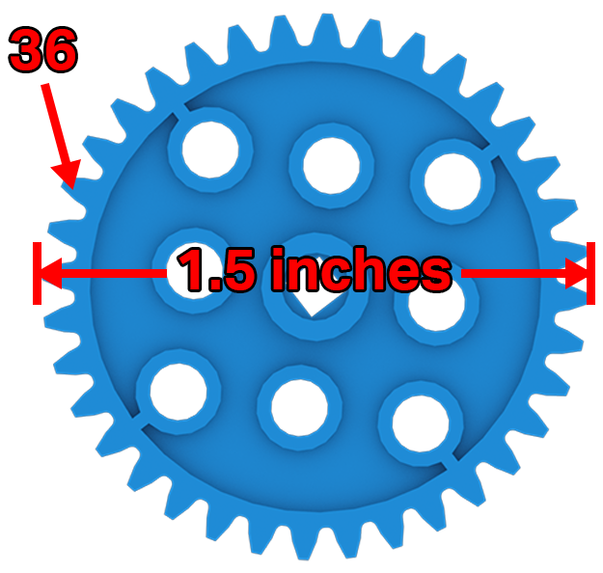 | How Big Are Your Teeth?  Can you calculate the pitch of your gears and sprockets?

Step by Step
- Print the VEX IQ Parts Ruler or gather another measuring tool.
- VEX IQ gears need the same size teeth to work together. VEX IQ sprockets also need their teeth size to match. The tooth size for gears and sprockets is called pitch.
- Select a 12 Tooth Gear and a 36 Tooth Gear. Be sure to count the number of teeth. Measure the gear’s diameter in inches from the tip of 1 tooth directly across the gear to the tip of the tooth on the other side. Divide the number of teeth by the diameter of the gear. How does the pitch of the 36 Tooth Gear compare to the 12 Tooth Gear?
- Select an 8 Tooth Sprocket and a 16 Tooth Sprocket. Be sure to count the number of teeth. Measure the sprocket’s diameter in inches from the tip of 1 tooth directly across the sprocket to the tip of the tooth on the other side. Divide the number of teeth by the diameter of the sprocket. How does the pitch of the 16 Tooth Sprocket compare to the 8 Tooth Sprocket?
‘LEVEL UP’  - Gear Comparison - In your engineering notebook create a chart to compare the number of teeth, diameter, and pitch for each size gear in your VEX IQ kit.  - Sprocket Comparison - In your engineering notebook create a chart to compare the number of teeth, diameter, and pitch for each size sprocket in your VEX IQ kit. | Pro Tips  - The mechanical advantage of a gear or sprocket system can be determined by the gear/sprocket ratio.
Standard: NGSS (5-PS1.3)Structure and Properties of Matter - Make observations and measurements to identify materials based on their properties.

