Activity
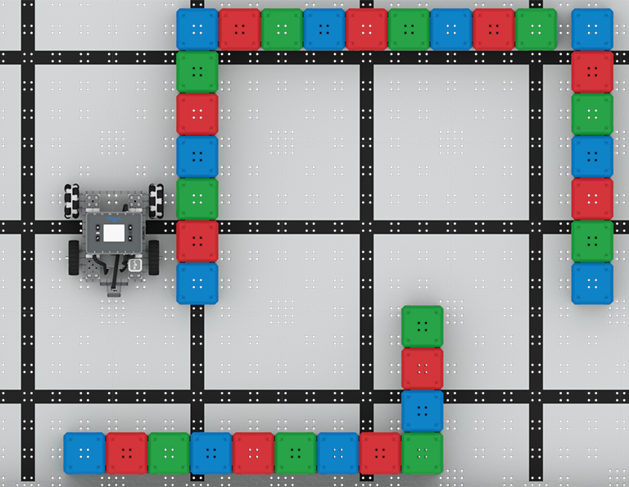 | Navigate the Maze  Use the Bumper Switch to solve a cube maze!

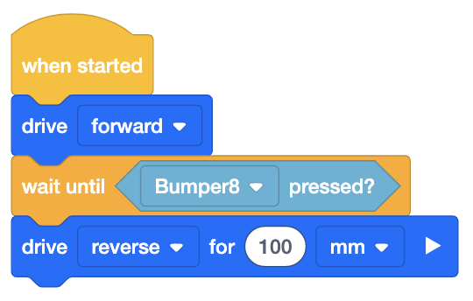
Step by Step
- Build the BaseBot and attach a Bumper Switch to the front plate. Open the BaseBot (Drivetrain 2-motor) template in VEXcode IQ and configure the Bumper Switch. Set up the Field by using Connector Pins to secure “walls'' of cubes to the tiles, or use IQ Field Walls.
- The Bumper Switch will return “True” when the switch is pressed and “False” when the switch is not pressed. In this activity, the Bumper Switch will be used to detect the walls of the maze. Build the code in the image to the right.
- Place the robot at the start of the maze, as shown in the image above. Download and run the project to test it.
- Add additional [Drive] and [Turn for] blocks to escape the maze.
‘LEVEL UP’  - Reverse - Move the Bumper Switch to the back of the BaseBot and code it to navigate the maze in reverse!  - Labyrinth - Make the maze more complex, add more walls or dead ends. Can you still solve the maze? | Pro Tips  - Draw the maze in your engineering notebook and solve it by hand. Use the solved maze to plan the project flow. When will the robot need to turn left or right?
Standard: CSTA (2-AP-14) Modularity - Create procedures with parameters to organize code and make it easier to reuse.

