Activity
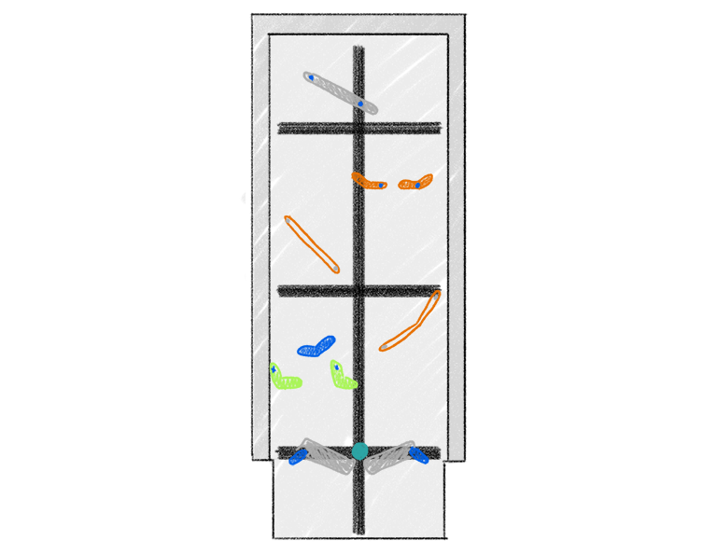 | Pinball Wizard  Create a pinball game that includes simple machines using VEX IQ parts!

Step by Step

- You will need a pencil, paper, and a marble for this activity.
- Sketch a pinball machine using VEX IQ parts. Be sure to include a lever and an inclined plane. Only use parts that do not require power.
- Build your pinball machine by elevating the tiles to create a slope, and test out your design. Does it work as intended? What improvements can you make?
- Create a second iteration of your pinball machine based on your test. Play again!
- Keep testing and iterating until you are happy with your design.

‘LEVEL UP’  - More machines! Can you find a way to include a wheel and axle in your design? What about a pulley?  - Double Trouble! Find a way to use two marbles at one time in your design. | Pro Tips  - If you are not sure where to start, look at some pictures of pinball machines and observe their features. Look for pieces in the IQ Kit that would work to recreate them!  - Use rubber bands when creating the levers on the bottom to flip the balls back into the game!
Standard: NGSS MS-ETS1-3: Analyze data from tests to determine similarities and differences among several design solutions to identify the best characteristics of each that can be combined into a new solution to better meet the criteria for success.

