Activity
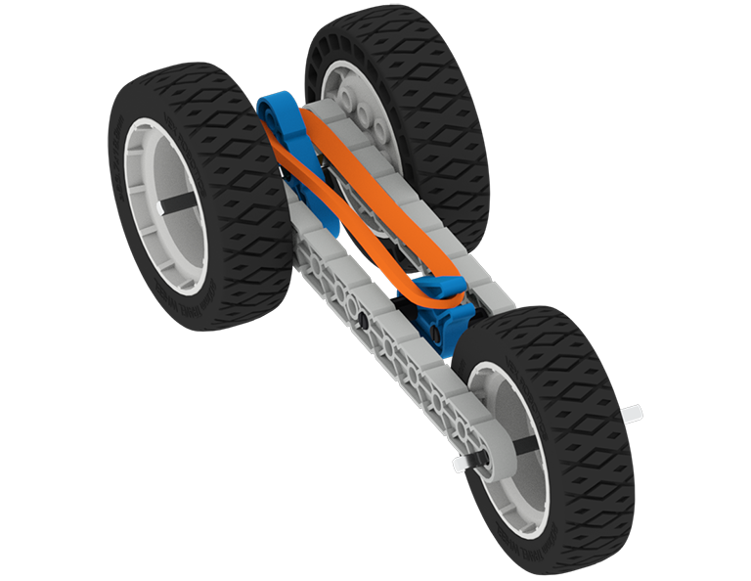 | Rubber Band Car  Can you design and build a car powered only by a single rubber band?

Step by Step
- Design problems usually have constraints or limits within them. For this challenge, you must design a car which will move under the power of just a single rubber band.
- Ideas: Join together with one or two partners and brainstorm ideas on how to build a rubber band powered car. Decide on a design to build. Document the reasons why you decided on this design.
- Build: Assemble your rubber band car design. Be sure to document and diagram the parts needed, the steps taken to build the car, and any problems encountered during the build.
- Test: Test out how well your car moves. Document the results of your test. Remember measurements always add strength to the reporting of your test. How did your rubber band powered car work? Did your test help you come up with any new ideas?
‘LEVEL UP’  - Built for Speed- Layout a meter long drag strip. Challenge your classmates to find out who has the fastest rubber band powered car.  - Go the Distance - Challenge your classmates to find out which car will travel the farthest using only the power from a single rubber band. | Pro Tips  - Leaving a tiny amount of space between the shaft collar and the structural piece (enough space to slide in a piece of paper) will allow your car’s shafts to spin faster.  - The acceleration of your car will be equal to the force from the rubber band divided by the car's mass. If all other things are equal, the lighter your car, the faster it will go.
Standard: ISTE (4) Innovative Designer - 4a: Students know and use a deliberate design process for generating ideas, testing theories, creating innovative artifacts or solving authentic problems.

